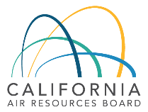


CVRP Rebate Influence
Clean Vehicle Rebate Project
Retrospective Report
February 6, 2026

Please cite this reference: Pallonetti, N., Sechley, T., & Puckett, L. (2026, February). “CVRP Rebate Influence: Clean Vehicle Rebate Project Retrospective Report.” Prepared by the Center for Sustainable Energy for the Clean Vehicle Rebate Project, California Air Resources Board, Sacramento USA.

© 2026 Center for Sustainable Energy
Disclaimer: The Center for Sustainable Energy® (CSE) makes every effort to present accurate and reliable information. However, the content is presented “as is” without warranty of any kind. Reference to any specific commercial product, process or service does not constitute or imply endorsement, recommendation or favoring by CSE. Center for Sustainable Energy, CSE and CSE logo are registered trademarks of the Center for Sustainable Energy.
CSE Headquarters
Center for Sustainable Energy
3980 Sherman Street, Suite 170
San Diego, CA 92110
858-244-1177
EnergyCenter.org
Contents
Executive Summary 5
Introduction 12
Program Context 12
Market Context 14
Previous Related Work 21
Data, Methods, and Limitations 24
Results and Discussion 26
What influence did CVRP have on EV buying? 26
Metrics of Program Influence 26
Rebate Importance 27
Rebate Essentiality 32
Influence Metrics Compared 36
Why did rebate influence change over time? 38
Program Evolution and EV Market Development 38
What are the market implications of CVRP influence? 48
Statewide EV Market Implications 48
Conclusion 54
What are key takeaways for other programs? 56
Acknowledgments 57
APPENDICES 58
Appendix A: Data Summary & Program Design 59
Appendix B: Counterfactual Behavior Survey Data 61
Appendix C: CVRP & Federal EV Tax Credit Influence 63
Appendix D: Survey Language 65

Executive Summary
California’s Clean Vehicle Rebate Project (CVRP) offered a post-purchase cash incentive for residents who acquired a new eligible electric vehicle (EV) from March 2010 through late 2023. The primary goals of the program were to support mass deployment of zero-emission vehicles and to build a sustainable EV market in the state. From its inception through its closure, CVRP awarded over 586,000 rebates including 556,758 for personal-use, battery-electric vehicles (BEVs) and plug-in electric vehicles (PHEVs), totaling $1.375 billion. This report evaluates how influential the CVRP incentive was in driving EV adoption in California over the course of the program by examining levels of participant-reported influence metrics overall and in the context of changes in CVRP program design, eligibility, and broader EV market developments.
This report primarily explores two measures of program influence. Survey respondents were asked how important the CVRP rebate was “in making it possible” to acquire their clean vehicle. Five response options ranged from “Not at all important” to “Extremely important.” Following previous related work,, participants who selected “Moderately,” “Very,” or “Extremely important” responses are classified as being Rebate Important. Respondents were also asked, “Would you have purchased or leased your [EV] if the state vehicle rebate (CVRP) did not exist?” Participants who selected “No” (indicating they would not have acquired their EV without CVRP) are referred to as Rebate Essential.,,, The frequency of these influenced consumers within a group or period (termed “Rebate Importance” and “Rebate Essentiality”) provide quantitative indicators of the program’s influence on EV adoption. As such, groups with high Rebate Essentiality indicate where the program was most influential.
Over 90,000 survey responses that characterize the influence of the rebate on participants’ purchase decisions (and were weighted to represent the program population from 2012–2023) suggest the program had significant impact. Overall, nearly 90% of all survey respondents throughout the course of the program were Rebate Important. Nearly 50% of all respondents and 65% of those who received the Increased Rebate for lower-income consumers were Rebate Essential. Over the course of CVRP’s nearly 14 years, the EV market developed significantly from its infancy and CVRP evolved from a broad market program to a more targeted incentive with vehicle- and income-based eligibility criteria. The evolution of the program had significant impact on its reach. CVRP rebated as much as 79% of the new EV market in 2013 (in the era before income-based eligibility) and as little as 11% in 2022 (a year with particularly high EV prices overall and when a large portion of the EVs on the market exceeded CVRP’s MSRP cap). Because the program spanned such changes, its influence metrics can be better understood when evaluated over time and against the backdrop of distinct program design changes and significant market developments. As such, rebate influence metrics are analyzed across five eras of CVRP, each distinguished by major changes made to the program design over time (and denoted by shaded areas in the figures below).
Rebate Importance did not change substantially over time—this metric of rebate influence was steadily near 90% with the exception of a modest dip during the onset of the COVID-19 pandemic in 2020. Rebate Essentiality, on the other hand, was much more variable, ranging from 57% to 35% (Figure ES1). The overall importance of the program being granted, Rebate Essentiality is used to drill down on the changes in program impact over time. In summary, Rebate Essentiality set out on an increasing trend throughout the first program era as the EV market developed from its earliest stages and expanded beyond initial, pent-up demand for EVs and enthusiastic early adopters. Rebate Essentiality peaked at 57% in 2017 following a series of program changes that introduced both an income cap that excluded high earners from the program and an increased rebate amount for low- to moderate-income consumers. It dipped modestly to 50–52% in 2018 and 2019 when two new popular models were released that had lower Essentiality levels. These were the Tesla Model 3 and, to a lesser extent, the Chevrolet Bolt. It is likely that the lower levels of Essentiality among these long-range models was due to their inherent attractiveness to consumers (i.e., their long range and other features were, in essence, “selling themselves” more often). Unsurprisingly, Essentiality levels were depressed during the height and aftermath of the COVID-19 pandemic. This was likely related to the type of consumers willing to purchase a new car regardless of the uncertainty and elevated prices during this time. The phase-out of the most popular EV manufacturers’ (Tesla and GM) eligibility for federal EV tax credits also likely contributed by suppressing adoption among price-sensitive consumers. Essentiality then spiked dramatically in 2023 (the last year of the program) from all-time lows of 35–36% in 2021 and 2022 to a near all-time high of 56%, paralleling similar trends observed in New York. This occurred after the program was redesigned in 2022 to further emphasize equity and was likely also related to price-sensitive consumers reentering the market after holding off due to pandemic-related concerns and prices inflated by subsequent supply-chain and other pressures peaking in 2022, as well as popular EV manufacturers becoming re-eligible for federal EV tax credits. The combined effect of these factors is consistent with the marked increase in Rebate Essentiality observed in the program’s final year.
Figure es1
Rebate Essentiality and Rebate Importance Over Time
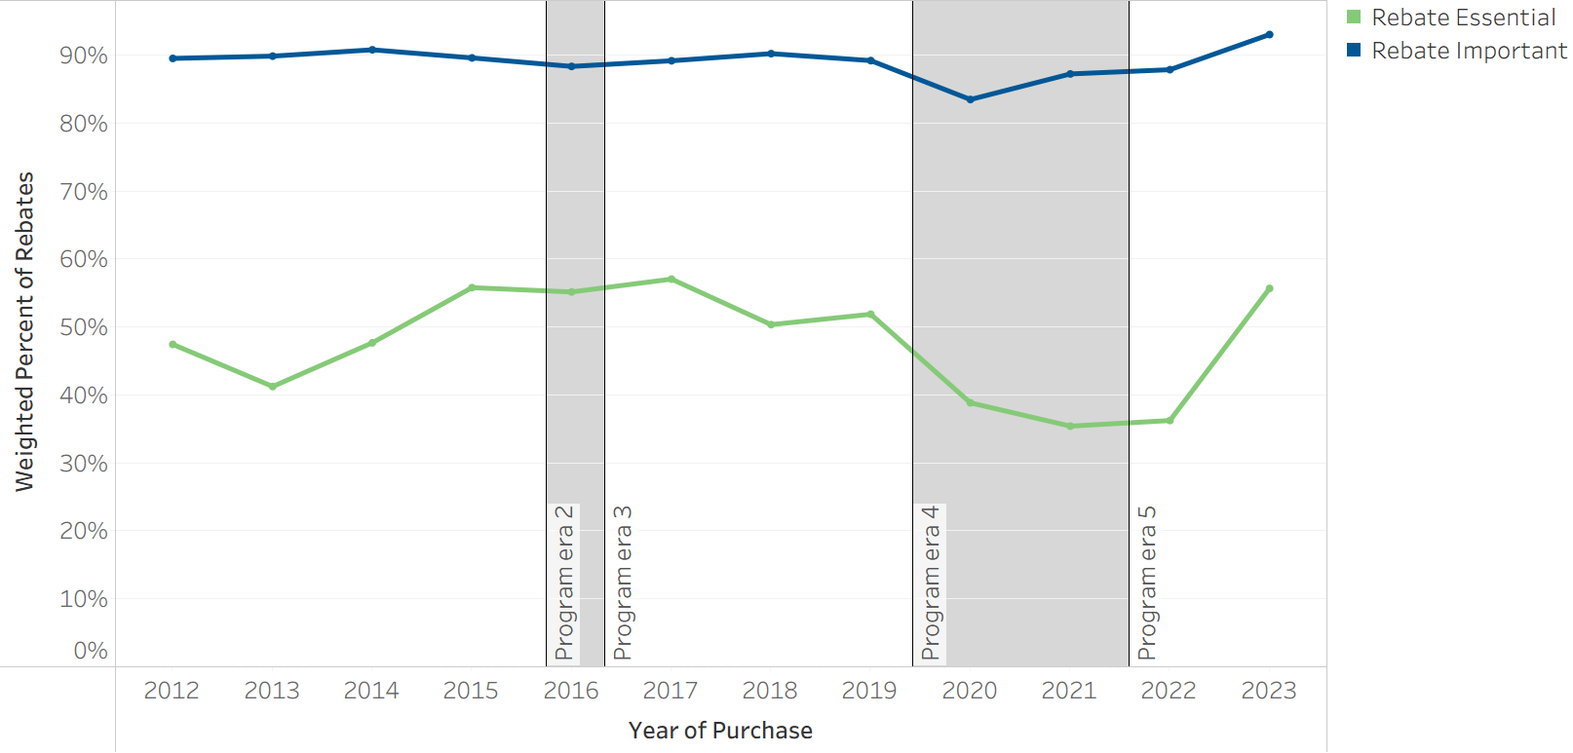
Summary of results: Rebate Importance was steadily near 90% with the exception of a modest dip during the onset of the COVID-19 pandemic in 2020. Rebate Essentiality was much more variable, ranging from 57% in 2017 to 35% in 2021.
Rebate influence can vary substantially across different participant groups and examining influence levels across various dimensions related to program design has confirmed several trends. Rebate influence has been found to vary by EV technology type, likely due to both CVRP rebate amounts varying by EV technology and different technologies appealing to consumers with distinct characteristics and preferences., Rebate influence also varies by rebate type,,, with Standard Rebate recipients tending to have lower levels of influence (30%–56%) than Increased Rebate recipients (49%–75%), likely due to both Increased Rebates being directed toward lower-income participants and to the higher dollar amount those rebates represent. Rebate Essentiality has been found to be higher for consumers with lower incomes,, and rebates of higher amounts more generally,, as well as for vehicles with lower prices.,, Rebate Essentiality has been found to be lower for inherently attractive models such as Tesla (up until 2023) and other models with long range capabilities.
Evaluating rebate influence in relation to EV sales helps contextualize the program’s broader impact on California’s EV market. Scaling rebate influence metrics up to reflect rebate totals indicates that CVRP was important in enabling 506k EVs and that 276k specific EVs would not have otherwise been purchased (Figure ES2). In the context of the statewide EV market, Rebate Important and Rebate Essential EVs reflected as much as 69% and 37% of all new EVs purchased in California during the first era of the program (through 2015), respectively. Based on more detailed but less complete survey data on purchase decisions that participants think they may have made in absence of the rebate, at least 171k participants from 2016–2023 would not have otherwise purchased a new EV at all.
Figure ES2
EV Market and Rebate Influence Over Time
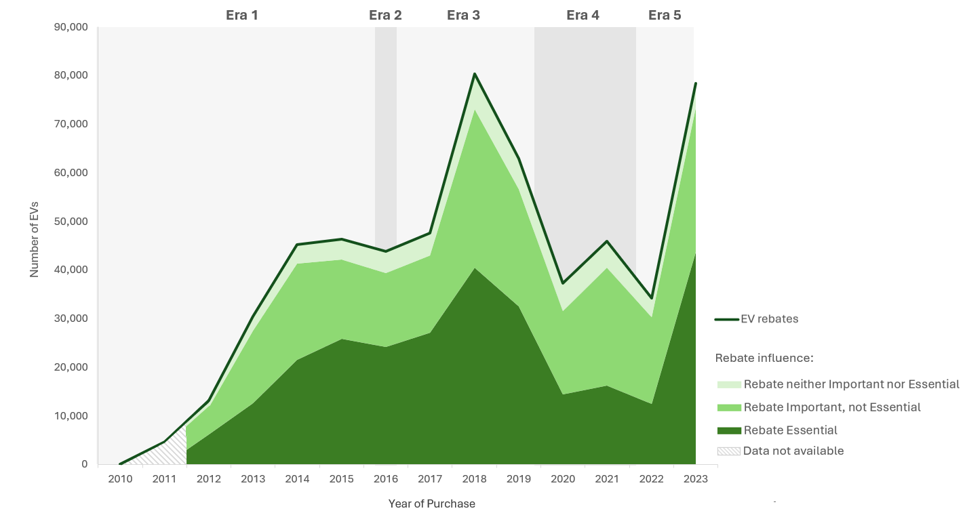
Summary of results: Rebate influence metrics among program participants remained relatively high and steady over time, even as rebate volumes varied. In total, an estimated 506k EVs were Rebate Important and 276k were Rebate Essential.
Since more stringent eligibility criteria were introduced over time, the program’s reach was widest during the earlier program eras and narrowed over time. In Era 1, for example, which lasted until March 2016, more than 75% of EVs purchased or leased in California received a rebate. That the rebate was an important factor in enabling approximately 90% of these indicates that CVRP was directly influencing approximately 69% of all EVs acquired in California through 2015. The wide reach and influence of the program at this time suggest that CVRP helped set the state out on its successful EV trajectory. As the market developed and EVs became more inherently attractive and widely adopted in California, the program rolled out design changes that directed eligibility to more mainstream consumers, emphasized priority populations, and eventually prioritized improving equity in the EV transition. These changes progressively narrowed the eligible consumer pool but directed program benefits toward a more mainstream, skeptical, and/or price-sensitive base. This likely helped keep its influence levels relatively high and steady, even as barriers to EV adoption decreased over time. During the last program era, the percentage of the market that was rebated reached all-time lows, but Rebate Essentiality reached a near all-time high (56% in 2023).
While the survey data evaluated for this report is useful to help understand the influence that the CVRP rebate had on EV consumer purchase decisions over time and across various dimensions, the metrics analyzed do have important limitations. They do not capture the impact of the program outside of its effect on individual purchase decisions, nor do they necessarily fully isolate the impact of CVRP from other EV-benefitting policies such as California’s ZEV Regulation. Considering second-order and long-run effects would increase the benefits attributable to the program. Also, the consistently available metrics of rebate influence do not necessarily identify whether respondents would have purchased an EV generally. For example, some Rebate Essential respondents reported that they would have purchased some other EV in absence of the rebate. More detailed, but less complete survey data on purchase decisions that participants think they may have made in absence of the rebate is used to better understand new EV attribution.
The motivations and limitations of this work suggest several avenues for future research. A more detailed analysis of the program’s final year may extract additional insight from the most recent and relevant data. In addition, ongoing work by CSE employing a diffusion-of-innovation framework to project new EV market development may provide insight into the longer-term impacts of CVRP., Other ongoing efforts include analyzing levels of rebate influence across various dimensions, such as those detailed in this report, to inform program design for cost-effectiveness and equity within budget constraints or other goals., Finally, given limitations inherent in survey data, future research should also consider complementary statistical methods for assessing the EV additionality attributable to CVRP.
Lessons learned from CVRP can inform both California’s ongoing efforts, such as CARB’s focus on expanding EV adoption in priority populations, and the design of similar programs in other states as they pursue clean transportation goals. Select takeaways include the following.
- EV rebates have proven to be broadly influential in encouraging new EV adoption across consumers, technologies, and time periods.
- Rebate Importance was stable and high, even while Rebate Essentiality varied, suggesting that while program design and evolving market dynamics may have bearing on the degree to which rebates are a determinative factor in consumers’ decision to acquire an EV, rebates remain widely influential on the overall decision-making process regardless of these factors.
- Results indicate there is merit in targeting incentives for efficiency. High-priced vehicles (e.g., over $60,000) and high-income consumers (e.g., over $300,000 in annual income) tended to be less Rebate Essential over time and recipients of the Increased Rebate for low- to moderate-income consumers were substantially more Rebate Essential than Standard Rebate recipients.
- Program design decisions should balance goals, as targeted eligibility criteria will come at the expense of program reach. While progressively targeting eligibility at a narrower priority population can be appropriate in well-developed EV markets, a broader incentive to spur interest in EVs may also still be warranted in regions with less-developed EV markets.
Overall, CVRP rebate influence metrics from more than a decade of survey data indicate that the program played a significant role in enabling EV adoption in California. While a holistic approach is needed to evaluate a program such as CVRP with various and evolving goals, this research explores one important dimension of the program’s impact and can help inform ongoing efforts to support EV adoption.

Introduction
California’s Clean Vehicle Rebate Project (CVRP) ran between 2010–2023 with the primary goals of supporting mass deployment of zero-emission vehicles and building a sustainable electric vehicle (EV) market in the state. The program, which was funded by the California Air Resources Board (CARB) and administered statewide by the Center for Sustainable Energy (CSE), offered a post-purchase cash incentive for residents who acquired a new eligible EV. From its inception in March 2010 through its closure in late 2023, the bulk of the over 586,000 CVRP incentives awarded were the 556,758 rebates for personal-use battery-electric vehicles (BEVs) and plug-in electric vehicles (PHEVs), totaling $1.375 billion. To evaluate the impact of the program, it is important to understand its influence on consumers to purchase or lease EVs. In this report, CSE evaluates how effective the CVRP incentive was in driving EV adoption in California over the course of the program by examining levels of participant-reported influence metrics overall and in the context of changes in CVRP program design and broader EV market trends.

Program Context
CVRP was initially funded through CARB’s Air Quality Improvement Program (AQIP), which was established by the California Alternative and Renewable Fuel, Vehicle Technology, Clean Air, and Carbon Reduction Act of 2007 (AB 118). AQIP’s goals were to fund clean vehicle and equipment projects, air quality research, and workforce training. Accordingly, the CVRP’s primary goal at the time it was established was to accelerate on-road deployment of zero-emission passenger vehicles and plug-in hybrid electric vehicles by spurring consumer demand and encouraging clean technology innovation. Over the course of the program, the EV market developed and CVRP evolved from a broad market program to a more targeted incentive with vehicle- and income-based eligibility criteria (rebating as much as 79% of the market in 2013 and as little as 11% in 2022, see Figure 1).
While various consumer types and EV technologies were eligible for the program, this report focuses on personal (nonfleet) consumers and the two dominant EV technologies: BEVs and PHEVs (together, plug-in EVs, or PEVs). BEVs, as the cleaner, all-electric option, received larger rebate amounts than PHEVs. Base rebate amounts varied over time, primarily spanning $2,000–$2,500 for BEVs and $1,000–$1,500 for PHEVs.
CVRP can be divided into five distinct program eras (descriptions following), each characterized by changes made to the program design as it evolved. Additional details on program design elements and rebate amounts over time are summarized in Appendix A, and more detail on program eligibility is available on the CVRP website.,

Program Era 1 (March 15, 2010 – March 28, 2016)
The first era spans the inception of the program on March 15, 2010, through to March 28, 2016. During this time, the program was primarily focused on encouraging diffusion of the nascent technology by spurring interest in EVs. It did so by incentivizing the purchase or lease of new EVs with minimal eligibility criteria and by providing EV market information to California consumers and stakeholders. As such, the percentage of the market that received an incentive was relatively high (69–79% annually), with increases in rebate volumes tracking overall increases in EV sales statewide.

Program Era 2 (March 29, 2016 – October 31, 2016)
In 2014, SB 1275 established the Charge Ahead California Initiative and directed changes to CVRP including limiting consumer eligibility based on income and considering pre-qualification and point-of-sale mechanisms. In 2016, the California legislature passed SB 859, which mandated several changes to the CVRP program design aimed at expanding the program’s reach and making EVs more affordable for lower-income consumers. On March 29, 2016, CVRP introduced a second rebate type: an “Increased Rebate” (worth $1,500 more than the existing “Standard Rebate”) available to low- to moderate-income consumers (initially defined as earning up to 300% of the federal poverty level) and the program began conducting additional outreach and prioritizing incentive payments to low-income consumers., At this same time, an income cap was introduced excluding the highest earners from the program. These changes were aimed at improving equity in the transition to electric vehicles by accelerating market transformation in priority populations and encouraging EV uptake by customers not traditionally among the first to adopt newer technologies. During this era, the percentage of the market that was rebated decreased, even as the number of incentivized EVs increased overall.

Program Era 3 (November 1, 2016 – December 3, 2019)
The third program era continued the focus of the relatively short Era 2: directing the benefits of the program toward a lower-income, more mainstream consumer base. This era is marked by a $500 increase to the Increased Rebate (to $2,000 more than the Standard Rebate) and a lowering of the income cap to exclude additional high earners. The first vehicle-based eligibility criteria were also implemented at this time, requiring vehicles to have an electric drive capability rating of at least 20 miles.

Program Era 4 (December 3, 2019 – February 23, 2022)
Era 4 began on December 3, 2019, when an MSRP cap of $60,000 for all BEVs and PHEVs was introduced, excluding more expensive vehicles from the program. The electric range requirement was also increased to a 35-mile minimum. The limit on total rebates an individual could receive for PEVs was reduced from two to one, directing rebates toward new participants in the EV market rather than those who have already converted. The Standard Rebate amount was also decreased by $500 at this time. Later in this era, Increased Rebate eligibility was extended to consumers with income up to 400% of the federal poverty level (January 2021) and the electric range requirement was increased again (April 2021). The electric range requirement was changed at this time from being based on Urban Dynamometer Driving Schedule (UDDS) ratings to the general EPA ratings, with the requirement of a 30-mile minimum, approximately equivalent to 45 UDDS-based miles.
In addition to widening the reach of the incentives by targeting higher rebate amounts at low- to moderate-income consumers, these design changes also aimed to improve efficiency by excluding high earners purchasing expensive EVs and to minimize funding waitlists by slowing the spend of program funds as the EV market rapidly expanded, particularly following the release of popular Tesla models in 2017 and 2019. During this era, statewide EV sales and the number of incentivized EVs both decreased in 2020, during the height of the COVID-19 pandemic. After 2020, statewide EV sales increased sharply, while the number of incentivized vehicles remained fairly stable at around 51,000 vehicles per year on average between 2021 and 2022.

Program Era 5 (February 24, 2022 – Program Close)
The fifth and final program era began on February 24, 2022, and continued through the end of the program in late 2023. At this time, the MSRP cap was lowered to $45,000 for cars (the $60,000 cap remained in place for inherently more expensive “large vehicles”, including SUVs, vans, and pickups), and the income cap was again lowered to ensure that an increasing proportion of program benefits were directed to priority populations. Later in this era (February 2023), the Increased Rebate was raised by $3,000 (to $5,500 above Standard Rebate amounts) for BEVs and PHEVs. These changes were all indicative of a prioritization of equity, helping ensure that an increasing proportion of program funding was channeled toward increasing EV affordability for lower-income consumers. During this era, statewide EV sales continued to increase sharply while rebate volumes dipped in 2022 (popular Tesla models were above the MSRP caps for much of the year) and rebounded to a near all-time high in 2023.

Market Context
Because CVRP ran from 2010 through 2023, it spanned the burgeoning of the EV market from its infancy to the point where over 1 in 4 new vehicles sold was electric. This period also spanned significant improvements in EV technology. Here, CVRP application data and other EV data sources are used to characterize pertinent developments in the PEV market over time.
When CVRP launched in 2010, the modern U.S. EV market was just forming. There were only three BEV models and one PHEV model widely available with a 2011 model year. In 2011, 5,062 BEVs and 1,656 PHEVs were sold in California and 70% of those received a CVRP rebate (Figure 1). EV availability, sales, and rebates all increased rapidly over the next few years. Through 2017, BEVs and PHEVs were rebated at high rates. In 2018, BEVs started to become the dominant technology as two widely popular and longer-range BEV models were released (Chevrolet Bolt and Tesla Model 3) and continued to increase in popularity (Figure 2). By 2023, PHEVs accounted for only 3% of all rebated vehicles.
Figure 1
CVRP Rebates by Technology and Percent of Market Rebated Over Time
Number of EVs & Percent of EV Market Rebated
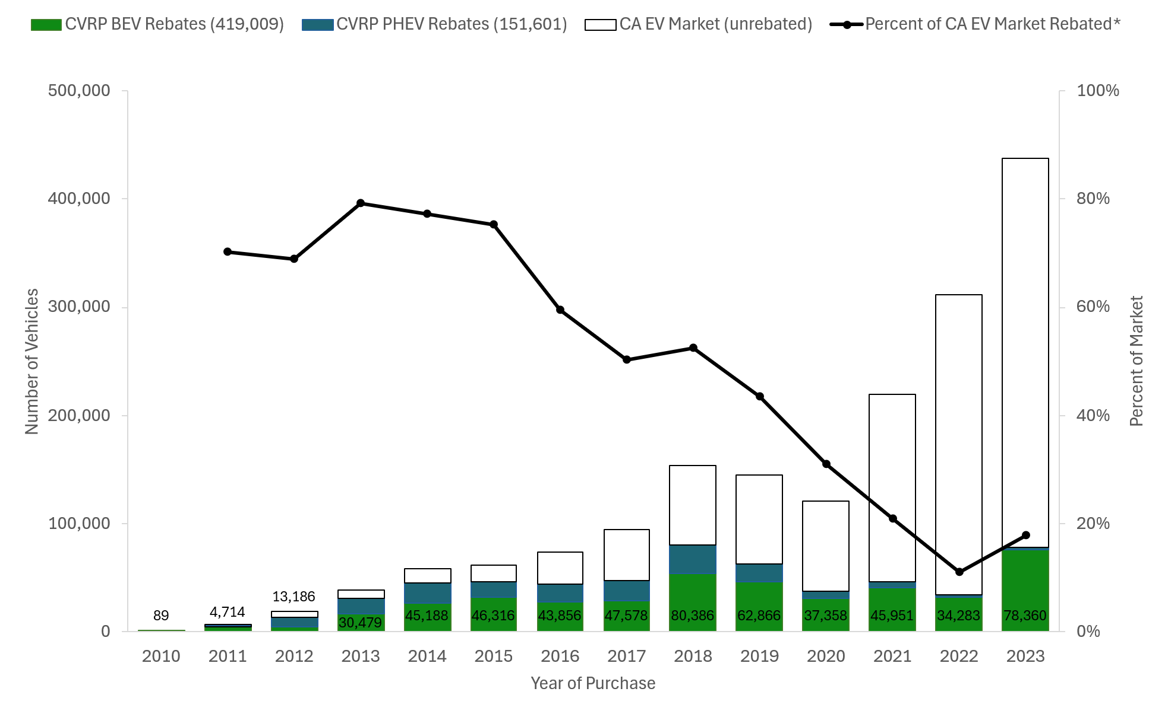
Note: Numbered data labels on bars describe total CVRP rebates.
* Market data unavailable for 2010.
Figure 2
CVRP Rebates by Technology Over Time
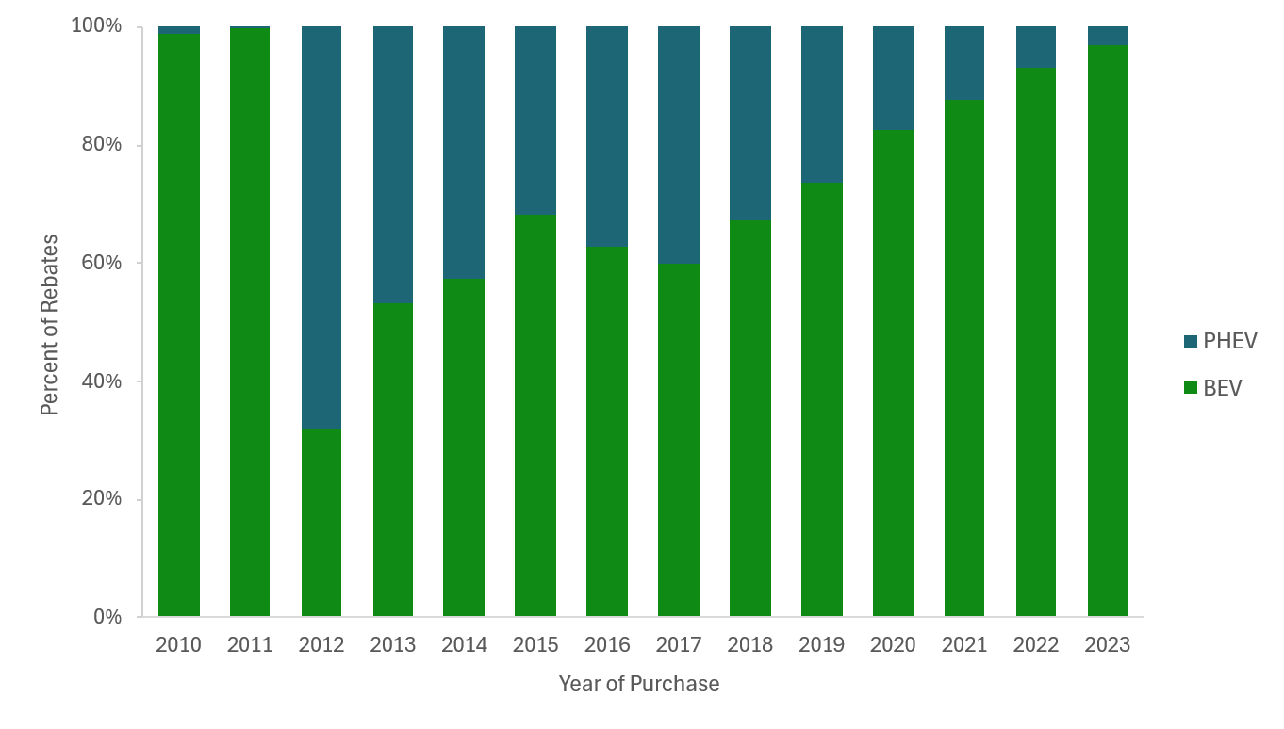
In mid-2017, the entry of the Tesla Model 3 dramatically impacted the EV landscape. Rebate volumes surged in 2018 and BEV rebates alone surpassed all 2017 rebates (Figure 1). From 2018 on, Tesla composed no less than 50% of all rebates in a given year and increased over time to 79% in 2023 (Figure 3). Due to the significant share of the program that Tesla composes and the uniqueness of the product and its consumers,,, Tesla is in some cases analyzed separately from other vehicle types.
Figure 3
Tesla Rebates Over Time
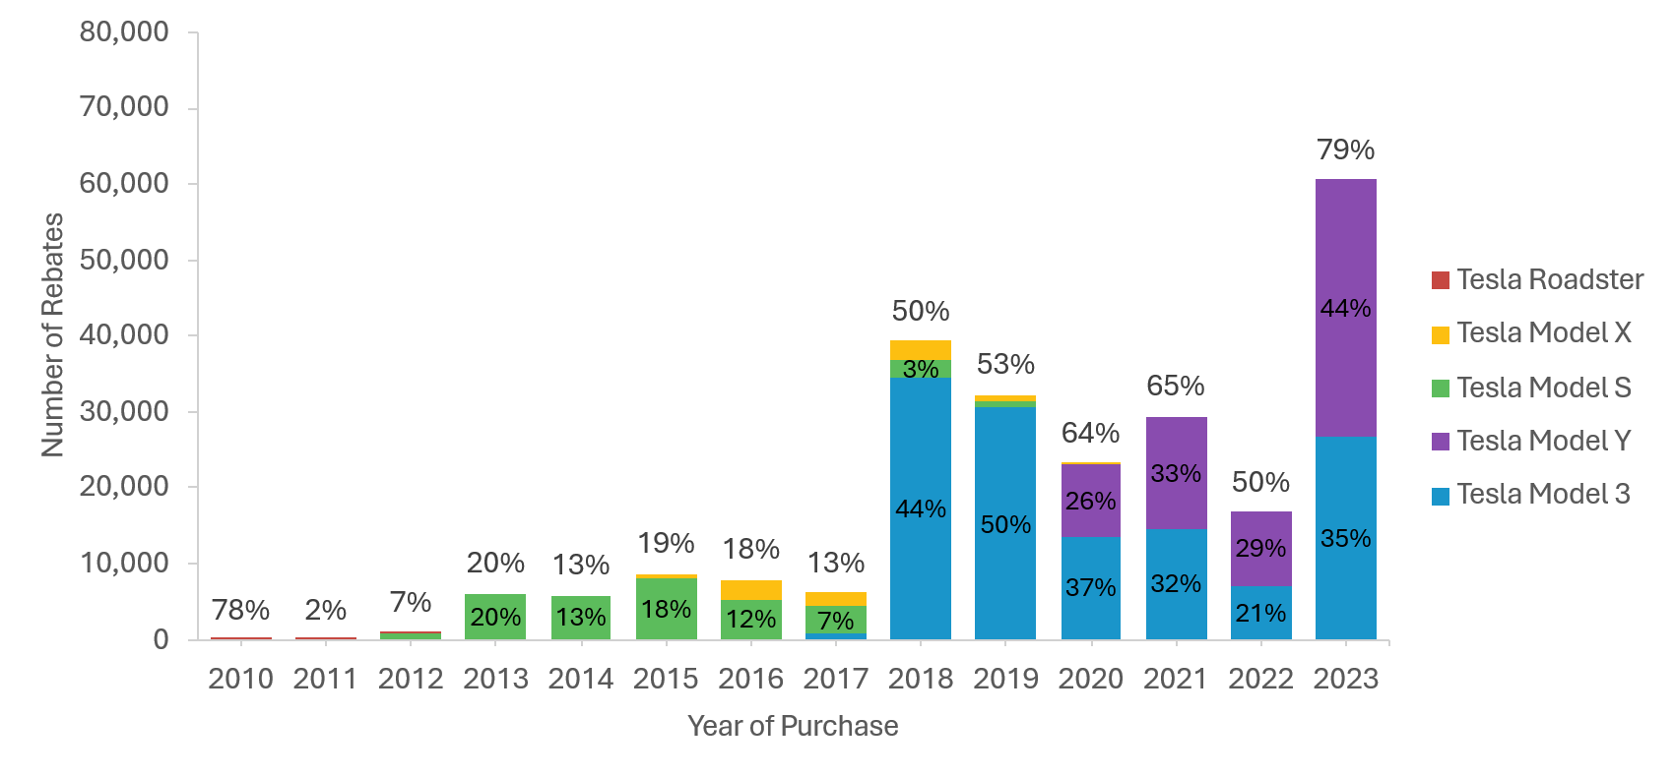
Note: Height of bars represents number of Tesla rebates, data labels represent the percentage of total CVRP rebates Tesla composed.
EV technology rapidly progressed during the course of the CVRP. For example, the electric range capability of BEVs increased significantly. After 2010, a year with few rebates overall and BEVs dominated by the high-priced Tesla Roadster, the average range of rebated models doubled from just 75 miles in 2011 to 163 miles in 2017 (based on the minimum range of models, see Figure 4). Performance continued increasing rapidly, reaching an average of over 200 miles of range in 2018. By the end of the program in 2023, the average range of rebated BEVs was 267 miles, a remarkable 3.5-fold increase over the course of the program. Relatedly, early market product offerings were limited to smaller sedans. Through 2019, the bulk of rebates went to compact and midsize cars. As EV technology improved, the product line diversified in terms of vehicle price and size. Eventually, larger body styles began to emerge and electric SUV uptake in particular saw rapid growth, increasing from 5% of all incentivized vehicles in 2019 to 30% in 2020 and 54% by 2023 (Figure 5). By the end of the program, most light-duty body styles had widely available electric models.
Figure 4
Average Electric Range Capability of Rebated Vehicles Over Time
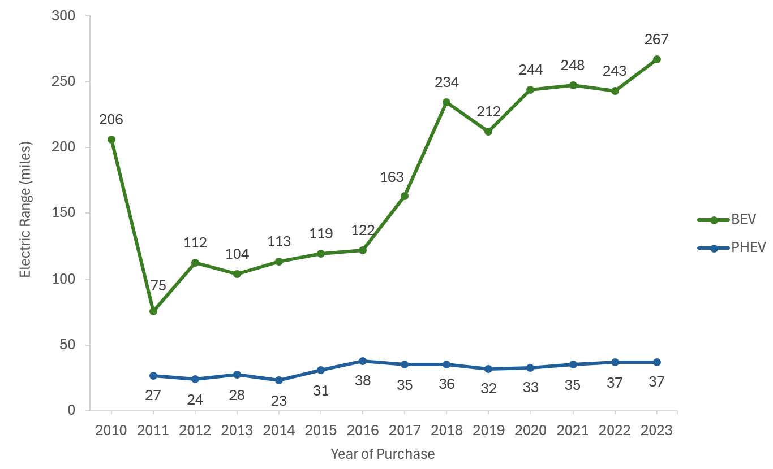
Note: Electric range based on the minimum range of any trim for a given model and model year.

Figure 5
Rebates by Vehicle Class Over Time
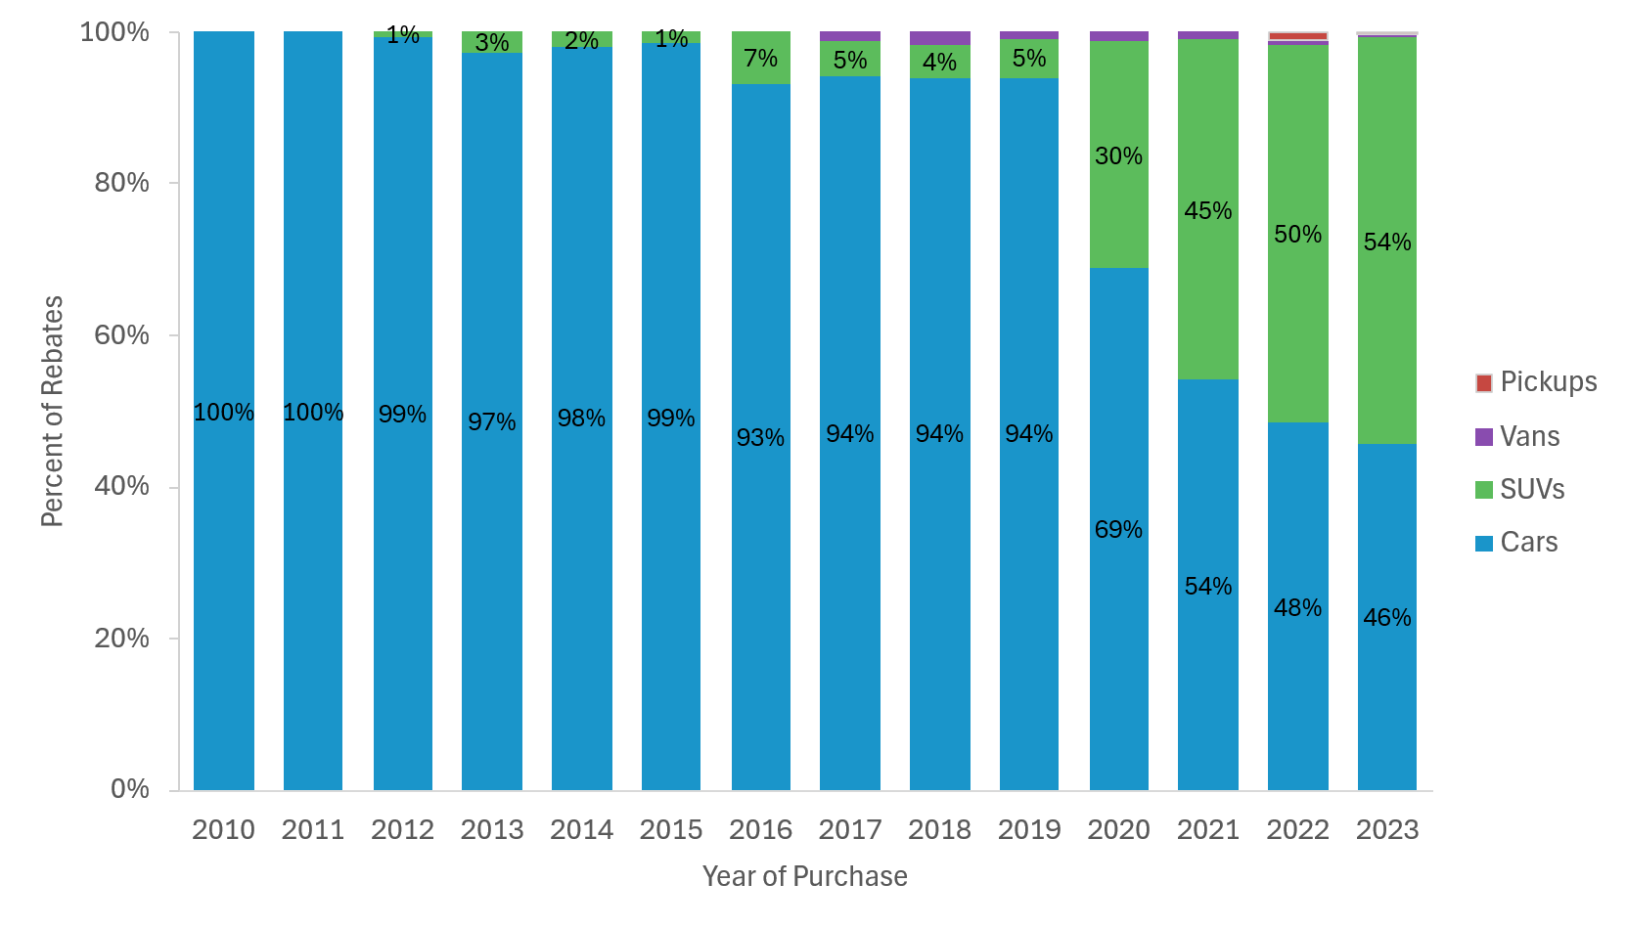
Average EV prices varied over time as EV manufacturing expanded and technology developed. Nominal prices tended to decline over time across the board through 2015 (Figure 6). In 2017, average prices for non-Tesla BEVs began increasing, likely due to the increased production of vehicles with longer range (Figure 4) requiring larger batteries. PHEV and Tesla prices continued declining over time through 2019. Prices began inflating across the board starting in 2020 due to supply-chain and other pressures, and remained elevated through 2023 for non-Tesla vehicles.
Figure 6
Average Purchase Price of Rebated Vehicles Over Time (Quarterly)
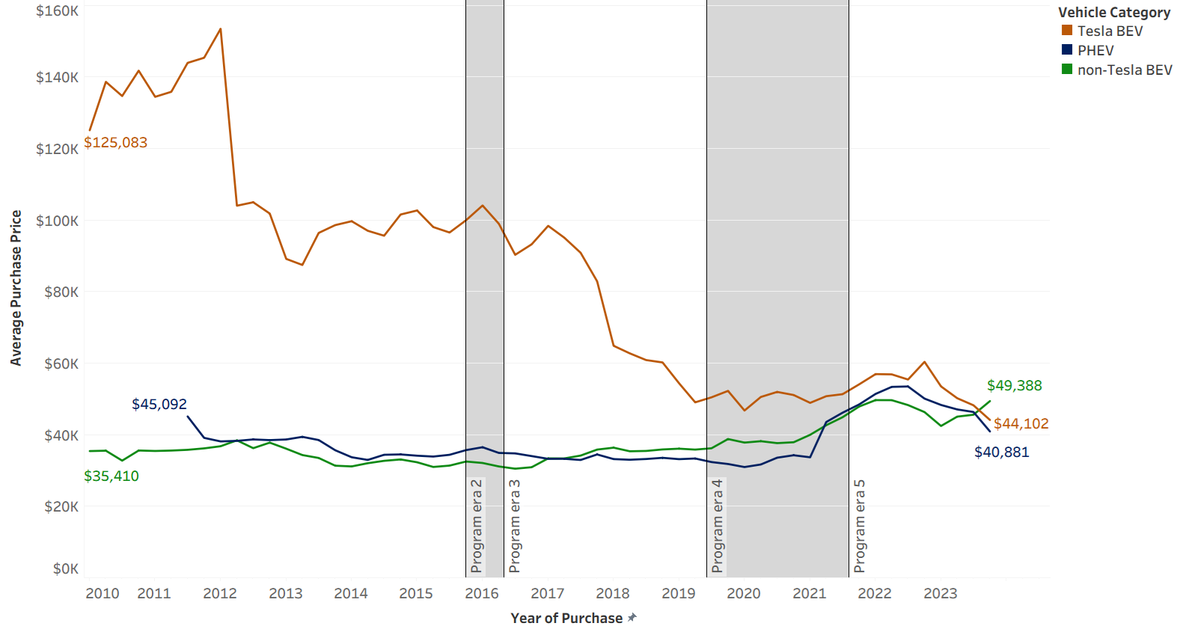
Note: Figure builds on precursor work that includes additional details on CVRP price considerations.
As the EV market diversified over time, so too did the consumer base. Early market participants are often enthusiasts—more willing to pay a premium, make sacrifices, and/or adapt to a less-capable product and early market issues., As the EV ecosystem developed and product offerings improved and expanded, the market broadened to a more mainstream and skeptical consumer base. Trends in CVRP participant demographic characteristics have been explored in prior work and will be summarized across the life of the program in forthcoming reporting. The evolving consumer base is reflected both in the progression of EV market share and the distribution of Increased Rebates (for lower-income households) over time. Starting as a small portion of the new car market, EV market share increased from 2% in 2013 to 26% in 2023, with significant strides in 2018 and each year from 2021–2023 (Figure 7). Similarly, starting as a small portion of the program when launched in 2016, Increased Rebate share grew over time, reaching nearly one third of rebates in 2023 (Figure 8).
Figure 7
California EV Market Share Over Time
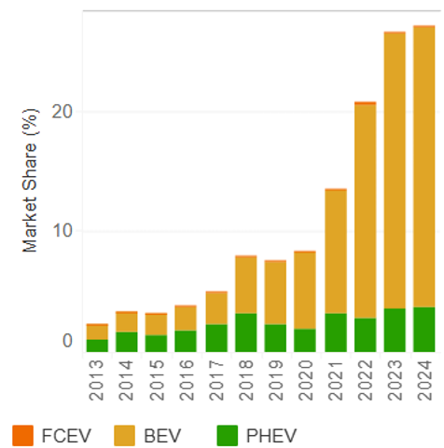
Source: Alliance for Automotive Innovation. (2025). Advanced Technology Sales Dashboard. Data compiled by the Alliance for Automotive Innovation using information provided by S&P Global Mobility (formerly IHS Markit) (2011-2018, November 2019-present) and Hedges & Co. (January 2019-October 2019). Date of last update: 5/22/2025. Retrieved 7/24/2025.
Figure 8
Increased Rebate Share of Program Over Time
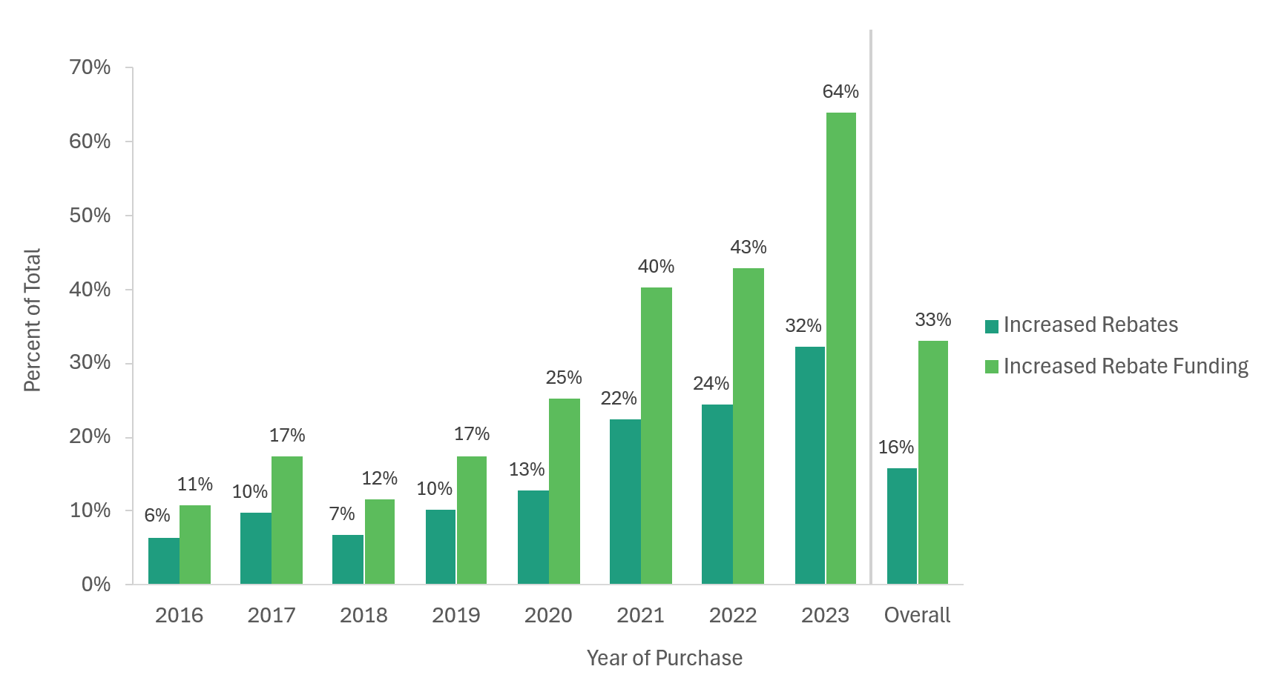
Note: Eligibility for Increased Rebates was extended in January 2021 from consumers with income up to 300% of the Federal Poverty Level to up to 400%. Overall percentages based on 2016–2023.

Previous Related Work
Evaluation of program impacts depends on an understanding of how effective the state rebate has been at influencing consumers to adopt EVs. For example, in past work by CSE, rebate influence metrics helped differentiate estimates of the GHG emissions saved by all rebated vehicles from those saved specifically by those consumers most highly influenced by the rebate to acquire an EV (i.e., approximating reductions “attributable to the program”). Other examples of past work detailed patterns in rebate influence, and the factors associated with it to highlight where to target program design, outreach, and other resources in order to cost-effectively amplify EV adoption. Further, ongoing efforts include analyzing levels of rebate influence across various dimensions (such as those detailed in this report) to inform program design for cost-effectiveness and equity within budget constraints or other goals.,, This work builds on these and other previous analysis and reporting by CSE, with an aim to update and expand the understanding of the CVRP’s impact by examining the level of rebate influence overall and in the context of changes in program design and broader EV market developments over time.
As summarized in previous related work, prior examinations of EV purchase incentives in the literature examined their importance to, or magnitude of effect on, EV markets. A literature review of 35 studies through January 2017 found, “Due to the abundance of literature using diverse methodologies this literature review can confidently state that PEV incentives are an effective policy measure in increasing PEV sales” (p. 1110). It categorizes the findings and provides recommendations for incentive design. Subsequently, analyses continue to grow in number and include, for example, early works by Jenn et al. and Narassimhan and Johnson. They used fixed-effects regression on databases of U.S. vehicle registrations spanning 2008–2016 to quantify the effect of various factors, including state incentives, on adoption. A more modest body of research characterizes those consumers who were most highly influenced to buy an EV. In 2016, Tal and Nicholas examined the influence of the U.S. federal tax credit on consumers, the majority of which acquired a Tesla Model S or Nissan LEAF in 2013. In 2019, Sherlock examined 2016 tax records to characterize the income of recipients of the federal tax credit for EVs. Starting in 2016, Johnson and Williams, used one of the consumer-provided indicators of rebate influence examined herein (“Rebate Essentiality”) but focused on characterizing those highly influenced consumers rather than examining trends in Rebate Essentiality as a metric of influence. Additional discussion of the incentive literature and its findings relative to another, similar characterization of consumers most highly influenced by the federal tax credit is available., More recent studies have analyzed the impact of the Inflation Reduction Act’s federal tax credit, estimating additionality of 25%. Several UC research reports have also recently explored the impact of CARB’s clean transportation incentives and regulatory programs qualitatively and quantitatively before CVRP’s closure.

Data, Methods, and Limitations
CVRP administered voluntary surveys of participants since 2012 to provide insight into EV consumers, the evolving EV market, and program impacts. This report examines 98,089 responses to the CVRP Consumer Survey collected over six sequential editions. It includes personal (nonfleet) consumers of plug-in hybrid electric vehicles (PHEVs) and battery electric vehicles (BEVs). Survey administration details, representativeness, and statistical weighting will be described in forthcoming survey summary documentation. Additional details specific to this analysis are provided in Appendix A.
Survey statistics (e.g., response proportions) are weighted in order to be more representative of the project participant population. Due to rounding, summing the weighted proportions may not add to 100%.
In some cases, survey question language and/or response options varied slightly across survey editions. Question language from each survey edition for key metrics is provided in Appendix D; additional survey details will be made available in forthcoming documentation.
As discussed in previous work, while CVRP participants have comprised large percentages of the California EV market, it should not be assumed that they fully represent all EV consumers in the state. As such, though the results of this work may be useful for informing the assessment of other EV deployments and providing broader insights into the EV market, CVRP participants may not be a representative sample for these other use cases. Lack of insight into non-participant characteristics and behavior may limit the ability to appropriately extrapolate results outside the context of the program. Further, program eligibility requirements cause the CVRP population to systematically differ from the general EV-buying population, and changes in program eligibility over time (see Appendix A) will affect results.
Finally, the results are subject to uncertainty due to the scope of this analysis and the nature of the data. This work measures CVRP’s impact via self-reported survey data related to the influence that participants perceive the rebate had on their purchase decision and what they think they otherwise might have done. Positive spillover and market (e.g., network) effects from influenced adoption and other second-order impacts are not analyzed; including these unmeasured impacts would increase the benefits attributed to the program.,,, Other recent reporting on the impact of CARB’s clean transportation incentives and regulatory programs has described longer-run second-order effects as being crucial and inclusive of, “… effects on resale value, consumer awareness, and support for charging infrastructure, among others” but, “…difficult to accurately quantify solely based on available data.” Ongoing work using a CSE-developed tool that uses a diffusion-of-innovation approach to project new EV market development may provide insight into the impact of these long-run effects., Furthermore, as reported elsewhere,, California’s mix of various EV-benefitting policies make it difficult to isolate the impact of a single regulation or incentive program. These policies complement one another, and even the perceived effect of the rebate on consumer decision-making (as is the focus of this report) doesn’t account for other policy impacts such as vehicle availability resulting from California’s ZEV Regulation (which requires that ZEVs compose an increasing percentage of automakers deliveries for sale in California). As such, while this study leverages a vast program dataset to provide insight into CVRP’s effectiveness, it does not necessarily isolate the impact of the program from other policies such as the ZEV Regulation. Finally, potential bias is a limitation of all survey data—there is uncertainty in the results presented as they are subject to response bias (resulting from respondents answering questions inaccurately) or nonresponse/selection bias (resulting from the survey being voluntary).

Results and Discussion
In this section, CVRP rebate influence metrics, their trends over time, and their implications for the EV market are presented and discussed.

What influence did CVRP have on EV buying?
We begin by introducing the metrics of program influence used throughout the remainder of this report and discuss their interpretation. Each are then explored individually and compared.

Metrics of Program Influence
This report primarily explores two measures of program influence: Rebate Importance and Rebate Essentiality. Survey respondents were asked how important the CVRP rebate was “in making it possible” to acquire their clean vehicle. Five response options ranged from “Not at all important” to “Extremely important” (see Figure 9). Following previous related work,, participants who selected “Moderately,” “Very,” or “Extremely important” responses are classified as “Rebate Important.” Respondents are also asked, “Would you have purchased or leased your [EV] if the state vehicle rebate (CVRP) did not exist?” Participants who selected “No” (indicating they would not have acquired their EV without CVRP) are referred to as Rebate Essential and those who selected “Yes” as non-Rebate Essential. ,,,

Interpreting Rebate Influence
As previously reported, Rebate-Essential participation can be interpreted as the best consistently available estimate of rebated EVs that are attributable to the program, based on responses to a straightforward dichotomous survey question asking consumers whether they would have purchased/leased their EV without the state rebate specifically. Rebate Essentiality data have displayed reasonable patterns and proven useful in a variety of other works. This metric provides a clearer and potentially more conservative measurement of program influence than other candidate measures (such as Rebate Importance), barring any response or selection bias. California’s EV market benefits from a mix of policies supportive of EVs, including regulatory policies and numerous consumer incentive programs. As such, various factors likely play a role in EV purchase decisions in the state. Measurements of Rebate Essentiality help determine the degree to which CVRP rebates are influencing consumers to acquire their EVs, as well as help account for potential overlap with other programs with the same goals, as it provides an estimate of sales that reportedly would not have happened without the rebate, regardless of other factors. However, this metric does not necessarily isolate the rebate’s impact from the impact of the complementary ZEV Regulation (which requires automakers to supply EVs in the state), nor does it necessarily indicate that consumers would not have otherwise acquired a different EV.
While Rebate-Essential program participants are not free riders (consumers not influenced by the rebate who nevertheless claim it), it is not necessarily the case that all other participants are free riders. Evidence for this can be found in the other metric of rebate influence, “Rebate Importance.” Most survey respondents were Rebate-Important consumers and their ability to acquire an EV was influenced by the rebate in some less straightforward way. Even the majority of non-Rebate-Essential respondents reportedly found the rebate at least moderately important in making it possible for them to acquire their EV. Though it is not accurate for programs to claim sole credit for enabling all Rebate-Important EVs (e.g., other incentives like the federal tax credit for EVs and/or regulatory factors could have played a part), the rebate reportedly played an important role for these consumers. This likely disqualifies them from being true free riders (as “Not at all important” consumers reported being, and the remaining Rebate Un-Important consumers [who selected “Slightly important”] might be).
A tertiary survey question asking about more detailed counterfactual vehicle acquisition behaviors had CVRP not been available adds further nuance to the understanding of program impacts. However, it is a more complex metric and was not consistently available across survey editions, making it less suitable for analyzing time trends—one of the primary motivations of this report. This metric will be explored further and will be used in the quantification of CVRP’s GHG emissions impact in a separate retrospective CVRP report. Importantly for interpreting rebate influence, it indicates that a non-negligible portion of Rebate-Essential respondents also state that they think they would have purchased some other EV (e.g., a different new or used EV) in absence of CVRP. This distinguishes Rebate Essentiality as a metric of influence on specific purchase decisions from an indication of an EV purchase occurring generally. In other words, even though the Rebate Essentiality survey question is simple and dichotomous, there is still room for interpretation among respondents, and it may more directly reflect whether participants would have purchased their exact vehicle model as opposed to whether they would have purchased an EV at all. This metric is explored further in the Statewide EV Market Implications section and responses to this question are summarized in Appendix B. Nonetheless, as described, Rebate Essentiality is a useful metric for measuring where the program was most highly influential and can be used to consistently assess the impact of program in the context of changes in CVRP program design and broader EV market developments over time.

Rebate Importance
As described, Rebate Importance is based on a five-option ranking of how important the CVRP rebate was “in making it possible” for respondents to acquire their clean vehicle. It speaks to the influence of the rebate in enabling the EV acquisition among other factors, but not necessarily whether the rebate was a determinative (make-or-break) factor. Responses of “Not at all important,” however, are likely indicative of free ridership (receiving the rebate without being influenced by it).
The survey results show that consistently over time, the higher importance rankings were selected the most frequently. “Extremely important” was the most frequently selected response, ranging from a low of 38% of respondents in 2020, and a high of 54% during the last program year (Figure 9). “Not at all important” was consistently the least frequently selected response option, ranging from a high of 5% of respondents in 2020 to a low of 2% during the last program year. This represents a steady but very low level of free ridership throughout the entirety of the program.
Figure 9
Rebate Importance Rankings Over Time
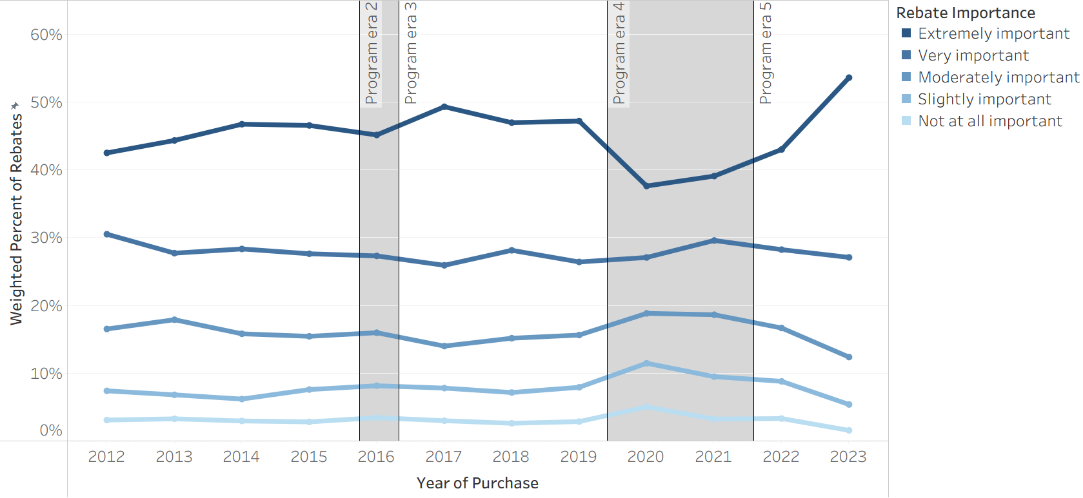
Combining “Moderately,” “Very,” and “Extremely important” responses into one “Rebate Important” group, we see that 89% of participants overall were Rebate Important throughout the entirety of the project. This ranges from 83% to 93% annually, representing a relatively steady and high level of influence throughout the entirety of the program (Figure 10). The highest occurrence of Rebate Importance is observed in the last program year (2023) and the lowest was in 2020 (during the onset and peak of the COVID-19 pandemic). Aside from those two years, Rebate Importance was steady—ranging only between 87% and 91% throughout the course of the program.
Figure 10
Rebate Importance Over Time
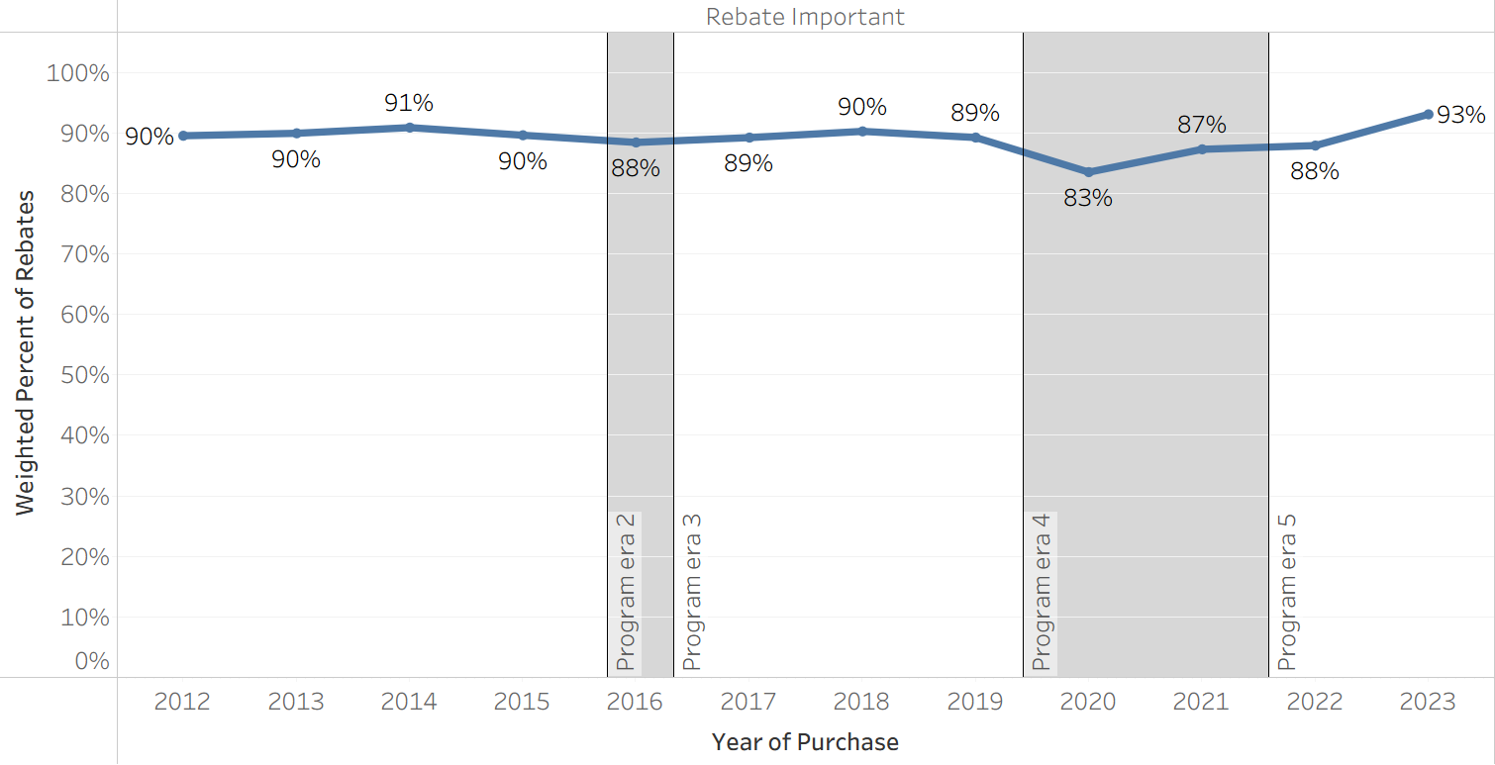
Rebate influence can differ substantially across different participant groups. One reason for this is that the program included different EV technology types (e.g., BEVs and PHEVs), which received different rebate amounts (see Appendix A) and appeal to consumers with distinct characteristics and preferences., Further, starting in 2016, two rebate types were included in the program: a Standard Rebate and an Increased Rebate, distinguished by the household income of consumers. As such, we explore influence metrics across EV technology type and CVRP rebate type groups (treating Tesla BEVs separately in some cases to highlight their unique characteristics,,).
Across technology types, non-Tesla BEV consumers tended to have the highest rates of Rebate Importance over time (Figure 11, panel 1). PHEV consumers consistently reported slightly lower rates of Rebate Importance than non-Tesla BEVs. Both non-Tesla BEV and PHEV rates were relatively steady but decreased modestly over time. Tesla consumers had lower rates of Rebate Importance early on (throughout program Era 1 and 2), but they steadily increased through 2018 and reached PHEV levels by 2017. Tesla also displayed the most prominent dip in Rebate Importance during the onset of COVID-19 in 2020, but continued its increase thereafter, displaying the highest rate of Rebate Importance among technology types in the last program year of 2023.
Income-qualified Increased Rebate recipients, who typically received $1,500–$2,000 more per rebate, tended to display Rebate Importance levels approximately 5–10 percentage points higher than that of Standard Rebate recipients (Figure 11, panel 2). The largest difference was seen in 2020, when Rebate Importance increased among Increased Rebate recipients but decreased among Standard Rebate recipients. Rebate Importance increased to all-time highs in 2023 for both rebate types. Interestingly, the 2023 increase among Standard Rebates was larger than that of Increased Rebates, even though rebate amounts were constant for Standard Rebates and Increased Rebate amounts were raised.
Figure 11
Rebate Importance Over Time by Vehicle Type and Rebate Type
(1)
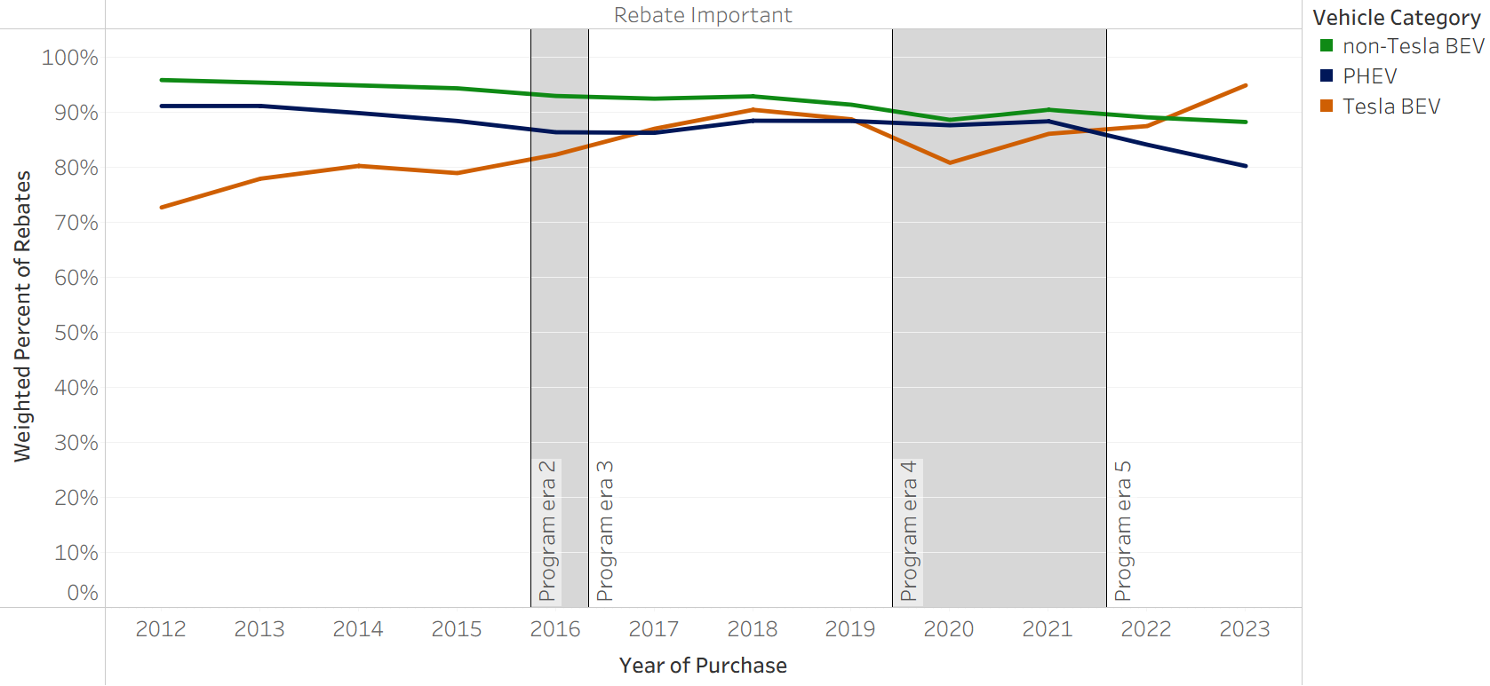
(2)
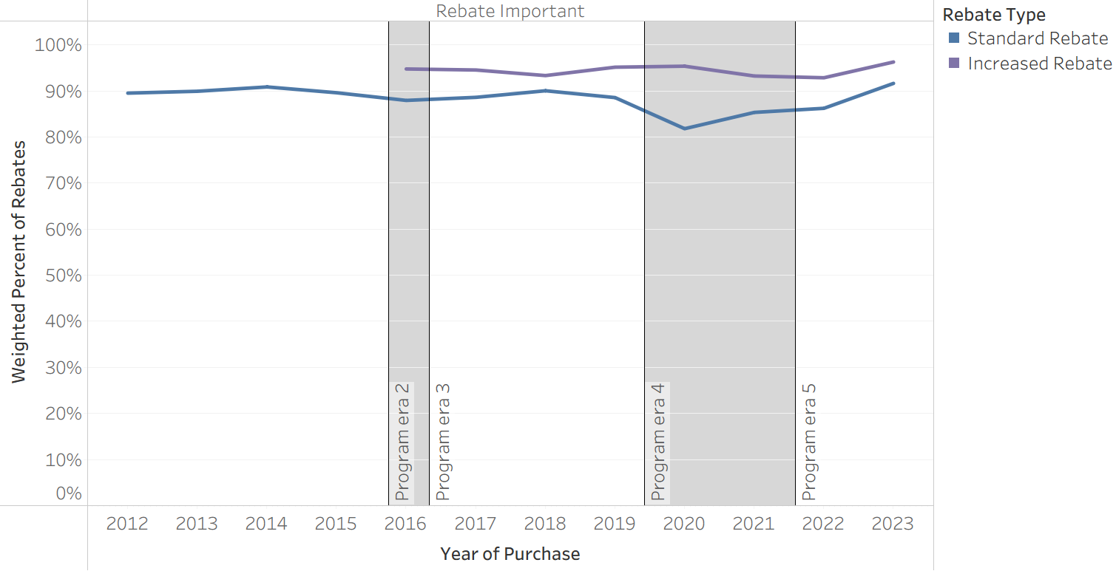
Subsetting by both vehicle technology and rebate type reveals how technology trends differ across income groups. For example, Figure 12 illustrates that the Tesla trends visible in Figure 11 were unique to Standard Rebate recipients—Tesla consumers receiving Increased Rebates reported high Rebate Importance levels early on (rather than increasing through 2018) and did not dip in 2020. Figure 12 also highlights a substantial divergence in the Importance level between Standard and Increased Rebates for PHEVs in 2023. Rebate Importance among PHEV consumers in 2023 remained fairly high for Increased Rebate recipients but decreased substantially for Standard Rebate recipients.
Figure 12
Rebate Importance Over Time by Vehicle and Rebate Type 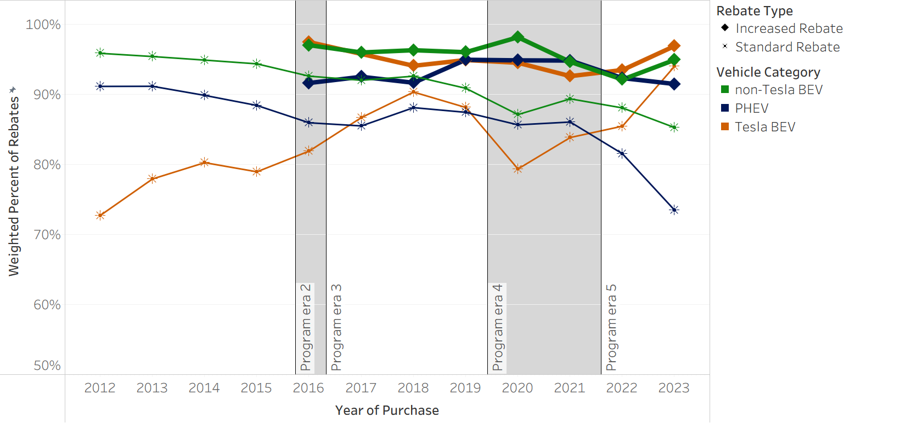

Rebate Essentiality
Rebate Essentiality characterizes respondents who stated that they would not have acquired their EV if CVRP did not exist. In total, 49% of respondents over time were Rebate Essential, though levels fluctuated over time (Figure 13). Rebate Essentiality generally increased until reaching an all-time high of 57% in 2017, then proceeded to decrease until reaching an all-time low of 35% in 2021 (amid the COVID-19 pandemic) before rebounding dramatically back up to a near all-time high of 56% in 2023 (the last program year).
Figure 13
Rebate Essentiality Over Time
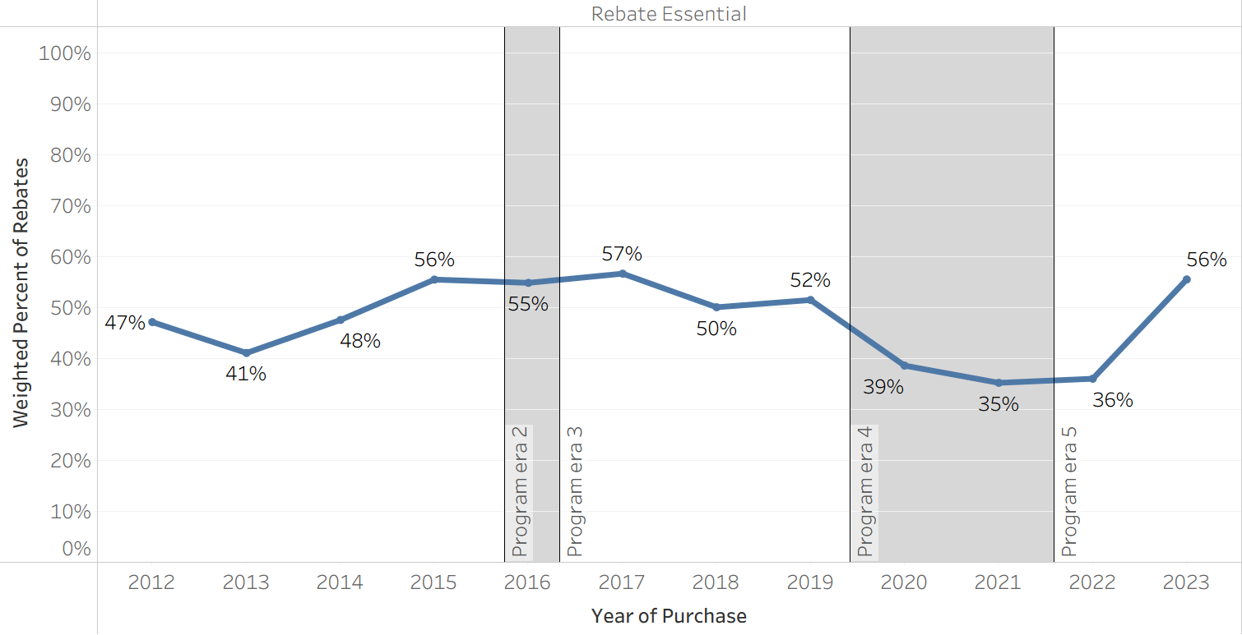
As with Rebate Importance, Rebate Essentiality can vary substantially across different groups. For example, Rebate Essentiality for non-Tesla BEVs was as much as 40 percentage points higher than for Teslas (Figure 14, panel 1). Also, Essentiality for non-Tesla BEVs peaked early on (reaching a high in 2015 that neither Teslas nor PHEVs ever reached) before steadily declining through 2022, whereas Essentiality for PHEVs and Teslas continued increasing gradually through 2019, not declining until the COVID-19 pandemic. With respect to rebate types, Rebate Essentiality tended to be approximately 20 percentage points higher for Increased Rebates (ranging from 49%–75%) than Standard Rebates (ranging from 30%–56%), while trending similarly over time (Figure 14, panel 2). Throughout the entirety of the project, 65% of Increased Rebate recipients were Rebate Essential.
Figure 14
Rebate Essentiality Over Time by Technology and Rebate Type
(1) 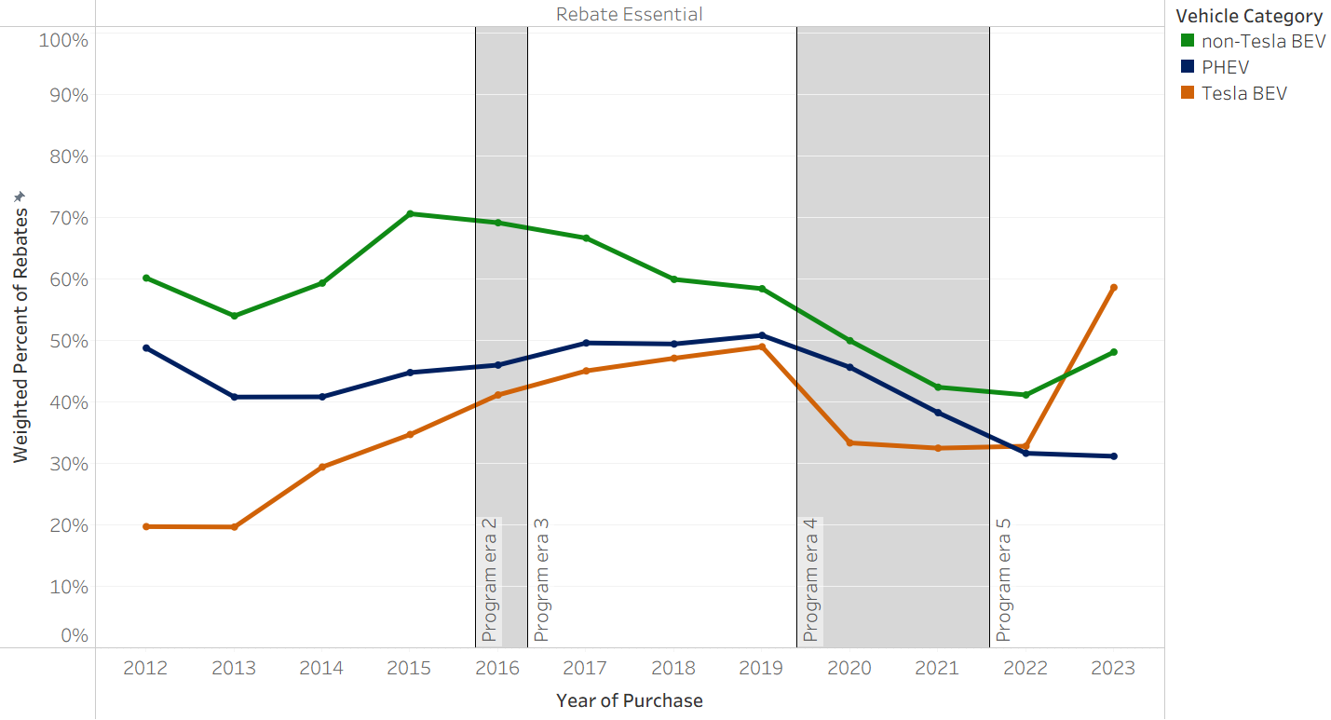
(2)
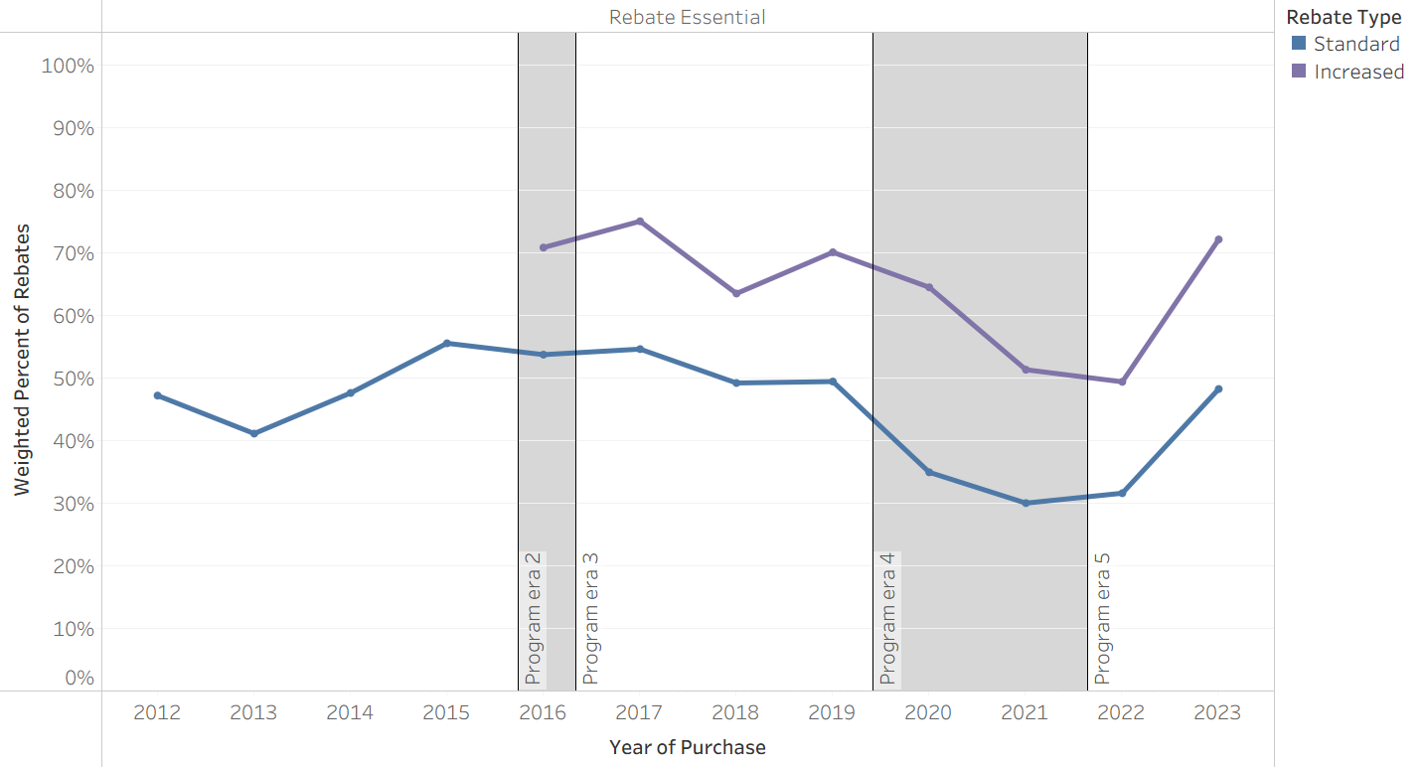
Subsetting the results by vehicle technology and rebate type reveals that Rebate Essentiality patterns across technology types are similar within each rebate type, with increased levels among Increased Rebate recipients (Figure 15). Interestingly, Tesla’s 2023 Essentiality spike to the highest of any technology was consistent across rebate types (higher- and lower-income consumers).
Figure 15
Rebate Essentiality Over Time by Vehicle and Rebate Type
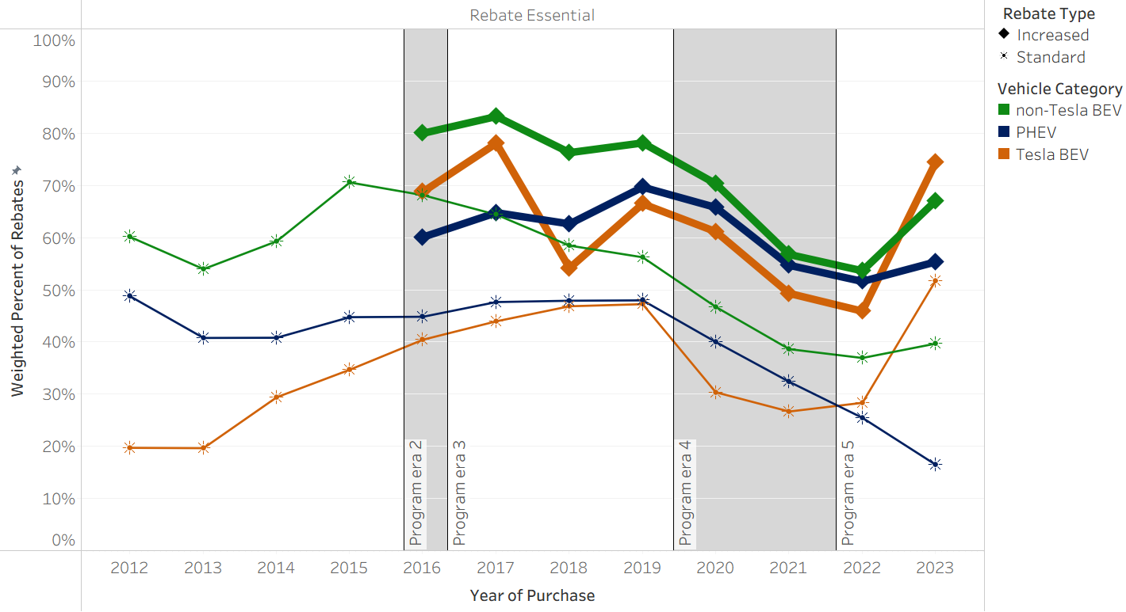

Because rebate amounts varied by technology type and rebate type, and Rebate Essentiality differed across these groups, the fraction of rebate funding that went to Rebate Essential participants does differ from the percentage of rebates. The largest of these differences occurred in 2023 (when Increased Rebate amounts were raised substantially), with 64% of funding and 56% of rebates going to Rebate Essential participants (Figure 16).
Figure 16
Rebate Essential Rebates and Funding
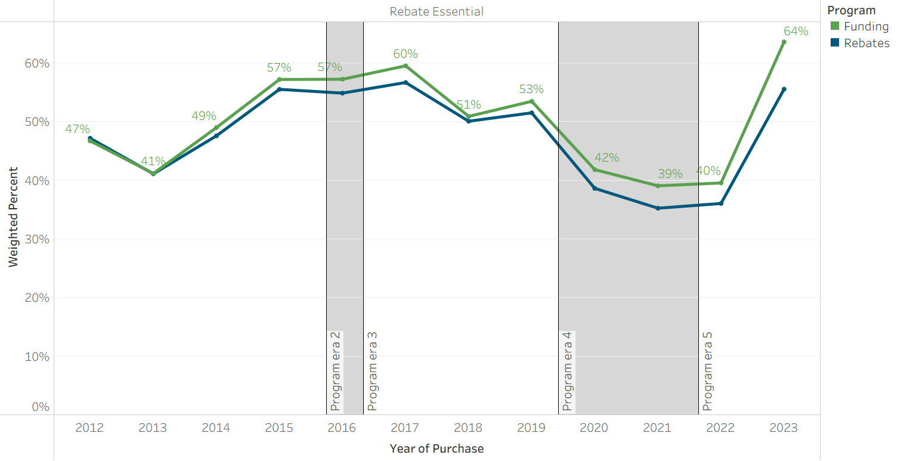

Influence Metrics Compared

Essentiality and Importance
While Rebate Importance was steadily near 90% over time, barring a modest dip in 2020, Rebate Essentiality was more variable, ranging from 57% to 35% (Figure 17). This suggests that while program design changes and evolving market dynamics may have bearing on the degree to which rebates are a determinative factor in consumer’s decision to acquire an EV, rebates remain widely influential on the overall decision-making process regardless of these factors. This is further supported by the finding that differences in these metrics between Standard and Increased Rebate recipients are much wider for Rebate Essentiality than Rebate Importance. While Essentiality tends to be approximately 20 percentage points higher for Increased Rebates than Standard Rebates (Figure 14), Importance for both rebate types was quite high, differing only modestly in most years (Figure 11). Figure 18 shows that among respondents who were not Rebate Essential, most of them were still Rebate Important, with “Very important” being the most common response over time. “Not at all important” was infrequently selected even among non-Rebate Essential respondents.
Rebate Importance bottoms at 83% in 2020, reflecting a modest dip during the onset of the COVID-19 pandemic, and quickly rebounds. In contrast, Rebate Essentiality falls more substantially in 2020 and continues declining in 2021, not rebounding until 2023 (when it spiked to near all-time high levels). That Importance remained high and increasing even as Essentiality fell and remained depressed in 2021 and 2022 may be a function of the type of consumer willing/needing to purchase a new car during the uncertain times of the pandemic, and regardless of elevated vehicle prices at this time (Figure 6). The impact of additional factors on Rebate Essentiality is explored further in the Program Evolution and EV Market Development section.
Figure 17
Rebate Essentiality and Rebate Importance Over Time
Figure 18
Rebate Importance among Non-Rebate Essential Respondents
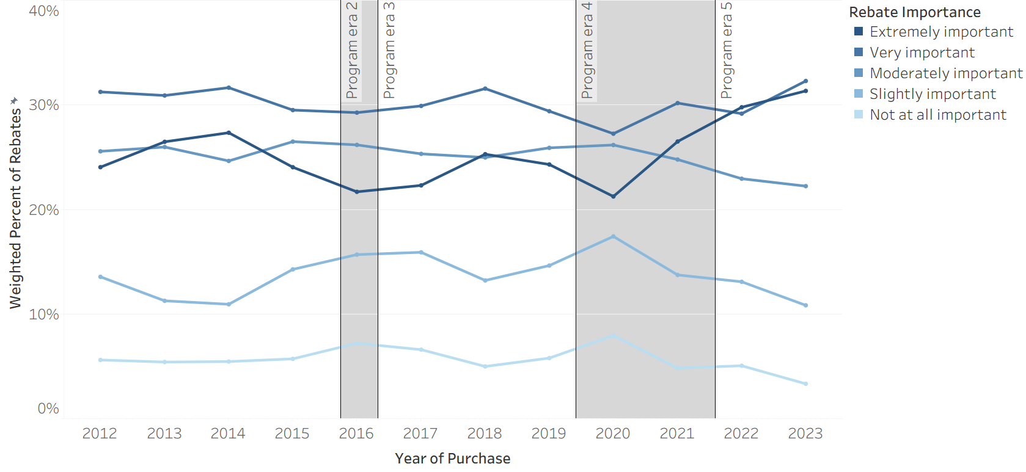

Why did rebate influence change over time?
CVRP ran from 2010 through 2023. During this period, the EV market developed from its infancy to composing over a quarter of California’s new car market (Figure 7). The program itself was also changed over time to align program design and eligibility criteria with evolving policy goals as the EV market expanded (e.g., from spurring interest in EVs to targeting priority populations and mainstreaming EV adoption, as described in the Introduction). As such, program and market context are important in understanding how and why the influence of CVRP rebates varied over time.
Importantly, as described, Rebate Importance did not change substantially over time—this metric of rebate influence was consistently very high. We therefore focus this section on the more variable metric of Rebate Essentiality to discuss the influence of the rebate across distinct program design eras and against the backdrop of major market developments.

Program Evolution and EV Market Development
The five distinct eras of CVRP (described in the Program Context section and denoted by shaded areas in timeseries figures throughout) are characterized by major changes made to the program design over time (detailed further in Appendix A). The range of annual EV sales, market share, and CVRP rebates during each program era are summarized in Table 1. A discussion of Rebate Essentiality in the context of program design and market developments during each era follows.
Table 1
Program and EV Market Summary by Program Era
Era and Representative Years | Annual EV Sales | Annual EV Market Share | Annual EV Rebates** | Annual Percent of Market Rebated
Era 1 (2012*–2015) | 19,161–61,590 | 2–3% | 13,186–46,316 | 69–79%
Era 2–3 (2016–2019) | 73,854–153,442 | 4–8% | 43,856–80,386 | 43–59%
Era 4 (2020–2021) | 120,793–219,776 | 8–13% | 37,358–45,951 | 21–31%
Era 5 (2022–2023) | 311,953–438,227 | 20–26% | 34,283–78,360 | 11–18%
* Era 1 is characterized with a 2012 start year to align with start of survey data.
** While this report primarily focuses on personal (nonfleet) CVRP participants, fleet vehicles (2% of rebated BEVs and PHEVs) are included in these rebate totals for comparability to EV market totals.

Program Era 1 (March 15, 2010 – March 28, 2016)
The first program era represents the initial design of the CVRP, before many eligibility criteria were implemented. It also reflects the early years of the modern EV market. As such, vehicle prices were relatively high, model selection was limited, and consumer income skewed higher. Relatedly, EV consumers during this period were early adopters of the then-new EV technology. Early adopters tend to be enthusiasts—more willing to make sacrifices in convenience or product capabilities and adapt to other early-market issues., The early-adopter enthusiasm is reflected in Rebate Essentiality, which increased over time during this era (Figure 13), consistent with the expansion of the program beyond early EV enthusiasts to more skeptical and mainstream consumers.
As discussed in previous reporting, the trend of increasing rebate influence over time as more mainstream consumers enter the EV market is illustrated even more dramatically within Tesla’s early business model (see Figure 14, panel 1). Initial vehicles had very high prices (Figure 6) and were targeted at high-income consumers. Over time, EV offerings and price points expanded, opening the market to a wider and more price-sensitive, and thus rebate-influenced, consumer base.
Program Eras 2 & 3 (March 29, 2016 – October 31, 2016 & November 1, 2016 – December 3, 2019)
During the second program era, the Increased Rebate for lower-income consumers was introduced and an income cap that excluded high earners was implemented. The third program era followed shortly thereafter when Increased Rebate amounts were raised, the income cap was lowered, and a 20-mile electric range requirement was instated. During this time, the statewide EV market also began to increase more rapidly. Annual sales and rebates each roughly doubled from 2016 to 2018, even as the percent of the EV market that CVRP rebated decreased (likely as a result of changes to eligibility criteria) from 69–79% in Era 1 to 43–59% in Eras 2–3.
Figure 19 and Figure 20 confirm previous reporting,, that higher-income consumers tended to have lower levels of Rebate Essentiality and their exclusion should increase average rebate influence. Further, those claiming the newly available Increased Rebate tended to be more highly influenced (Figure 14, panel 2),,, which should also lead to elevated levels of overall program influence. Overall Rebate Essentiality does modestly increase in 2017 (to an all-time high of 57%), as would be expected based on the new program design, but then decreases to 50–52% in 2018 and 2019. The data suggest that decreasing Essentiality is likely a function of two significant market developments. First, decreasing overall Rebate Essentiality during this time was driven in part by decreasing levels among non-Tesla BEVs (Figure 14, panel 1). Although Essentiality among PHEVs and non-Tesla BEVs did continue to steadily increase throughout this era, the steep decrease in Essentiality among non-Tesla BEVs following the peak in 2015 contributed to bringing the program average down. This trend is associated with the emergence of the Chevrolet Bolt, which became the dominant non-Tesla BEV in 2018 and is associated with lower Rebate Essentiality than its predecessors and peers (Figure 21). The lower rebate influence among Bolt consumers may be due to its attractive combination of improved range capabilities relative to prior non-Tesla BEVs and modest price point relative to other long range BEVs on the market at this time (Teslas). Tesla came to dominate the program in 2018 (Figure 3) upon the widespread availability of the Model 3—a model with many of the attractive features of prior Tesla models, but at a much lower price point. Though increasing overall, Rebate Essentiality levels among Tesla consumers was lower than non-Tesla BEV or PHEV consumers. Thus, their emergence as the dominant vehicle category also played a major role in the decreasing program-wide Rebate Essentiality.
Importantly, even as Rebate Essentiality among non-Tesla BEVs was decreasing during this time, it remained higher than the Essentiality levels of PHEVs and Teslas. While the larger rebate amounts available to BEVs compared to PHEVs is likely a factor, the high Essentiality levels among non-Tesla BEVs early on may also reflect rebates being more impactful in incentivizing consumers to overcome barriers associated with these less capable products. First-generation non-Tesla BEVs may have been viewed less favorably at this stage in their development than PHEVs and Teslas due to their limited range and/or other concerns. The decrease in Essentiality levels among non-Tesla BEVs during program Eras 2 and 3 may reflect an increasing attractiveness of this technology more broadly as it became more capable (Figure 4) and related aspects of the EV ecosystem (such as charging infrastructure developments) improved. For example, Figure 22 confirms reporting that Essentiality levels among short range BEVs are higher than those of long range BEVs, although this could also reflect their lower price point appealing to more price-sensitive (and thus rebate-influenced) consumers.
Program Era 4 (December 3, 2019 – February 23, 2022)
The fourth program era introduced numerous program changes. An MSRP cap of $60,000 ($60k) was established, the electric-range requirement was nearly doubled to 35 miles, Standard Rebate amounts were decreased by $500, and the total rebate limit per person was decreased from two to one. Later in this era, eligibility for the Increased Rebate was extended to household incomes up to 400% (previously 300%) of the Federal Poverty Level (FPL) and the electric range requirement was increased again to 45 miles. This era also spanned the market’s whiplash reaction to the COVID-19 pandemic, with sales volumes decreasing in 2020 before spiking to new highs in 2021 (see Figure 1), though rebate volumes increased only modestly in 2021.
In terms of rebate influence, this period is characterized by a dip in Rebate Essentiality, which bottomed out at 35% in 2021 and averaged 37% from 2020–2021 (as compared to an average of 51% across all other years). This is likely the result of a combination of factors, including program changes and market developments during this period as well as issues stemming from the onset of the COVID-19 pandemic. The pandemic caused widespread economic turbulence, and the EV market was no exception. Although EV sales in California, after dipping modestly in 2020, increased dramatically year over year from 2020 through 2023, as previously discussed, uncertainties caused by COVID-19 likely reduced or delayed program participation by more risk-averse consumers. Furthermore, the most popular EV manufacturers—Tesla and GM—became ineligible for the federal EV tax credit as of 2020 (see Appendix C for further detail), which is also likely to have suppressed EV adoption among price-sensitive and incentive-influenced consumers. Inflated vehicle prices (Figure 6) due to supply chain issues were likely an additional factor that discouraged price-sensitive consumers from acquiring new vehicles during this time. A final market development during this period was a dramatic increase in rebated SUVs (Figure 5), which had lower levels of Rebate Essentiality than cars during this time (Figure 23), perhaps due to enthusiasm about these new product offerings.
While counterfactual outcomes in the absence of the COVID-19 pandemic are uncertain, Rebate Essentiality measurements provide some indication of potential effects of the late 2019 program changes. Figure 24 and Figure 25 confirm previous reporting,, that high-priced vehicles tend to have lower levels of Rebate Essentiality (expectedly, as a $2,500 rebate represents a smaller relative discount at higher price points), so their exclusion likely increased Essentiality levels. Households that have previously owned an EV tend to be similarly influenced by the rebate as households that have not (Figure 26), suggesting that limiting individuals to one rebate likely had little impact to influence metrics. Figure 27 confirms previous reporting, that higher rebate amounts tend to have higher Rebate Essentiality. Thus, the December 2019 reduction in the Standard Rebate amount likely lowered Essentiality levels among Standard Rebate recipients, and the January 2021 broadening of Increased Rebate eligibility likely increased Essentiality overall (while potentially reducing it among the subgroup of Increased Rebate recipients). The electric range minimum was increased from 20 UDDS miles to 35 UDDS miles in December 2019 and then again to ~45 UDDS miles (30 EPA miles) in April 2021. The Rebate Essentiality of PHEV models excluded by these eligibility changes were not substantially different from other PHEV models prior to their exclusion, suggesting that these updates to the electric range minimum may not have impacted influence metrics.

Program Era 5 (February 24, 2022 – Program Close)
The fifth and final CVRP era is characterized by the introduction of a more restrictive MSRP cap of $45k for cars (the $60k cap remained in place for SUVs, vans, and pickups) and a more restrictive income cap (lowering to $135k–$200k from $150k–$300k). Later changes included a $3,000 hike to the Increased Rebate amount (in February 2023, to $5,500 above the Standard Rebate amount) and a $2,000 charge card being distributed to Increased Rebate recipients starting in August 2023. This era also had the lowest rates of the EV market rebated, with a low of 11% in 2022 (a year with particularly high EV prices overall and when a large portion of the market exceeded CVRP’s MSRP cap, including all Tesla models for much of the year).
These program changes should all be expected to increase rebate influence levels—either by excluding less-influenced, higher-priced vehicle consumers and/or higher-income households, or providing larger rebate amounts to lower-income consumers—and this period did see an unprecedented jump in Rebate Essentiality from a near-record low of 36% in 2022 to a near-record high of 56% in 2023.
As with the decrease in Era 4, a number of factors likely contributed to the Rebate Essentiality spike in 2023. In terms of program evolution, Increased Rebate amounts were at an all-time high as of February 2023 and there was a large spike in Essentiality among Increased Rebate recipients. However, Rebate Essentiality among Standard Rebate recipients increased almost as much, suggesting other factors also played a role. High MSRP vehicles and higher-income consumers do typically have lower levels of Essentiality (Figure 25 and Figure 19), and program changes restricting eligibility among these consumers are likely related to the increase in Essentiality. In 2021, for example, Rebate Essentiality of vehicles in the $40–50k and $50–60k MSRP ranges were both near 30%, while for vehicles with an MSRP between $30–40k and <$30k, Essentiality was 39% and 47%, respectively (Figure 25).
The program closure in 2023 may also have contributed to elevated Rebate Essentiality, if consumers who would not have otherwise purchased an EV made a point to do so before the program closed. Indeed, while CVRP participation and EV sales volumes both spiked in California in 2023, the fact that rebate volumes increased at a higher rate than statewide sales volumes suggests that the increase in program participation may have been driven by its impending closure. However, spikes in EV sales were seen nationally in 2023, with similar increases seen in other states. Furthermore, similar jumps in 2023 incentive influence levels were also seen in other programs that did not have major design changes or closures. Thus, the spike in Rebate Essentiality may instead be more reflective of price-sensitive consumers reentering the market after holding off due to pandemic-related concerns and subsequent inflated prices peaking in 2022, and/or Tesla and GM becoming re-eligible for the federal EV tax credit (see Appendix C).
Overall, the increases in rebate volume and Essentiality are primarily driven by Tesla consumers (Figure 3 and Figure 14). Specifically, Essentiality spiked most dramatically for Tesla consumers, and Tesla accounted for a record high of 79% of program participants in 2023. After price hikes that put the Tesla Model 3 and Model Y above the MSRP cap for much of 2022, both received substantial price cuts and were eligible throughout 2023. The Model Y in particular saw pricing reduced to all-time low levels and dominated the program, composing 44% of all CVRP rebates in 2023 (Figure 3). Furthermore, after being phased out of eligibility for the federal EV tax credit through 2019 and becoming ineligible in 2020, Tesla and GM were again eligible for the revamped EV tax credit that launched in January 2023 (see Appendix C). After years of growth in popularity, but at higher price points and with fewer subsidies, the combination of price cuts and the renewed availability of the CVRP rebate and federal tax credit may have incentivized many price-sensitive consumers with pent up demand for Teslas and/or electric SUVs to make their purchase in 2023.
In contrast to the overall trend, Rebate Essentiality among PHEV Standard Rebates recipients continued its fall, reaching an all-time low in 2023. This may indicate that PHEVs had become viewed as a convenient substitute for gasoline vehicles and/or the relatively low rebate amount ($1,000) meant the rebate was not a determinant factor for most consumers. However, PHEV popularity was also decreasing and reached record lows both in terms of the share of the program and California’s EV market. Nevertheless, Rebate Importance remained fairly high (80%) among these participants in 2023, indicating the rebate still was an influential factor in the decision for most rebated PHEVs, albeit not a make-or-break one.
Figure 19
Rebate Essentiality by Annual Household Income and Program Era
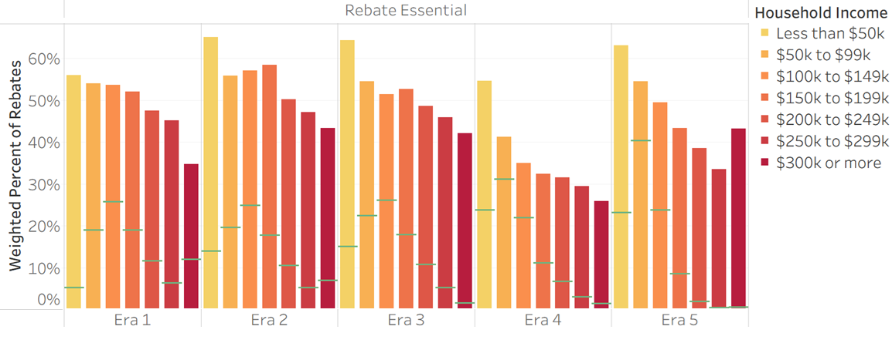
Note: Bars display Rebate Essentiality, green markers display the income distribution during each program era.
Figure 20
Rebate Essentiality by Household Income Over Time
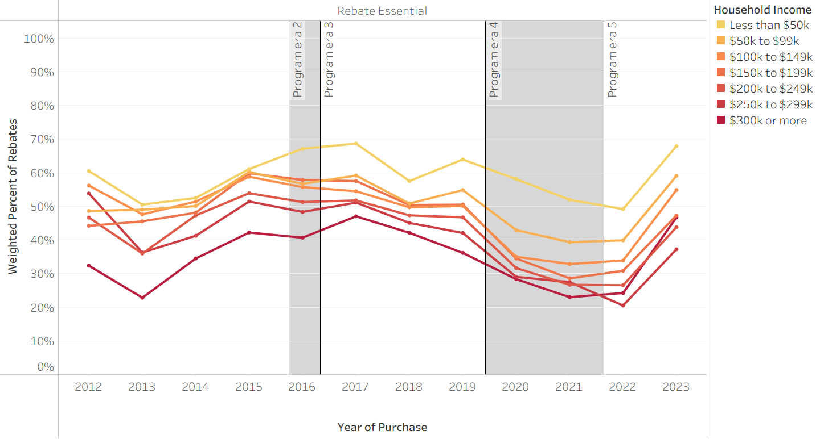
Figure 21
Rebate Essentiality by Model Over Time
Top 6 Most Rebated non-Tesla BEVs
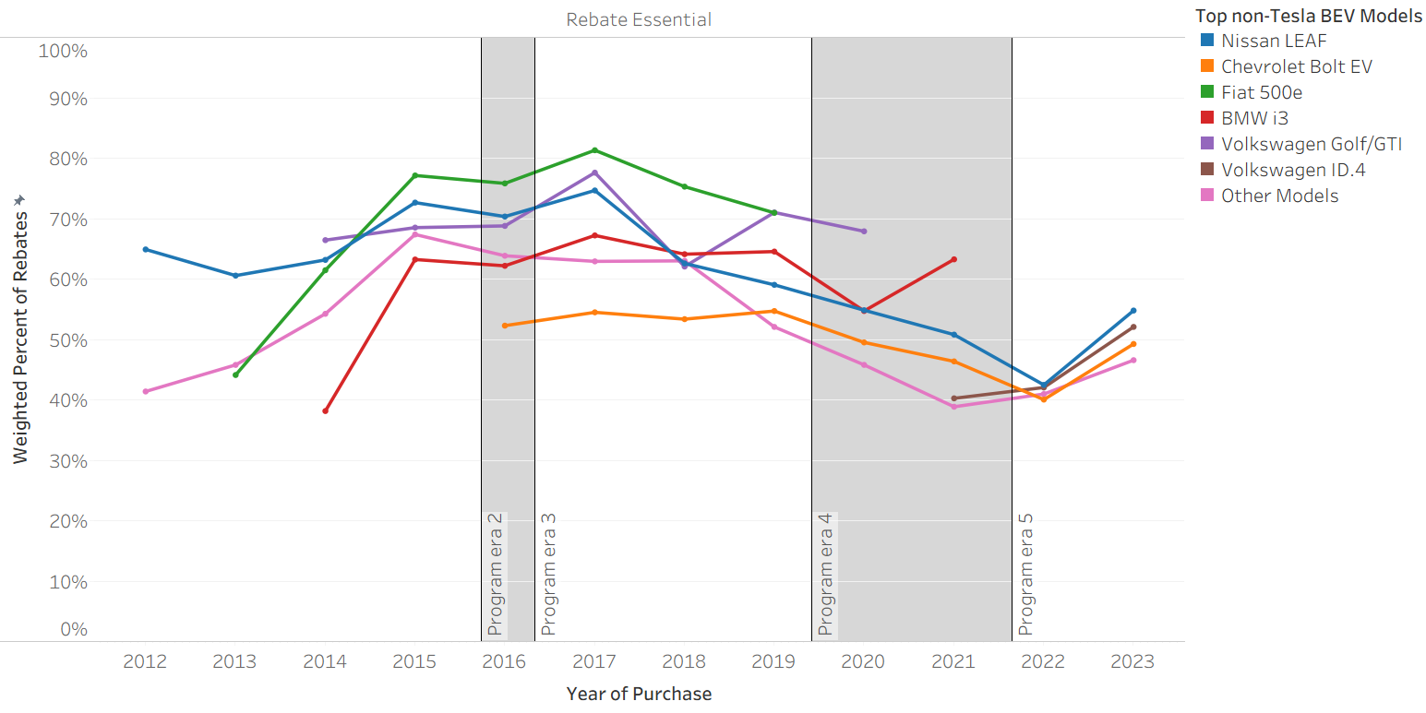
Figure 22
BEV Rebate Essentiality by Electric Range
All BEVs & non-Tesla BEVs
(1)
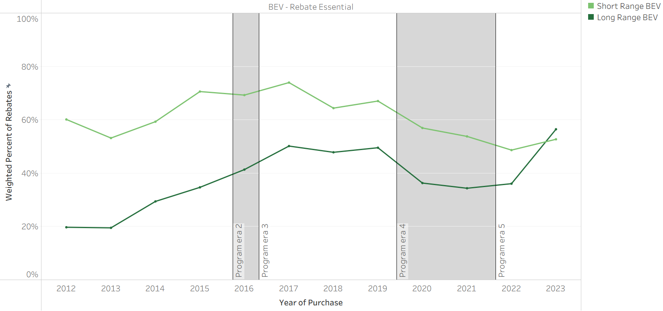
(2)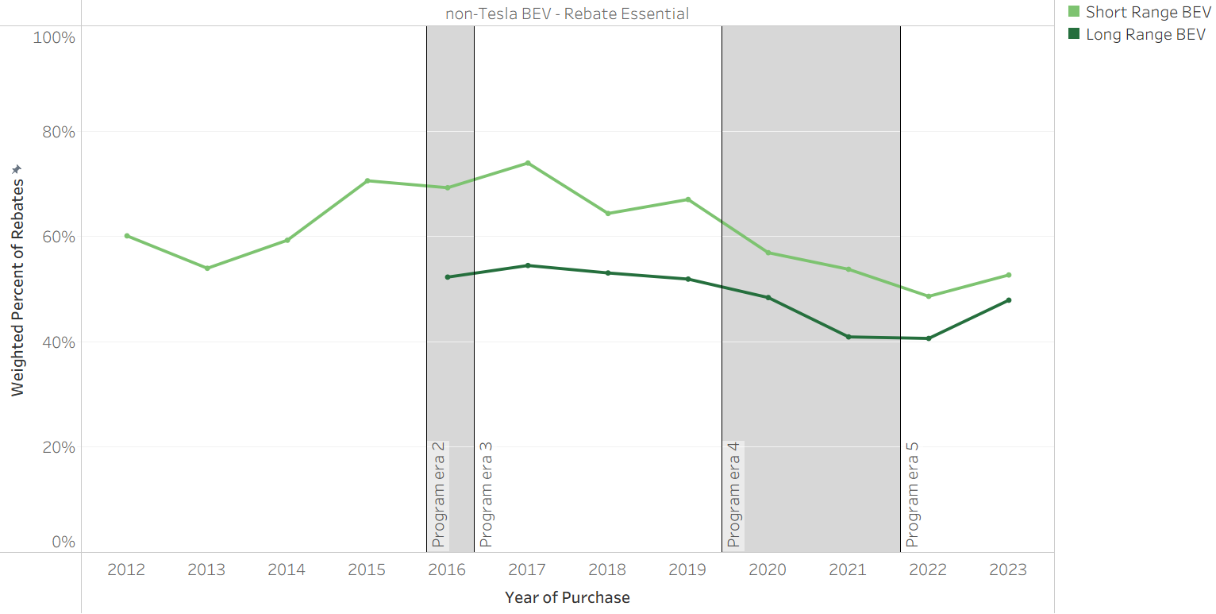Note: Long Range includes models with 200+ EPA-rated electric miles. Short range BEVs became less prevalent over time—fewer than 4% of rebated BEVs were short range each year from 2020 on.
Figure 23
Rebate Essentiality by Vehicle Class Over Time
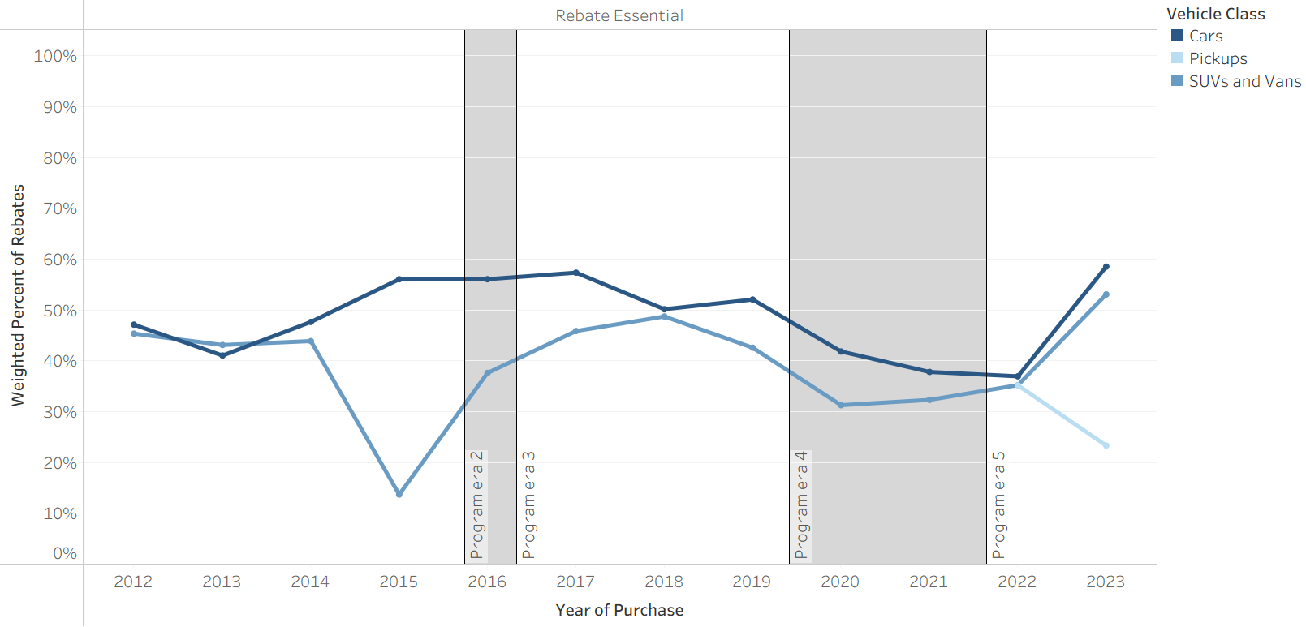

Figure 24
Rebate Essentiality by Purchase Price
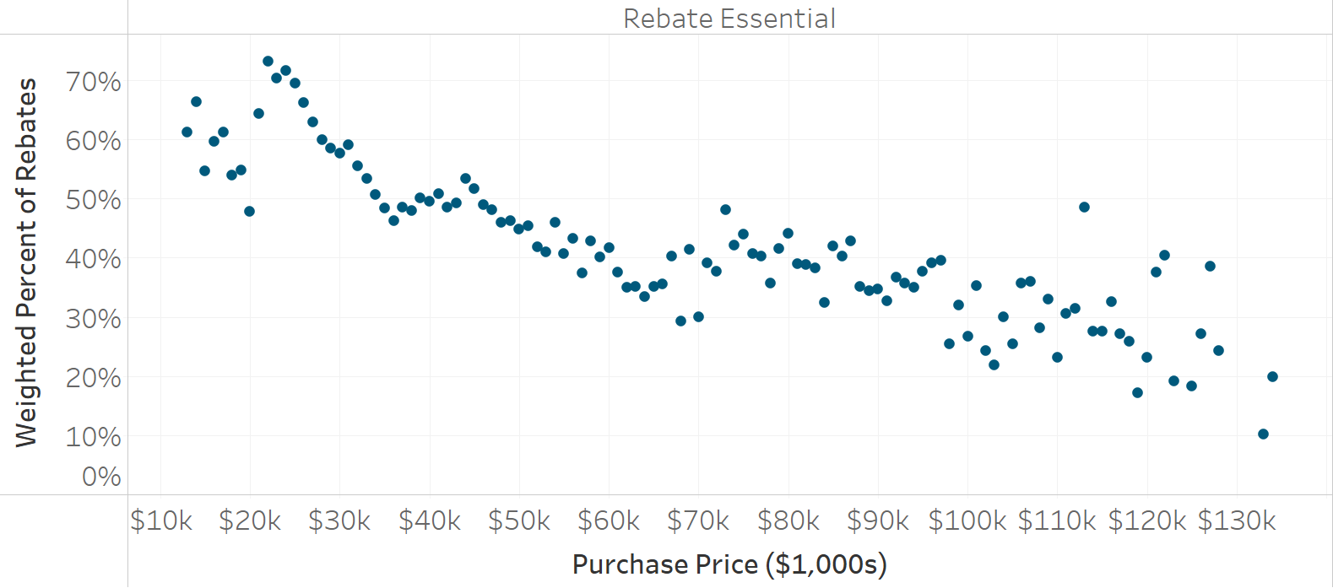
Figure 25
Rebate Essentiality by Model Minimum MSRP* Over Time
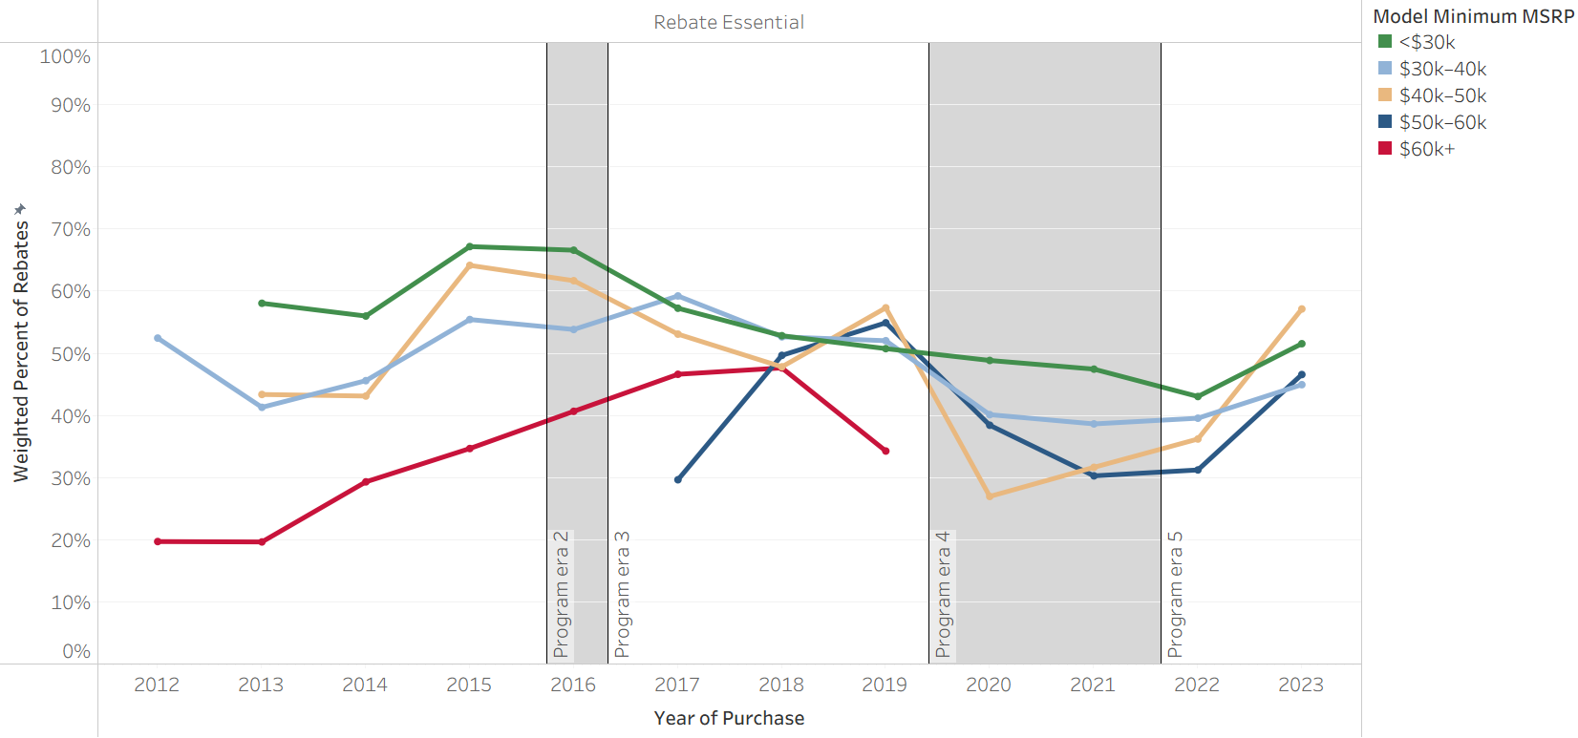
* Model minimum MSRP reflects the minimum MSRP of any trim for a given model and model year.

Figure 26
Rebate Essentiality by Previous EV Ownership Over Time
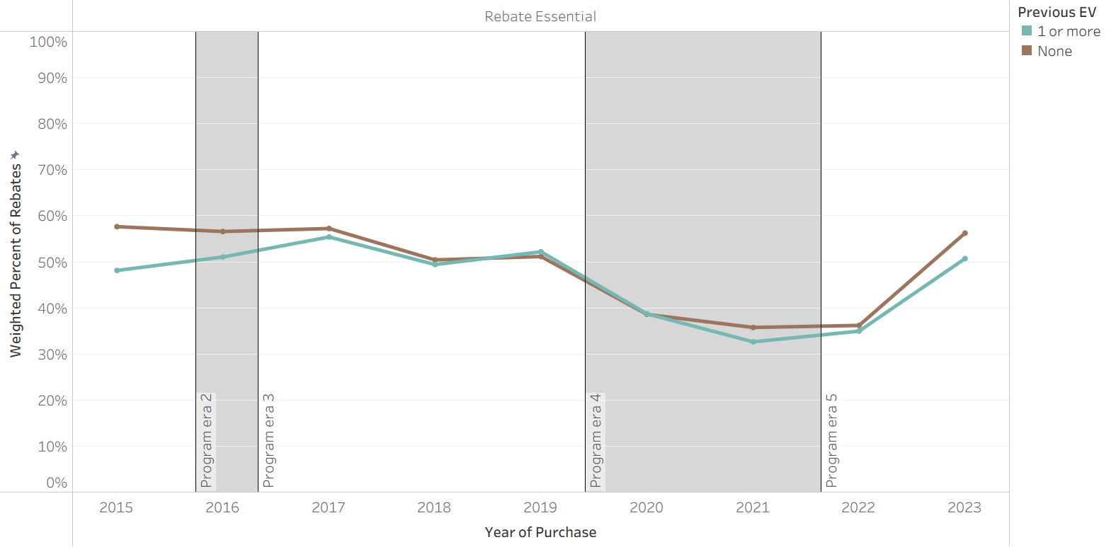
Note: Previous EV ownership survey question was introduced in the 2015–2016 Survey Edition.

Figure 27
Rebate Essentiality by Rebate Amount Over Time
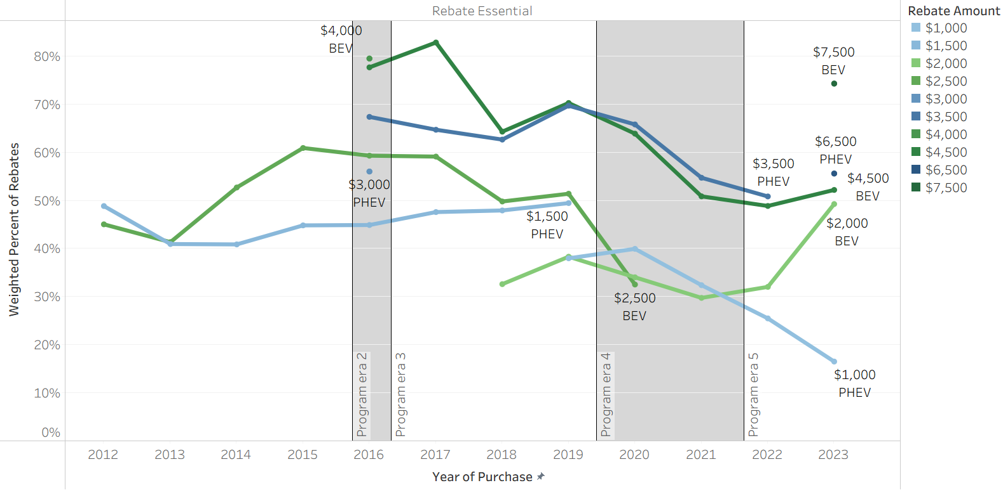 Note: BEV rebate amounts are displayed in green and PHEV rebate amounts are in blue. Darker shades reflect larger amounts.

What are the market implications of CVRP influence?
This research indicates that nearly 90% of CVRP participants were Rebate Important and half were Rebate Essential. Here we examine what this implies about CVRP’s impact on California’s EV market more broadly.

Statewide EV Market Implications
Approximately 1.74 million BEVs and PHEVs were sold in California between 2012–2023. Of these, 565,807 (33%) received a CVRP rebate. An average of 89% of CVRP survey respondents during this period stated that the rebate was “moderately,” “very,” or “extremely important” in enabling their EV purchase (i.e., they were Rebate Important). Scaled up to reflect the program population, this 89% of CVRP survey respondents represents 506k EV purchases—or 29% of California’s entire EV market—for which the CVRP rebate played an important role in the purchase decision. Across this same period, 49% of CVRP participants stated that they would not have purchased their EV without the incentive (i.e., they were Rebate Essential). Scaled up to reflect the program population, these findings suggest that 276k EV purchases—16% of all new EVs sold in California from 2012 to 2023—were Rebate Essential. These CVRP influence metrics are visualized year-over-year (panel 1) and relative to statewide EV sales (panel 2) in Figure 28 and cumulatively over time in Figure 29. In both cases, it is clear that CVRP rebated a much greater portion of the EV market through 2020 than from 2021–2023. As such, the market implications of CVRP can also be better understood when assessed over time.
While 33% of the market was rebated between 2012–2023, this varied significantly as the program evolved from a broad market-acceleration program to a more targeted incentive (see Program Context; additional factors that may affect the percentage of the market that was rebated include limits to funding availability and program awareness). As such, the percentage of the EV market receiving a rebate was highest early on and decreased over time (see Figure 1 and Table 1). Rebate volume and influence metrics relative to the market are detailed by era in Table 2. Approximately 76% of EVs purchased in California received a CVRP rebate between 2012–2015. Survey data available during program Era 1 (starting September 2012) indicate that 90% of participants were Rebate Important and 49% were Rebate Essential during this time. When scaled to represent California’s entire EV market, this indicates that approximately 69% of all EV purchases in the state were Rebate Important and 37% were Rebate Essential.
From 2016 through 2019, California’s EV market began to expand more rapidly. CVRP continued to play a large role in supporting adoption while beginning to target incentives more narrowly. Program changes during Eras 2 and 3 introduced Increased Rebates for low- to moderate-income consumers and excluded high earners from eligibility. As such, the percentage of the market that was rebated decreased, with slightly more than half of all EVs purchased in California receiving a rebate during this time. Of these, 89% were Rebate Important and 53% were Rebate Essential. Scaled to reflect program totals relative to the market, this indicates that 45% of all EV purchases in the state were Rebate Important and 26% were Rebate Essential.
After a dip in sales and rebates during the onset of COVID-19 in 2020, California’s EV market increased exponentially, with statewide EV sales increasing 3.5-fold between 2020 and 2023. Rebate volumes remained relatively steady during this time, and thus the percentage of the EV market receiving a rebate decreased. The steadiness of rebate volumes while the market expanded is reflective of the continued progression of the program’s targeting in Eras 4 and 5 toward increasing EV affordability for lower-income consumers and away from higher earners and expensive EVs. CVRP rebated 24% of EVs from 2020–2021 (during Program Era 4) and 15% from 2022–2023 (during Program Era 5). Rebate Importance was 86% and 91% in Eras 4 and 5, indicating 21% and 14% of EV purchases statewide were Rebate Important. Rebate Essentiality was 37% and 50% in Eras 4 and 5, indicating 9% and 7% of EV purchases statewide were Rebate Essential.
Figure 28
Rebate Influence and Statewide EV Sales Over Time
(1)
(2)
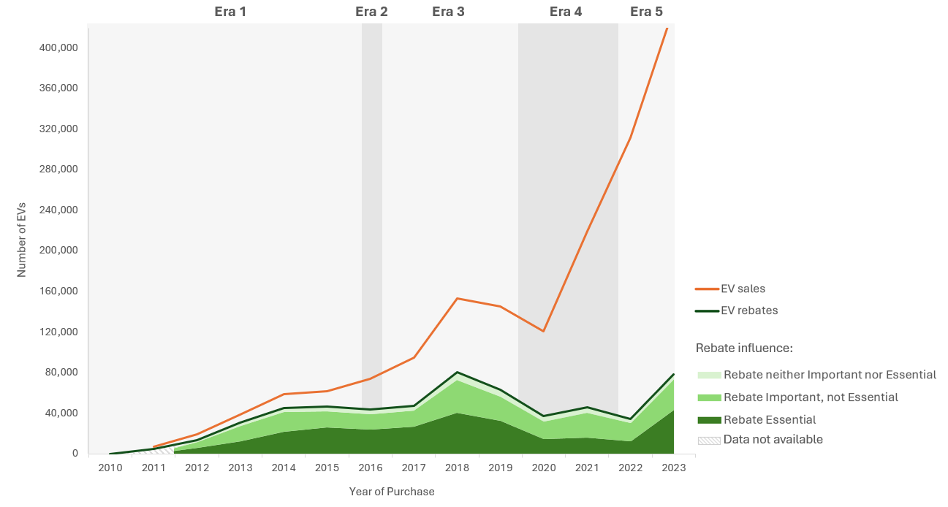

Figure 29
Rebate Influence and Cumulative Statewide EV Sales
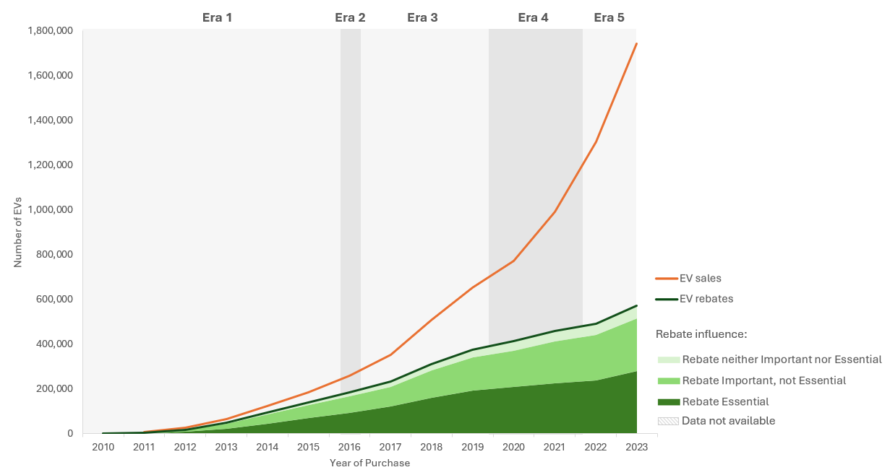
Note: For cumulative data visualization, rebate influence proportions in 2012 are implied for previous years.
It is important to note that, as discussed previously (see Interpreting Rebate Influence), Rebate Essentiality speaks most directly to the influence of the rebate on purchasing decisions for the specific EVs that consumers acquired. This is not equivalent to the number of EV sales that CVRP has directly enabled (i.e., additionality). Measurements of more detailed counterfactual behaviors (available starting in 2015) can help better understand CVRP’s impact on influencing consumers to buy new EVs specifically. This differs slightly from Rebate Essentiality in that consumers can be Rebate Essential (meaning they would not have acquired their EV without CVRP) but still would have acquired some other EV. From mid-2015 through 2023, at least 40% of CVRP survey respondents stated that in absence of CVRP they think they would have purchased something other than a new EV (i.e., a non-EV, a used EV, or no purchase at all—see Appendix B for further detail). When scaled up to represent the program, these findings suggest that at least 171k new EVs—11% of all new EVs sold in California from 2016 to 2023—were directly enabled by CVRP and reportedly would not have otherwise occurred. Like other rebate influence metrics, this metric varied over time, ranging from 43% of the program and 22% of the market in Era 2 to 29% of the program in Era 4 and 6% of the market in Era 5 (see Table 2). Importantly, these measurements are conservative in that they do not include indirect impacts which would increase the benefits attributed to the program (see Data, Methods, and Limitations). Counterfactual behaviors relative to statewide sales are visualized year-over-year in Figure 30 and cumulatively in Figure 31.
Figure 30
Counterfactual Decisions and Statewide EV Sales Over Time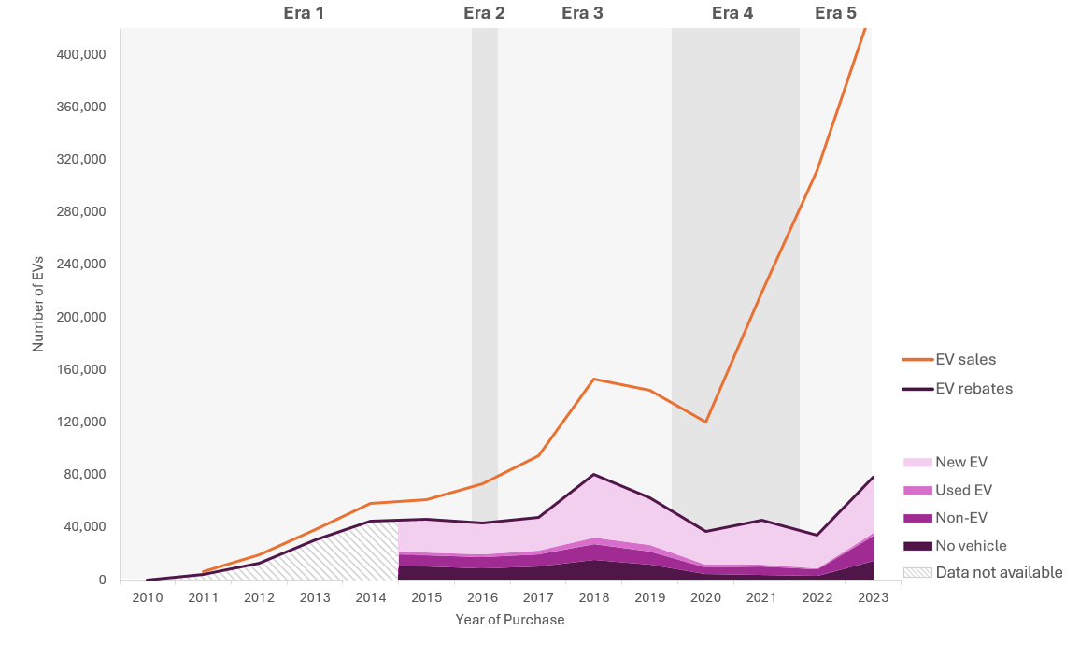
Figure 31
Counterfactual Decisions and Cumulative Statewide EV Sales
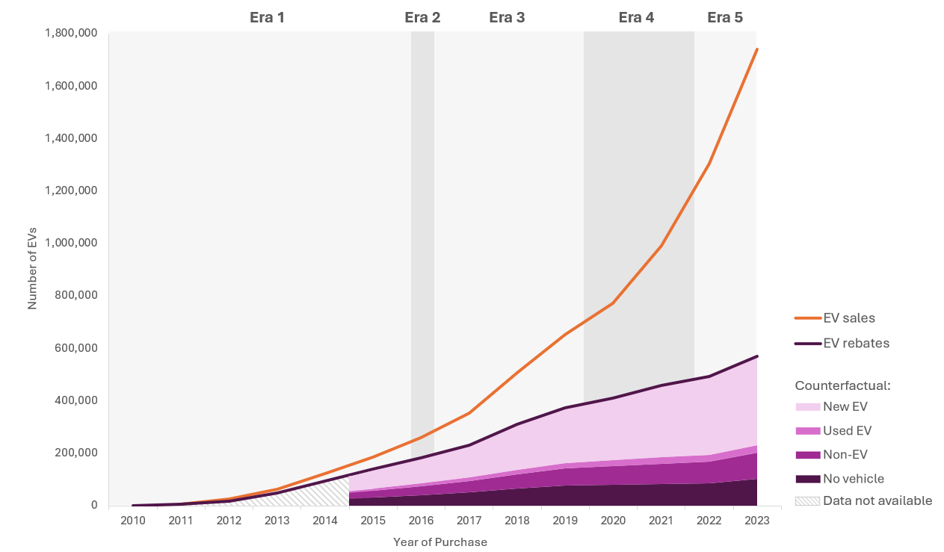
Note: For cumulative data visualization, counterfactual decision proportions in 2015 are implied for previous years. Counterfactual data are unavailable for non-Rebate Essential respondents after 2020—all are grouped with “New EV.”
Table 2
California EV Sales and CVRP Rebate Influence by Program Era
Era and Representative Years | All EV Sales | Percent Rebated | Rebate Important  (program %) | Rebate Essential  (program %) | New EV Enabled (program %) | Rebate Important  (% of all sales) | Rebate Essential  (% of all sales) | New EV Enabled  (% of all sales)
Era 1  (2012*–2015) | 177,752 | 76% | 90% | 49% | ** | 121,805 (69%) | 66,025 (37%) | **
Era 2–3 (2016–2019) | 467,188 | 50% | 89% | 53% | 43% | 209,853 (45%) | 123,621 (26%) | 101,550 (22%)
Era 4  (2020–2021) | 340,569 | 24% | 86% | 37% | 29% | 71,308 (21%) | 30,609 (9%) | 24,000 (7%)
Era 5  (2022–2023) | 750,180 | 15% | 91% | 50% | 40% | 103,053 (14%) | 55,878 (7%) | 45,143 (6%)
* Survey data begins September 2012.
** Omitted due to limited data—counterfactual survey data begins May 2015.

The wide reach and substantial influence of incentives during Era 1 suggests that CVRP was successful in its goal of helping to spur EV interest and accelerate the market during its nascent years. California’s early implementation of a strong EV policy mix likely helped set the stage for the state to be the preeminent state for EV adoption. The accelerated pace of EV adoption in California enabled CVRP to evolve over time to increasingly direct rebates toward priority populations. That rebate influence levels remained relatively stable across program eras (barring a perhaps unavoidable dip during the height and aftermath of the COVID-19 pandemic), even as many of the early market issues continued diminishing and technology continued improving (both of which might be expected to reduce the need for the incentive), suggests that program changes were successful in targeting program eligibility toward the population where it would continue being effective.
Skyrocketing EV sales in California from 2020–2023 may signify success of California’s EV policy mix, of which CVRP was historically a critical piece. Nevertheless, California EV market performance and related policy decisions should be considered within the context of the state’s broader goals. In 2020, California established a goal to reach an EV market share of 100% by 2035 (Executive Order N-79-20). Even with recent growth, the state remains far from reaching this goal. The approximately 440,000 EV sales in 2023 represented a market share of 26%—high relative to the U.S. overall, but still well short of full market adoption. Accordingly, continued policy support will be important to sustain the pace of growth needed for California to achieve an all-electric new car market by 2035.

Conclusion
From 2010 through 2023, CVRP distributed $1.375 billion in rebates to incentivize the purchase of 556,758 new BEVs and PHEVs in California. Survey data collected from 2012–2023 that characterize the influence of the rebate on participant’s purchase decisions suggest the program had significant impact. Overall, nearly 90% of all survey respondents throughout the course of the program stated that the CVRP rebate was important in enabling their EV purchase. Nearly 50% of all respondents and 65% of Increased Rebate recipients stated that they would not have purchased their EV without the rebate.
Over the course of the program’s nearly 14 years, the EV market developed significantly from its infancy, and CVRP evolved from a broad market program to a more targeted incentive with vehicle- and income-based eligibility criteria. The evolution of the program had significant impact on its reach. CVRP rebated as much as 79% of the new EV market in 2013 and as little as 11% in 2022. Because CVRP spanned such changes, the influence metrics can be better understood when evaluated over time and against the backdrop of distinct program design changes and significant market developments. As such, metrics are analyzed across five distinct eras of CVRP, each distinguished by major changes made to the program design over time.
Rebate Importance did not change substantially over time—this metric of rebate influence was steadily near 90%. Rebate Essentiality, on the other hand, was much more variable, ranging from 57% to 35%. This difference suggests that while program design and evolving market dynamics may have bearing on the degree to which rebates are a determinative factor in consumer’s decision to acquire an EV, rebates remain widely influential on the decision-making process regardless of these factors. The overall importance of the program being granted, Rebate Essentiality is used to drill down on the changes in rebate influence over time. In summary, Rebate Essentiality began following an increasing trend as the EV market expanded from its infancy and peaked at 57% in 2017. It dipped modestly to 50–52% in 2018 and 2019, when two new popular models were released that had lower Essentiality levels. These were the Tesla Model 3 and, to a lesser extent, the Chevrolet Bolt. As discussed in previous work, it is likely that the lower levels of Essentiality among these models was due to their inherent attractiveness to consumers (i.e., their long range and other features were, in essence, “selling themselves” more often). Unsurprisingly, Essentiality levels were depressed during the height and aftermath of the COVID-19 pandemic. This was likely related to several factors converging at this time that may have discouraged risk-averse and price-sensitive consumers from acquiring EVs, including economic uncertainty due to the pandemic, the most popular EV manufacturers (Tesla and GM) phasing out of eligibility for the federal EV tax credit, and elevated prices across all vehicle markets. Essentiality then spiked dramatically in 2023 (the last year of the program) from all-time lows of 35–36% in 2021 and 2022 to a near all-time high of 56%, paralleling similar trends observed in New York. This occurred after the program was redesigned in 2022 to further emphasize equity and was likely also related to price-sensitive consumers reentering the market after holding off in prior years as well as Tesla/GM being eligible for the revamped federal EV tax credit.
As found in previous work, rebate influence (Essentiality, in particular) continued to differ substantially across different participant groups and examining influence levels across various dimensions related to program design has confirmed several trends. Rebate Essentiality has been found to vary by EV technology type, likely due to both CVRP rebate amounts varying by EV technology and different technologies appealing to consumers with distinct characteristics and preferences. Rebate influence also varies by rebate type, with Standard Rebate recipients tending to have lower levels of Rebate Essentiality (30%–56%) than Increased Rebate recipients (49%–75%), likely due to both Increased Rebates being directed toward lower-income participants and to the higher dollar amount those rebates represent. Rebate Essentiality has been found to be higher for consumers with lower incomes and rebates of higher amounts more generally, as well as for vehicles with lower prices. It also tends to be lower for inherently attractive models such as Tesla (up until 2023) and other models with long range capabilities.
Evaluating rebate influence in relation to statewide EV sales helps contextualize the program’s broader impact on California’s EV market. Scaling rebate influence metrics to reflect rebate totals indicates that CVRP was important in enabling 506k EVs and that 276k specific EVs would not have otherwise been purchased. In the context of the statewide EV market, those Rebate Important and Rebate Essential EVs reflect 29% and 16% of all new EVs purchased in California from 2012 through 2023, respectively. Based on more detailed but less complete survey data on purchase decisions that participants think they may have made in absence of the rebate, at least 40% of participants from mid-2015 through 2023 would not have otherwise purchased a new EV at all (171k EVs in total, or 11% of the new EV market from 2016 to 2023).
Since more stringent eligibility criteria were introduced over time, the program’s reach was widest during the earlier program eras and narrowed over time. In Era 1, for example, which lasted until March 2016, more than 75% of EVs purchased or leased in California received a rebate. That the rebate was an important factor in enabling approximately 90% of these indicates CVRP was influencing 69% of all EVs acquired in California through 2015. The wide reach and influence of the program at this time suggest that CVRP helped set the state out on its successful EV trajectory. As the market developed and EVs became more inherently attractive, the program rolled out design changes that directed eligibility to more mainstream consumers, emphasized priority populations, and eventually prioritized improving equity in the EV transition. These changes progressively narrowed the eligible consumer pool but directed program benefits toward a more mainstream and price-sensitive base. This likely helped keep its influence levels relatively high and steady, even as barriers to EV adoption decreased over time. During the last era of the program, the percentage of the market that was rebated reached all-time lows, but Rebate Essentiality reached a near all-time high (56% in 2023).
While the survey data analyzed for this report provide insight into the influence of the CVRP rebate on EV purchase decisions, the metrics have important limitations. They do not capture the impact of the program outside of its effect on individual purchase decisions, nor do they necessarily isolate the impact of CVRP from other EV-supporting policies such as California’s ZEV Regulation. Considering second-order and long-run effects would increase the benefits attributed to the program. The consistently available metrics of rebate influence also do not necessarily identify whether respondents would have purchased an EV generally. For example, some Rebate Essential respondents reported that they would have purchased some other EV in absence of the rebate. More detailed but less complete survey data on purchase decisions that participants think they may have made in absence of the rebate is used to better understand new EV attribution.
The motivations and limitations of this work suggest several avenues for future research. A more detailed analysis of the program’s final year may extract additional insight from the most recent and relevant data on the influence of statewide EV rebates in California. In addition, ongoing work by CSE employing a diffusion-of-innovation framework to project new EV market development may provide insight into the longer-term impacts of CVRP. , Other ongoing efforts include analyzing levels of rebate influence across various dimensions, such as those detailed in this report, to inform program design for cost-effectiveness and equity within budget constraints or other goals., Finally, given limitations inherent in survey data, future research should also consider complementary statistical methods for assessing EV additionality attributable to CVRP.
Overall, CVRP rebate influence metrics from more than a decade of survey data indicate that the program played a significant role in enabling EV adoption in California. While a holistic approach is needed to evaluate a program such as CVRP with various and evolving goals, this research explores one important dimension of the program’s impact and can help inform ongoing efforts to support EV adoption.

What are key takeaways for other programs?
Lessons learned from CVRP can inform both California’s ongoing efforts, such as CARB’s focus on expanding EV adoption in priority populations, and the design of similar programs in other states as they pursue clean transportation goals (though care should be taken when extrapolating results; see Data, Methods, and Limitations). Select takeaways include the following.

- Use participant surveys to monitor performance metrics over time.
Surveying participants on the influence of the incentive has enabled evaluation of program performance and has been leveraged to make data-informed program design decisions. Assessing data regularly is valuable since the EV market is still experiencing significant developments that can rapidly shift performance metrics. For example, overall Rebate Essentiality increased 20 percentage points from 2022 to 2023, and Tesla—historically among the least influenced by the rebate—became the most influenced vehicle category in 2023. Trends in rebate influence can inform where to focus program design, outreach, and other resources to efficiently and effectively support EV adoption.,

- Rebates have proven broadly influential across consumers, technologies, and time periods.
That Rebate Importance was stable and high, even while Rebate Essentiality varied, suggests that while program design and evolving market dynamics may have bearing on the degree to which rebates are a determinative factor in consumers’ decision to acquire an EV, rebates remain widely influential on the overall decision-making process regardless of these factors. Furthermore, Rebate Essentiality reached near all-time high levels in the program’s last year.
- Balance consumer targeting with program reach.
CVRP design changes aligned with evolving program goals of progressively targeting priority populations as California’s EV market grew. These changes likely improved rebate influence levels but necessarily came at the expense of program reach. While a targeted incentive can be appropriate in well-developed EV markets, a broader incentive to spur interest in EVs may also still be warranted in regions with less-developed EV markets.
- Incentives can be targeted for efficiency.
Although CVRP rebates were broadly Important, select examples for targeting Essentiality include the following. High-priced vehicles (e.g., models with a minimum MSRP over $60k) and high-income consumers (e.g., over $300,000 in annual income) tended to be less Rebate Essential over time. Recipients of the Increased Rebate for low- to moderate-income consumers were substantially more Rebate Essential than Standard Rebate recipients. However, the Increased Rebate was not necessarily more cost-effective than Standard Rebates, underscoring that design decisions should rely on a holistic approach that considers both efficiency and effectiveness in achieving equity-related and other program goals.,

Acknowledgments
We thank our CARB program managers and those at CSE who supported this work, including Anjelica Thang, Meridith Bartley, Christian Sheja, and Cori Erickson. Thanks are also due to Brett Williams for leading and collaborating on precursor work.



APPENDICES

Appendix A: Data Summary & Program Design
Table A1
CVRP Consumer Survey Sample Size and Representativeness by Survey Edition
BEVs and PHEVs
Survey Edition | 2013–2015 Edition | 2015–2016 Edition | 2016–2017 Edition | 2017–2020 Edition | 2020–2023 Edition | 2023–Close Edition | Total
Purchase/  Lease Dates | 9/1/2012–5/31/2015 | 4/1/2015– 5/31/2016 | 5/1/2016– 6/01/2017 | 6/1/2017–11/30/2020 | 12/1/2020– 7/31/2023 | 8/1/2023– Close | 9/1/2012– Close
Program Population* | 90,329 | 48,852 | 48,212 | 195,812 | 150,320 | 13,416 | 546,941
Survey Responses | 19,365 | 11,607 | 8,923 | 32,524 | 24,069 | 1,601 | 98,089
Response Rate | 21% | 24% | 19% | 17% | 16% | 12% | 18%
* Application data used to weight the survey were current as of February 2025 and may differ from final program totals due to data settling.

Table A2
Rebate Amounts Over Time
Technology Type | as of  Mar. 2010 | as of  Jun. 2011 | as of  Jul. 2013 | as of  Jun. 2014 | as of  Mar. 2016 | as of  Nov. 2016 | as of  Dec. 2019 | as of  Feb. 2023
Battery EVs † | $3,000§– $5,000‡ | $1,500§– $2,500‡ | $2,500 | $2,500 | SR*: $2,500  IR*: $4,000 | SR: $2,500  IR: $4,500 | SR: $2,000  IR: $4,500 | SR: $2,000  IR: $7,500
Plug-in Hybrid EVs | $3,000§ | $1,500 | $1,500 | $1,500 | SR: $1,500  IR: $3,000 | SR: $1,500  IR: $3,500 | SR: $1,000  IR: $3,500 | SR: $1,000  IR: $6,500
† Range-extended battery electric vehicles were given the BEV rebate amount.
‡ Amounts varied by ZEV type. For definitions, see CCR 1962.1.
* SR = Standard Rebate, IR = Increased Rebate
§ None distributed.

Table A3
Program Design Over Time
Personal (nonfleet) PHEVs and BEVs
Program Era 1 (March 15, 2010 – March 28, 2016)​  as of Mar. 2010​  - Incentive stacking permitted​  - 36-month ownership requirement​  - Rebates per year limit = 20​  as of Dec. 2013​  - Rebates per year limit = 2​  as of May 2014​  - 18-month application window​  as of Dec. 2014 / Jan. 2015​  - 30-month ownership requirement (retroactive)​  - Total rebate limit = 2​ | Program Era 4 (December 3, 2019 – February 23, 2022)​  as of Dec. 2019​  - Total rebates limit = 1 §​  - Base MSRP ≤ $60k (PEVs)​  - 3-month application window ‡​  - ≥ 35 UDDS electric miles​  - +$2,500 † for income-qualified households (≤ 300% FPL), excl. ZEMs​  as of Apr. 2020​  - Stacking with CVAP grant permitted​  as of Jan. 2021​  - +$2,500 for income-qualified households, ≤ 400% FPL, excl. ZEMs​  as of Apr. 2021​  - ≥ 30 U.S. EPA electric miles (45 UDDS)​  - Rebate Now preapproval option limited to income-qualified households, expanded from San Diego to include San Joaquin Valley​
Program Era 2 (March 29, 2016 – October 31, 2016)​
as of Mar. 2016​
- $250k–$500k income cap (PEVs)​
- +$1,500 for income-qualified households (≤ 300% FPL), excluding ZEMs​
Program Era 5 (February 24, 2022 – Program Close)​
as of Feb. 2022​
- Base MSRP: ≤ $60k for Large Vehicles*, ≤ $45k for Cars*​
- $135k–$200k income cap (PEVs)​
- $135k–$200k income cap on stacking HOV decal (only binding on FCEVs)​
as of Jul. 2022​
- $150k–$300k income cap on stacking HOV decal (only binding on FCEVs)​
as of Feb. 2023​
- +$3,000–$5,500 for income-qualified households, ≤ 400% FPL, excl. ZEMs​
as of Aug. 2023​
- $2,000 EV Charge Card for income-qualified households, ≤ 400% FPL (PEVs)​
Program Era 3 (November 1, 2016 – December 3, 2019)​
as of Nov. 2016​
- $150k–$300k income cap (PEVs)​
- ≥ 20 UDDS electric miles​
- +$2,000 for income-qualified households (≤ 300% FPL), excl. ZEMs​
as of Jan. 2018​
- $150k–$300k income cap on stacking HOV decal (only binding on FCEVs)​
- Rebate Now San Diego County preapproval pilot with point-of-sale option​
as of Jan. 2019​
- Stacking with CVAP grant not permitted (retroactive)​

PEVs = plug-in EVs. FPL = Federal Poverty Level. ZEMs = zero-emission motorcycles. UDDS = Urban Dynamometer Driving Schedule. HOV = high-occupancy-vehicle. FCEVs = fuel-cell EVs. CVAP = Clean Vehicle Assistance Program. MSRP = manufacturer suggested retail price.
§ A second rebate can be approved for a FCEV if the first rebate was for a PEV.
‡ COVID exemptions on application window effectively delayed implementation until 4/15/2021.
† Change due to $500 decrease in standard rebate amounts (Table A2).
* Large Vehicles include minivans, pickups, and SUVs; Cars include all other light-duty vehicle classes (e.g., hatchbacks, sedans, and wagons).

Appendix B: Counterfactual Behavior Survey Data
The counterfactual behavior survey data vary across survey editions. The survey question was introduced in the 2015–2016 Survey Edition. Complete counterfactual behavior data are available through the 2017–2020 Edition after which the question was only asked to those that responded that they were Rebate Essential.
From 2015 through 2020, for CVRP participants who were not Rebate Essential (i.e., the group that didn’t receive the survey question in subsequent survey editions), results indicate that the vast majority (~90%) would have likely purchased a new EV even if the rebate was not available, with most (70%) noting that they would have purchased the exact same EV (Table B1). In this report, non-Rebate-Essential respondents after the 2017–2020 Edition (who did not receive the question) are assumed to be included in the “new EV” counterfactual group as a conservativism. In data from 2015 through 2020, 10% of non-Rebate-Essential respondents reported other counterfactual behaviors: 4% used EV, 3% non-EV, 3% no vehicle (Table B1). As such, new-EV counterfactuals from December 2020 on are likely to be inflated. Results across all survey editions are summarized in Table B2.
Table B1
Counterfactual Behavior by Rebate Essentiality
Survey Editions 2015–2016, 2016–2017, & 2017–2020
Counterfactual Behavior | Non-Rebate-Essential Respondents | Rebate-Essential Respondents | All Respondents
New EV | 90% | 27% | 58%
Acquired this exact vehicle anyway  (2015–16, 2016–17, 2017–20) | 70% | 4% | 36%
Acquired a less expensive version of the same model  (2015–16, 2016–17, 2017–20) | 15% | 11% | 13%
Acquired a different new EV  (2016–17, 2017–20) | 4% | 9% | 7%
Acquired a different EV  (2015–16) | 1% | 2% | 1%
Used EV | 4% | 8% | 6%
Acquired a used EV  (2015–16, 2016–17, 2017–20) | 4% | 8% | 6%
Non-EV | 3% | 29% | 17%
Acquired a new non-EV instead  (2015–16, 2016–17, 2017–20) | 2% | 22% | 12%
Acquired a used non-EV instead  (2015–16, 2016–17, 2017–20) | 1% | 8% | 4%
No Vehicle | 3% | 36% | 20%
Not made any purchase/lease at all  (2015–16, 2016–17, 2017–20) | 3% | 36% | 20%
Note: Parentheses describe which of the three survey editions shown each response option was offered in.

Table B2
Counterfactual Behavior
All Survey Editions (2015–2016 through 2023–Close)
Counterfactual Behavior | Responses | Percent
New EV | 48,699 | 60%
Acquired this exact vehicle anyway  (2015–16, 2016–17, 2017–20) | 18,853 | 23%
Acquired a less expensive version of the same model  (2015–16, 2016–17, 2017–20, 2020–23, 2023–Close) | 8,184 | 10%
Acquired a different new EV  (2016–17, 2017–20, 2020–23, 2023–Close) | 4,944 | 6%
Acquired a different EV  (2015–16) | 689 | 1%
[Non-Rebate Essential]  (2020–23, 2023–Close) | 16,029 | 20%
Used EV | 3,896 | 5%
Acquired a used EV  (2015–16, 2016–17, 2017–20, 2020–23, 2023–Close) | 3,896 | 5%
Non-EV | 14,292 | 18%
Acquired a new non-EV instead  (2015–16, 2016–17, 2017–20) | 6,439 | 8%
Acquired a conventional hybrid  (2020–23, 2023–Close) | 3,233 |  | 4%
Acquired a used non-EV instead  (2015–16, 2016–17, 2017–20) | 2,226 |  | 3%
Acquired a gasoline/diesel vehicle  (2020–23, 2023–Close) | 2,123 |  | 3%
Acquired another alternative-fuel vehicle  (2020–23, 2023–Close) | 271 |  | 0.3%
No Vehicle | 14,456 | 18%
Not made any purchase/lease at all  (2015–16, 2016–17, 2017–20, 2020–23, 2023–Close) | 14,456 | 18%
Note: Parentheses describe which of the survey editions each response option was offered in.

Appendix C: CVRP & Federal EV Tax Credit Influence
The U.S. Department of Energy introduced a tax credit of up to $7,500 for eligible new electric vehicles purchased after January 1, 2010. The Federal Tax Credit (FTC) had a phase-out plan that lowers the maximum credit available by manufacturer after they have sold 200,000 eligible EVs. Tesla model tax credits began phasing out starting in January 2019 and were no longer eligible by January 2020. General Motors (GM) makes such as Cadillac and Chevrolet began phasing out starting in April 2019 and were no longer eligible by April 2020. The FTC underwent criteria changes for vehicles purchased on or after August 17, 2022. Under the new criteria, final assembly of vehicles had to be completed in North America for the vehicle to qualify for the credit. Tesla and GM vehicles continued to be ineligible after the change as they had already reached the manufacturer sales cap. The Federal Tax Credit was revamped again in January 2023, at which point the previously phased-out manufacturers (Tesla and GM) were once again eligible. Other eligibility criteria were implemented at this time, however, to exclude high-income earners, vehicles with small batteries, and vehicles with MSRP above $80,000 for vans, SUVs, and pickup trucks or MSRP above $55,000 for other vehicles.
Figure C1 compares CVRP Rebate Importance to Federal Tax Credit Importance (both defined as survey respondents who selected that the incentives were “Moderately,” “Very,” or “Extremely important” in making it possible for them to acquire their clean vehicle) among CVRP participants over time. Both incentives show similar levels of Importance over time.
Figure C1
Rebate Importance and Federal Tax Credit Importance Over Time
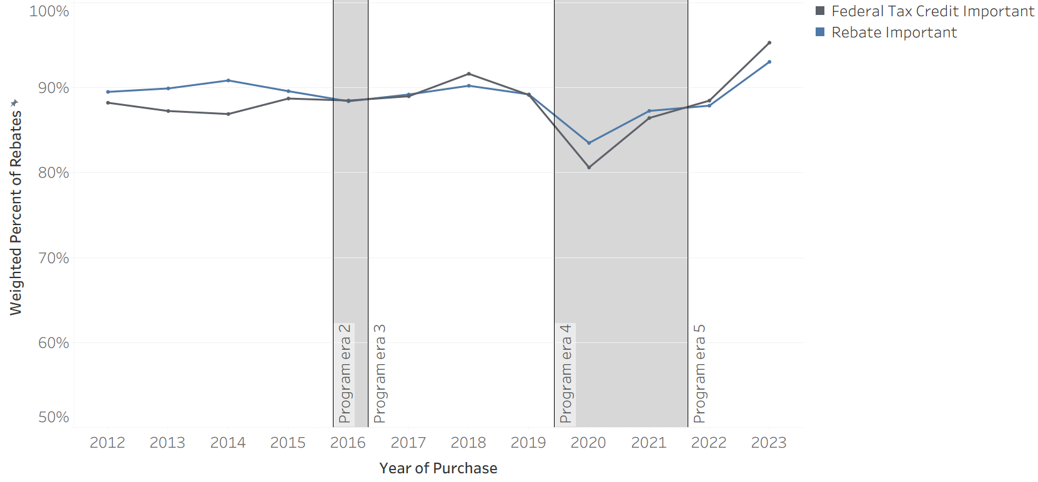
Figure C2 displays CVRP Rebate Essentiality over time by FTC eligibility. Overall, results indicate that CVRP participants that were ineligible for the FTC had lower levels of Rebate Essentiality. CVRP Rebate Essentiality for Tesla/GM consumers decreased from 2019 to 2020 by 15 percentage points—much more than it did other models that did not became ineligible for the FTC during this time (7 percentage points). CVRP Rebate Essentiality for Tesla/GM consumers also increased in 2023, after becoming re-eligible for FTC, by 24 percentage points—much more than other models (5–7 percentage points depending on eligibility of the revamped FTC). Both findings suggest that FTC ineligibility may have weighed on CVRP Rebate Essentiality by suppressing adoption among price-sensitive consumers.
Figure C2
Rebate Essentiality by Federal Tax Credit Eligibility Over Time 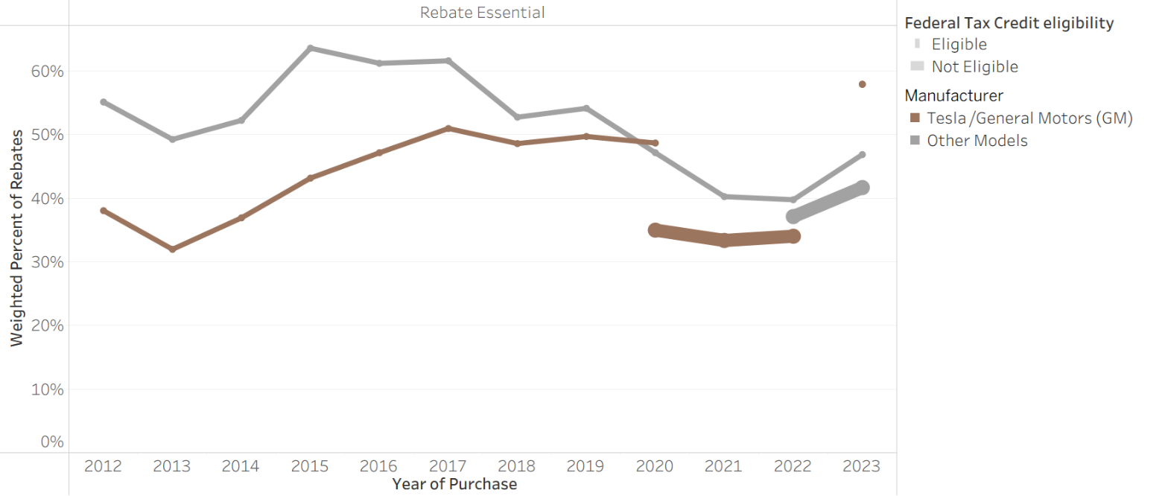

Appendix D: Survey Language
Table D1
Rebate Importance Survey Question Details
Survey Edition | 2013–2015 | 2015–2016, 2016–2017, 2017–2020, 2020–2023, 2023–Close
Question Type | Single select | Single select
Question Language | How important were each of the following factors in making it possible for you to acquire a PEV?: State Rebate (CVRP) | How important were each of the following factors in making it possible for you to acquire your clean vehicle?: State vehicle rebate (CVRP)
Response Option | N/A | Not applicable
Response Option | Not at all important | Not at all important
Response Option | Slightly important | Slightly important
Response Option | Moderately important | Moderately important
Response Option | Very important | Very important
Response Option | Extremely important | Extremely important

Table D2
Rebate Essentiality Survey Question Details
Survey Edition | 2013–2015 | 2015–2016 | 2016–2017 | 2017–2020, 2020–2023, 2023–Close
Question Type | Single select | Single select | Single select | Single select
Question Language | Would you have purchased or leased your PEV without the CVRP rebate? | Would you have purchased or leased your [acquired vehicle] without the state vehicle (CVRP) rebate? | Would you have purchased or leased your [acquired vehicle] without the state vehicle rebate (CVRP)? | Would you have purchased/leased your [acquired vehicle] if the state vehicle rebate (CVRP) did not exist?
Response Option | Yes | Yes | Yes | Yes
Response Option | No | No | No | No


EnergyCenter.org
One mission — DECARBONIZE.®
Center for Sustainable Energy® (CSE) is a national nonprofit that accelerates adoption of clean transportation and distributed energy through effective and equitable program design and administration. Governments, utilities and the private sector trust CSE for its data-driven and software-enabled approach, deep domain expertise and customer-focused team. CSE’s fee-for-service business model frees it from the influence of shareholders, members and donors, and ensures its independence.

Totals reflect rebate application data as of April 30, 2025.
Williams, B. D., Searles, K. (2017). Presentation: “California’s Electric Vehicle Rebates: Exploring Impact.” In: Behavior, Energy & Climate Change Conference. Sacramento CA; 2017. https://cleanvehiclerebate.org/en/content/presentation-california%E2%80%99s-electric-vehicle-rebates-exploring-impact.
Williams, B. D.H., & Pallonetti, N. (2023, Mar.). Rebate Influence on Electric Vehicle Adoption in California. 36th International Electric Vehicle Symposium (EVS36), Sacramento CA, USA. https://www.researchgate.net/publication/371905706_Rebate_Influence_on_Electric_Vehicle_Adoption_in_California.
Ibid.
Johnson, C., & Williams, B. (2017). Characterizing Plug-In Hybrid Electric Vehicle Consumers Most Influenced by California’s Electric Vehicle Rebate: Transportation Research Record, 2628, 23–31. https://doi.org/10.3141/2628-03.
Williams, B. D.H. (2022). Targeting Incentives Cost Effectively: ‘Rebate Essential’ Consumers in the New York State Electric Vehicle Rebate Program. 35th International Electric Vehicle Symposium (EVS35), Oslo, Norway. https://doi.org/doi: 10.13140/RG.2.2.22877.28640.
Pallonetti, N., Williams, B.D.H., Sa, B. (2024, December). “CVRP Greenhouse Gas Emission Reductions and Cost-Effectiveness: 2022 Purchases/Leases.” Prepared by the Center for Sustainable Energy for the Clean Vehicle Rebate Project, California Air Resources Board, Sacramento USA. https://cleanvehiclerebate.org/en/content/cvrp-greenhouse-gas-emission-reductions-and-cost-effectiveness-2022-purchasesleases.
Johnson, C., & Williams, B. (2017). Characterizing Plug-In Hybrid Electric Vehicle Consumers Most Influenced by California’s Electric Vehicle Rebate: Transportation Research Record, 2628, 23–31. https://doi.org/10.3141/2628-03.
Williams, B. D.H., & Pallonetti, N. (2023, Mar.). Rebate Influence on Electric Vehicle Adoption in California. 36th International Electric Vehicle Symposium (EVS36), Sacramento CA, USA. https://www.researchgate.net/publication/371905706_Rebate_Influence_on_Electric_Vehicle_Adoption_in_California.
Ibid.
Williams, B. D.H., & Pallonetti, N. (2025, Mar.). Presentation: “Rebate Influence through 2023 and Designing for Cost-Effectiveness,” prepared by the Center for Sustainable Energy for NYSERDA. https://www.nyserda.ny.gov/All-Programs/Drive-Clean-Rebate-For-Electric-Cars-Program/Rebate-Data.
Williams, B. D.H., & Pallonetti, N. (2025, Mar.), Presentation: “CVRP 2022 Data Summary: Rebate Influence & MSRP Considerations,” prepared by the Center for Sustainable Energy for the Clean Vehicle Rebate Project, California Air Resources Board, Sacramento USA.
Williams, B. D.H., & Pallonetti, N. (2023, Mar.). Rebate Influence on Electric Vehicle Adoption in California. 36th International Electric Vehicle Symposium (EVS36), Sacramento CA, USA. https://www.researchgate.net/publication/371905706_Rebate_Influence_on_Electric_Vehicle_Adoption_in_California.
Williams, B. D.H. (2022). Targeting Incentives Cost Effectively: ‘Rebate Essential’ Consumers in the New York State Electric Vehicle Rebate Program. 35th International Electric Vehicle Symposium (EVS35), Oslo, Norway. https://doi.org/doi: 10.13140/RG.2.2.22877.28640.
Williams, B. D.H., & Pallonetti, N. (2022, May). Presentation: “CVRP 2020 Data Brief: Incentive Influence,” Clean Vehicle Rebate Project, administered by the Center for Sustainable Energy on behalf of the California Air Resources Board.
Williams, B. D.H., & Pallonetti, N. (2023, Mar.). Rebate Influence on Electric Vehicle Adoption in California. 36th International Electric Vehicle Symposium (EVS36), Sacramento CA, USA. https://www.researchgate.net/publication/371905706_Rebate_Influence_on_Electric_Vehicle_Adoption_in_California.
Pallonetti, N., Williams, B.D.H., Sa, B. (2024, Dec.). “CVRP Greenhouse Gas Emission Reductions and Cost-Effectiveness: 2022 Purchases/Leases.” Prepared by the Center for Sustainable Energy for the Clean Vehicle Rebate Project, California Air Resources Board, Sacramento USA. https://cleanvehiclerebate.org/en/content/cvrp-greenhouse-gas-emission-reductions-and-cost-effectiveness-2022-purchasesleases.
Williams, B. D. & Santulli, C. (2016, Aug.). Presentation: “CVRP Income Cap Analysis: Informing Policy Discussions,” Clean Vehicle Rebate Project, administered by the Center for Sustainable Energy on behalf of the California Air Resources Board. https://cleanvehiclerebate.org/en/content/presentation-%E2%80%9Ccvrp-income-cap-analysis-informing-policy-discussions%E2%80%9D.
Williams, B. D.H., & Pallonetti, N. (2023, Mar.). Rebate Influence on Electric Vehicle Adoption in California. 36th International Electric Vehicle Symposium (EVS36), Sacramento CA, USA. https://www.researchgate.net/publication/371905706_Rebate_Influence_on_Electric_Vehicle_Adoption_in_California.
Williams, B.D.H. and Pallonetti, N. (2024, Mar.). Presentation: “NY Drive Clean Rebate: Vehicle Replacement & Rebate Influence thru 2022.” New York State Drive Clean Program (DCRP), NYSERDA. http://dx.doi.org/10.13140/RG.2.2.15816.33289.
Williams, B. D. (2017, Apr.). “Video: ‘Supporting EV Commercialization with Rebates,’” in Blueprint for Clean Energy, p. 58 min. [Online]. Available: https://cbey.yale.edu/event/supporting-ev-commercialization-with-rebates.
Williams, B.D.H. and Pallonetti, N. (2024, Mar.). Presentation: “NY Drive Clean Rebate: Vehicle Replacement & Rebate Influence thru 2022.” New York State Drive Clean Program (DCRP), NYSERDA. http://dx.doi.org/10.13140/RG.2.2.15816.33289.
Williams, B., Jones M., and Arreola, G. (2018). “Electric Vehicle Rebates: Exploring Indicators of Impact in Four States.” Proc., EV Roadmap 11 Conference, Portland, OR, Forth, Portland, OR, 2018. https://cleanvehiclerebate.org/sites/default/files/attachments/2018-06-20-4State-EV-Rebate-Impact_EVRM11.pdf. Accessed November 10, 2025.
Williams, B. D.H. & Pallonetti N. (2022, Mar.). Presentation: “CVRP Data Brief: MSRP Considerations,” for CARB’s Public Work Group Meeting to Discuss the Clean Vehicle Rebate Project, Clean Vehicle Rebate Project, 30 June 2021, revised for ADA. https://cleanvehiclerebate.org/en/content/presentation-cvrp-data-brief-msrp-considerations.
Williams, B. D.H., & Pallonetti, N. (2023, Mar.). Rebate Influence on Electric Vehicle Adoption in California. 36th International Electric Vehicle Symposium (EVS36), Sacramento CA, USA. https://www.researchgate.net/publication/371905706_Rebate_Influence_on_Electric_Vehicle_Adoption_in_California.
Ibid.
While this report primarily focuses on personal (nonfleet) CVRP participants, fleet vehicles (primarily for businesses, composing 2% of rebated BEVs and PHEVs) are included in the totals of this section for comparability to EV market totals. When scaled to represent the program population, survey data averages based on personal consumers (98% of total BEV and PHEV rebates) are applied to all program participants – both personal and fleet.
https://www.autosinnovate.org/EVDashboard.
California Air Resources Board. (2024, Oct.). “Proposed Fiscal Year 2024-25 Funding Plan for Clean Transportation Incentives, Appendix C: Updated Long-Term Plan for Light-Duty Zero-Emission Vehicle Market, Light-Duty Vehicle Purchase Incentives, Clean Mobility Investments, and Outreach.” https://ww2.arb.ca.gov/sites/default/files/2024-10/FY%202024-25%20Funding%20Plan%20Appendix%20C.pdf.
https://energycenter.org/software/caret.
Williams, B. D.H., & Pallonetti, N. (2023, Mar.). Rebate Influence on Electric Vehicle Adoption in California. 36th International Electric Vehicle Symposium (EVS36), Sacramento CA, USA. https://www.researchgate.net/publication/371905706_Rebate_Influence_on_Electric_Vehicle_Adoption_in_California.
Pallonetti, N., Williams, B.D.H., Sa, B. (2024, Dec.). “CVRP Greenhouse Gas Emission Reductions and Cost-Effectiveness: 2022 Purchases/Leases.” Prepared by the Center for Sustainable Energy for the Clean Vehicle Rebate Project, California Air Resources Board, Sacramento USA. https://cleanvehiclerebate.org/en/content/cvrp-greenhouse-gas-emission-reductions-and-cost-effectiveness-2022-purchasesleases.
https://ww2.arb.ca.gov/news/californias-clean-vehicle-rebate-program-will-transition-helping-low-income-residents.
https://ww2.arb.ca.gov/project-background.
Totals reflect rebate application data as of April 30, 2025.
https://ww2.arb.ca.gov/project-background.
https://cleanvehiclerebate.org/sites/default/files/attachments/CVRP%20Final%20Report%20FY%2012-13_Final.pdf.
Other consumer types included business/non-profit and government fleets, which claimed 2% of total BEV and PHEV rebates.
Other EV types included fuel-cell EVs, zero-emission motorcycles, and neighborhood EVs, which composed 3% of total personal rebates.
https://cleanvehiclerebate.org/en/eligibility-guidelines.
https://cleanvehiclerebate.org/sites/default/files/attachments/Disruptions_Fact_Sheet_9_2021.pdf.
https://ww2.arb.ca.gov/project-background.
Ibid.
An Increased Rebate was also introduced for public fleets in Disadvantaged Communities (https://cleanvehiclerebate.org/en/terms-and-conditions), though fleets are outside of the scope of this report.
Summarized in Appendix A and detailed in online documentation (https://cleanvehiclerebate.org/sites/default/files/attachments/Disruptions_Fact_Sheet_9_2021.pdf).
Electric mileage ratings based on Urban Dynamometer Driving Schedule (UDDS) testing.
https://fueleconomy.gov/.
Alliance for Automotive Innovation. (2025). Advanced Technology Sales Dashboard. Data compiled by the Alliance for Automotive Innovation using information provided by S&P Global Mobility (formerly IHS Markit) (2011-2018, November 2019-present) and Hedges & Co. (January 2019-October 2019). Date of last update: 5/22/2025. Retrieved 7/24/2025.
One exception to Tesla share increasing over time was in 2022, a year in which Tesla models were priced above the MSRP cap and ineligible for a significant period.
Williams, B. D.H., & Anderson, J. (2019). Growing the Electric Vehicle Market: EV Adopters, ‘Rebate Essentials,’ and ‘EV Converts.’ Roadmap 12 Conference, Portland, OR. https://energycenter.org/thought-leadership/research-and-reports/growing-electric-vehicle-market-ev-adopters-rebate.
Santulli, C., & Williams, B. D. (2015). Implementation Status Update | Clean Vehicle Rebate Project. Proc., CVRP Long-Term Planning Workshop, California Air Resources Board (CARB), Sacramento. https://cleanvehiclerebate.org/sites/default/files/attachments/2015-12-08%20Implementation%20Update.pdf. Accessed November 10, 2025.
Anderson, J. B., & Williams, B. D.H. (2019). Proposed FY 2019–20 Funding Plan: Final CVRP Supporting Analysis. Clean Vehicle Rebate Project. CVRP. https://cleanvehiclerebate.org/en/content/proposed-fy-2019%E2%80%9320-funding-plan-final-cvrp-supporting-analysis. Accessed November 10, 2025.
Williams, B. D.H., & Pallonetti, N. (2025, Mar.). Presentation: “CVRP 2022 Data Summary: Rebate Influence & MSRP Considerations,” prepared by the Center for Sustainable Energy for the Clean Vehicle Rebate Project, California Air Resources Board, Sacramento USA.
Rogers, E. M. (1962). Diffusion of Innovations. Free Press, New York.
Enkel, E. & Wintgens, S. (2025). Understanding mass-market electric vehicle adoption: Integrating diffusion of innovation theory with risk mitigation strategy in Germany. Technological Forecasting & Social Change, https://doi.org/10.1016/j.techfore.2025.124329.
Johnson, C., & Williams, B. (2017). Characterizing Plug-In Hybrid Electric Vehicle Consumers Most Influenced by California’s Electric Vehicle Rebate: Transportation Research Record, 2628, 23–31. https://doi.org/10.3141/2628-03.
Williams, B. D.H. (2025, Mar.). Presentation: “Assessing Progress Toward Equitable Access to EVs with Incentive Program Metrics: Lessons Learned from CVRP and NY DCRP Using Program Data and Baselines of Comparison,” for CARB Clean Transportation Equity Incentives Symposium, Sacramento CA. https://cleanvehiclerebate.org/en/content/assessing-progress-toward-equitable-access-evs-incentive-program-metrics-lessons-learned.
Pallonetti, N., Williams, B. D. H., & Sa, B. (2023). CVRP Greenhouse Gas Emission Reductions and Cost-Effectiveness, Update: 2021 Purchases/Leases. https://cleanvehiclerebate.org/sites/default/files/attachments/CVRP-2021-GHG-CE-update.pdf
Williams, B. D.H. (2020, Dec.). “Presentation: ‘EV Purchase Incentives: Program Design, Outputs, and Outcomes of Four Statewide Programs with a Focus on Massachusetts,’” in Behavior, Energy, and Climate Change (BECC) Conference, ACEEE, UC Berkeley CIEE, and SEEPAC. doi: 10.13140/RG.2.2.13166.08001.
The CVRP Rebate Survey Dashboard provides select CVRP rebate influence and other survey metrics over time with the ability to filter by several variables (available online: https://cleanvehiclerebate.org/en/rebate-survey-dashboard).
Williams, B. D.H. (2022). Targeting Incentives Cost Effectively: ‘Rebate Essential’ Consumers in the New York State Electric Vehicle Rebate Program. 35th International Electric Vehicle Symposium (EVS35), Oslo, Norway. https://doi.org/doi: 10.13140/RG.2.2.22877.28640.
Williams, B. D.H., & Pallonetti, N. (2025, Mar.), Presentation: “CVRP 2022 Data Summary: Rebate Influence & MSRP Considerations,” prepared by the Center for Sustainable Energy for the Clean Vehicle Rebate Project, California Air Resources Board, Sacramento USA.
Williams, B. D.H., & Pallonetti, N. (2023, Mar.). Rebate Influence on Electric Vehicle Adoption in California. 36th International Electric Vehicle Symposium (EVS36), Sacramento CA, USA. https://www.researchgate.net/publication/371905706_Rebate_Influence_on_Electric_Vehicle_Adoption_in_California.
Pallonetti, N., Williams, B.D.H., Sa, B. (2024, December). “CVRP Greenhouse Gas Emission Reductions and Cost-Effectiveness: 2022 Purchases/Leases.” Prepared by the Center for Sustainable Energy for the Clean Vehicle Rebate Project, California Air Resources Board, Sacramento USA. https://cleanvehiclerebate.org/en/content/cvrp-greenhouse-gas-emission-reductions-and-cost-effectiveness-2022-purchasesleases.
Johnson, C., & Williams, B. (2017). Characterizing Plug-In Hybrid Electric Vehicle Consumers Most Influenced by California’s Electric Vehicle Rebate: Transportation Research Record, 2628, 23–31. https://doi.org/10.3141/2628-03.
Additional data tools and other related work can be found on the CVRP Data & Reports pages (https://cleanvehiclerebate.org/en/program-reports).
Williams, B. D.H., & Pallonetti, N. (2023, Mar.). Rebate Influence on Electric Vehicle Adoption in California. 36th International Electric Vehicle Symposium (EVS36), Sacramento CA, USA. https://www.researchgate.net/publication/371905706_Rebate_Influence_on_Electric_Vehicle_Adoption_in_California.
Hardman, S., Chandan, A., Tal, G., & Turrentine, T. (2017). The effectiveness of financial purchase incentives for battery electric vehicles – A review of the evidence. Renewable and Sustainable Energy Reviews, 80, 1100–1111. https://doi.org/10.1016/j.rser.2017.05.255.
Jenn, A., Springel, K., & Gopal, A. R. (2018). Effectiveness of electric vehicle incentives in the United States. Energy Policy, 119, 349–356. https://doi.org/10.1016/j.enpol.2018.04.065.
Narassimhan, E., & Johnson, C. (2018). The role of demand-side incentives and charging infrastructure on plug-in electric vehicle adoption: Analysis of US States. Environmental Research Letters, 13(7), 074032. https://doi.org/10.1088/1748-9326/aad0f8.
Tal, G., & Nicholas, M. (2016). Exploring the Impact of the Federal Tax Credit on the Plug-In Vehicle Market. Transportation Research Record: Journal of the Transportation Research Board, 2572(1), 95–102. https://doi.org/10.3141/2572-11.
Sherlock, M. F. (2019, May). “The Plug-In Electric Vehicle Tax Credit,” Congressional Research Service, IF11017. Accessed: Feb. 28, 2021. [Online]. Available: https://crsreports.congress.gov/product/pdf/IF/IF11017
Johnson, C., & Williams, B. (2017). Characterizing Plug-In Hybrid Electric Vehicle Consumers Most Influenced by California’s Electric Vehicle Rebate: Transportation Research Record, 2628, 23–31. https://doi.org/10.3141/2628-03
Williams, B. D. & Johnson, C. (2016, Oct.). “Presentation: ‘Characterizing California Electric Vehicle Consumer Segments,’” in Behavior, Energy, and Climate Change (BECC) Conference, Baltimore: ACEEE, UC Berkeley CIEE, and SEEPAC. doi: 10.13140/RG.2.2.29388.13444.
Williams, B. D.H. (2022). Targeting Incentives Cost Effectively: ‘Rebate Essential’ Consumers in the New York State Electric Vehicle Rebate Program. 35th International Electric Vehicle Symposium (EVS35), Oslo, Norway. https://doi.org/doi: 10.13140/RG.2.2.22877.28640.
Williams, B. D.H. & Anderson J. B. (2022). Lessons Learned About Electric Vehicle Consumers Who Found the U.S. Federal Tax Credit Extremely Important in Enabling Their Purchase. 35th International Electric Vehicle Symposium (EVS35), Oslo, Norway. https://www.researchgate.net/publication/365977337_Lessons_Learned_About_Electric_Vehicle_Consumers_Who_Rated_the_US_Federal_Tax_Credit_Extremely_Important_in_Enabling_Their_Purchase.
Allcott, H., et al. (2024). “The Effects of “Buy American”: Electric Vehicles and the Inflation Reduction Act.” Energy Institute WP 350R. https://haas.berkeley.edu/wp-content/uploads/WP350.pdf.
Sarode, S., Elkind, E., & Cremers, E. (2023). “CALIFORNIA’S POLICY APPROACH TO REDUCING MOBILE SOURCE EMISSIONS.” The Regents of the University of California, on behalf of its Berkeley campus (UC Berkeley). https://www.law.berkeley.edu/wp-content/uploads/2023/06/CARB-Policies-Paper-Final.pdf.
Chakraborty, D., et al. (n.d.) “MEASURING THE EMISSIONS AND SOCIOECONOMIC BENEFITS OF CARB’S INCENTIVES AND REGULATORY PROGRAMS: THE LIGHT-DUTY VEHICLE SECTOR PROGRAMS.” University of California at Davis Institute of Transportation Studies, Electric Vehicle Research Center. https://ww2.arb.ca.gov/sites/default/files/2024-02/CSA_Contract_LDV_Quantification_Method_Dec%2022_header_0%20-%20Copy.pdf.
Pallonetti, N. & Williams, B. D.H. (2023, Mar.), Vehicle Replacement: Findings from California’s Clean Vehicle Rebate Project. 36th International Electric Vehicle Symposium (EVS36), Sacramento CA, USA. https://www.researchgate.net/publication/371905633_Vehicle_Replacement_Findings_from_California's_Clean_Vehicle_Rebate_Project.
Violette, D. M., & Rathbun, P. (2017). “Chapter 21: Estimating Net Savings – Common Practices.” In The Uniform Methods Project: Methods for Determining Energy Efficiency Savings for Specific Measures. Golden, CO: National Renewable Energy Laboratory. https://www.nrel.gov/docs/fy17osti/68578.pdf.
Chakraborty, D., Bunch, D. S., Brownstone, D., Xu, B., & Tal, G. (2022). Plug-in electric vehicle diffusion in California: Role of exposure to new technology at home and work. Transportation Research Part A: Policy and Practice, 156, 133–151. https://doi.org/10.1016/j.tra.2021.12.005. https://www.sciencedirect.com/science/article/abs/pii/S0965856421003190.
Clinton, B. C., & Steinberg, D. C. (2019). Providing the Spark: Impact of financial incentives on battery electric vehicle adoption. Journal of Environmental Economics and Management, 98, 102255. https://doi.org/10.1016/j.jeem.2019.102255.
Gillingham, K., & Stock, J. H. (2018). The Cost of Reducing Greenhouse Gas Emissions. Journal of Economic Perspectives, 32(4), 53–72. https://doi.org/10.1257/jep.32.4.53.
Sarode, S., Elkind, E., & Cremers, E. (2023). “CALIFORNIA’S POLICY APPROACH TO REDUCING MOBILE SOURCE EMISSIONS.” The Regents of the University of California, on behalf of its Berkeley campus (UC Berkeley). https://www.law.berkeley.edu/wp-content/uploads/2023/06/CARB-Policies-Paper-Final.pdf.
California Air Resources Board. (2024, Oct.). “Proposed Fiscal Year 2024-25 Funding Plan for Clean Transportation Incentives, Appendix C: Updated Long-Term Plan for Light-Duty Zero-Emission Vehicle Market, Light-Duty Vehicle Purchase Incentives, Clean Mobility Investments, and Outreach.” https://ww2.arb.ca.gov/sites/default/files/2024-10/FY%202024-25%20Funding%20Plan%20Appendix%20C.pdf.
https://energycenter.org/software/caret.
Sarode, S., Elkind, E., & Cremers, E. (2023). “CALIFORNIA’S POLICY APPROACH TO REDUCING MOBILE SOURCE EMISSIONS.” The Regents of the University of California, on behalf of its Berkeley campus (UC Berkeley). https://www.law.berkeley.edu/wp-content/uploads/2023/06/CARB-Policies-Paper-Final.pdf.
Chakraborty, D., et al. (n.d.) “MEASURING THE EMISSIONS AND SOCIOECONOMIC BENEFITS OF CARB’S INCENTIVES AND REGULATORY PROGRAMS: THE LIGHT-DUTY VEHICLE SECTOR PROGRAMS.” University of California at Davis Institute of Transportation Studies, Electric Vehicle Research Center. https://ww2.arb.ca.gov/sites/default/files/2024-02/CSA_Contract_LDV_Quantification_Method_Dec%2022_header_0%20-%20Copy.pdf.
https://afdc.energy.gov/laws/4249.
Williams, B. D., Searles, K. (2017). Presentation: “California’s Electric Vehicle Rebates: Exploring Impact.” In: Behavior, Energy & Climate Change Conference. Sacramento CA; 2017. https://cleanvehiclerebate.org/en/content/presentation-california%E2%80%99s-electric-vehicle-rebates-exploring-impact.
Williams, B. D.H., & Pallonetti, N. (2023, Mar.). Rebate Influence on Electric Vehicle Adoption in California. 36th International Electric Vehicle Symposium (EVS36), Sacramento CA, USA. https://www.researchgate.net/publication/371905706_Rebate_Influence_on_Electric_Vehicle_Adoption_in_California.
Question language varied slightly in some survey editions (see Appendix D).
Ibid.
Johnson, C., & Williams, B. (2017). Characterizing Plug-In Hybrid Electric Vehicle Consumers Most Influenced by California’s Electric Vehicle Rebate: Transportation Research Record, 2628, 23–31. https://doi.org/10.3141/2628-03.
Williams, B. D.H. (2022). Targeting Incentives Cost Effectively: ‘Rebate Essential’ Consumers in the New York State Electric Vehicle Rebate Program. 35th International Electric Vehicle Symposium (EVS35), Oslo, Norway. https://doi.org/doi: 10.13140/RG.2.2.22877.28640.
Pallonetti, N., Williams, B.D.H., Sa, B. (2024, December). “CVRP Greenhouse Gas Emission Reductions and Cost-Effectiveness: 2022 Purchases/Leases.” Prepared by the Center for Sustainable Energy for the Clean Vehicle Rebate Project, California Air Resources Board, Sacramento USA. https://cleanvehiclerebate.org/en/content/cvrp-greenhouse-gas-emission-reductions-and-cost-effectiveness-2022-purchasesleases.
Ibid.
Williams, B. D.H. (2022). Targeting Incentives Cost Effectively: ‘Rebate Essential’ Consumers in the New York State Electric Vehicle Rebate Program. 35th International Electric Vehicle Symposium (EVS35), Oslo, Norway. https://doi.org/doi: 10.13140/RG.2.2.22877.28640.
Pallonetti, N. & Williams, B. D.H. (2023, Mar.), Vehicle Replacement: Findings from California’s Clean Vehicle Rebate Project. 36th International Electric Vehicle Symposium (EVS36), Sacramento CA, USA. https://www.researchgate.net/publication/371905633_Vehicle_Replacement_Findings_from_California's_Clean_Vehicle_Rebate_Project.
Williams, B. D.H., & Anderson, J. (2019). Growing the Electric Vehicle Market: EV Adopters, ‘Rebate Essentials,’ and ‘EV Converts.’ Roadmap 12 Conference, Portland, OR. https://energycenter.org/thought-leadership/research-and-reports/growing-electric-vehicle-market-ev-adopters-rebate.
Santulli, C., & Williams, B. D. (2015). Implementation Status Update | Clean Vehicle Rebate Project. Proc., CVRP Long-Term Planning Workshop, California Air Resources Board (CARB), Sacramento. https://cleanvehiclerebate.org/sites/default/files/attachments/2015-12-08%20Implementation%20Update.pdf. Accessed November 10, 2025.
Anderson, J. B., & Williams, B. D.H. (2019). Proposed FY 2019–20 Funding Plan: Final CVRP Supporting Analysis. Clean Vehicle Rebate Project. CVRP. https://cleanvehiclerebate.org/en/content/proposed-fy-2019%E2%80%9320-funding-plan-final-cvrp-supporting-analysis. Accessed November 10, 2025.
Williams, B. D.H., & Pallonetti, N. (2023, Mar.). New York State’s Drive Clean Rebate for Electric Vehicles: Measures of Impact. 36th International Electric Vehicle Symposium (EVS36), Sacramento CA, USA. https://www.researchgate.net/publication/371109282_New_York_State's_Drive_Clean_Rebate_for_Electric_Vehicles_Measures_of_Impact.
Williams, B. D.H., & Pallonetti, N. (2023, Mar.). Rebate Influence on Electric Vehicle Adoption in California. 36th International Electric Vehicle Symposium (EVS36), Sacramento CA, USA. https://www.researchgate.net/publication/371905706_Rebate_Influence_on_Electric_Vehicle_Adoption_in_California.
Alliance for Automotive Innovation. (2025). Advanced Technology Sales Dashboard. Data compiled by the Alliance for Automotive Innovation using information provided by S&P Global Mobility (formerly IHS Markit) (2011-2018, November 2019-present) and Hedges & Co. (January 2019-October 2019). Date of last update: 5/22/2025. Retrieved 9/26/2025.
Rogers, E. M. (1962). Diffusion of Innovations. Free Press, New York.
Enkel, E. & Wintgens, S. (2025). Understanding mass-market electric vehicle adoption: Integrating diffusion of innovation theory with risk mitigation strategy in Germany. Technological Forecasting & Social Change, https://doi.org/10.1016/j.techfore.2025.124329.
Johnson, C., & Williams, B. (2017). Characterizing Plug-In Hybrid Electric Vehicle Consumers Most Influenced by California’s Electric Vehicle Rebate: Transportation Research Record, 2628, 23–31. https://doi.org/10.3141/2628-03.
Williams, B. D.H., & Pallonetti, N. (2023, Mar.). Rebate Influence on Electric Vehicle Adoption in California. 36th International Electric Vehicle Symposium (EVS36), Sacramento CA, USA. https://www.researchgate.net/publication/371905706_Rebate_Influence_on_Electric_Vehicle_Adoption_in_California.
Summarized in Appendix A and detailed in online documentation: https://cleanvehiclerebate.org/sites/default/files/attachments/Disruptions_Fact_Sheet_9_2021.pdf.
Williams, B. D. & Santulli, C. (2016, Aug.). Presentation: “CVRP Income Cap Analysis: Informing Policy Discussions,” Clean Vehicle Rebate Project, administered by the Center for Sustainable Energy on behalf of the California Air Resources Board. https://cleanvehiclerebate.org/en/content/presentation-%E2%80%9Ccvrp-income-cap-analysis-informing-policy-discussions%E2%80%9D.
Williams, B. D.H., & Pallonetti, N. (2023, Mar.). Rebate Influence on Electric Vehicle Adoption in California. 36th International Electric Vehicle Symposium (EVS36), Sacramento CA, USA. https://www.researchgate.net/publication/371905706_Rebate_Influence_on_Electric_Vehicle_Adoption_in_California.
Williams, B.D.H. and Pallonetti, N. (2024, Mar.). Presentation: “NY Drive Clean Rebate: Vehicle Replacement & Rebate Influence thru 2022.” New York State Drive Clean Program (DCRP), NYSERDA. http://dx.doi.org/10.13140/RG.2.2.15816.33289.
Williams, B. D.H., & Pallonetti, N. (2022, May). Presentation: “CVRP 2020 Data Brief: Incentive Influence,” Clean Vehicle Rebate Project, administered by the Center for Sustainable Energy on behalf of the California Air Resources Board.
Williams, B. D.H., & Pallonetti, N. (2023, Mar.). Rebate Influence on Electric Vehicle Adoption in California. 36th International Electric Vehicle Symposium (EVS36), Sacramento CA, USA. https://www.researchgate.net/publication/371905706_Rebate_Influence_on_Electric_Vehicle_Adoption_in_California.
Pallonetti, N., Williams, B.D.H., Sa, B. (2024, December). “CVRP Greenhouse Gas Emission Reductions and Cost-Effectiveness: 2022 Purchases/Leases.” Prepared by the Center for Sustainable Energy for the Clean Vehicle Rebate Project, California Air Resources Board, Sacramento USA. https://cleanvehiclerebate.org/en/content/cvrp-greenhouse-gas-emission-reductions-and-cost-effectiveness-2022-purchasesleases.
Williams, B. D.H., & Pallonetti, N. (2023, Mar.). Rebate Influence on Electric Vehicle Adoption in California. 36th International Electric Vehicle Symposium (EVS36), Sacramento CA, USA. https://www.researchgate.net/publication/371905706_Rebate_Influence_on_Electric_Vehicle_Adoption_in_California.
Ibid.
Williams, B. D.H., & Pallonetti, N. (2025, Mar.). Presentation: “CVRP 2022 Data Summary: Rebate Influence & MSRP Considerations,” prepared by the Center for Sustainable Energy for the Clean Vehicle Rebate Project, California Air Resources Board, Sacramento USA.
Ibid.
Williams, B., Jones M., and Arreola, G. (2018). “Electric Vehicle Rebates: Exploring Indicators of Impact in Four States.” Proc., EV Roadmap 11 Conference, Portland, OR, Forth, Portland, OR, 2018. https://cleanvehiclerebate.org/sites/default/files/attachments/2018-06-20-4State-EV-Rebate-Impact_EVRM11.pdf. Accessed November 10, 2025.
Williams, B. D.H. & Pallonetti N. (2022, Mar.). Presentation: “CVRP Data Brief: MSRP Considerations,” for CARB’s Public Work Group Meeting to Discuss the Clean Vehicle Rebate Project, Clean Vehicle Rebate Project, 30 June 2021, revised for ADA. https://cleanvehiclerebate.org/en/content/presentation-cvrp-data-brief-msrp-considerations.
Williams, B. D.H., & Pallonetti, N. (2023, Mar.). Rebate Influence on Electric Vehicle Adoption in California. 36th International Electric Vehicle Symposium (EVS36), Sacramento CA, USA. https://www.researchgate.net/publication/371905706_Rebate_Influence_on_Electric_Vehicle_Adoption_in_California.
Williams, B. D. (2017, Apr.). “Video: ‘Supporting EV Commercialization with Rebates,’” in Blueprint for Clean Energy, p. 58 min. [Online]. Available: https://cbey.yale.edu/event/supporting-ev-commercialization-with-rebates.
Williams, B.D.H. and Pallonetti, N. (2024, Mar.). Presentation: “NY Drive Clean Rebate: Vehicle Replacement & Rebate Influence thru 2022.” New York State Drive Clean Program (DCRP), NYSERDA. http://dx.doi.org/10.13140/RG.2.2.15816.33289.
Alliance for Automotive Innovation. (2025). Advanced Technology Sales Dashboard. Data compiled by the Alliance for Automotive Innovation using information provided by S&P Global Mobility (formerly IHS Markit) (2011-2018, November 2019-present) and Hedges & Co. (January 2019-October 2019). Date of last update: 9/26/2025. Accessed 11/10/2025.
Williams, B. D.H., & Pallonetti, N. (2025, Mar.). Presentation: “Rebate Influence through 2023 and Designing for Cost-Effectiveness,” prepared by the Center for Sustainable Energy for NYSERDA. https://www.nyserda.ny.gov/All-Programs/Drive-Clean-Rebate-For-Electric-Cars-Program/Rebate-Data.
Alliance for Automotive Innovation. (2025). Advanced Technology Sales Dashboard. Data compiled by the Alliance for Automotive Innovation using information provided by S&P Global Mobility (formerly IHS Markit) (2011-2018, November 2019-present) and Hedges & Co. (January 2019-October 2019). Date of last update: 5/22/2025. Retrieved 7/24/2025.
While this report primarily focuses on personal (nonfleet) CVRP participants, fleet vehicles (primarily for businesses, composing 2% of rebated BEVs and PHEVs) are included in the totals of this section for comparability to EV market totals.
When scaled to represent the program population, survey data averages based on personal consumers (98% of total BEV and PHEV rebates) are applied to all program participants – both personal and fleet.
Center for Sustainable Energy. (2021, Sept.). “Summary of CVRP Rebate Eligibility and Funding Availability Over Time.” https://cleanvehiclerebate.org/sites/default/files/attachments/Disruptions_Fact_Sheet_9_2021.pdf.
Counterfactual data are unavailable for non-Rebate Essential respondents after 2020—all are grouped with “New EV.” See Appendix B for additional detail.
Alliance for Automotive Innovation. (2025). Advanced Technology Sales Dashboard. Data compiled by the Alliance for Automotive Innovation using information provided by S&P Global Mobility (formerly IHS Markit) (2011-2018, November 2019-present) and Hedges & Co. (January 2019-October 2019). Date of last update: 5/22/2025. Retrieved 9/26/2025.
California has been the leading state in EV market share since the modern EV market began (https://www.autosinnovate.org/EVDashboard).
Totals reflect rebate application data as of April 30, 2025.
Williams, B. D.H., & Pallonetti, N. (2023, Mar.). Rebate Influence on Electric Vehicle Adoption in California. 36th International Electric Vehicle Symposium (EVS36), Sacramento CA, USA. https://www.researchgate.net/publication/371905706_Rebate_Influence_on_Electric_Vehicle_Adoption_in_California.
Williams, B. D.H., & Pallonetti, N. (2025, Mar.). Presentation: “Rebate Influence through 2023 and Designing for Cost-Effectiveness,” prepared by the Center for Sustainable Energy for NYSERDA. https://www.nyserda.ny.gov/All-Programs/Drive-Clean-Rebate-For-Electric-Cars-Program/Rebate-Data.
California Air Resources Board. (2024, Oct.). “Proposed Fiscal Year 2024-25 Funding Plan for Clean Transportation Incentives, Appendix C: Updated Long-Term Plan for Light-Duty Zero-Emission Vehicle Market, Light-Duty Vehicle Purchase Incentives, Clean Mobility Investments, and Outreach.” https://ww2.arb.ca.gov/sites/default/files/2024-10/FY%202024-25%20Funding%20Plan%20Appendix%20C.pdf.
https://energycenter.org/software/caret.
Williams, B. D.H., & Pallonetti, N. (2023, Mar.). Rebate Influence on Electric Vehicle Adoption in California. 36th International Electric Vehicle Symposium (EVS36), Sacramento CA, USA. https://www.researchgate.net/publication/371905706_Rebate_Influence_on_Electric_Vehicle_Adoption_in_California.
Pallonetti, N., Williams, B.D.H., Sa, B. (2024, December). “CVRP Greenhouse Gas Emission Reductions and Cost-Effectiveness: 2022 Purchases/Leases.” Prepared by the Center for Sustainable Energy for the Clean Vehicle Rebate Project, California Air Resources Board, Sacramento USA. https://cleanvehiclerebate.org/en/content/cvrp-greenhouse-gas-emission-reductions-and-cost-effectiveness-2022-purchasesleases.
https://ww2.arb.ca.gov/news/californias-clean-vehicle-rebate-program-will-transition-helping-low-income-residents.
Williams, B. D.H., & Pallonetti, N. (2023, Mar.). Rebate Influence on Electric Vehicle Adoption in California. 36th International Electric Vehicle Symposium (EVS36), Sacramento CA, USA. https://www.researchgate.net/publication/371905706_Rebate_Influence_on_Electric_Vehicle_Adoption_in_California.
Pallonetti, N., Williams, B.D.H., Sa, B. (2024, December). “CVRP Greenhouse Gas Emission Reductions and Cost-Effectiveness: 2022 Purchases/Leases.” Prepared by the Center for Sustainable Energy for the Clean Vehicle Rebate Project, California Air Resources Board, Sacramento USA. https://cleanvehiclerebate.org/en/content/cvrp-greenhouse-gas-emission-reductions-and-cost-effectiveness-2022-purchasesleases.
Ibid.
Williams, B. D.H. (2025, Mar.). “Assessing Progress Toward Equitable Access to EVs with Incentive Program Metrics: Lessons Learned from CVRP and NY DCRP Using Program Data and Baselines of Comparison,” for CARB Clean Transportation Equity Incentives Symposium, Sacramento CA. https://www.youtube.com/watch?v=vRC6MeNJT_c&list=PLSOs1pufasEa7g7orgTGsZEkefPEtY9Pb&index=5.
Adapted from Williams, B. D.H. (2025, Mar.). Presentation: “Assessing Progress Toward Equitable Access to EVs with Incentive Program Metrics: Lessons Learned from CVRP and NY DCRP Using Program Data and Baselines of Comparison,” for CARB Clean Transportation Equity Incentives Symposium, Sacramento CA. https://cleanvehiclerebate.org/en/content/assessing-progress-toward-equitable-access-evs-incentive-program-metrics-lessons-learned.
Adapted from B.D.H. Williams (2025, Mar.), Williams, B. D.H. (2025, Mar.). Presentation: “Assessing Progress Toward Equitable Access to EVs with Incentive Program Metrics: Lessons Learned from CVRP and NY DCRP Using Program Data and Baselines of Comparison,” for CARB Clean Transportation Equity Incentives Symposium, Sacramento CA. https://cleanvehiclerebate.org/en/content/assessing-progress-toward-equitable-access-evs-incentive-program-metrics-lessons-learned.
https://fueleconomy.gov/feg/tax2022.shtml#phaseout.
https://afdc.energy.gov/laws/electric-vehicles-for-tax-credit#/tab-2022.
https://fueleconomy.gov/feg/tax2023.shtml.

