
CVRP Greenhouse Gas Emission
Reductions and Cost-Effectiveness

This report and additional program, consumer, and market analysis is available at:
https://cleanvehiclerebate.org/en/program-reports

Please cite this reference: Pallonetti, N., Sa, B., Williams, B.D.H. (2026, April). “CVRP Greenhouse Gas Emission Reductions and Cost-Effectiveness.” Prepared by the Center for Sustainable Energy for the Clean Vehicle Rebate Project, California Air Resources Board, Sacramento USA.

Contents
Contents 3
Executive Summary 5
1. Introduction 8
2. Data Summary 9
Rebate Application Data 9
Participant Survey Data 10
Vehicle Registration Data 10
3. Methods and Inputs 11
Methodology for Calculating GHG Emission Reductions 11
Rebated Vehicles 11
Baseline Vehicles 12
Quantification Period 13
Rebate Influence 14
Counterfactual Behaviors 15
4. Results and Discussion 19
GHG Emission Reductions and Cost-Effectiveness: All Rebated Vehicles 19
GHG Emission Reductions and Cost-Effectiveness: Rebate-Influenced Vehicles 23
Interpreting Rebate Influence 26
GHG Emission Reductions and Cost-Effectiveness: Detailed Counterfactual Reductions 27
Program & Market Context 36
Comparisons to Previous Research & Reporting 39
Limitations and Opportunities for Future Research 39
5. Summary 40
Acknowledgements 42
Appendix A: GHG Input Values 43
Carbon Intensity of Fuels 43
Fuel Consumption Rate 44
Vehicle Miles Traveled 48
Detailed Counterfactual Analysis Inputs & Assumptions 51
Appendix B: Sensitivity Analyses 54
Sensitivity to Vehicle and Fuel Inputs 54
Electric Utility Carbon Intensity 56
Home Solar Electricity 56
Sensitivity to Quantification Period 57
Appendix C: Additional Program and Market Context 58
Appendix D: Fleet and TNC GHG Emission Reductions 60
Fleet GHG Emission Reductions 60
TNC GHG Emission Reductions 63
References 64

Executive Summary
Original estimates of greenhouse gas (GHG) emission reductions associated with the Clean Vehicle Rebate Project (CVRP) were 1) developed as a part of multi-program planning, 2) based upon average light-duty vehicle characterizations, and 3) were described as intentionally conservative as a starting point for future refinement (CARB, 2017b). Subsequent program-specific work by CSE that builds on (CARB, 2017b) includes an interim life-of-program accounting through mid-2018 (Pallonetti & Williams, 2021) and annual assessments of GHG impacts of 2019–2022 purchases/leases (Pallonetti et al., 2023, 2024; Pallonetti & Williams, 2022a, 2022b; B. Williams & Pallonetti, 2022). Here we report on the GHG impacts and cost-effectiveness of CVRP rebates for electric vehicles (EVs) over the entire life of the program through its closure in 2023 and introduce a refined methodology that is increasingly case-specific relative to prior work. For example, the CVRP survey data on detailed counterfactual behaviors, as introduced in the 2022 purchases/leases report, is updated and employed over the life of the program. Additionally, this analysis is made increasingly time-variant by modeling each year of driving with temporal information as available, whereas previous reporting modeled first-year emissions and scaled those up to estimate the lifetime period.
Emissions are estimated using disaggregated data from nearly 600,000 approved CVRP rebate applications for plug-in hybrid electric vehicles (PHEVs), all-battery electric vehicles (BEVs), and fuel-cell electric vehicles (FCEVs) and from more than 100,000 survey responses weighted to represent project participants. The analysis incorporates time-variant and state-specific or other best-available inputs that characterize mileage, fuel use, and fuel carbon intensity for both rebated EVs and baseline comparison vehicles. It also includes data-based characterizations of rebate influence and counterfactual behaviors related to what would have happened in absence of the project, provided by or tailored to each rebated consumer.
Compared to new gasoline vehicles, GHG emission reductions associated with all rebated EVs over the first year of ownership average 2.2–3.6 metric tons of carbon-dioxide-equivalent (CO₂e) emissions per vehicle, depending on the EV technology type, with BEVs reducing the most on average. Over a standardized 100,000-mile quantification period, an estimated total of 15.5M metric tons of CO₂e emissions are saved. Comparing rebate costs to all rebated-vehicle emissions benefits over a 100,000-mile quantification period produces CO₂e abatement costs averaging $93 per metric ton.
To isolate the emission reductions from participants most influenced by the rebate, case-specific indicators of rebate influence (Johnson & Williams, 2017; B. Williams & Anderson, 2018; B. D. H. Williams, 2022; B. Williams & Pallonetti, 2023) can be used. In total, approximately 50% of the rebated reductions over the life of the project are associated with “Rebate-Essential” participants (those who stated they would not have acquired their EV without the rebate) and 90% of reductions are associated with “Rebate-Important” participants (those who stated the rebate was at least moderately important in making it possible for them to acquire their EV). Rebate Essentiality was more frequent for recipients of CVRP’s Increased Rebate for consumers with lower household incomes (65%) and FCEV rebates (71%). Rebate costs per ton of Rebate-Essential GHG reductions range from $172–410 per ton for PHEVs and FCEVs, respectively, and average $166 and $299 per ton for Standard and Increased Rebates, respectively.
To improve evaluation of the impact and cost-effectiveness of the program specifically, the emission reductions that are directly attributable to CVRP can be estimated using self-reported data detailing a variety of counterfactual behaviors that enable nuanced assessment of the vehicle types participants would have driven in absence of the rebate. Compared to the fleet likely to exist in the program’s absence (rather than a new gasoline vehicle baseline), the CO₂e abatement costs of BEVs and PHEVs over a 100,000-mile quantification period are estimated to average $386 per metric ton. Costs per ton of reductions range from $332 per metric ton for Standard Rebate BEVs to $667 for Increased Rebate PHEVs. Using comparison vehicles based on these detailed counterfactual survey data thus increases the costs of GHG reductions, because many participants state that, in absence of the rebate, they would have alternatively been driving cleaner vehicles than those represented by a new gasoline baseline vehicle. Refining emission estimates with detailed counterfactual behaviors also changes key insights. BEVs are more cost-effective than PHEVs under this analysis, despite their higher rebate amounts. Also, Increased Rebate results improve relative to Standard Rebates primarily due to their counterfactual vehicles less frequently being other EVs.
Figure ES1 compares cost-effectiveness measures across each of the quantification levels (all rebated, rebate-influenced, and detailed counterfactual reductions). The substantial variance in results across the different levels underscores the importance of detailed and context-specific analysis of the influence of programs on consumer behavior when evaluating program impacts. The wide range of cost-effectiveness across counterfactual behaviors (e.g., acquiring different new/used gasoline, hybrid, or electric vehicles) but relatively expensive overall costs per ton of counterfactual reductions highlights an opportunity for programs to improve cost-effectiveness by targeting consumers that are most highly influenced by incentives to transition to EVs from high-emitting alternatives.
FIGURE ES1
Cost-Effectiveness and Rebate Influence
Rebate dollars per ton of GHG emissions reduced, 100k miles
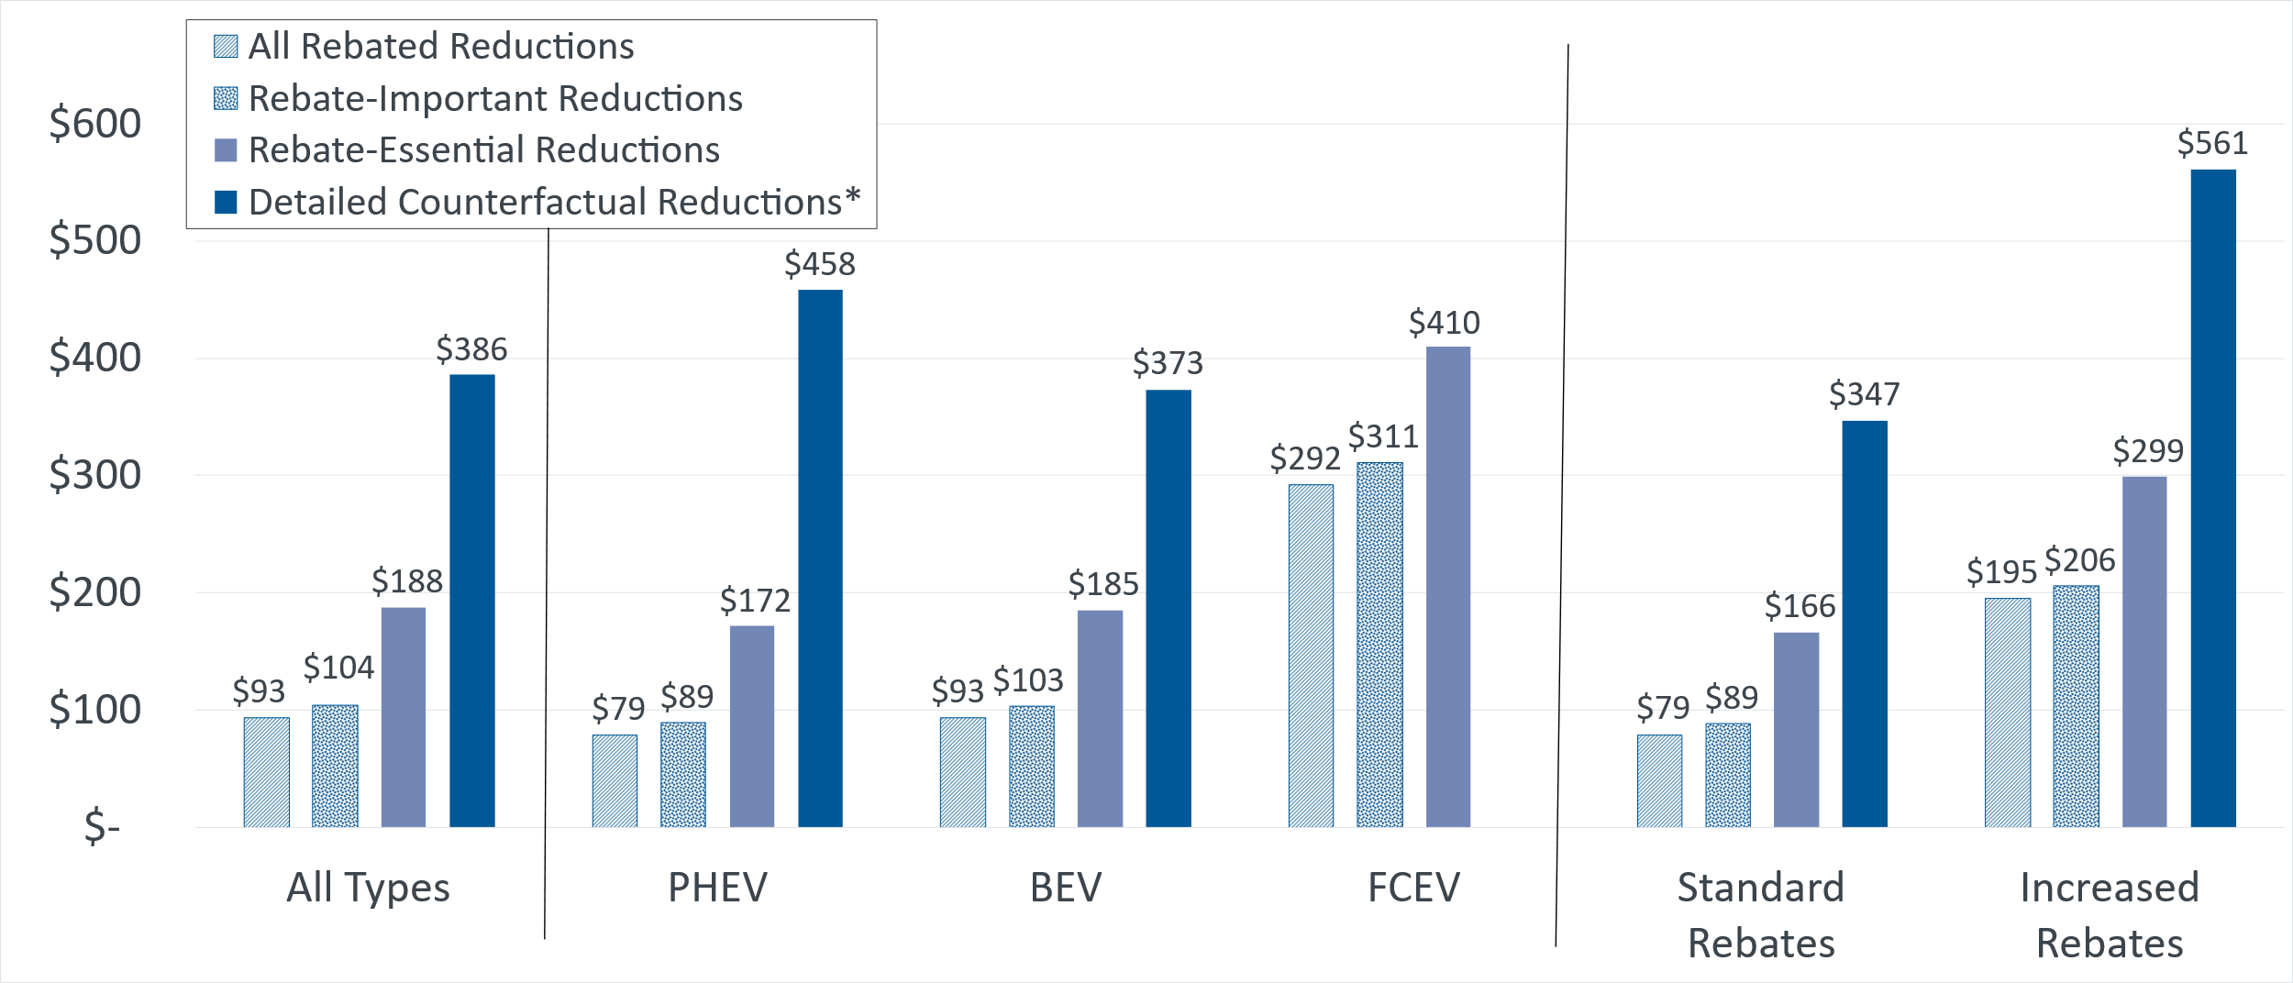
* Detailed Counterfactual Reductions exclude FCEVs (2% of rebates).
Importantly, the results of this study are limited by the scope of analysis and are sensitive to several of the generally conservative inputs and assumptions used. The cost-effectiveness metrics in this report exclude important, but difficult to quantify, long-term market-transformation benefits (e.g., spillover effects) which would increase the benefits attributed to the program. Also, the results are found to be particularly sensitive to baseline vehicle fuel efficiency inputs and the quantification period (i.e., total number of operational miles or miles/year). Sensitivity analysis suggests cost-effectiveness improves by 34% when using a common 150k-mile quantification period and changes 14–15% when altering baseline vehicle fuel efficiency by +/-10%. Uncertainty in EV use and other inputs presents opportunities for refinement in future work aiming to understand the emission benefits of EVs.
Because CVRP ran for roughly 13 years (2010–2023), it spanned both the burgeoning of the EV market and various program designs as it evolved to meet the needs of the developing EV landscape. Therefore, the emission-reduction and cost-effectiveness results should be interpreted in the context of program design and market dynamics over time. On the program side, for example, Standard Rebate amounts incrementally decreased over time while Increased Rebates were introduced in 2016 to broaden inclusion and increased over time. These changes directly affect cost-effectiveness results. Other relevant program changes included consumer income caps (2016), vehicle performance criteria (2016), and vehicle price caps (2019), all becoming more stringent over time. On the market side, major developments with GHG implications included the increase in BEV range and BEV popularity over time, as well as the rapid proliferation of SUVs beginning in 2020.

1. Introduction
A primary motivation for federal, state, and regional investment in widespread electric vehicle adoption is the need to reduce greenhouse gas (GHG) and other emissions. The California Air Resources Board’s (CARB’s) Clean Vehicle Rebate Project (CVRP) provided cash rebates for the purchase or lease of eligible light-duty electric vehicles (EVs) in California. From its inception in March 2010 through its closure in late 2023, rebate investments exceeded $1.4 billion to incentivize nearly 600,000 electric vehicles. Here we present a detailed examination of the quantity and cost-effectiveness of GHG reductions from those rebated vehicles.
As described in previous related work (Pallonetti & Williams, 2021), many studies have evaluated the emissions impacts of electric vehicles. Literature reviews of such studies (Lattanzio & Clark, 2020; Marmiroli et al., 2018) have found widely varying results. Lattanzio and Clark (2020) highlight that studies have generated a wide range of results due to differing goals, scopes, models, scales, timespans, and datasets. They also explain that differing results can all be accurate based on each study’s defined parameters. This underscores the need for context-specific analyses to understand EV impacts for a given vehicle population. Prior estimates of GHG emission reductions associated with CVRP specifically have included annual projections in CARB’s Funding Plans for Clean Transportation Incentives (e.g., [CARB, 2017b]). These are based on average light-duty vehicle characterizations and described as intentionally conservative as a starting point for future refinement. The California State Auditor (2021) emphasized the need for further refinement and the importance of basing funding and program design decisions on program benefits and costs. This underscores the importance of cost-effectiveness metrics that incorporate the influence of the rebate.
This work builds on (CARB, 2017b) and other previous work by CSE for CVRP that includes an interim life-of-program accounting through August 2018 (Pallonetti & Williams, 2021) and annual assessments of GHG impacts of 2019–2022 purchases and leases (Pallonetti et al., 2023, 2024; Pallonetti & Williams, 2022a, 2022b; B. Williams & Pallonetti, 2022). Compared to previous reporting, this full life-of-program accounting analyzes the program from its inception through its closure and uses a refined methodology. For example, the CVRP survey data on detailed counterfactual behaviors, as introduced in the 2022 purchases/leases report, is updated and employed over the life of the program. Additionally, this analysis is made increasingly time-variant by modeling each year of driving with temporal information as available, whereas previous reporting modeled first-year emissions and scaled those up to estimate the lifetime period.
The remainder of the report is organized as follows. Section 2 characterizes the data used. Section 3 describes the approach taken to estimate GHG emission reductions. Section 4 describes and discusses the resulting estimates and provides caveats. Section 5 presents summarizing thoughts. Appendices provide further detail on inputs (both derived from the literature and calculated for this analysis) and their changes over time, describe a sensitivity analysis, and explore fleet impacts.

2. Data Summary
The three main data sources are: rebate applications, participant surveys, and vehicle registration.

Rebate Application Data
The studied dataset was sourced from approved CVRP rebate applications as of April 2025, spanning the program’s inception in March 2010 through its closure in late 2023. Public and private fleet vehicles totaled 2% of all records and are analyzed separately from personal (nonfleet) participants (see Appendix D). Zero-emission motorcycles, neighborhood EVs, and commercial EVs totaled 0.2% of rebates and were excluded from this study. The final nonfleet dataset analyzed includes 570,668 rebates totaling $1.45B. Note that not all EVs purchased in California receive rebates, nor are all EVs or EV consumers eligible (CVRP, 2024). Compared to light-duty EV registration totals in the state from 2012 to 2023 (Auto Innovators, 2025), approximately 33% overall (ranging from 11% and 79% annually) received rebates.
As detailed in Table 1, the data analyzed include plug-in hybrid electric vehicles (PHEVs), all-battery electric vehicles (BEVs), and fuel-cell electric vehicles (FCEVs).
Table 1
Rebates by Vehicle Technology Type
Personal Consumers
Technology Type | Rebate Amount | Rebate Counts | Total Rebate Dollars
PHEV | Standard/Increased:  $1,000–$1,500/$3,000–$6,500 | 148,472  (26%) | $242,048,295  (17%)
BEV | Standard/Increased:  $2,000–$5,000/$4,000–$7,500 | 408,286  (72%) | $1,133,373,299  (78%)
FCEV | Standard/Increased:  $2,500–$5,000/$6,500–$7,500 | 13,910  (2%) | $71,234,818  (5%)
All | Standard/Increased:  $1,000–$5,000/$3,000–$7,500 | 570,668  (100%) | $1,446,656,412  (100%)
As detailed in Table 1 and Table 2, personal consumers received one of two rebate types: Standard Rebates and Increased Rebates for low-/moderate-income consumers (CSE, 2021). Increased Rebates were introduced to the program in March 2016 to broaden inclusion.
Table 2
Rebates by Vehicle Rebate Type
Personal Consumers
Rebate Type | Rebate Amount | Rebate Counts  (2010–2023) | Total Rebate Dollars  (2010–2023)
Standard  (2010–2023) | $1,000–$5,000 | 501,791  (88%) | $1,072,590,613  (74%)
Increased  (Starting Mar. 2016) | $3,000–$7,500 | 68,877  (Life of program: 12%  Since inception: 16%) | $374,065,799  (Life of program: 26%  Since inception: 33%)
All | $1,000–$7,500 | 570,668  (100%) | $1,446,656,412  (100%)

Participant Survey Data
Since 2012, CVRP invited personal participants approved for a rebate to fill out a voluntary Consumer Survey. Survey responses are weighted using the raking method (iterative proportional fitting) to make them more representative of the program population along the dimensions of technology type, rebate type, vehicle model, purchase vs. lease, year of purchase/lease, county of residence, and survey edition received. The survey data includes 100,505 responses. More information on the CVRP Consumer Survey is available in (B. Williams et al., 2018) and updated details will be made available in forthcoming survey documentation.

Vehicle Registration Data
CSE calculated sales-weighted average fuel consumption rates using monthly California new-vehicle registration data to characterize vehicles used for emissions comparison to rebated EVs. The dataset spans registration dates from March 2010 through December 2024 and is used to characterize vehicles of model years (MYs) 2010 (used for MY 2010 and a few earlier vehicles) through 2023 (used for MY 2023 and a small number of MY 2024 vehicles).

3. Methods and Inputs
GHG reductions associated with the project are calculated by comparing estimates of fuel-cycle emissions for each rebated electric vehicle to a baseline vehicle. Fuel-cycle estimates account for “well-to-wheels” GHGs, including upstream (e.g., fuel production and distribution) and combustion emissions. As in precursor work, (e.g., [Pallonetti & Williams, 2021; Pallonetti et al., 2024]) reductions are quantified relative to a new gasoline baseline at two levels: 1) savings associated with all rebated project participants (“rebated reductions”) and 2) savings associated with consumers influenced by the rebate to purchase/lease an EV (“rebate-influenced reductions”). Here, we fully incorporate analysis at an additional level: 3) savings attributable to the program relative to more detailed information about counterfactual purchase and use decisions that participants reportedly think they would have made in absence of CVRP, or “detailed counterfactual reductions.”
The methodology for estimating emissions follows. Details on inputs and sources are provided in Appendix A, and sensitivity testing of those inputs is described in Appendix B. Only light-duty vehicles are included in the input data and assumptions throughout.

Methodology for Calculating GHG Emission Reductions
Following the general approach in precursor work, GHG reductions (in metric tons of CO₂e emissions, or “tons”) are calculated by summing for each rebate the difference between estimates of the emissions avoided (from a baseline gasoline or counterfactual comparison vehicle) and the emissions produced (by a rebated vehicle). Calculations for rebated vehicles, baseline vehicles, and the quantification period are described next, followed by details of rebate influence and counterfactual behaviors.
Time-variant and state-specific or other best-available inputs tailored to the program are used to quantify emissions from each baseline and rebated vehicle. These inputs (detailed further in Appendix A) characterize the carbon intensity of fuels, the vehicle consumption rate of fuel, and the vehicle miles traveled.

Rebated Vehicles
Following the approach in (CARB, 2017b), emissions are calculated using statewide average carbon intensity (CI) values for each fuel. To account for cleaning of the California electric fuel pool under the Low Carbon Fuel Standard (LCFS), time-variant inputs are used based on annual carbon intensity data from LCFS reporting (see Appendix A).
Rebated-vehicle fuel consumption rates are converted from the model- and model-year-specific combined city/highway fuel economy label ratings from the EPA (US Department of Energy & US Environmental Protection Agency, 2024). Annual vehicle miles traveled (VMT) estimates are derived from surveys of EV drivers in California (detailed along with other inputs in Appendix A). These estimates vary by the rebated vehicle technology type and, for BEVs, a range subcategory (short or long range) of the model. Annual VMT is assumed to decrease year over year based on the Transportation Energy Data Book (Davis & Boundy, 2022) Table 3.14 schedule. For PHEVs, which use both electric and gasoline fuels, a curve is fit through key data points in the literature to produce model-specific electric VMT percentages (or utility factors) to assign proportions of total travel to electricity (see Appendix A). The emissions produced by each individual rebated vehicle are calculated as:
$$E_{i, rebated}=∑_{f}{(CI}_{f}\left(CY\right)* {FC}_{f}\left(m,MY\right) *{[VMT}_{f}\left(d,t,r\right)*P_{f}(m,MY)])$$
where:
$E$ = Annual GHG emissions
$i$ = each individual vehicle
f = fuel used by rebated vehicle {gasoline, electricity, hydrogen}
${CI}_{f}$ = carbon intensity of fuel f [in units of life-cycle CO₂e emissions per unit of fuel], which is calendar year (CY) specific for electricity
${FC}_{f}$= fuel consumption rate [in units of gal, kWh, or kg of fuel f per mile], which varies by model (m) and model year (MY)
${VMT}_{f}$ = vehicle miles traveled annually on fuel f, which varies by drivetrain category (d), year of operation (t), and for BEVs, range subcategory (r)
$P_{f}$ = percentage of miles traveled on fuel f, which varies by m and MY for PHEVs

Baseline Vehicles
Baseline vehicles are characterized based on the analysis level. Building on the approach in (CARB, 2017b), a new gasoline baseline vehicle is used to analyze both 1) all rebated reductions and 2) rebate-influenced reductions. These baseline gasoline vehicles are represented as the average new gasoline vehicle of the same model year as the paired rebated vehicle. New gasoline vehicle fuel consumption rates are generated by calculating California sales-weighted averages based on the EPA ratings for the 75 top-selling new light-duty gasoline vehicle models for each MY (see Appendix A). For the analysis of detailed counterfactual reductions, the comparison vehicle varies based on participant survey responses regarding what they would have done in the absence of the rebate. Counterfactual vehicle fuel consumption rates are generated similarly but take on additional values based on reported behaviors in absence of the program (e.g., acquired different new/used gasoline, hybrid, or electric vehicles) as detailed in Appendix A. Vehicle miles traveled are determined by the paired EV. The emissions from each individual baseline gasoline vehicle are calculated as:
$$E_{i, baseline}= {CI}_{gasoline}* {FC}_{gasoline}\left(MY, d\right) *{VMT}_{gasoline}\left(d, t,r\right)$$
where:
${CI}_{gasoline}$ = carbon intensity of gasoline [in units of life-cycle CO₂e emissions per gallon]
${FC}_{gasoline}$ = fuel consumption rate [in units of gallons per mile], which varies by model year (MY), and for counterfactual reductions, the baseline vehicle’s drivetrain category (d)
${VMT}_{gasoline}$ = vehicle miles traveled annually, which varies by the paired rebated vehicle’s drivetrain category (d), year of operation (t), and for BEVs, range subcategory (r)

Quantification Period
New to this analysis, GHG emissions are computed as an annual calendar-year time series. To generate emission totals, the per-year rebated and baseline emissions are computed and summed up to the quantification period. Total emission reductions across all vehicles are therefore calculated as:
$$Emission reductions=∑_{i}∑_{t} m_{i,t}×(E_{i,t,baseline}-E_{i,t,rebated})$$
where:
$i$ = each individual baseline and rebated vehicle pair
t = calendar year time index
$m_{i,t}∈\left[0,1\right]$ = multiplier representing the fraction (ranging from 0 to 1) of calendar year $t$ for which vehicle $i$’s emission reductions are quantified, derived from the quantification period mileage (e.g., 1 until the year during which the vehicle reaches 100,000 miles)
First-year GHG reduction estimates correspond to one full year of driving during the vehicle purchase year. The 100,000-mile (100k-mile) results are obtained by summing the calendar-year series until cumulative mileage reaches 100,000 miles (such that the multiplier m is equal to 1 until the last calendar year, which is generally a partial year).
The 100k-mile quantification period provides a useful unit for comparing potential emission reductions across a standardized period (that is less impacted by varying use per year across technologies or over time than alternative periods such as based on years might be). Further, it is more intuitive to think of cost-effectiveness “per mile” than “per year.” And although most EVs are expected to be in operation longer than 100k miles, and PHEVs specifically were required to have 150k-mile battery warranties in California during much of this time period, 100k is both the most common battery warranty in the U.S. (US Office of Energy Efficiency and Renewable Energy, 2020) and the expected warranty requirement for both PHEVs and BEVs for 2026 and subsequent model years (Warranty Requirements for Zero-Emission and Batteries in Plug-in Hybrid Electric 2026 and Subsequent Model Year Passenger Cars and Light-Duty Trucks, 2022).
Both first year and 100k-mile perspectives are useful for different reasons. First-year GHG savings better illustrate the variations across vehicle and consumer types that result from differences in annual mileage estimates. On the other hand, 100k-mile reductions can be viewed as a conservative proxy for potential vehicle benefits over a substantial portion of its lifetime.
GHG emission reductions and cost-effectiveness are quantified at various levels (rebated, rebate-influenced, and detailed counterfactual reductions) to illustrate how results vary across different methodological approaches that have been implemented in prior studies of EV subsidy impacts. These approaches range from those that are commonly implemented, which provide a comparable result to previous related work such as (CARB, 2017b), to those that leverage the most detailed program data characterizing what would have occurred absent the program, which provide the best-available estimate to evaluate benefits attributable to the program. The following sections further describe methods that improve upon the common approach by introducing measures of rebate influence to isolate GHG reductions from EV adoption that the rebate helped enable and further refining estimates using case-specific counterfactual behaviors.

Rebate Influence
The CVRP Consumer Survey includes several questions that provide case-specific indicators of rebate influence. First, the survey includes the question, “How important [was the rebate] in making it possible for you to acquire your clean vehicle?” Following previous related work, those who answered moderately, very, or extremely important are categorized as “Rebate-Important” consumers (B. Williams & Searles, 2017; B. D. H. Williams & Pallonetti, 2023) and GHG reductions from this group are termed, “Rebate-Important reductions.” Further, a more direct and conservative indicator is produced from the question, “Would you have purchased/leased your [rebated EV] if the state vehicle rebate (CVRP) did not exist?” Those who answer “No” are categorized as “Rebate Essential” (Johnson & Williams, 2017; B. Williams & Anderson, 2018; B. D. H. Williams, 2022; B. Williams & Pallonetti, 2023) and GHG reductions from this group are termed, “Rebate-Essential reductions.” Rebate-Essential reductions are calculated separately to estimate emission reductions from those highly influenced by the program. Rebate Importance is described more illustratively to provide additional context for Rebate Essentiality and the complex influence of the rebate more generally. Both metrics will be explored further in another retrospective CVRP report focused on rebate influence.
Consistent with precursor work (e.g., [Pallonetti & Williams, 2021]), Rebate-Essential reductions were calculated as follows (and Rebate-Important reductions were calculated similarly):
- If a participant was known to be Rebate Essential, their emission reductions are included.
- If a participant was known to not be Rebate Essential, their emission reductions are not included.
- If it was unknown whether a participant was Rebate Essential (i.e., participants that didn’t respond to the survey or this survey question), a proportion of their emission reductions are included equal to the weighted percentage of Rebate Essentiality among their cohort. The cohorts are defined as each distinct combination of technology category and rebate type (see Table 3). Tesla is treated as a separate technology category from other BEVs since they compose a large portion of the program and their consumers tend to have unique characteristics (Santulli & Williams, 2015; Anderson & Williams, 2019; B. D. H. Williams & Anderson, 2019).
Other important effects that are not analyzed but would increase benefits attributed to the program are discussed in the Limitations section.
Table 3
Rebate Influence by Vehicle and Rebate Types
Range of results across purchase/lease years*
Technology Category | Standard Rebate  Rebate Essentiality | Increased Rebate  Rebate Essentiality | Standard Rebate  Rebate Importance | Increased Rebate  Rebate Importance
PHEV | 16–49% | 52–70% | 73–91% | 91–95%
BEV (non-Tesla) | 37–71% | 54–83% | 85–96% | 92–98%
Tesla BEV | 20–52% | 46–78% | 73–94% | 93–97%
FCEV** | 57–75% | 73–85% | 83–95% | 93–99%
* Vehicles purchased before 2012 are assigned 2012 influence percentages (first year of survey data). Eighteen vehicles were purchased in 2024 and assigned 2023 influence percentages.
** FCEVs are grouped by program eras (see Table 9) rather than purchase/lease year to ensure all results are based on a sample of at least 30 responses (era 2 and 3 combined for Increased Rebates to reach sample quota).

Counterfactual Behaviors
As discussed in previous reports (Muehlegger & Rapson, 2023; Pallonetti & Williams, 2021, 2023; Xing et al., 2021), while new gasoline vehicles are a common baseline against which EV emissions are compared, a more appropriate comparison point for evaluating EV impacts is based on what would have alternatively been on the road. The impact of CVRP should therefore be evaluated relative to what participants would alternatively have driven absent the program. This is the “counterfactual behavior” of program participants. Using this more specific comparison point is particularly important because prior work (Pallonetti & Williams, 2021; Gohlke & Zhou, 2021) has demonstrated that EV emission reduction estimates are highly sensitive to the fuel efficiency of the vehicle to which EVs are compared. For detailed counterfactual reductions, data from the CVRP Consumer Survey are used to incorporate self-reported counterfactual behaviors into the quantification of GHG reductions for BEVs and PHEVs.
The survey question about counterfactual behavior was altered over time, so this analysis necessarily has three variations. For each variation, results are extrapolated from the survey sample to the full program population using an approach similar to that described previously for extrapolating Rebate Essentiality. For participants that didn’t respond to the survey or provide valid responses to the required survey questions, average values for the participant’s cohort are calculated from survey responses. The cohorts are composed of each distinct combination of purchase/lease year, technology category (excluding FCEV, with BEVs split by Tesla and non-Tesla) and rebate type. See Appendix A for further detail.
Survey Editions 2020–2023 & 2023–Close: A sequence of survey questions is utilized to determine the counterfactual vehicle likely to be on the road in CVRP’s absence (Figure 1). First is the “Rebate Essentiality” question previously described. As with Rebate-Essential reductions, those who indicated they would have purchased/leased their EV even if CVRP did not exist are assigned no emission reductions attributable to the project. For those who indicated they were Rebate Essential (i.e., they would not have purchased/leased their EV without CVRP), a follow-up question asks, “If [CVRP] were not available, what do you think you would have done?” Response options span variants of purchasing other EVs, other non-EVs, and no vehicle at all. Figure 1 displays this series of questions and the specific response options, and Appendix A describes the emissions comparison assumption used for each. Finally, for respondents who indicated that without CVRP they would not have purchased a vehicle at all, a third survey question is referenced that specifies the model year and technology type of their previous primary vehicle (that they would be driving had they not acquired their rebated EV).
Survey Editions 2015–2016, 2016–2017, 2017–2020: The counterfactual survey question is provided to all respondents and are used directly, regardless of responses to the Rebate Essentiality question, to utilize the more detailed information available during this period. Other details are as described above for Survey Editions 2020–2023 & 2023–Close, though response options differ slightly. These survey editions also differ in that previous vehicle details are only collected from those who replaced a previous car with their rebated EV. Replaced vehicles were assumed to be the previous primary vehicle and are used as comparison vehicles for respondents who indicated that without CVRP they would not have purchased a vehicle at all (cohort averages are used when replaced vehicle information is unavailable). Appendix A details the specific response options and the emissions comparison assumption used for each.
Survey Edition 2013–2015: The first survey edition did not include the counterfactual behavior question at all. Participants during this period are treated like non-respondents are in other periods and receive response proportions based on the 2015 cohorts (distinct combinations of technology category and rebate type).
Figure 1
Counterfactual Survey Question Flowchart
Survey Editions 2020–2023 & 2023–Close
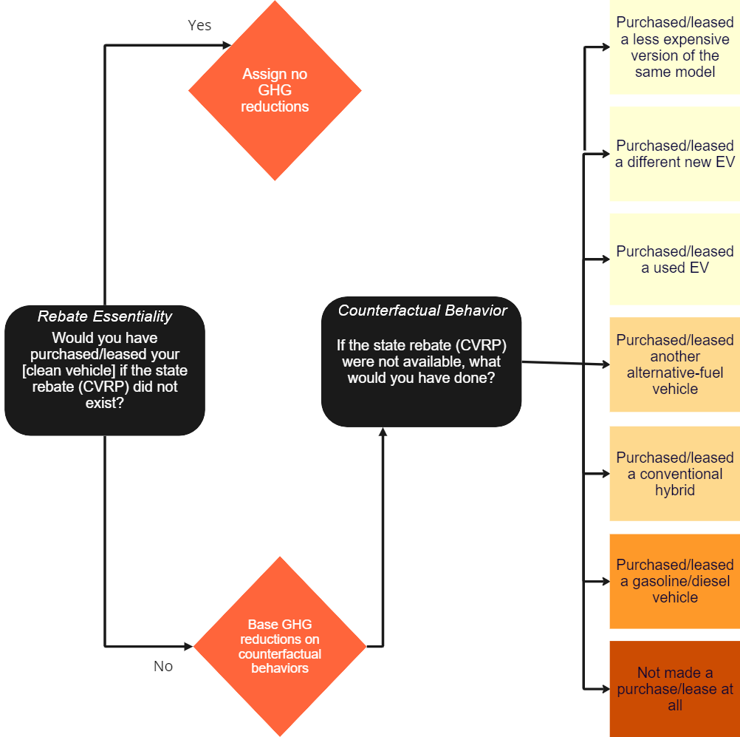

4. Results and Discussion
GHG emission reductions and cost effectiveness are assessed at various levels next. First are GHG reductions associated with all rebated EVs, relative to a commonly assumed baseline—new gasoline vehicles. Then, these reductions are adjusted using two different participant-reported measures of rebate influence to isolate impacts that the rebate helped enable. Lastly, to account for reductions most directly attributable to CVRP, results are estimated relative to detailed data characterizing what would have alternatively occurred in absence of the program.

GHG Emission Reductions and Cost-Effectiveness: All Rebated Vehicles
CVRP rebated 570,668 personal-use PHEVs, BEVs, and FCEVs from its inception in March 2010 through its closure in late 2023. Rebated reductions—total GHG emission reductions of those EVs relative to new gasoline vehicles—over the first year of ownership are estimated to be approximately 1.9M metric tons of CO₂e emissions. According to the EPA, this is equivalent to the GHGs avoided by 566 wind turbines running for a year (US Environmental Protection Agency, 2025). Further, this estimate indicates that the emissions produced from these EVs are only 32% of what new gasoline vehicles would have produced, or 68% fewer. The total rebated reductions estimate increases to approximately 15.5M tons when quantified over 100k miles of driving using year-specific carbon intensity of electricity and vehicle miles traveled. Rebated EVs are estimated to emit a total of only 6.5M tons over 100k miles, compared to a total of 22.0M tons from new gasoline vehicles (Figure 2). Dividing the $1.45B in CVRP rebates (averaging roughly $2,500 per vehicle) by the 15.5M tons of GHG reductions indicates that each ton of reductions is associated with $93 in CVRP rebates. (Association versus attribution is discussed in subsequent sections on rebate influence.)
Figure 2
Cumulative GHG Emissions Over Time
All Rebated EVs & New Gasoline Vehicle Baseline, 100k miles
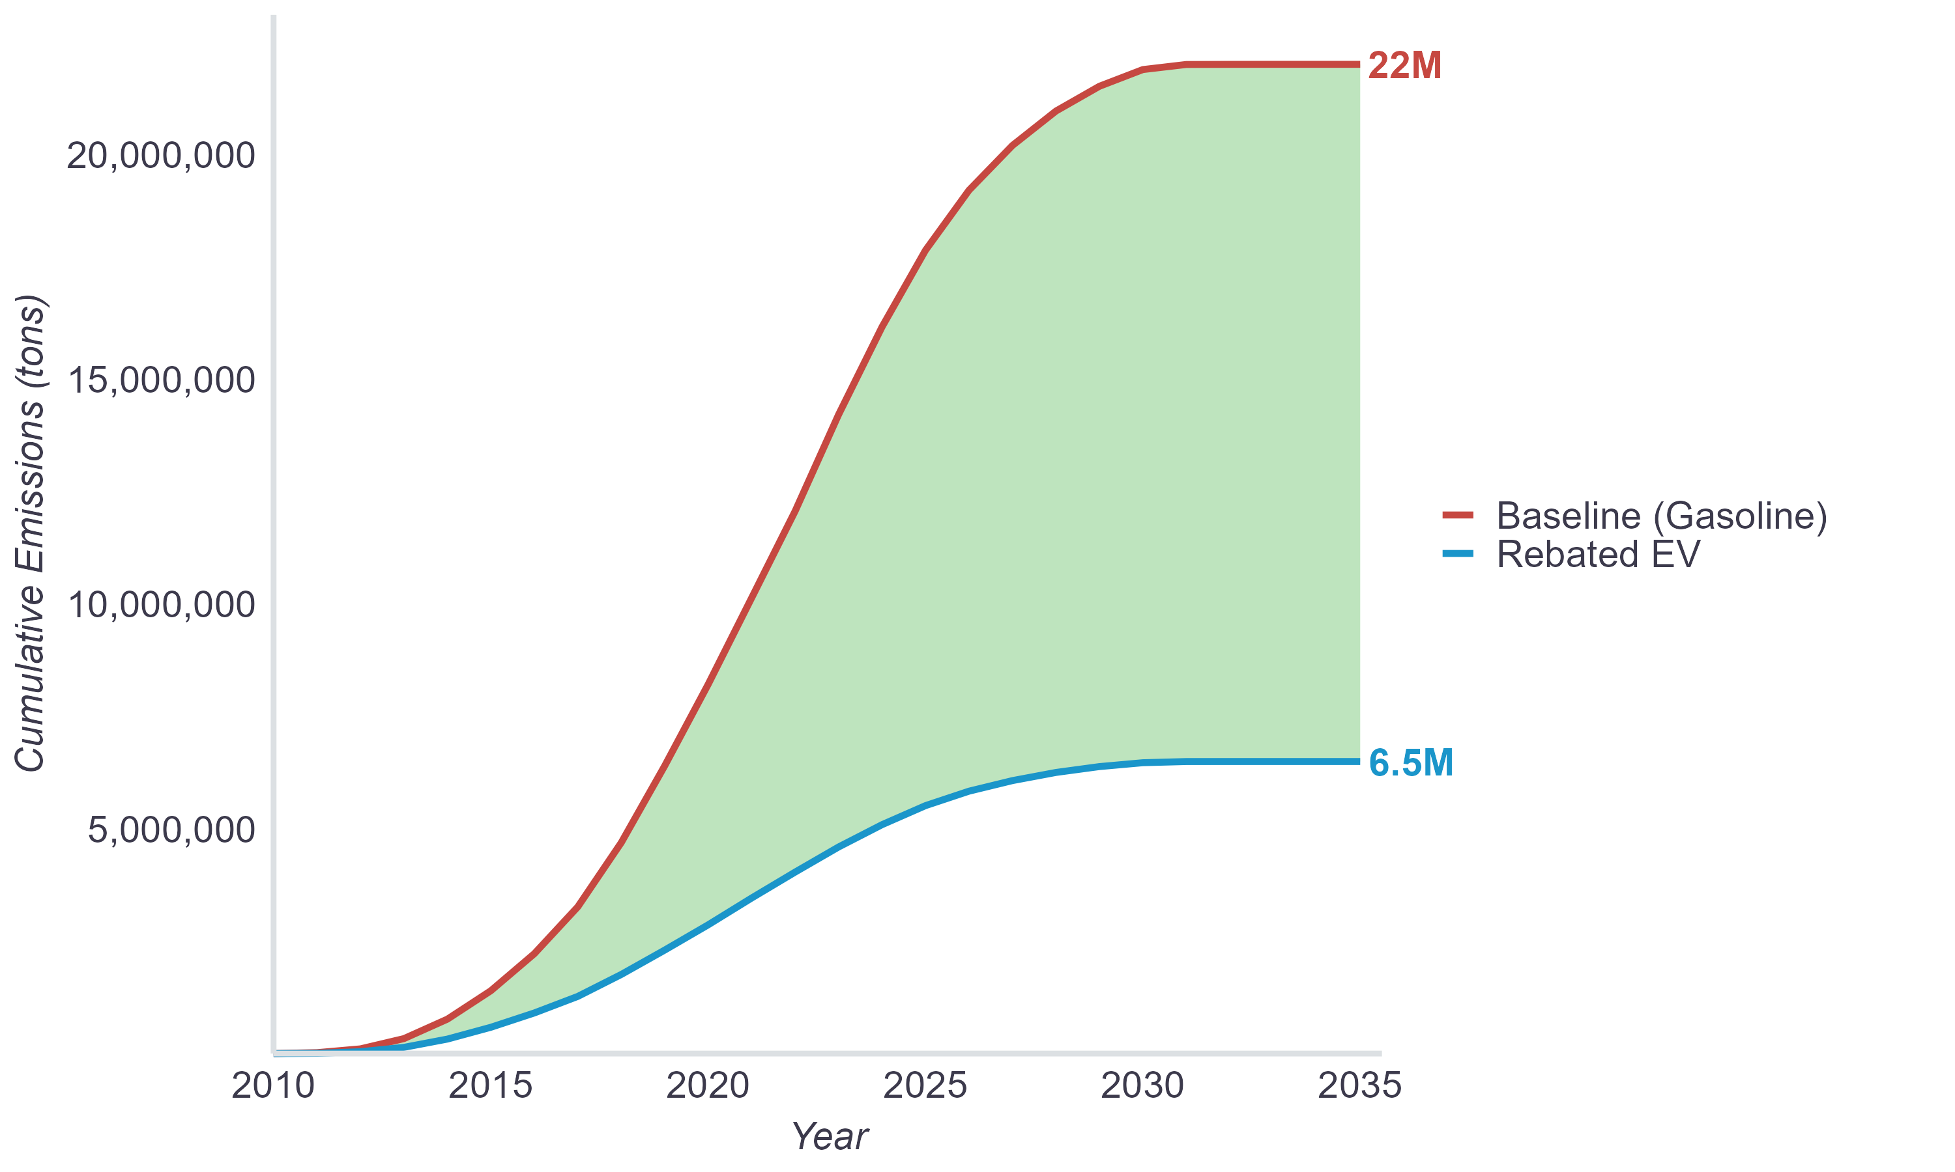
When comparing all rebated EVs to new gasoline vehicles, estimated first-year reductions average 3.3 tons per vehicle and 100k-mile reductions average 27 tons per vehicle (Table 4). By technology type, first-year reductions range from 2.2 tons per FCEV to 3.6 tons per BEV and 100k-mile reductions range from 18 tons per FCEV to 30 tons per BEV. Rebate dollars per ton of 100k-mile reductions range from $79 for PHEVs to $292 for FCEVs. PHEVs were found to be the most cost-effective vehicle type when compared to new gasoline vehicles, narrowly below the BEV average of $93. This is largely due to their lower rebate amounts compared to BEVs and FCEVs (see Table 1). If rebate levels were equivalent across vehicle categories, BEVs would be most cost-effective based on their advantage in per-vehicle savings. Reductions from FCEVs were found to be the least cost-effective due to a combination of their higher rebate amounts and lower per-vehicle savings compared to other vehicle types.
When compared to new gasoline vehicles, per-vehicle savings were similar between the two rebate types, with vehicles receiving Increased Rebates reducing slightly more GHGs on average (Table 4). Because Increased Rebate amounts are higher than Standard Rebate amounts (+$1,500–$5,500), they were found to be less cost-effective. As discussed in precursor work (Pallonetti et al., 2024), this result should be interpreted in the context of the primary purpose of the Increased Rebate, to enable an additional swath of lower income consumers to access an EV who may not otherwise participate in the program. Indeed, 33% of rebate funding from its March 2016 inception onwards went to the 16% of participants who received an Increased Rebate. Further, the gap in cost-effectiveness narrows when considering rebate influence and detailed counterfactual behaviors, discussed next.
Table 4
GHG Reduction and Cost-Effectiveness Estimates by Technology & Rebate Type
All Rebated Reductions (New Gasoline Vehicle Baseline)
Technology or Rebate Type | Total  Vehicles | Average First-Year Reductions Per Vehicle (tons) | Average 100k-mile Reductions Per Vehicle (tons) | Rebate Dollars Per  Ton of GHG Reductions  (100k miles)
PHEV | N = 148,472 | 2.7 | 21 | $79
BEV | N = 408,286 | 3.6 | 30 | $93
FCEV | N = 13,910 | 2.2 | 21 | $292
Standard Rebate | N = 501,791 | 3.3 | 27 | $79
Increased Rebate | N = 68,877 | 3.5 | 28 | $195
All | N = 570,877 | 3.3 | 27 | $93

Over time, average per-vehicle GHG reductions relative to new gasoline vehicles was highest in 2010 and 2011, when BEVs composed nearly 100% of the program. After dropping in 2012 when PHEV participation widely emerged (Figure C1), program average per-vehicle reductions gradually increased from 2012 through 2023 (Figure 3). The upward trend is primarily driven by the program composition shifting towards BEVs (which consistently had the highest average reductions) over time. Average reductions for each technology type increased from 2014–2018 as EV fuel efficiency improved and carbon intensity of California electricity decreased (see Appendix A). For PHEVs, another factor was improved range capability (Figure C2) which allowed for an increasing percentage of miles driven on electricity rather than gasoline (Figure A4 and Figure A5). Average reductions decreased after 2018 for BEVs and FCEVs and after 2020 for PHEVs as improvements in electric CI stalled (until 2023), improvements in baseline gasoline fuel efficiency accelerated, and less-efficient EV models proliferated (see Appendix A). However, program average reductions continued to increase during this time due to the increasing BEV rebate share.
Figure 3
Average GHG Reductions Per Vehicle by Purchase Year
All Rebated Reductions (New Gasoline Vehicle Baseline), 100k miles
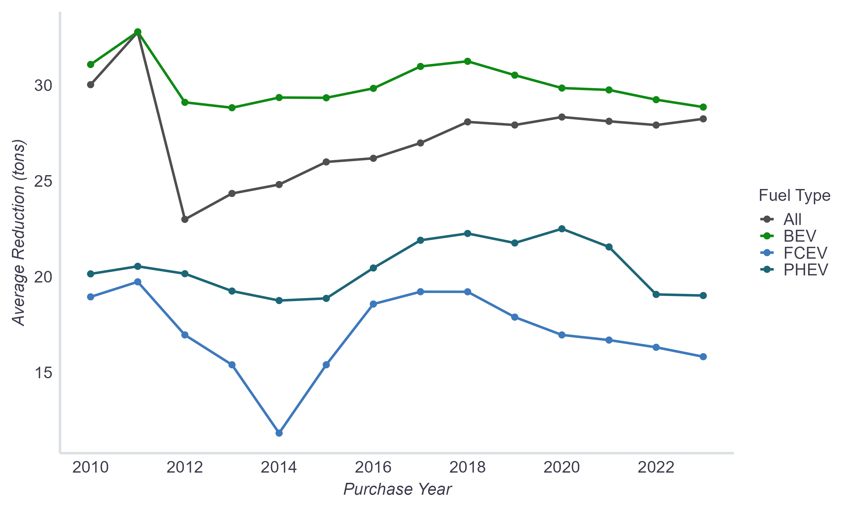
Note: Large fluctuations in FCEV reductions early on were a function of fuel efficiency changes (see Figure A2) as models were discontinued/released and the small size of the market (e.g., only two different models and 48 rebates in 2014).

Costs per ton of reductions over time were relatively stable between 2012 and 2022, ranging from $78–$96/ton (Figure 4). This stability, despite overall reductions per vehicle increasing over time, is reflective of average rebate costs also gradually increasing (see Program & Market Context). Costs per ton were above $100 only in the first two and last years of the program—both periods of elevated rebate amounts. From program launch through June 2011, rebate amounts were higher across the board (Table 8). In 2023, Increased Rebate amounts were hiked significantly and their availability was expanded (Table 9). These program changes resulted in the average rebate amount increasing more than $1,000 from 2022 to 2023, which drove the 2023 spike in the costs of reductions displayed in Figure 4 below.
Figure 4
Cost-Effectiveness by Purchase Year*
All Rebated Reductions (New Gasoline Vehicle Baseline), 100k miles
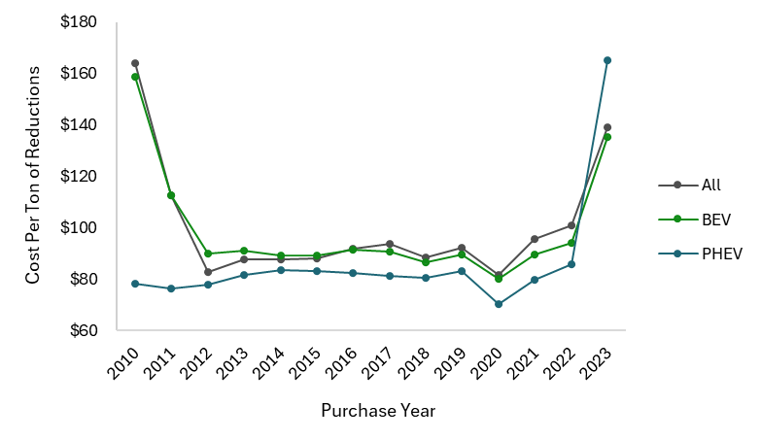
* FCEVs omitted to show the detail of other groups. FCEV costs/ton ranges from $127 in 2011 to $419 in 2014. “All” results do include FCEVs.

GHG Emission Reductions and Cost-Effectiveness: Rebate-Influenced Vehicles
Using the case-specific metrics of rebate influence defined in the Methodology section, 90% of the total GHG reductions over 100k miles of driving (13.9M tons) are associated with “Rebate-Important” participants and 50% (7.7M tons) are associated with “Rebate-Essential” participants (Figure 5). Across vehicle technology type and rebate type, Rebate Important reductions were relatively similar, while Rebate Essential reductions varied. Rebate Important reductions ranged from 88% of all PHEV reductions to 94% of all FCEV reductions and from 89% of Standard Rebate reductions to 95% of Increased Rebate reductions. Across technologies, Rebate Essential reductions composed 46% of PHEV, 50% of BEV, and 71% of FCEV reductions. By rebate type, approximately 48% of Standard Rebate reductions and 65% of Increased Rebate reductions were Rebate Essential. Changes in rebate influence over time are discussed in (B. D. H. Williams & Pallonetti, 2023) and will be explored further in another retrospective report focused on CVRP rebate influence.
Figure 5
Cumulative GHG Reductions by Rebate Influence Over Time (100k miles)
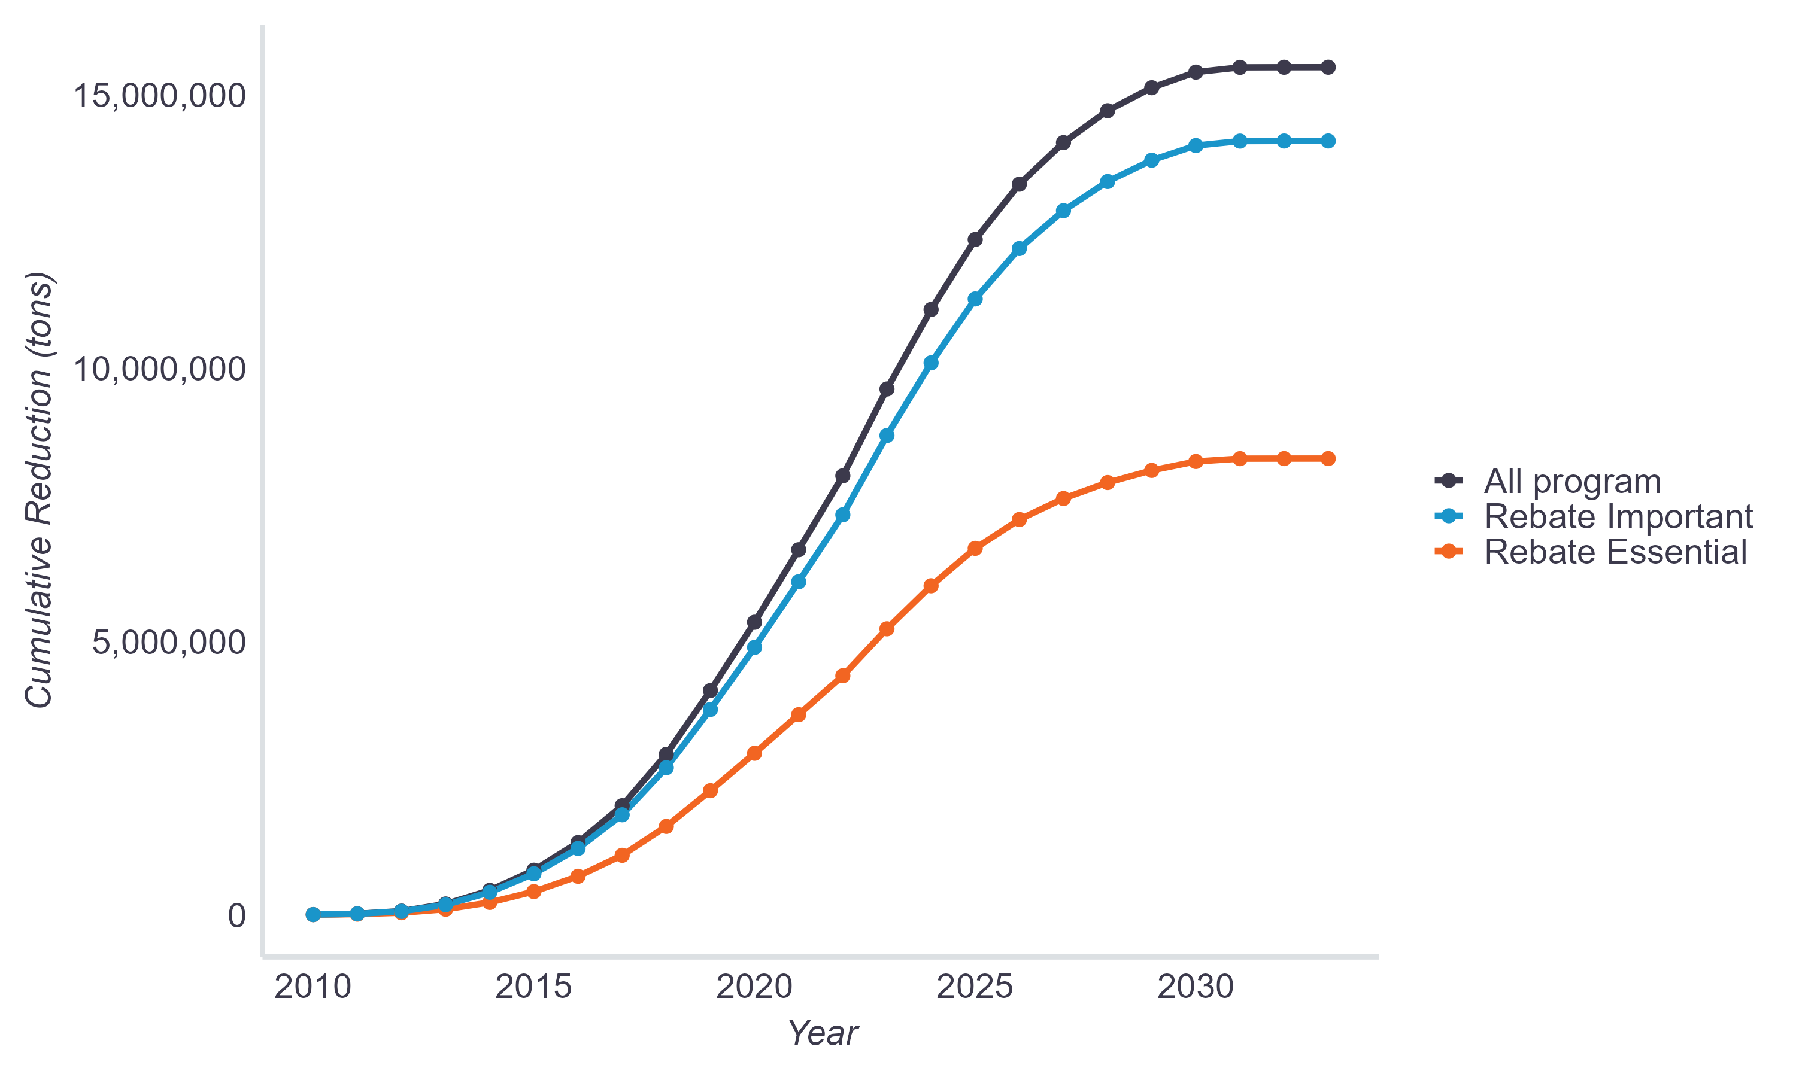
When assessing cost-effectiveness based only on Rebate-Essential emission reductions, the average cost per ton saved increases from $93 (Table 5) to $188. The values by technology type average $172 for PHEVs, $185 for BEVs, and $410 for FCEVs. Rebate-Essential emission reductions for BEVs were similarly cost-effective to PHEVs, despite having higher rebate amounts, due both to their higher levels of Rebate Essentiality (Table 3) and higher GHG reductions (Table 4). FCEVs remain the least cost-effective due to a combination of their higher rebate amounts and lower per-vehicle savings compared to other vehicle types, despite having high levels of Rebate Essentiality.
By rebate type, cost-effectiveness of Rebate-Essential emission reductions averaged $166 for Standard Rebates and $299 for Increased Rebates (Figure 6). By technology and rebate type, cost-effectiveness ranges from $159 for PHEV Standard Rebates to $546 for FCEV Increased Rebates. Since the groups with higher rebate amounts like FCEVs and Increased Rebates were associated with higher Rebate Essentiality, the cost-effectiveness gap between these groups and the lower-rebate groups (i.e., non-FCEVs and Standard Rebates) narrows when assessing Rebate-Essential reductions. These findings by technology and rebate type are displayed in Figure 6 (separately) and Table 5 (combined) along with the cost-effectiveness of Rebate-Important reductions for additional context.
Figure 6
Cost-Effectiveness by Rebate Influence
New Gasoline Vehicle Baseline, 100k miles
Rebate dollars per ton of GHG emissions reduced
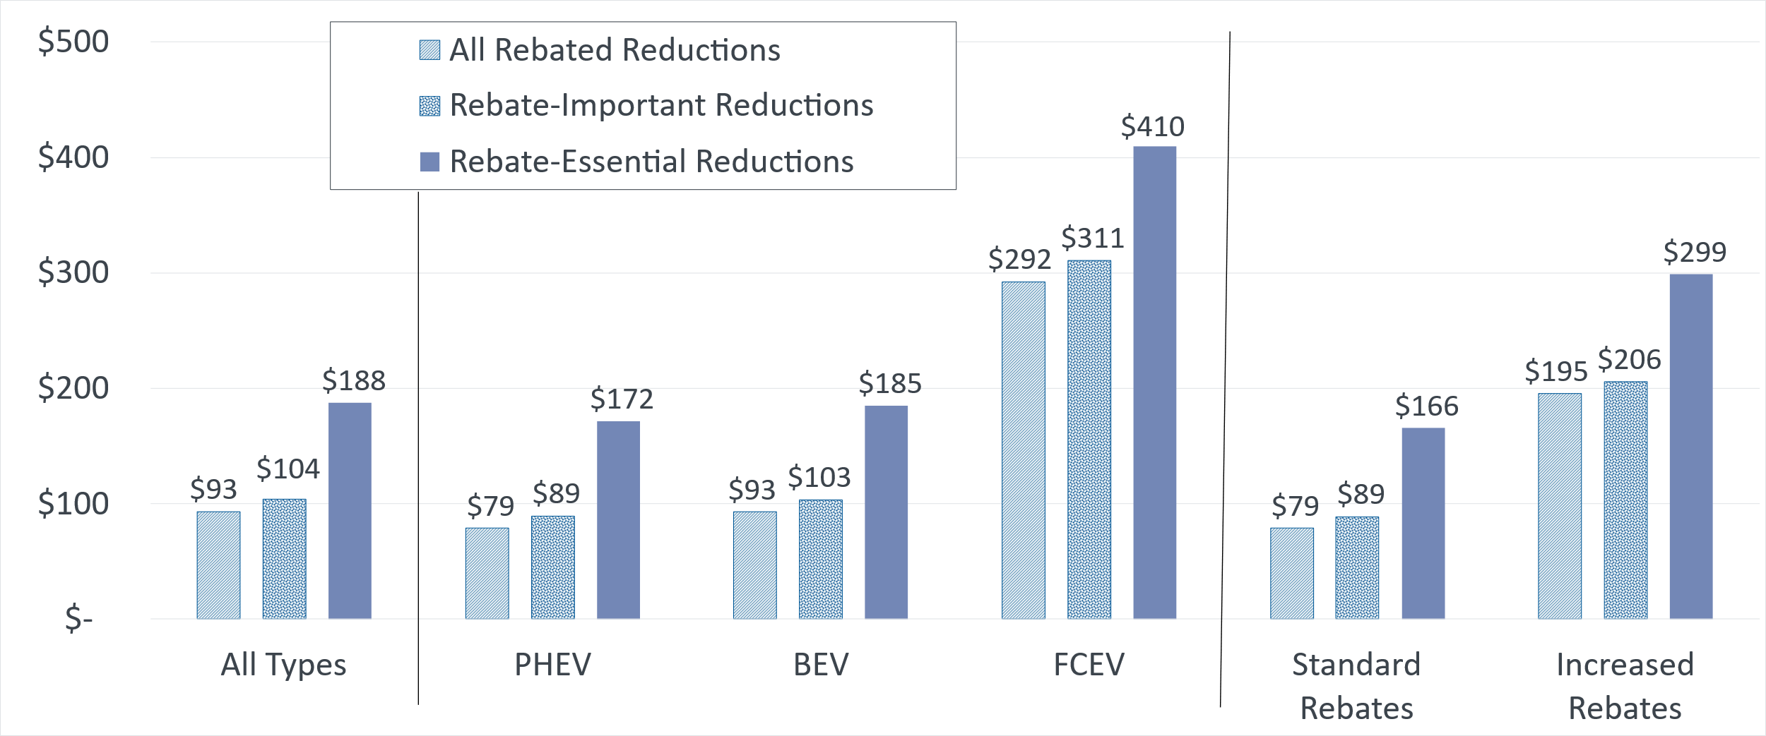

Table 5
GHG Reduction Cost-Effectiveness Estimates by Technology and Rebate Type
All and Rebate-Influenced Reductions (New Gasoline Vehicle Baseline)
Technology and Rebate Type | Total  Vehicles | Rebate Dollars Per Ton of All GHG Reductions  (100k miles) | Rebate Dollars Per Ton  of Rebate-Important GHG Reductions (100k miles) | Rebate Dollars Per Ton of Rebate-Essential GHG Reductions (100k miles)
PHEV, Standard | N = 136,142 | $70 | $80 | $159
PHEV, Increased | N = 12,330 | $167 | $179 | $267
BEV, Standard | N = 353,886 | $77 | $87 | $162
BEV, Increased | N = 54,400 | $195 | $205 | $297
FCEV, Standard | N = 11,763 | $270 | $288 | $384
FCEV, Increased | N = 2,147 | $421 | $439 | $546
All | N = 570,668 | $93 | $104 | $188

Interpreting Rebate Influence
As discussed in precursor work, Rebate-Essential reductions can be interpreted as reductions from participants that were highly influenced by the program. This metric roughly accounts for attribution based on case- and context-specific responses to a straightforward dichotomous survey question asking consumers whether they would have purchased/leased their EV without the state rebate specifically. Rebate Essentiality data have displayed reasonable patterns and proven useful in a variety of other works (Johnson & Williams, 2017; B. D. H. Williams, 2022; B. Williams & Pallonetti, 2023). This metric provides a clearer and potentially more conservative measurement of program impact than other candidate measures, barring any response or selection bias. Indeed, in past recommendations for refining the GHG emission reductions estimates in CARB funding plans, the California State Auditor (2021) Report presents a key finding that GHG emissions reductions may be overstated due to unaccounted factors. Those factors include determining whether the incentives are influencing consumers to acquire a cleaner vehicle than they otherwise would have, as well as accounting for potential overlap with other regulatory and incentive programs with the same goals. Measuring Rebate-Essential reductions can help account for these factors, as they provide an estimate of GHG reductions only from EV sales that participants report would not have happened without the state rebate, regardless of other factors.
While Rebate-Essential program participants are not free riders, it is not necessarily the case that all other participants are free riders. Evidence for this can be found in the other metric of rebate influence, “Rebate Importance” (see Methods section for details). In all, approximately 90% of survey respondents were Rebate-Important consumers and their ability to acquire an EV was influenced by the rebate in some less straightforward way. Even the majority of non-Rebate-Essential respondents reportedly found the rebate at least moderately important in making it possible for them to acquire their EV. It is not accurate for programs to claim direct credit for all Rebate-Important emissions reductions (e.g., other incentives like the federal tax credit for EVs and/or regulatory factors could have played a part). However, the rebate reportedly played an important role for these consumers, likely disqualifying them from being true free riders.
The survey question asking about more specific counterfactual vehicle acquisition behaviors had CVRP not been available (analyzed next) adds further nuance to the understanding of program impacts and provides a refined, but more complex, accounting of attribution. Importantly for interpreting rebate influence, it indicates that a non-negligible proportion of Rebate-Essential respondents also state that they think they would have purchased some other EV (e.g., a different new or used EV) in absence of CVRP. Even though the Rebate Essentiality survey question is simple and dichotomous, as formulated for CVRP, it asked about their specific rebated EV (i.e., asking would you have purchased “your PEV” or “your [vehicle model acquired]”), as opposed to whether they would have purchased an EV at all.

GHG Emission Reductions and Cost-Effectiveness: Detailed Counterfactual Reductions
Counterfactual reductions quantified using a detailed list of outcomes that would have occurred in absence of CVRP represent reductions that are most directly attributable to the program. Over the first year of ownership, these detailed counterfactual reductions from rebated PHEVs and BEVs are estimated to be approximately 489,000 metric tons of CO₂e emissions. These reductions accumulate to approximately 3.6M tons over 100k miles of driving. According to the EPA, this is equivalent to the GHGs avoided by 1,065 wind turbines running for a year (US Environmental Protection Agency, 2025). Counterfactual vehicles are estimated to have emitted 9.8M tons of CO₂e emissions over 100k miles—a substantial amount more than the 6.2M tons estimated to be emitted from rebated PHEVs and BEVs (Figure 7), but much less than the 22M from the new gasoline vehicle baseline, resulting in fewer savings (Figure 8). Compared with total rebate expenditures, this total indicates each ton of GHG reductions attributable to CVRP is associated with approximately $386 in CVRP rebates.
Figure 7
Cumulative GHG Emissions Over Time
Rebated BEVs and PHEVs & Counterfactual Vehicle Baseline, 100k miles
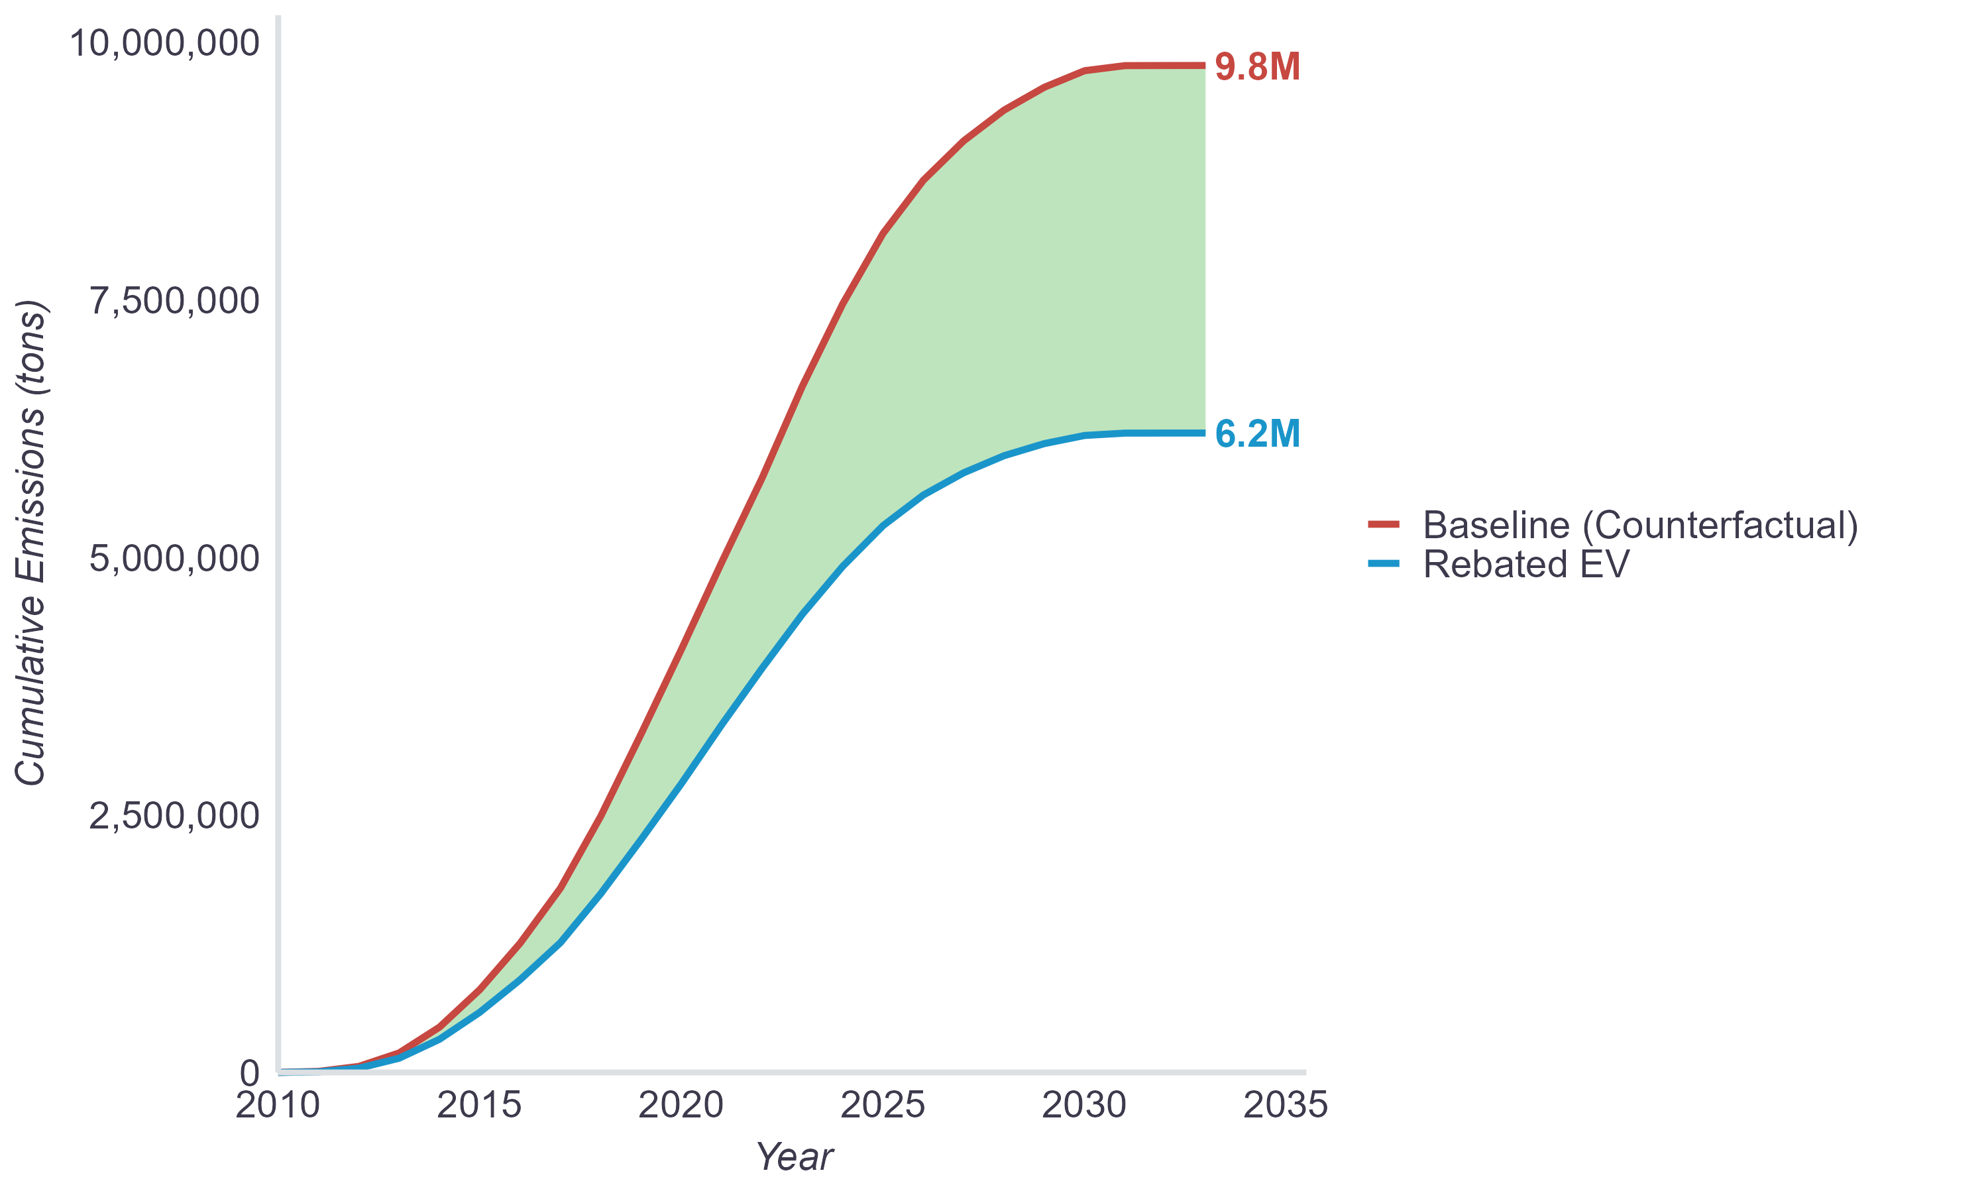
Figure 8
Cumulative GHG Reductions by Quantification Level Over Time (100k miles)
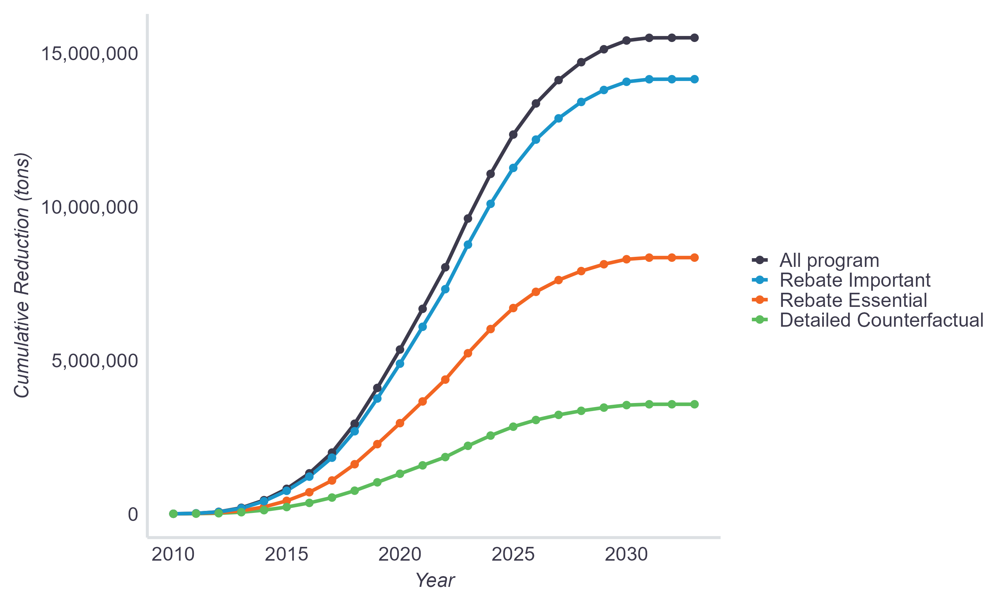
Note: Detailed counterfactual reductions exclude FCEV rebates, which composed 2% of “All program” reductions.

In total, estimated first-year counterfactual reductions average 0.9 tons per vehicle, ranging from 0.5 tons for Standard Rebate PHEVs to 1.5 tons for Increased Rebate BEVs (Table 6). Estimated 100k-mile counterfactual reductions average 6.4 tons per vehicle. By technology type, 100k-mile reductions average 3.6 tons per PHEV at $458 per ton and 7.4 tons per BEV at $373 per ton. By rebate type, 100k-mile reductions average 6.0 tons at $347 per ton for Standard Rebates and 9.6 tons at $561 per ton for Increased Rebates. By cohort, average reductions range from 3.4 tons for Standard Rebate PHEVs to 10.5 tons for Increased Rebate BEVs. Costs per ton of reductions range from $332 for Standard Rebate BEVs to $667 for Increased Rebate PHEVs. Taking detailed counterfactual behavior data into account thus decreases reductions, which increases costs of reductions significantly beyond simply accounting for rebate influence (Table 5). This is largely due to the portion of participants with EV counterfactuals (~65%, plus those who would have kept driving a previously-owned EV) exceeding the 51% of participants that were not Rebate Essential.
Refining emission estimates with detailed counterfactual behaviors produces unique insights. Not only do costs of reductions increase under the counterfactual analysis relative to the other quantification levels, important variations in results across groups are revealed due to differences in counterfactual behaviors between them. Broadly, BEV results improve relative to PHEVs and Increased Rebate results improve relative to Standard Rebates. Contrasting with estimates comparing rebated emissions to new gasoline vehicles, detailed counterfactual reductions are more cost effective for BEVs than PHEVs, despite BEVs having higher rebate amounts. This results from BEV reductions increasing relative to PHEVs, primarily from their counterfactual vehicles less-frequently being other EVs, more frequently being their previous vehicles, and, since 2021, more frequently being gasoline vehicles (Figure 12). Detailed counterfactual reductions are also much higher for Increased Rebate recipients than Standard Rebate recipients (whereas they are similar when compared to new gasoline vehicles). This too results primarily from their counterfactual vehicles less frequently being other EVs. As with the other quantification levels, Increased Rebates remain less cost-effective due to their much higher rebate amounts, but the cost/ton gap from Standard Rebates is relatively narrower (Figure 9). These findings by technology and rebate type are displayed in Table 6.
The substantial variance in results across the three quantification levels (all, rebate influenced, and detailed counterfactual) confirms the importance of detailed and context-specific emissions analysis, in this case, by accounting for the influence of subsidies on consumer behavior when evaluating program impacts. Importantly, the change in cost-effectiveness outcomes between BEVs and PHEVs also highlights that failing to fully account for counterfactual behaviors when evaluating programs could lead to misleading results and the potential misallocation of resources.
Note that these results are subject to the caveats described in the Limitations section, and important program features and market dynamics described in the Program & Market Context section should be considered. Also, as detailed in Appendix B, the results are sensitive to several of the generally conservative inputs and assumptions used. For example, total costs per ton decrease 34% when using another commonly-used mileage assumption of 150k miles, and FCEV costs decrease 35% when using an alternative source for the carbon intensity of hydrogen.
Figure 9
Cost-Effectiveness by Quantification Level (100k miles)
Rebate dollars per ton of GHG emissions reduced
* Detailed Counterfactual Reductions exclude FCEVs (2% of rebates).

Table 6
GHG Reduction Cost-Effectiveness Estimates by Technology and Rebate Type
Detailed Counterfactual Reductions
Technology/Rebate Type | Total Vehicles | Average First-Year Reductions Per Vehicle (tons) | Average 100k-mile Reductions Per Vehicle (tons) | Rebate Dollars Per Ton of GHG Reductions (100k miles)
PHEV | N = 148,472 | 0.5 | 3.6 | $458
BEV | N = 408,286 | 1.0 | 7.4 | $373
Standard Rebate | N = 490,028 | 0.8 | 6.0 | $347
Increased Rebate | N = 66,730 | 1.4 | 9.6 | $561
Standard Rebate PHEV | N = 136,142 | 0.5 | 3.4 | $428
Increased Rebate PHEV | N = 12,330 | 0.8 | 5.5 | $667
Standard Rebate BEV | N = 353,886 | 0.9 | 7.0 | $332
Increased Rebate BEV | N = 54,400 | 1.5 | 10.5 | $548
All | N = 556,758 | 0.9 | 6.4 | $386
Over time, costs per ton of detailed counterfactual reductions decreased over time from 2010–2015, reaching a low of $312 before gradually increasing back up to nearly $520/ton in 2022 and then finally dropping in the last year of the program (Figure 10). Counterfactual behavior inputs are constant through 2015 due to lack of data, so cost-effectiveness improvements from 2010–2015 were due to dynamics previously described—primarily 1) decreases in rebate amounts in 2011 (Table 8) and 2) in later years the increasing share of rebates going to BEVs, which were much more cost-effective throughout this period due to their larger average reductions (Figure 11). Total cost per ton of reductions increasing after 2015 is likely due in large part to EV counterfactuals gradually becoming more common (Figure 13), resulting in average savings decreasing, and average rebate amounts increasing (Figure 16). Program average costs/ton then drop in 2023, despite a substantial increase in average rebate amounts, as EV counterfactuals decreased substantially for BEVs. PHEV results diverged from BEVs in 2023, with costs per ton of reductions increasing substantially as elevated rebate amounts were not offset by higher GHG reductions. PHEVs composed only a small share of 2023 rebates, however, and had little effect on the program totals.
Figure 10
Cost-Effectiveness by Purchase Year
Detailed Counterfactual Reductions, 100k miles
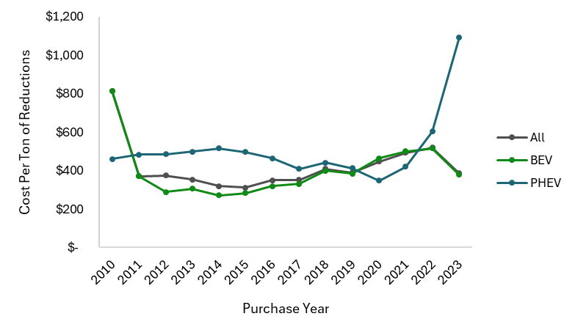
Figure 11
Average GHG Reductions Per Vehicle by Purchase Year
Detailed Counterfactual Reductions, 100k miles
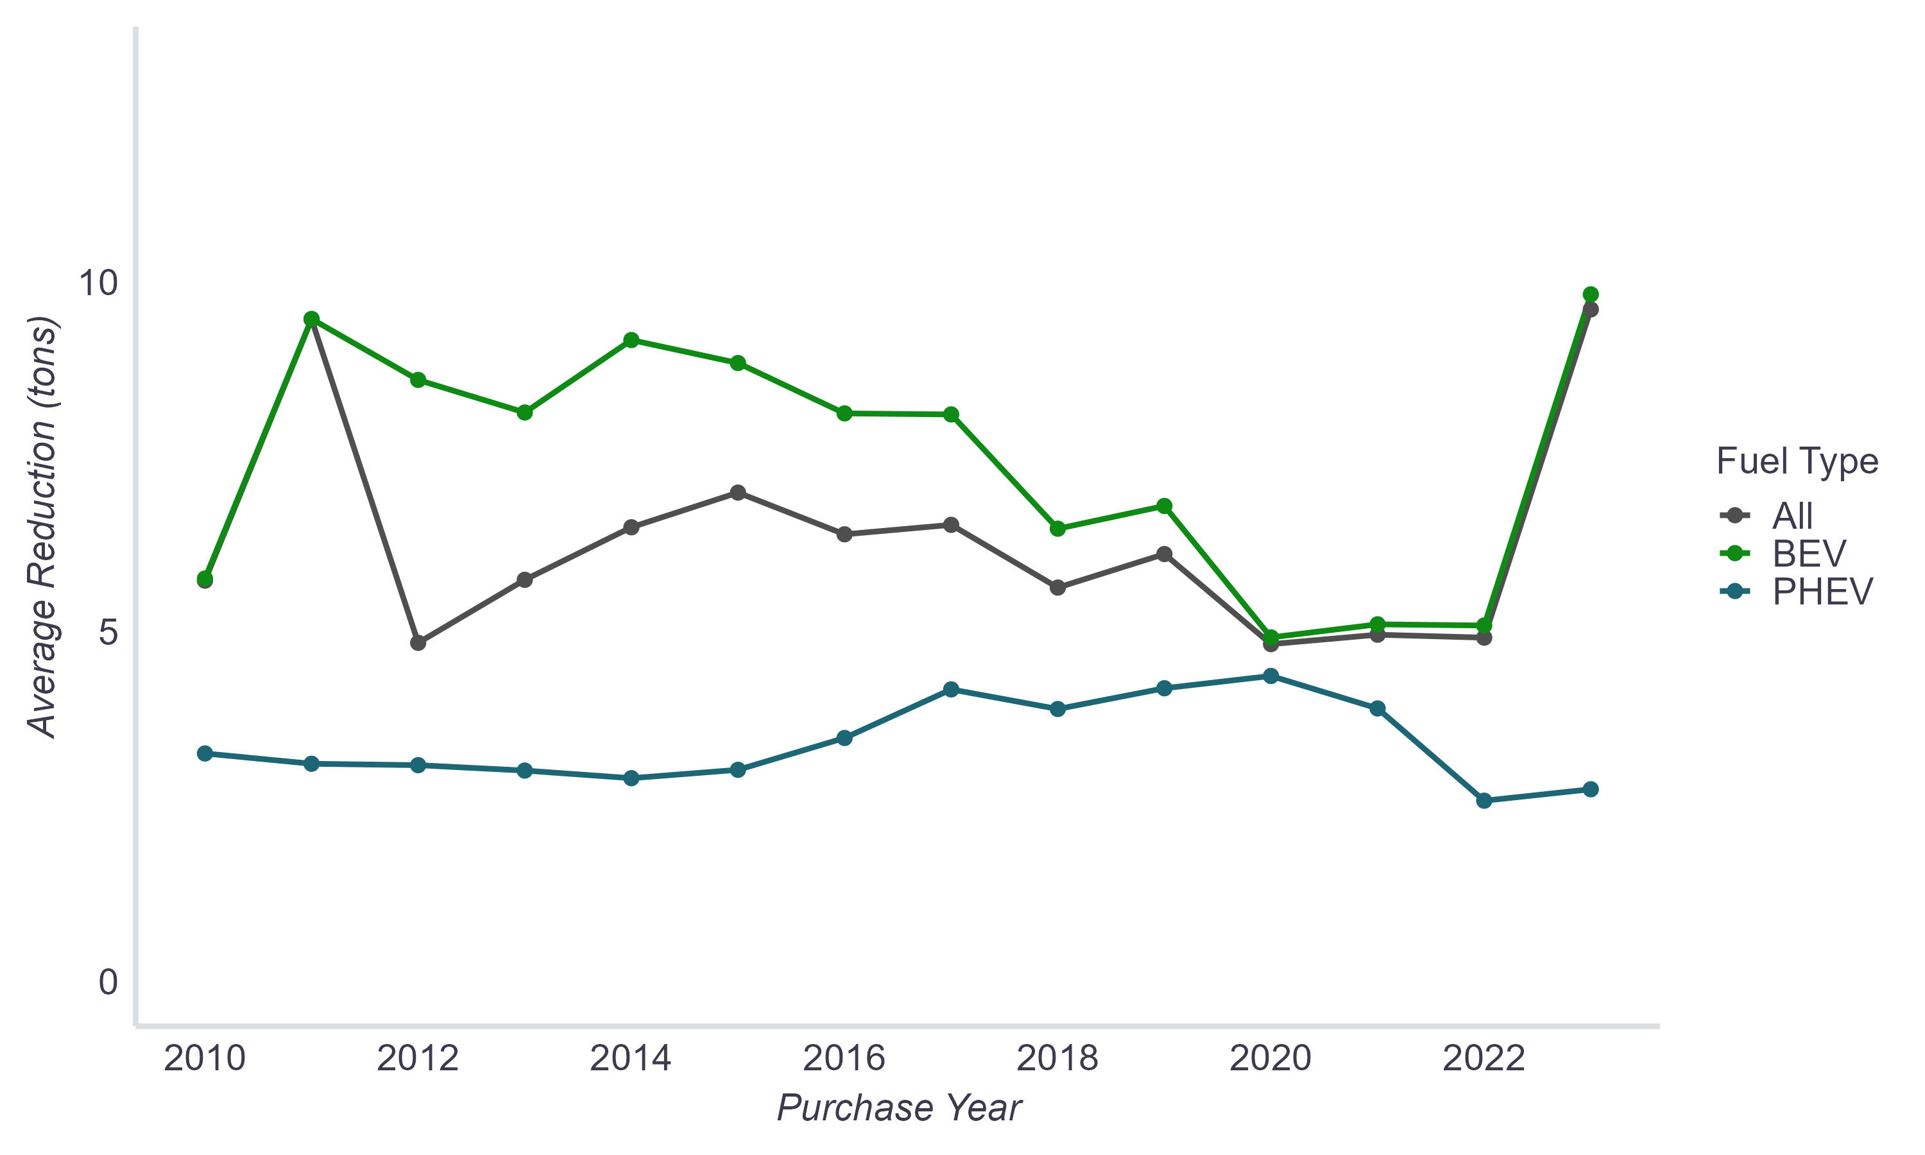
The wide range of counterfactual reductions across EV and rebate types, but relatively expensive overall costs per ton of counterfactual reductions, presents an opportunity to improve cost-effectiveness by identifying and targeting high-impact consumers. Accordingly, reductions and cost-effectiveness across counterfactual behaviors as well as behaviors across program participant cohorts are detailed further next.
Counterfactual reductions are based on four different comparison vehicle types: EVs, gasoline vehicles, hybrid vehicles, or previously owned vehicles. Inputs and assumptions for each are detailed in Appendix A. Among these comparison vehicle types, avoided emission estimates over 100k miles are highest for gasoline comparisons, averaging 32 tons at $110/ton (Table 7). Reductions average 18 tons at $196/ton for conventional hybrid comparisons. Reductions averaged 18 tons at $124/ton for gasoline-fueled replacements through 2020, before conventional hybrid was a separate response option. Reductions calculated relative to previously owned, often older gasoline, vehicles (for those who responded, “Not made any purchase/lease at all”) average 13 tons of GHGs avoided over 100k miles at $205/ton. Among the subset of this group that did not previously own an EV, reductions average 16 tons at $173 per ton. GHG reductions are assumed to average 0 tons avoided for electric comparison vehicles, including for those who would have continued driving a previously owned EV.
Table 7
GHG Reduction and Cost-Effectiveness Estimates by Counterfactual Behavior
Comparison Vehicle Type | Average First-Year (Y1) & 100k-mile Reductions Per Vehicle (tons) | Rebate Dollars Per Ton of GHG Reductions  (100k miles)
EV* | Y1 = 0  100k mile = 0 | n/a
Conventional hybrid vehicle (2021–2023)† | Y1 = 2.3  100k mile = 18 | $196
Gasoline vehicle (2021–2023)† | Y1 = 4.1  100k mile = 32 | $110
Gasoline / Conventional hybrid vehicle (2015–2020)† | Y1 = 2.1  100k mile = 18 | $124
Previous vehicle | Y1 = 3.4  100k mile = 13 | $205
Previous vehicle, non-EV | Y1 = 4.1  100k mile = 16 | $173
Previous vehicle, EV | Y1 = 0  100k mile = 0 | n/a
* Includes all non-Rebate-Essential respondents from December 2020 on.
† Gasoline and conventional hybrid response options are separate as of the 2020–2023 Survey Edition (Dec. 2020).
There is noteworthy variation across cohorts in counterfactual behaviors reported by respondents. To start, as displayed in Figure 12, no more than 26% of any cohort stated they would have bought a gasoline-fueled vehicle (incl. conventional hybrid) instead, the typically assumed baseline behavior used to calculate emission reductions. Increased Rebate recipients for BEVs were the most likely to have otherwise purchased a gasoline-fueled vehicle (26%) and Standard Rebate recipients for BEVs were the least likely (16%). Increased Rebate recipients overall are less likely to have purchased an EV without the rebate and Standard Rebate recipients for PHEVs were the most likely to. Increased Rebate recipients for BEVs were most likely to have not purchased a vehicle at all (23%). Figure 13 and Figure 14 display how these counterfactual vehicles vary across time overall and by cohort, respectively. Counterfactual behaviors over time will be explored further in additional forthcoming CVRP retrospective reporting.
Figure 12
Counterfactual Vehicle Types Assigned by Cohort
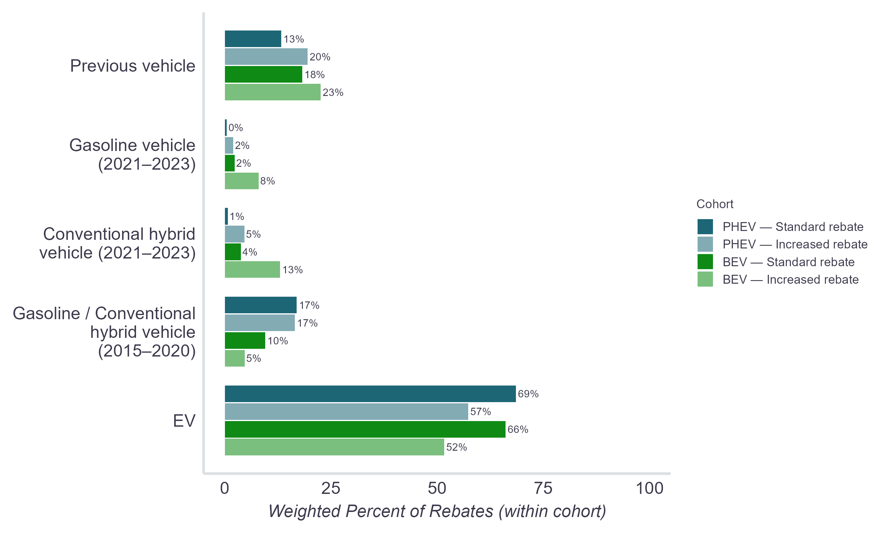
Note: Gasoline and conventional hybrid response options are separate as of the 2020–2023 Survey Ed. (Dec. 2020).
Figure 13
Counterfactual Vehicle Types Over Time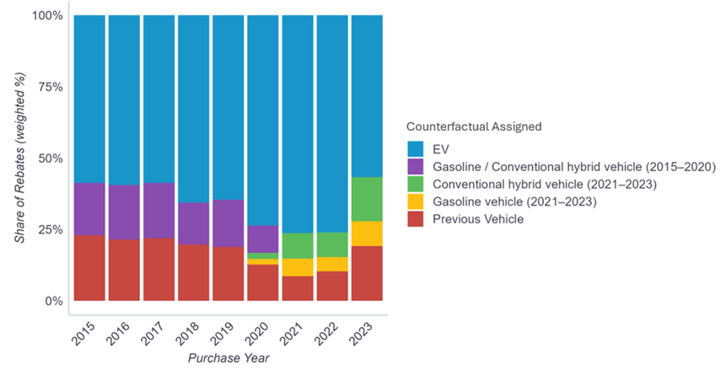
Note: Gasoline and conventional hybrid response options are separate as of the 2020–2023 Survey Ed. (Dec. 2020).
Figure 14
Counterfactual Vehicle Types Over Time by Cohort
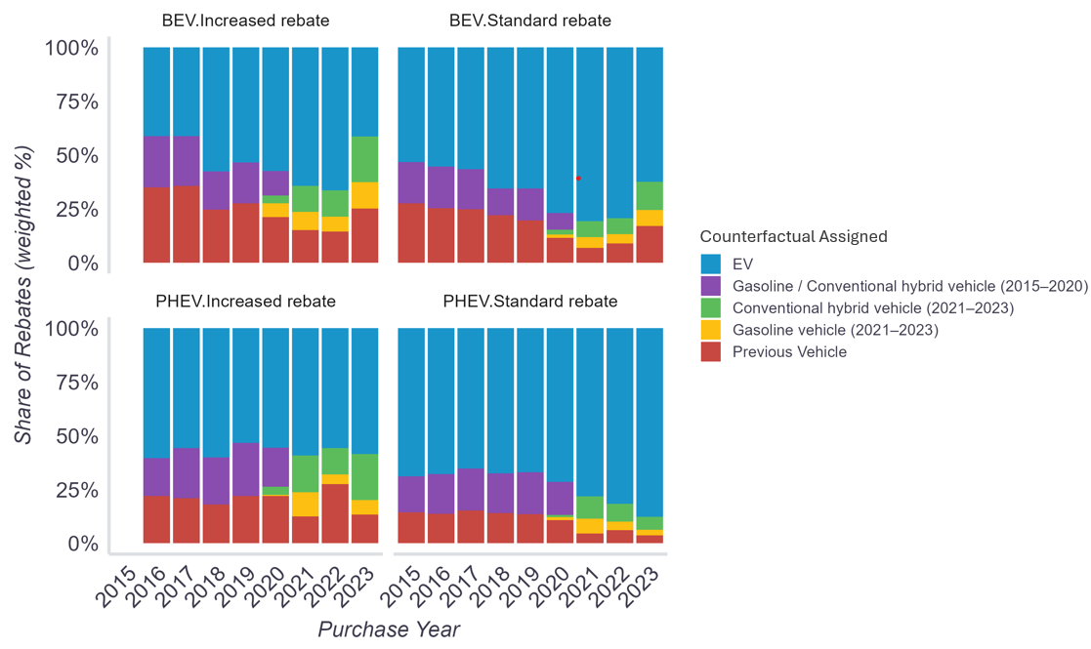
Note: Gasoline and conventional hybrid response options are separate as of the 2020–2023 Survey Ed. (Dec. 2020).

Program & Market Context
Results should be interpreted with regard to important program and market context. Because CVRP ran for roughly 13 years, it spanned both the burgeoning of the EV market and various program designs as program goals evolved to meet the needs of the changing EV landscape. Market context highlights are described below and further detailed in Appendix A and Appendix C. Rebate volumes over time are displayed in Figure 15, rebate amounts by EV technology type and rebate type are detailed in Table 8, and average rebate amounts over time are displayed in Figure 16. Other pertinent program design details are displayed in Table 9.
- EV technology share: The rebate share of PHEVs decreased substantially over time and BEVs came to dominate the program (Figure C1). This will impact project total results, as PHEVs tend to reduce fewer GHG emissions but also had lower rebate amounts.
- Range: The electric range capability of BEVs increased dramatically over time and long range BEVs, which are assumed to have higher annual VMT, became prominent in 2018 (Figure C2).
- Body style: While sedans historically dominated the program, less-efficient SUVs proliferated rapidly beginning in 2020 (Figure C3).
Figure 15
Approved Rebate Applications Over Time
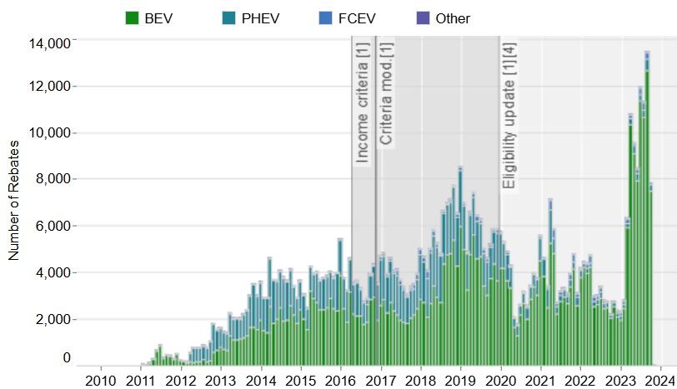
Source: https://cleanvehiclerebate.org/en/rebate-statistics (10/3/2025).
Table 8
Rebate Amounts Over Time
Technology Type | As of  Mar 2010 | As of  Jun 2011 | As of  Jul 2013 | As of  Jun 2014 | As of  Mar 2016 | As of  Nov 2016 | As of  Dec 2019 | As of  Feb 2023
BEV† | $3,000§– $5,000‡ | $1,500§– $2,500‡ | $2,500 | $2,500 | SR*: $2,500  IR*: $4,000 | SR: $2,500  IR: $4,500 | SR: $2,000  IR: $4,500 | SR: $2,000  IR: $7,500
PHEV | $3,000§ | $1,500 | $1,500 | $1,500 | SR: $1,500  IR: $3,000 | SR: $1,500  IR: $3,500 | SR: $1,000  IR: $3,500 | SR: $1,000  IR: $6,500
FCEV | $3,000§– $5,000‡ | $1,500§– $2,500‡ | $2,500 | $5,000 | SR: $5,000  IR: $6,500 | SR: $5,000  IR: $7,000 | SR: $4,500  IR: $7,000 | SR: $4,500  IR: $7,500
† Range-extended battery electric vehicles were given the BEV rebate amount.
‡ Amounts varied by ZEV type. For definitions, see CCR 1962.1.
* SR = Standard Rebate, IR = Increased Rebate.
§ None distributed.
Source: Adapted from (CSE, 2021; B. D. H. Williams, 2025).

Figure 16
Average Rebate Amount Over Time
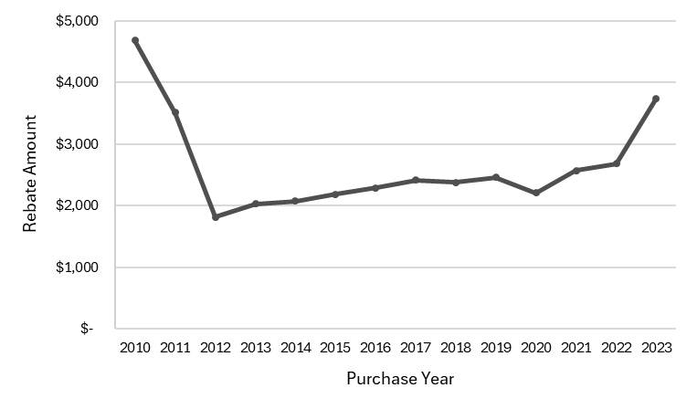

Table 9
Program Design Over Time
Personal (nonfleet) PHEVs and BEVs
Program Era 1 (March 15, 2010 – March 28, 2016)​  as of Mar. 2010​  - Incentive stacking permitted​  - 36-month ownership requirement​  - Rebates per year limit = 20​  as of Dec. 2013​  - Rebates per year limit = 2​  as of May 2014​  - 18-month application window​  as of Dec. 2014 / Jan. 2015​  - 30-month ownership requirement (retroactive)​  - Total rebate limit = 2​ | Program Era 4 (December 3, 2019 – February 23, 2022)​  as of Dec. 2019​  - Total rebates limit = 1 §​  - Base MSRP ≤ $60k (PEVs)​  - 3-month application window ‡​  - ≥ 35 UDDS electric miles​  - +$2,500 † for income-qualified households (≤ 300% FPL), excl. ZEMs​  as of Apr. 2020​  - Stacking with CVAP grant permitted​  as of Jan. 2021​  - +$2,500 for income-qualified households, ≤ 400% FPL, excl. ZEMs​  as of Apr. 2021​  - ≥ 30 U.S. EPA electric miles (45 UDDS)​  - Rebate Now preapproval option limited to income-qualified households, expanded from San Diego to include San Joaquin Valley​
Program Era 2 (March 29, 2016 – October 31, 2016)​
as of Mar. 2016​
- $250k–$500k income cap (PEVs)​
- +$1,500 for income-qualified households (≤ 300% FPL), excluding ZEMs​
Program Era 5 (February 24, 2022 – Program Close)​
as of Feb. 2022​
- Base MSRP: ≤ $60k for Large Vehicles*, ≤ $45k for Cars*​
- $135k–$200k income cap (PEVs)​
- $135k–$200k income cap on stacking HOV decal (only binding on FCEVs)​
as of Jul. 2022​
- $150k–$300k income cap on stacking HOV decal (only binding on FCEVs)​
as of Feb. 2023​
- +$3,000–$5,500 for income-qualified households, ≤ 400% FPL, excl. ZEMs​
as of Aug. 2023​
- $2,000 EV Charge Card for income-qualified households, ≤ 400% FPL (PEVs)​
Program Era 3 (November 1, 2016 – December 3, 2019)​
as of Nov. 2016​
- $150k–$300k income cap (PEVs)​
- ≥ 20 UDDS electric miles​
- +$2,000 for income-qualified households (≤ 300% FPL), excl. ZEMs​
as of Jan. 2018​
- $150k–$300k income cap on stacking HOV decal (only binding on FCEVs)​
- Rebate Now San Diego County preapproval pilot with point-of-sale option​
as of Jan. 2019​
- Stacking with CVAP grant not permitted (retroactive)​
PEVs = plug-in EVs. FPL = Federal Poverty Level. ZEMs = zero-emission motorcycles. UDDS = Urban Dynamometer Driving Schedule. HOV = high-occupancy-vehicle. FCEVs = fuel-cell EVs. CVAP = Clean Vehicle Assistance Program. MSRP = manufacturer suggested retail price.
§ A second rebate can be approved for a FCEV if the first rebate was for a PEV.
‡ COVID exemptions on application window effectively delayed implementation until 4/15/2021.
† Change due to $500 decrease in standard rebate amounts (see Table 8).
* Large Vehicles include minivans, pickups, and SUVs; Cars include all other light-duty vehicle classes (e.g., hatchbacks, sedans, wagons, and two-seaters).
Source: Adapted from (B. D. H. Williams, 2025).

Comparisons to Previous Research & Reporting
As described in the introduction, the results of this study should be expected to differ from other EV impacts assessments, including previous studies of CVRP. Each study’s goals and scope differ, as do the nature, quality, and vintage of the data available at the time. Indeed, the contributions of this work include using an increasingly case-specific methodology and illustrating how results vary across different methodological approaches that have been implemented in prior studies of EV subsidy impacts. Further, care should be taken when comparing results over time as the performance and types of vehicles on the market has evolved (see Appendix C) and program eligibility changes (see Program & Market Context above) alter the mix of vehicles and consumers.

Limitations and Opportunities for Future Research
Next steps for this and related research include ongoing opportunities for further refinement using additional participant-specific, time-variant, or otherwise more detailed inputs. For example, future work could incorporate increasingly case-specific VMT and consider marginal/induced grid emissions. Missing values of rebate influence and counterfactual behaviors could be addressed with statistical modeling rather than cohort assignment. Prioritization of these further refinements could be based on a Monte Carlo analysis of inputs and their impacts (e.g., [B. Williams & DeShazo, 2014]).
Additional opportunities for next steps are highlighted by the sensitivity analysis (Appendix B), which assesses the potential impact of uncertainty. For example, absent publicly available empirical data about the lifespan of EVs in the U.S., the results of this study are based on a conservative quantification period of 100k miles. The impact of this uncertainty is substantial: when using another common mileage assumption of 150k miles, costs decrease 34%. The analysis also shows that emission reduction estimates are sensitive to deviations from assumed fuel consumption rates of the baseline vehicles. Therefore, accuracy of the reduction estimate relies on the accuracy of these assumptions. As larger electric vehicle classes like pickup trucks become more prominent, including class-specific baselines for comparison may be increasingly important. Relatedly, expansion and refinement of the counterfactual analysis could improve understanding of emissions that might otherwise have been produced. For example, planned annual reporting on the final year of CVRP (2023 purchases/leases) will incorporate more detailed counterfactual survey data that describes the specific models that EVs replaced. It will also expand the sensitivity analysis of detailed counterfactual reductions. Explored in prior sensitivity analysis (Pallonetti et al., 2024) is the potential impact of survey biases, a limitation of all surveys. Biases may be further explored, with respect to how they may affect estimates of rebate influence and counterfactual behaviors.
The results are also sensitive to the scope of the analysis and how the boundaries are defined. Positive spillover and market (e.g., network) effects from influenced adoption and other second-order impacts are not analyzed; including these unmeasured impacts would increase the benefits attributed to the program (Violette & Rathbun, 2017; Chakraborty et al., 2022). Prior economic studies (Gillingham & Stock, 2018; Sheldon et al., 2023) have discussed that while EV subsidies fall on the higher-cost end of various types of GHG reduction policies, they have many benefits outside of direct emission reductions (i.e., “dynamic” or “network effects”) that can justify policies that appear to have high costs when these long-run effects are unaccounted for. Dynamic effects related to CVRP’s EV incentives include the benefits of increased volume for producers (economies of scale, learning-by-doing, supply-chain creation), consumers (awareness, information spillovers, learning-by-doing, and adoption network effects) and society (positive externalities) (B. Williams & Searles, 2017; Gillingham & Stock, 2018). Furthermore, Gillingham and Stock (2018) highlight that electric vehicle and other more costly technology diffusion policies are the scalable technologies in focus for transitioning to a low-carbon economy. These long-run benefits are well-documented as being important but difficult to quantify (Gillingham & Stock, 2018; Sarode et al., 2023).
In addition to unaccounted for long-run impacts, important aspects of CVRP that are outside the scope of this work are the impact of its equity components. For example, the Increased Rebate for income-qualified participants, designed for inclusion, has many benefits but tempers short-run cost-effectiveness metrics. As discussed in previous reporting (Pallonetti et al., 2024; B. D. H. Williams, 2025), this implies that a more nuanced, wholistic approach that considers market segments and program goals is warranted to evaluate program success.
Other examples of potential scope expansions for future research include: quantification of other vehicle pollutants and vehicle life-cycle emissions impacts, including those related to vehicle or battery production, maintenance and disposal; assessment of travel-behavior effects and/or household-level impacts such as vehicle substitution for lengthy trips; and further review of the literature to enrich understanding of program influence, attribution, and cost-effectiveness.

5. Summary
This report builds on CARB’s Funding Plans for Clean Transportation Incentives (e.g., [CARB, 2017b]) and previous work by CSE (Pallonetti et al., 2023, 2024; Pallonetti & Williams, 2022a, 2022b; B. Williams & Pallonetti, 2022) to create a more detailed and context-specific life-of-program accounting of CVRP’s GHG impacts and cost-effectiveness. Emissions are estimated using disaggregated data from nearly 600,000 approved CVRP rebate applications for plug-in hybrid electric vehicles (PHEVs), all-battery electric vehicles (BEVs), and fuel-cell electric vehicles (FCEVs), as well as from over 100,000 survey responses weighted to represent project participants. Results are quantified at various levels to illustrate how they vary across different methodological approaches that have been implemented in prior studies of EV subsidy impacts.
Compared to new gasoline vehicles, GHG emission reductions associated with all rebated EVs over the first year of ownership average 2.2–3.6 metric tons of carbon-dioxide-equivalent emissions per vehicle, depending on the EV technology type. Over 100,000 miles of driving, an estimated total of 15.5M metric tons of carbon-dioxide-equivalent emissions are estimated to be saved. Comparing rebate costs to rebated-vehicle emissions benefits over a 100,000-mile quantification period produces CO₂e abatement costs averaging $93 per metric ton. Approximately 90% of reductions are associated with “Rebate-Important” participants (those who stated the rebate was at least moderately important in making it possible for them to acquire their EV). Further, approximately 50% of the rebated reductions over the life of the project are associated with “Rebate-Essential” participants who were even more highly influenced by the rebate, stating they would not have acquired their EV without it. This metric can help to isolate the impacts that are attributable to the program. Rebate Essentiality was more frequent for recipients of CVRP’s Increased Rebate for consumers with lower household incomes (65%) and FCEV rebates (71%). Cost-effectiveness of Rebate-Essential reductions range from $172–410 per ton for PHEVs and FCEVs, respectively, and average $166 and $299 per ton for Standard and Increased Rebates, respectively.
To improve evaluation of the impact and cost-effectiveness of the program specifically, the emission reductions that are directly attributable to CVRP can be estimated using self-reported data detailing a variety of counterfactual behaviors that enable nuanced assessment of the vehicle types participants would have driven in absence of the rebate. Indeed, no more than 26% of respondents in any group analyzed stated they would have otherwise bought a new gasoline vehicle instead (the typically assumed baseline vehicle used to calculate emission reductions). Estimating GHG reductions from BEVs and PHEVs using these detailed counterfactual survey data increases the costs of reductions to $332–428 per ton for Standard Rebates, $548–667 for Increased Rebates, and $386 overall. Costs increase because many participants state that in absence of the rebate, they would have alternatively been driving cleaner vehicles than those represented by a baseline new gasoline vehicle. Detailed counterfactual reductions reveal variations across participant groups due to differences in counterfactual behaviors between them. BEVs are more cost-effective than PHEVs under this analysis, despite their higher rebate amounts. Also, Increased Rebate results improve relative to Standard Rebates primarily due to their counterfactual vehicles less frequently being other EVs.
The substantial variance in results across the different quantification levels (all rebated, rebate-influenced, and detailed counterfactual reductions) underscores the importance of detailed and context-specific analysis of the influence of programs on consumer behavior when evaluating program impacts. The wide range of cost-effectiveness across counterfactual response groups, but relatively expensive overall costs per ton of counterfactual reductions, highlights an opportunity for programs to improve cost-effectiveness by targeting consumers that are most highly influenced by incentives to transition to EVs from high-emitting alternatives. Forthcoming reporting will evaluate in more detail the GHG cost-effectiveness and counterfactual behaviors of CVRP-rebated EVs purchased in 2023. This study can help inform other programs by focusing on the most recent consumer behaviors and equity-focused CVRP program design.
Because CVRP ran for roughly 13 years, it spanned both the burgeoning of the EV market and various program designs as it evolved to meet the needs of the developing EV landscape. Therefore, the emission-reduction and cost-effectiveness results should be interpreted in the context of program design and market dynamics over time. For example, Standard Rebate amounts decreased over time while Increased Rebates (after their introduction in 2016) increased over time. Similarly, vehicle-based and consumer-income-based eligibility criteria rolled out and became more stringent over time. The market also developed throughout the course of the program, with major changes including drastic increases in BEV range and BEV popularity, as well as rapid proliferation of SUVs in recent years.
Various opportunities for future research have been identified. This includes expanding the scope of analysis to attempt to include important, but difficult to quantify, dynamic/long-term benefits. The sensitivity analysis can be used to inform other impactful areas of focus. The results are found to be particularly sensitive to baseline vehicle fuel efficiency and quantification period (i.e., total number of operational miles or VMT/year). Uncertainty in those and other inputs presents opportunities for refinement in future work aiming to understand the emission benefits of EV incentives.

Acknowledgements
This study was conducted by the Center for Sustainable Energy on behalf of CVRP and we thank CARB staff for the opportunity to contribute to the conversation. However, it does not necessarily represent the views of CARB. Nor does it represent a final determination. The authors thank all who provided feedback on the report (and we invite additional feedback), as well as those who supported this and prior works. Particular thanks are due here to Luc Rieffel and Dee Dee Daniel for supporting the development of the codebase for this analysis. The authors also thank Meridith Bartley, Dillman Delgado, Jaskirat Kaur, and Aria Gehrmann for their research assistance.

Appendix A: GHG Input Values
Time-variant and state-specific or other best-available inputs tailored to the program are used to quantify emissions from each baseline and rebated vehicle. Each are described further below.

Carbon Intensity of Fuels
Consistent with (CARB, 2017b), emissions are calculated using statewide average fuel carbon intensity (CI) values from California’s Low Carbon Fuel Standard (LCFS) regulation (CARB, 2020b, 2025a, 2025b). These values account for carbon-dioxide-equivalent (CO₂e) emissions over the entire well-to-wheels fuel cycle for gasoline, hydrogen, and electricity—including upstream (e.g., fuel production and distribution) and combustion emissions. The values used in this work, detailed in Table A1, all represent the California transportation fuel pool.
TABLE A1
Fuel Life-Cycle Carbon Intensity Values and Sources
Fuel | Carbon Intensity | Detail and Sources
Gasoline | 11,485 gCO₂e/gal | LCFS baseline (CARB, 2025b), using conversion from (CARB, 2020b)
Electricity | 252–379 gCO₂e/kWh | LCFS annual updates for data years spanning 2015–2023 (CARB, 2025a), using conversion from (CARB, 2020b), see Figure A1 for annual detail. 2023 value used for 2023 and later, as a conservatism (the rate of expected future decreases is unknown).
Hydrogen | 13,393 gCO₂e/kg | SB 1505-compliant 33% renewable mix, converted from (CARB, 2020b)

FIGURE A1
Electricity Life-Cycle Carbon Intensity
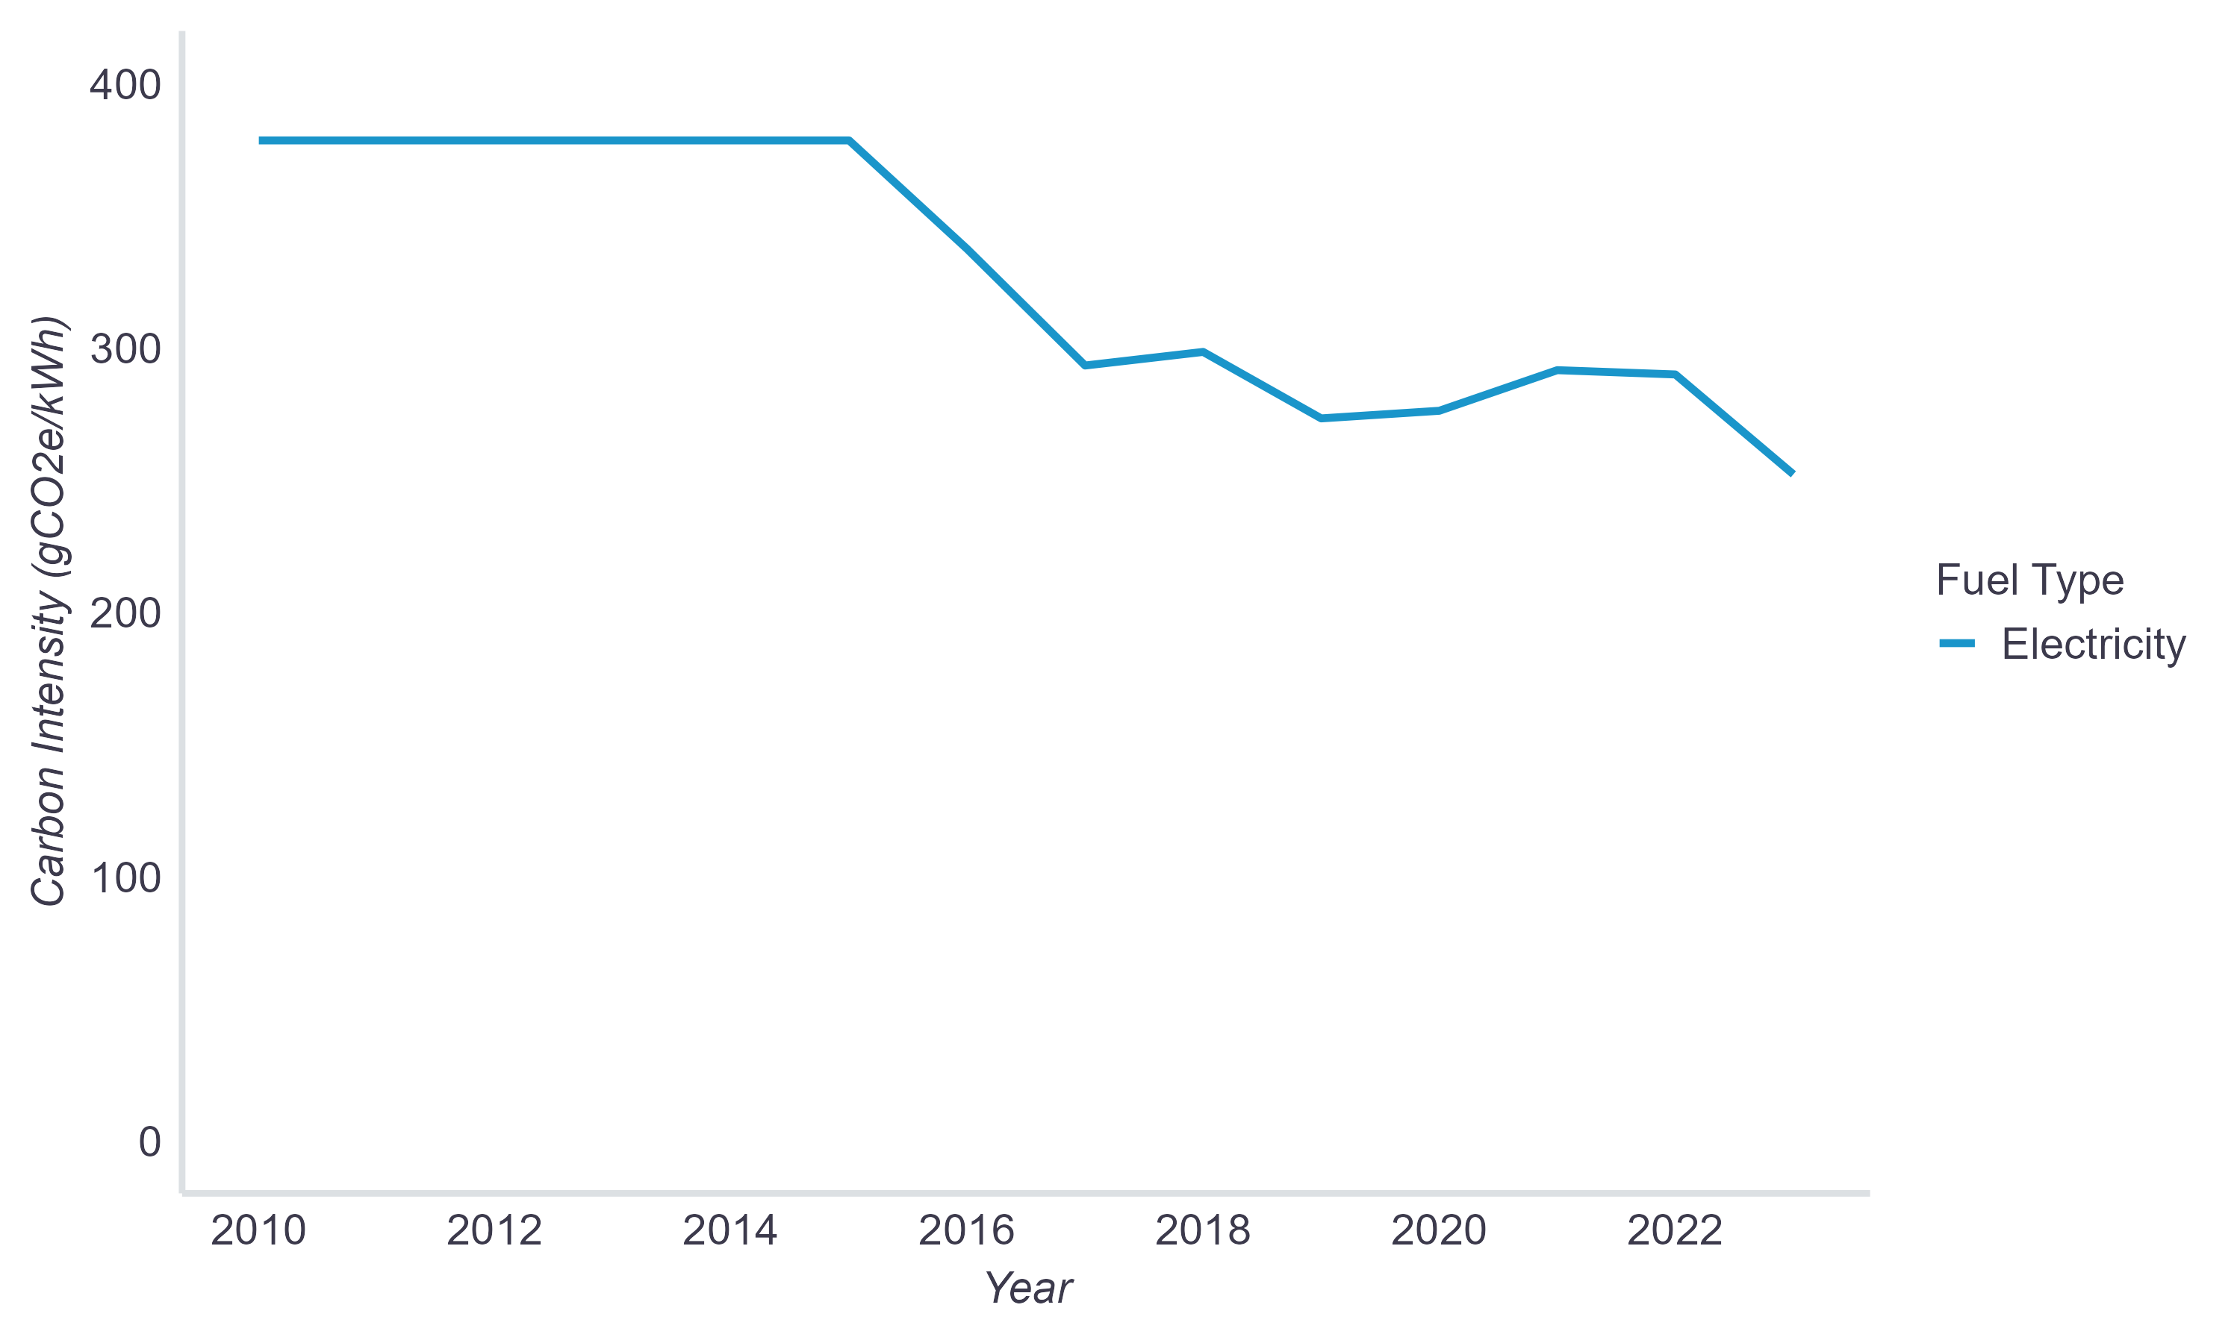

Fuel Consumption Rate
Rebated vehicle fuel consumption rates are converted for each rebated vehicle from the model- and model-year-specific combined city/highway fuel economy ratings from the EPA (US Department of Energy & US Environmental Protection Agency, 2024). As displayed in Figure A2, averages of the model-specific EV fuel efficiency rates tended to gradually increase over time through 2018 for BEVs and 2020 for PHEVs. Afterwards, average BEV efficiency declined modestly and PHEV efficiency declined substantially. There were only a few distinct FCEV models, so average FCEV efficiency fluctuated as models were discontinued or released (e.g., the steep increase after 2014 was due to the release of a new, more efficient model).
Following the approach in (CARB, 2017b), the baseline vehicle that EV emissions are compared to for all rebated and rebate influenced emission reductions is a new gasoline vehicle. The baseline vehicle fuel consumption rates are model-year-specific and produced by calculating California sales-weighted averages based on the EPA ratings for the 75 top selling new light-duty gasoline vehicle (including conventional hybrid) models each MY. Vehicles within each MY were assessed at the model level and vehicle classes that were not well represented in the rebate data (i.e., pickup trucks) were excluded. For models with multiple trims or series with varying fuel efficiency within a given MY, the most efficient (and therefore most conservative) fuel economy value was used in the sales weighting calculations. Averages of the model-year-specific baseline vehicle rates tended to gradually increase over time, as displayed in Figure A3 and detailed in Table A2.
Figure A2
Rebated EV Fuel Efficiency Over Time
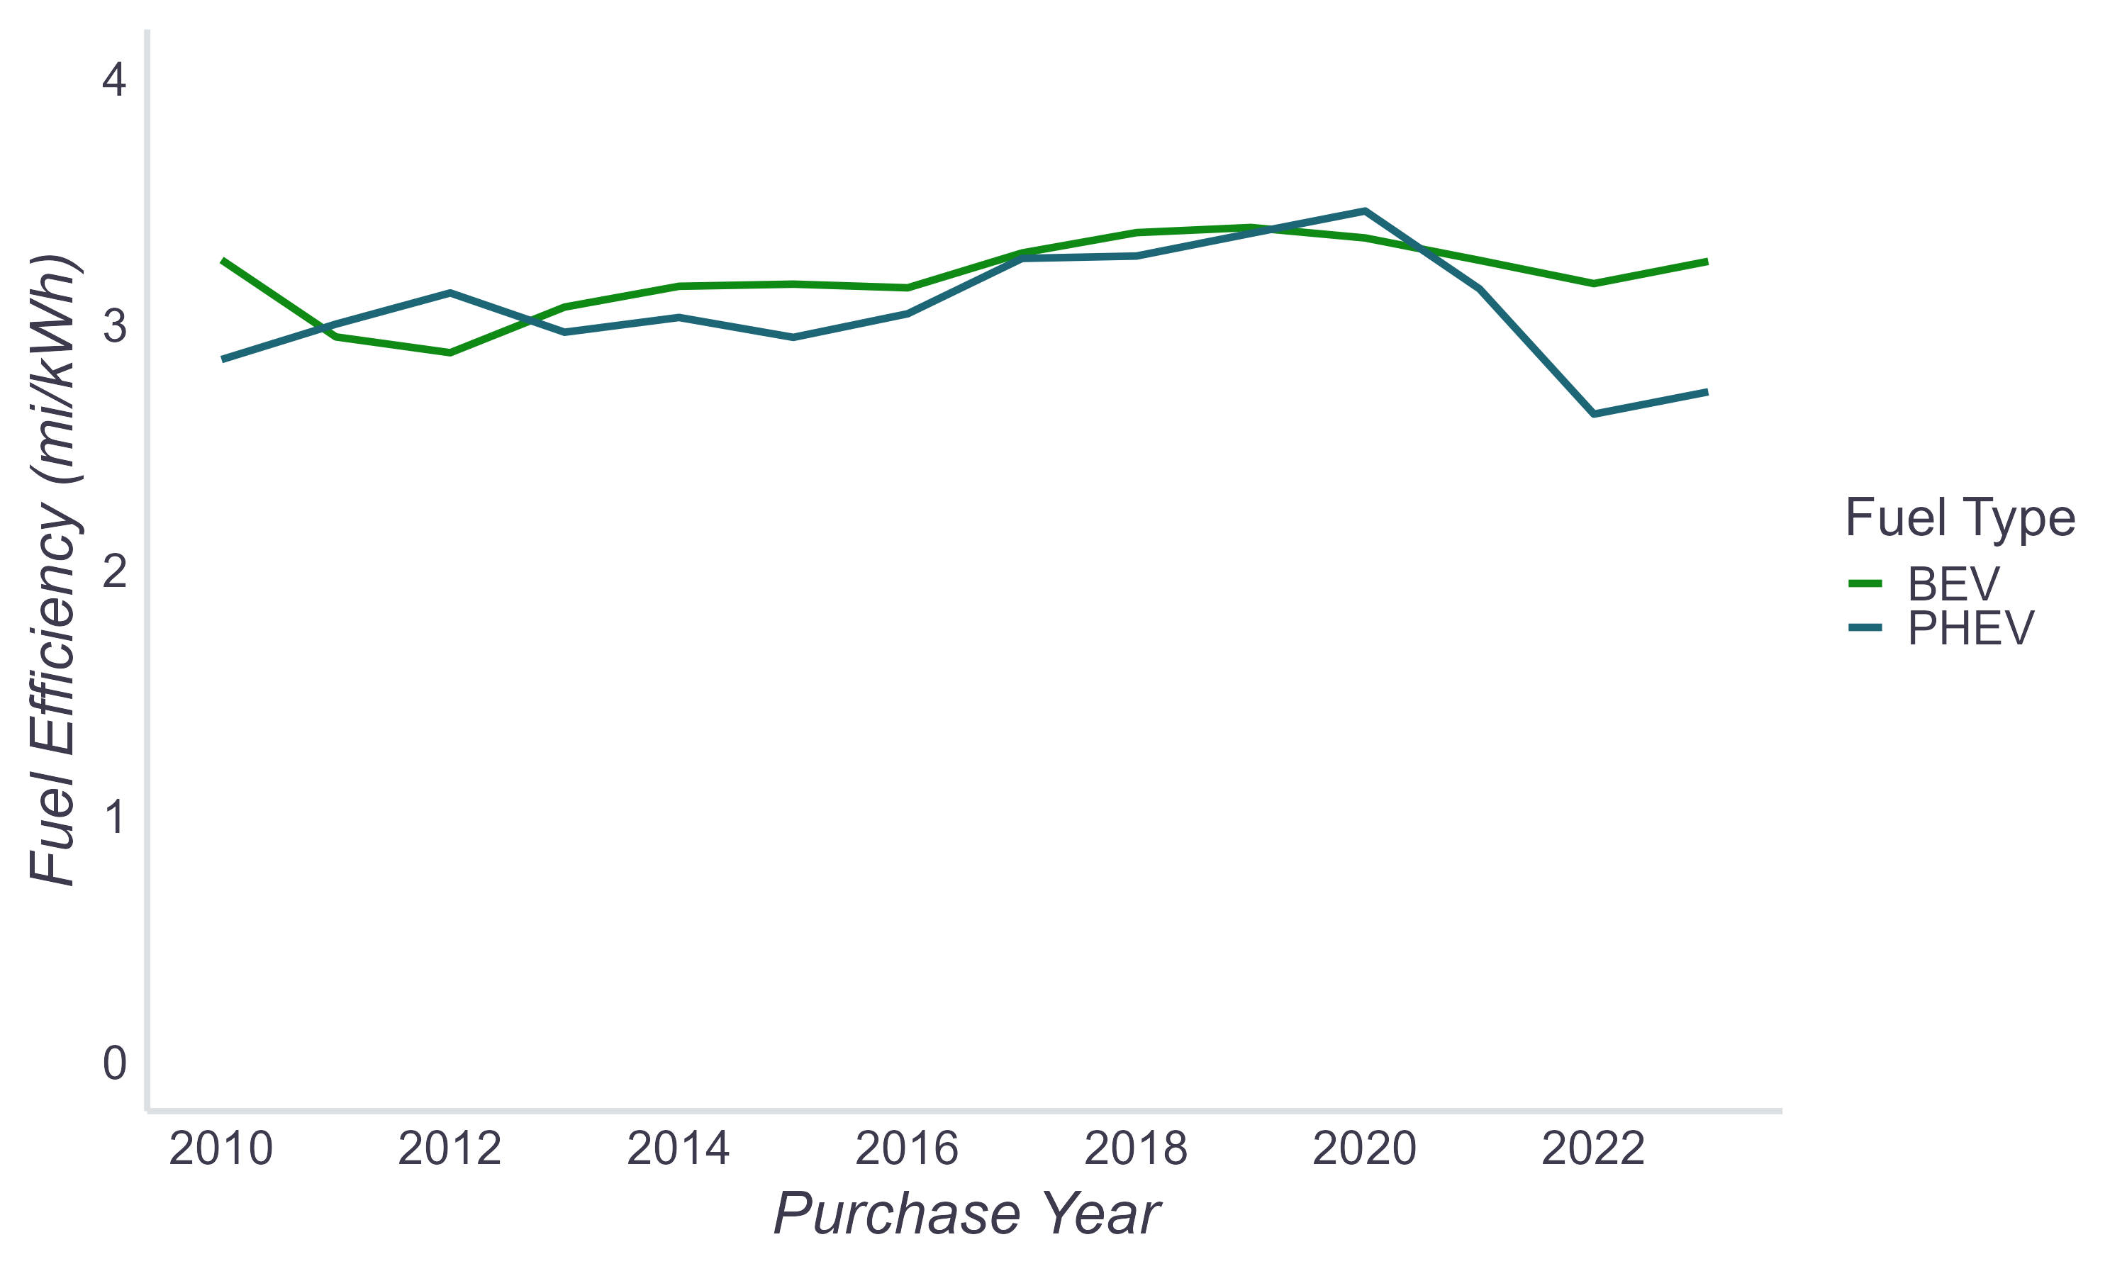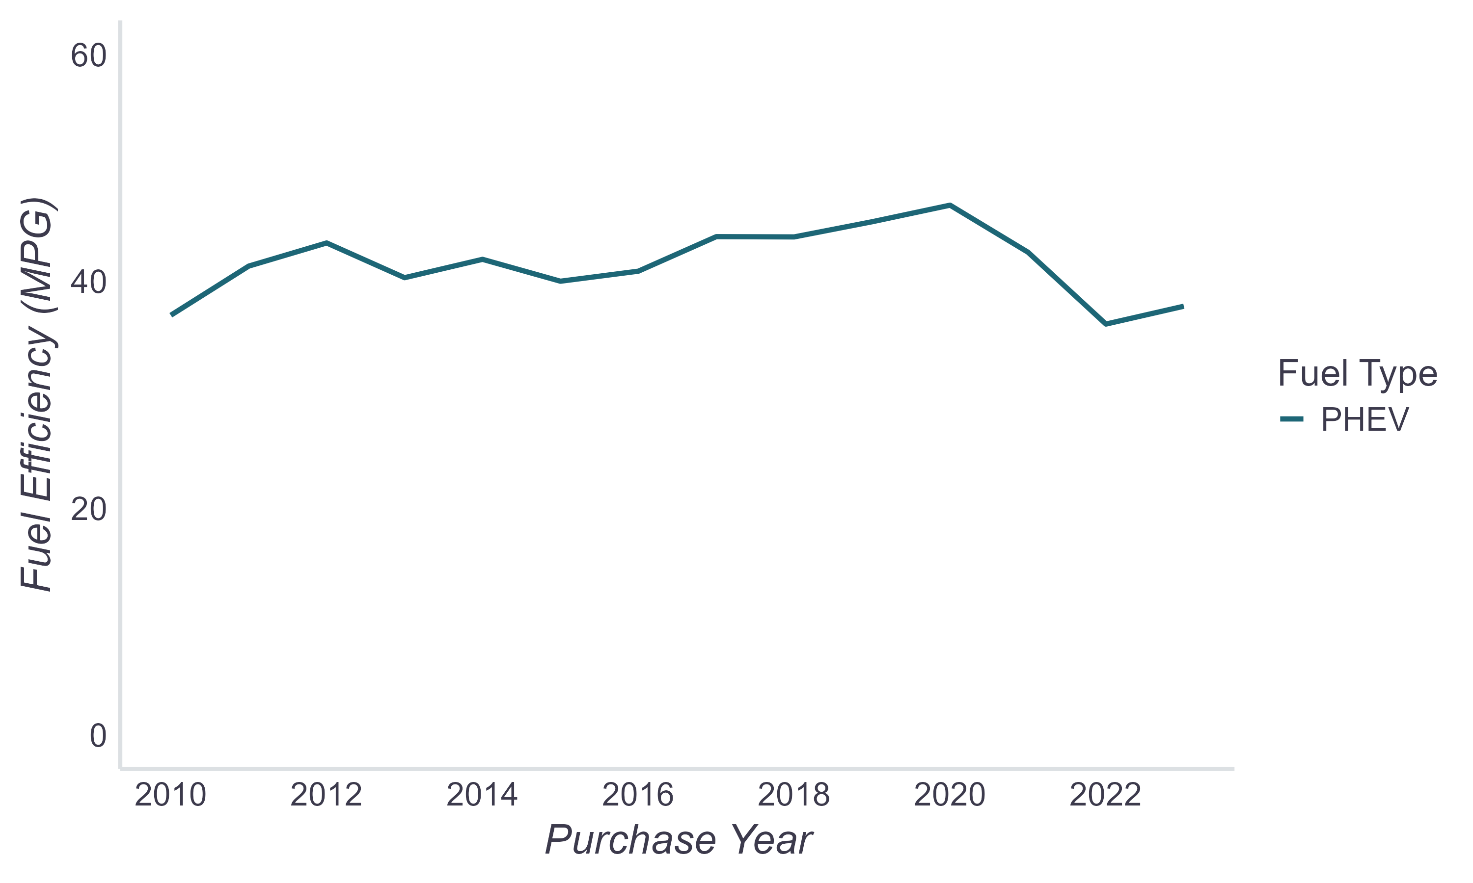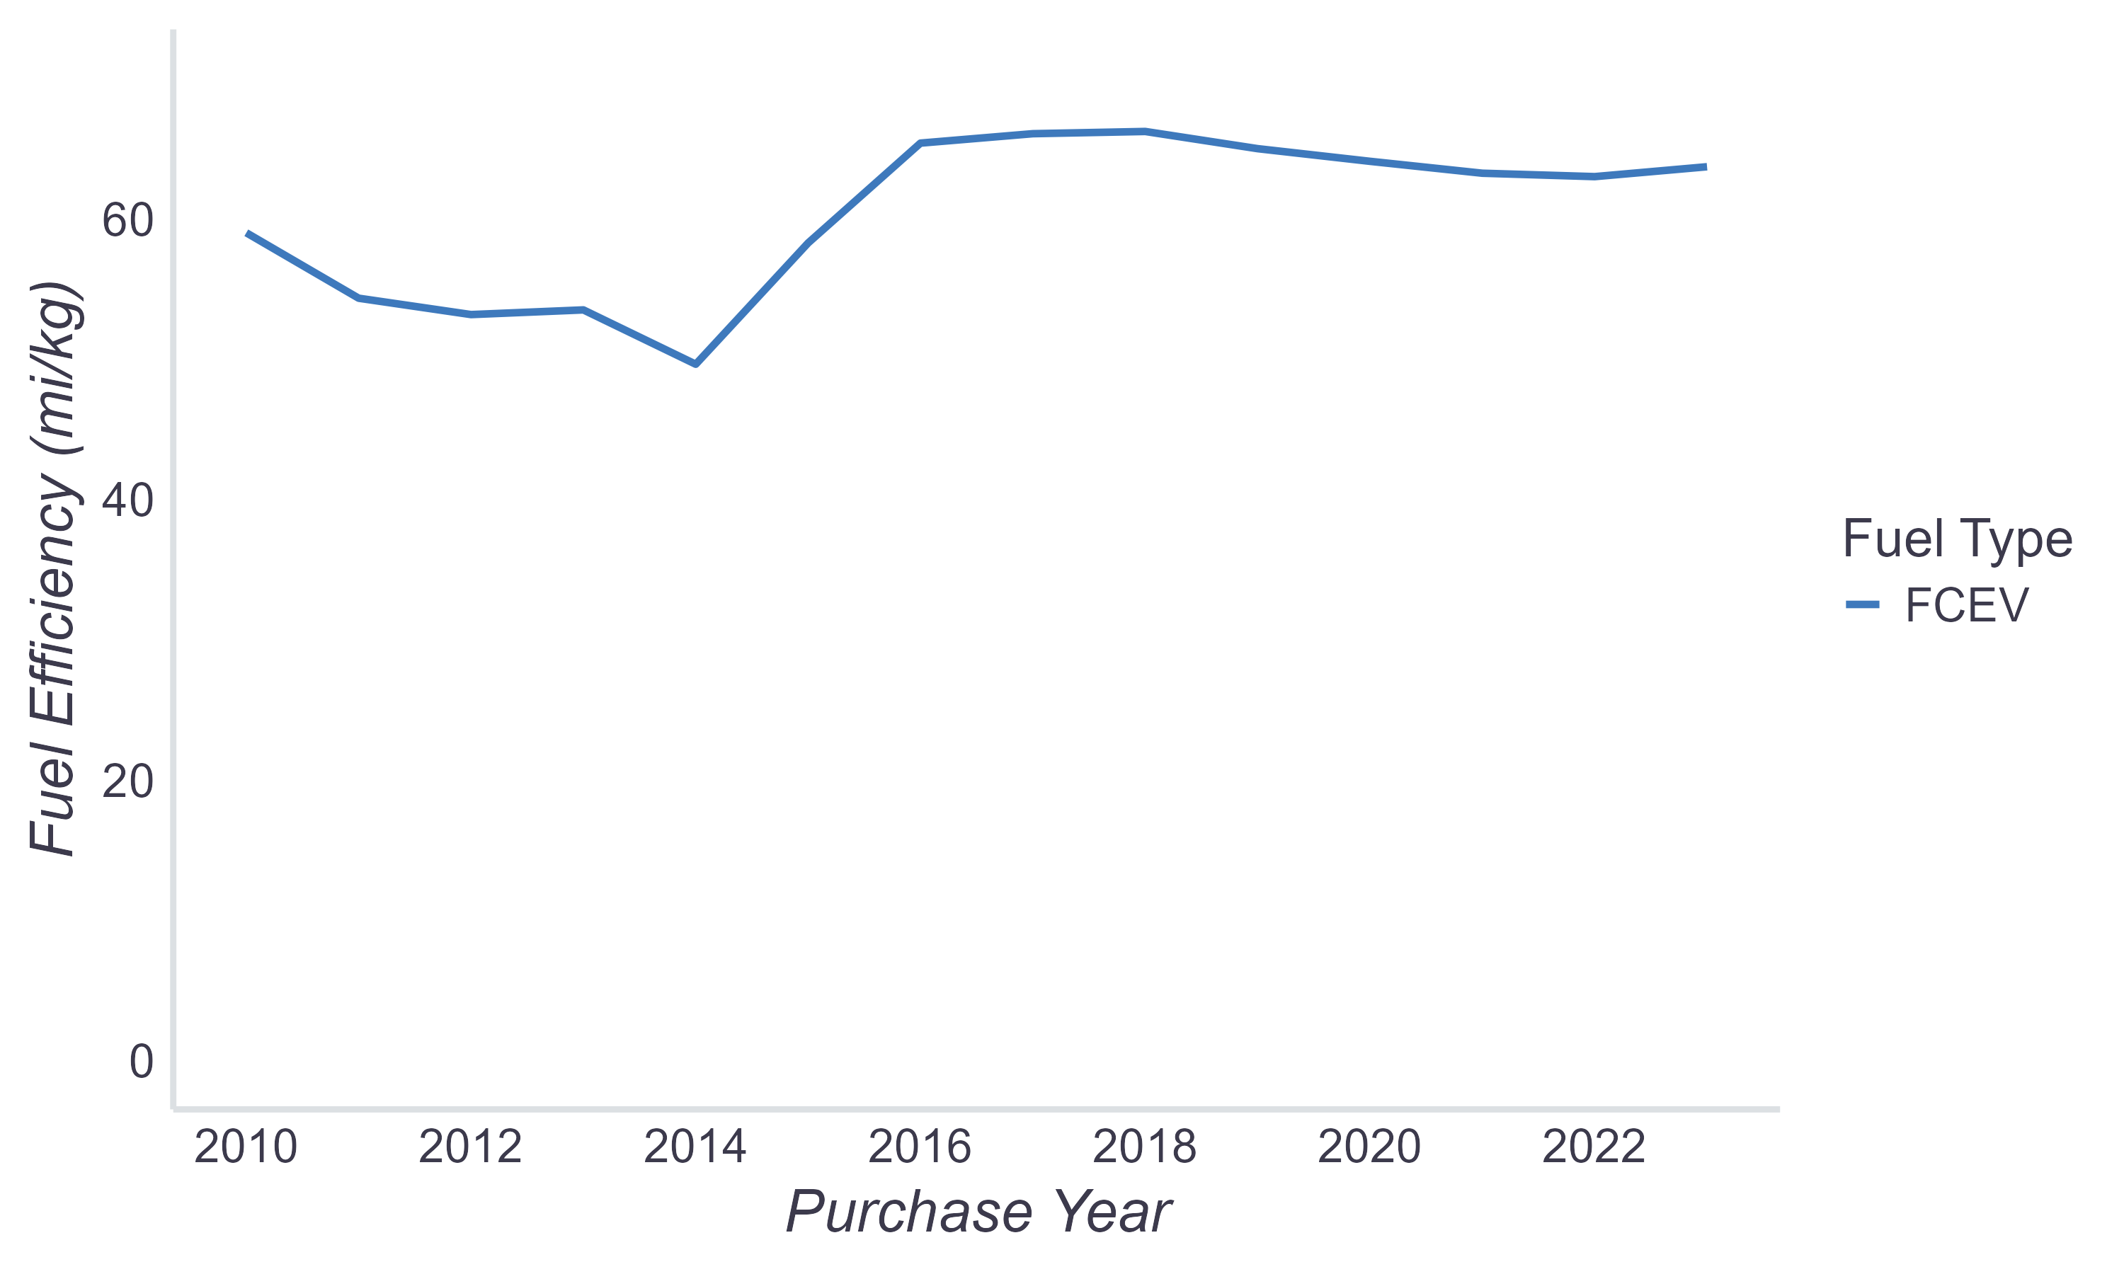
Note: Fuel efficiency values converted from fuel consumption rates (e.g., gallons/mile) used in GHG calculations.
Figure A3
Baseline MPG Average Over Time
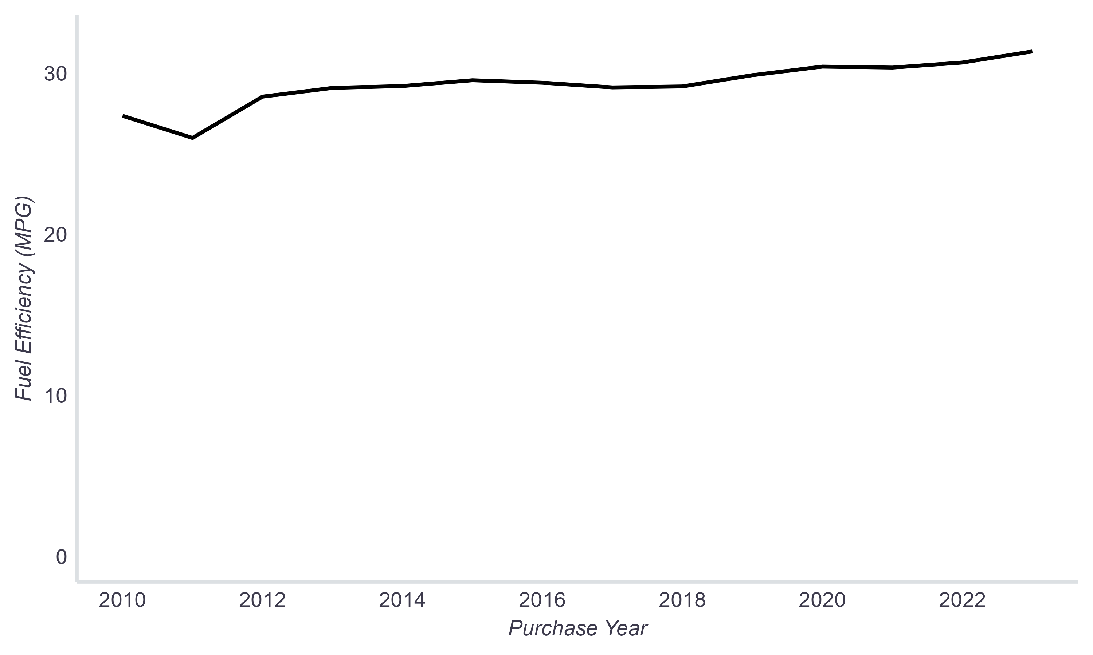
TABLE A2
Baseline MPG by Model Year
Model Year | Baseline MPG
2010* | 27.6
2011 | 25.8
2012 | 28.4
2013 | 29.1
2014 | 29.1
2015 | 29.6
2016 | 29.5
2017 | 29.1
2018 | 29.1
2019 | 29.8
2020 | 30.5
2021 | 30.3
2022 | 30.6
2023** | 31.4
* Used for model years 2010 and earlier.
** Used for model year 2023 and a small number of model year 2024 vehicles.

Vehicle Miles Traveled
Annual vehicle miles traveled (VMT) estimates come from surveys of EV drivers in California (Table A3). These estimates are used for the first year of driving and vary by the rebated vehicle technology type and, for BEVs, a range subcategory (short or long range) of the model. Annual VMT is assumed to decrease year over year based on the schedule reported for cars in the Transportation Energy Data Book (Davis & Boundy, 2022). VMT is scaled each year to match the percentage changes for the estimated annual vehicle miles of travel for cars (per Table A4 below).
TABLE A3
Annual VMT Values and Sources
Technology Type | Annual VMT (First Year) | Source
PHEV | 13,475 | (Chakraborty et al., 2021)
Short range BEV | 10,484 | (Chakraborty et al., 2021)
Long range BEV (200+ mi.) | 13,018 | (Chakraborty et al., 2021)
FCEV | 12,445 | (Hardman, 2019)
Baseline vehicle | 10,484 to 13,475 | Same as paired rebated vehicle, consistent with (CARB, 2017b)

TABLE A4
Annual VMT Over Time
Vehicle Age (years) | Year Over Year Change
0 | N/A
1 | -2%
2 | -2%
3 | -2%
4 | -2%
5 | -3%
6 | -3%
7 | -3%
8 | -3%
9 | -3%
10 | -3%
11 | -4%
12 | -4%
13 | -4%
14 | -4%
15 | -4%
16 | -4%
17 | -4%
18 | -4%
19 | -4%
20 | -4%
21 | -4%
22 | -4%
23 | -4%
24 | -3%
25 | -3%
26 | -3%
27 | -2%
28 | -2%
Source: converted from (Davis & Boundy, 2022)

For PHEVs, which use both electric and gasoline fuels, a model-specific electric VMT (eVMT) percentage (or utility factor) is used to assign proportions of total travel to electricity. Consistent with the general approach in (CARB, 2020a), in cases where on-road studies of driving behavior have been conducted for specific rebated models, the eVMT findings from those studies are used (or averages of findings, for models with more than one study). For models that have not been studied, eVMT percentages are determined as a function of electric range, derived from plotting eVMT findings from studied models by their corresponding electric ranges from (DOE and EPA, 2021). The eVMT studies (Boston & Werthman, 2016; CARB, 2017a; Duhon et al., 2015; Francfort et al., 2015; Idaho National Laboratory, 2015; Tal et al., 2020) are the same as those used in precursor work by the authors (e.g., [Pallonetti & Williams, 2021]). The plot, function, and relationship between the variables are presented in Figure A4. The average eVMT by vehicle purchase year is displayed in Figure A5.
FIGURE A4
PHEV Model-Specific Electric VMT by Electric Range
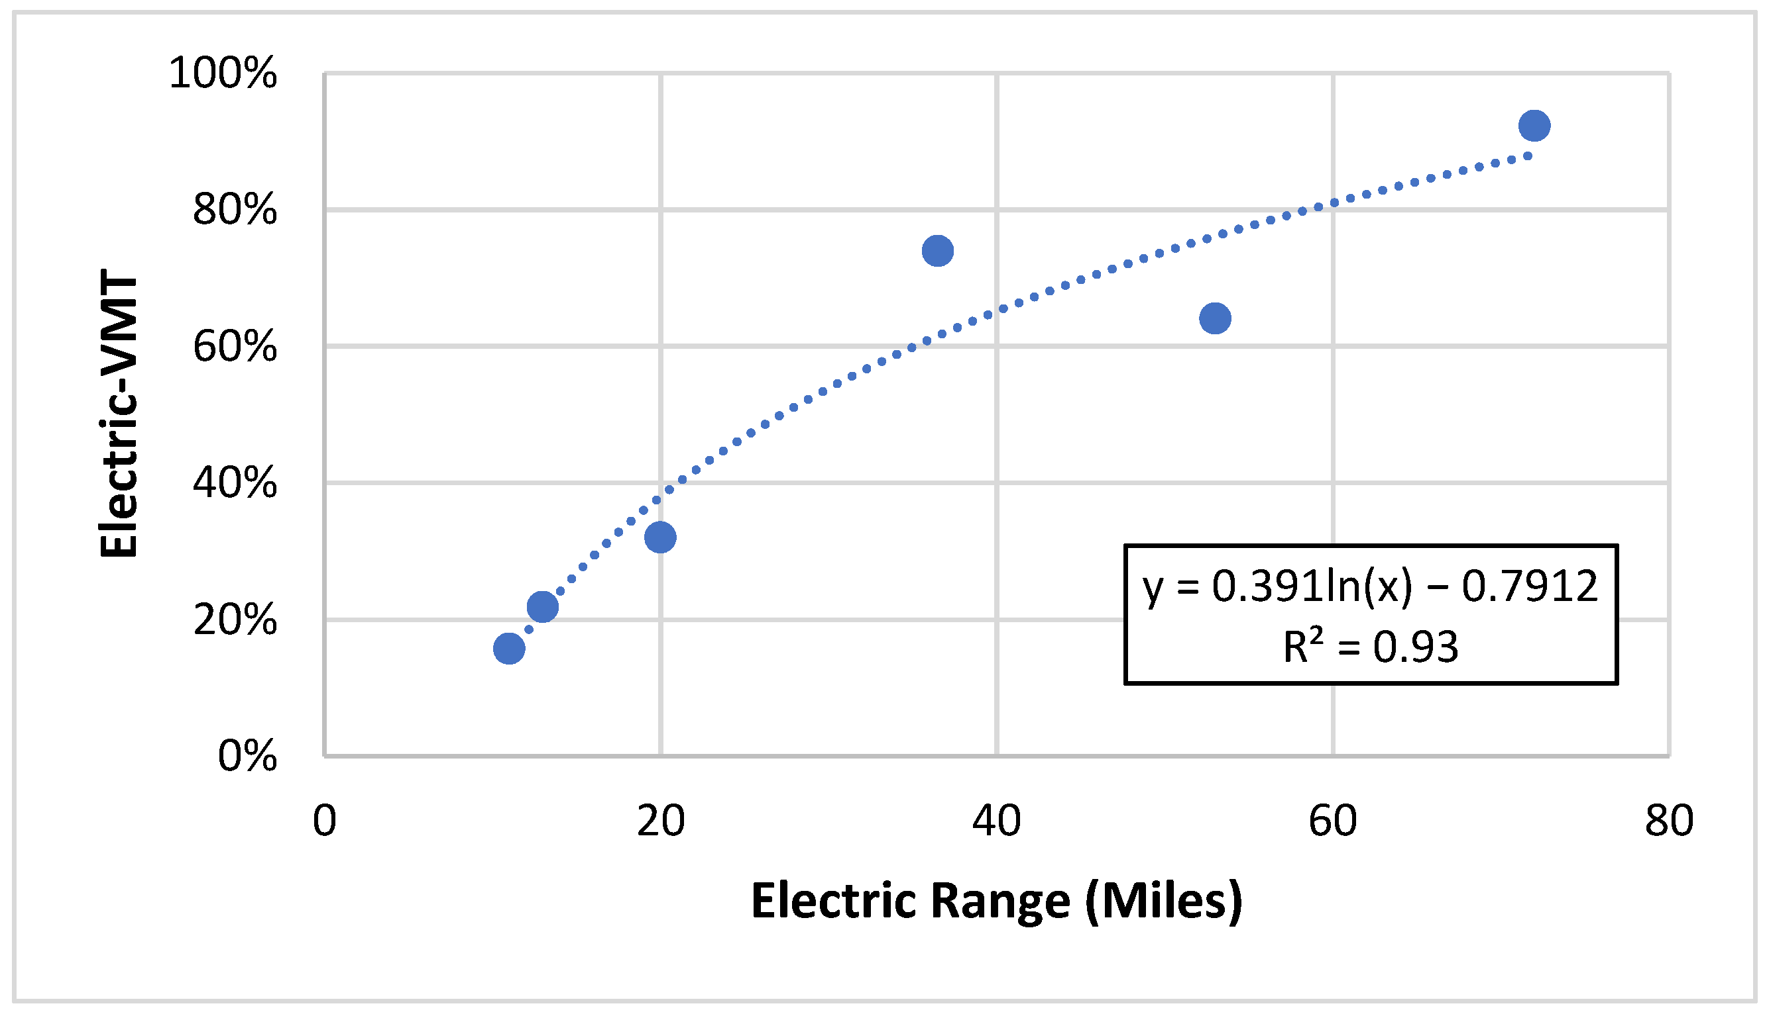
Source: (Pallonetti & Williams, 2021)

FIGURE A5
Average PHEV Model-Specific Electric VMT Over Time
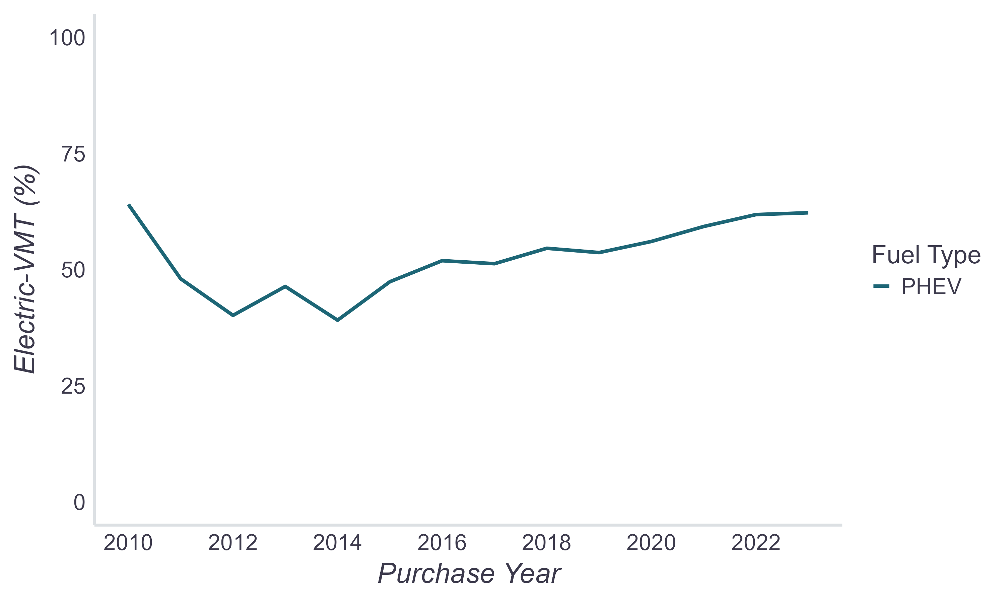

Detailed Counterfactual Analysis Inputs & Assumptions
Table A5 and Table A6 describe the detailed counterfactual behavior survey question and response options provided in each survey edition and the emissions comparison assumption used for each. For participants that didn’t respond to the survey or provide valid responses to the required survey questions, average values for the participant’s cohort are calculated from survey responses.
TABLE A5
Counterfactual Behaviors and Emissions Assumptions
Survey Editions 2020–2023 & 2023–Close: “If the state vehicle rebate (CVRP) were not available, what do you think you would have done?”
Response Option | Emissions Comparison Vehicle
Purchased/leased a less expensive version of the same model | EV  (no emission reductions)
Purchased/leased a different new EV | EV  (no emission reductions)
Purchased/leased a used EV | EV  (no emission reductions)
Purchased/leased another alternative-fuel vehicle (e.g., hydrogen, natural gas) | Conventional hybrid vehicle  (CA sales-weighted avg. fuel economy, same model year as rebated EV)
Purchased/leased a conventional hybrid
Purchased/leased a gasoline/diesel vehicle | Gasoline vehicle  (CA sales-weighted avg. fuel economy, same model year as rebated EV)
Not made any purchase/lease at all | First 3 years: previous vehicle  (Case-specific year/technology weighted avg. fuel economy (see Table A7), no emission reductions if EV)  Rest of 100k miles: cohort average vehicle with 3 years lag from rebated EV purchase (no emission reductions if previous was EV)
TABLE A6
Counterfactual Behaviors and Emissions Assumptions
Survey Editions 2015–2016, 2016–2017, 2017–2020: “If the state vehicle rebate (CVRP) were not available for a [rebated EV model] or any other plug-in electric vehicle (PEV), what do you think you would have done?”
Response Option | Emissions Comparison Vehicle
Purchased/leased this exact vehicle anyway | EV  (no emission reductions)
Purchased/leased a less expensive version of the same model | EV  (no emission reductions)
Purchased/leased a different new EV | EV  (no emission reductions)
Purchased/leased a used EV | EV  (no emission reductions)
Purchased/leased a new non-PEV instead | Gasoline / Conventional hybrid vehicle  (CA sales-weighted avg. fuel economy of gasoline and conventional hybrid vehicles, same model year as rebated EV, weighted 59% hybrid and 41% gasoline)
Purchased/leased a used non-PEV instead | Gasoline / Conventional hybrid vehicle  (CA sales-weighted avg. fuel economy of gasoline and conventional hybrid vehicles, MY 3 years earlier than rebated EV, weighted 59% hybrid and 41% gasoline)
Not made any purchase/lease at all | First 3 years: previous vehicle  (Case-specific year/technology weighted avg. fuel economy (see Table A7), no emission reductions if EV)  Rest of 100k miles: cohort average vehicle with 3 years lag from rebated EV purchase (no emission reductions if previous was EV)

TABLE A7
Previous Vehicle MPGs
Fuel Economy Approach | Sources
MY-specific CA-sales-weighted avg. of gasoline vehicles (top 59–74 models after removing HEV models from top 75 gasoline model lists). | S&P Global Mobility, (US Department of Energy & US Environmental Protection Agency, 2024)
MY-specific production-weighted avg for cars. "[YYYY] or earlier" values take latest result (e.g., "1994 or earlier" takes 1994 result). | (US Environmental Protection Agency, 2024)
MY-specific CA-sales-weighted avg of conventional hybrid vehicles (all models). | S&P Global Mobility, (US Department of Energy & US Environmental Protection Agency, 2024)
MY-specific US-sales-weighted avg of conventional hybrid vehicles (all models). MY 2000 value (earliest available) used for MY 2000 and earlier years. | (US Department of Energy, 2020; US Department of Energy & US Environmental Protection Agency, 2024)
N/A (assume no savings) | N/A

Model Year | Gasoline | Diesel | HEV | FFV | CNG | Other alt. fuel | BEV/PHEV/FCEV
2023 | 28.4 | 28.4 | 43.2 | 43.2 | 43.2 | 43.2 | N/A
2022 | 28.3 | 28.3 | 43.5 | 43.5 | 43.5 | 43.5 | N/A
2021 | 28.3 | 28.3 | 42.1 | 42.1 | 42.1 | 42.1 | N/A
2020 | 29.0 | 29.0 | 44.4 | 44.4 | 44.4 | 44.4 | N/A
2019 | 28.8 | 28.8 | 44.9 | 44.9 | 44.9 | 44.9 | N/A
2018 | 28.6 | 28.6 | 44.3 | 44.3 | 44.3 | 44.3 | N/A
2017 | 28.4 | 28.4 | 44.9 | 44.9 | 44.9 | 44.9 | N/A
2016 | 28.6 | 28.6 | 45.9 | 45.9 | 45.9 | 45.9 | N/A
2015 | 28.2 | 28.2 | 44.5 | 44.5 | 44.5 | 44.5 | N/A
2014 | 27.9 | 27.9 | 43.5 | 43.5 | 43.5 | 43.5 | N/A
2013 | 27.6 | 27.6 | 43.4 | 43.4 | 43.4 | 43.4 | N/A
2012 | 27.0 | 27.0 | 43.7 | 43.7 | 43.7 | 43.7 | N/A
2011 | 24.7 | 24.7 | 43.4 | 43.4 | 43.4 | 43.4 | N/A
2010 | 25.4 | 25.4 | 45.5 | 45.5 | 45.5 | 45.5 | N/A
2009 | 25.0 | 25.0 | 40.5 | 40.5 | 40.5 | 40.5 | N/A
2008 | 23.9 | 23.9 | 39.2 | 39.2 | 39.2 | 39.2 | N/A
2007 | 23.7 | 23.7 | 39.0 | 39.0 | 39.0 | 39.0 | N/A
2006 | 23.0 | 23.0 | 37.8 | 37.8 | 37.8 | 37.8 | N/A
2005 | 23.1 | 23.1 | 40.0 | 40.0 | 40.0 | 40.0 | N/A
2004 | 22.9 | 22.9 | 44.4 | 44.4 | 44.4 | 44.4 | N/A
2003 | 23.0 | 23.0 | 41.2 | 41.2 | 41.2 | 41.2 | N/A
2002 | 22.8 | 22.8 | 42.7 | 42.7 | 42.7 | 42.7 | N/A
2001 | 22.6 | 22.6 | 43.2 | 43.2 | 43.2 | 43.2 | N/A
2000 | 22.5 | 22.5 | 53.0 | 53.0 | 53.0 | 53.0 | N/A
1999 | 22.7 | 22.7 | 53.0 | 53.0 | 53.0 | 53.0 | N/A
1998 | 23.0 | 23.0 | 53.0 | 53.0 | 53.0 | 53.0 | N/A
1997 | 23.2 | 23.2 | 53.0 | 53.0 | 53.0 | 53.0 | N/A
1996 | 23.1 | 23.1 | 53.0 | 53.0 | 53.0 | 53.0 | N/A
1995 | 23.3 | 23.3 | 53.0 | 53.0 | 53.0 | 53.0 | N/A
1994 or earlier | 23.0 | 23.0 | 53.0 | 53.0 | 53.0 | 53.0 | N/A
Note: HEV = hybrid electric vehicle (non-plug-in), FFV = flex-fuel vehicle, CNG = compressed natural gas.

Appendix B: Sensitivity Analyses
Sensitivity analyses were conducted to assess the impact of the uncertainty in several of the input values on the cost-effectiveness of GHG reductions. The following sections detail sensitivity analyses on vehicle and fuel inputs and on the quantification period, focusing on Rebate-Essential reductions. The results highlight that the most impactful areas of uncertainty include the quantification period and vehicle/fuel inputs affecting baseline emissions.

Sensitivity to Vehicle and Fuel Inputs
The sensitivity of GHG reduction cost effectiveness to variations in vehicle and fuel inputs are first tested by scaling each up and down by 10%. Highlights are displayed in Figure B1. Some inputs were further tested using data or the literature about related topics to inform value ranges for sensitivity tests of vehicle and fuel inputs, each of which are described further below.
FIGURE B1
Impact of Uncertainty on Program Average Cost-Effectiveness
Vehicle and Fuel Inputs +/-10%
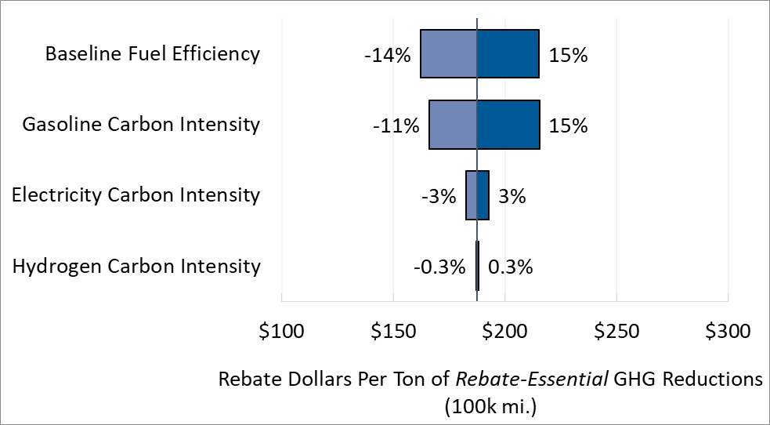

Baseline-Vehicle Fuel Efficiency: In Table B1 below, the impact of varying baseline fuel efficiency values by +/-10% is detailed alongside two additional tests. Primary fuel efficiency inputs were generated using the most efficient trim of each model when calculating sales-weighted fuel economy averages. Sensitivity to this conservative approach is tested by regenerating those values using the least efficient trim of each model. Additionally, the primary analysis uses overall light-duty fuel efficiency averages, rather than a disaggregated (e.g., body style-specific) average. This was based on CVRP Consumer Survey data displaying a fair amount of body style switching from replaced vehicles to rebated vehicles. However, it may be reasonable to expect that many consumers, had they not acquired their EV, would have acquired a different car with the same body style as their rebated EV. Sensitivity to this factor is tested by splitting each model year-specific top model lists that were used to generate fuel efficiency averages into three: on each for cars, SUVs, and vans. The Ford F-150 Lightning is compared to an F-150 hybrid (due to negligible program participation, trucks were not included in the original top model lists).
TABLE B1
Sensitivity of Cost-Effectiveness to Baseline-Vehicle Fuel Efficiency
Rebate-Essential Reductions
Baseline-Vehicle Fuel Efficiency Scenario | Rebate Dollars Per Ton of  Rebate-Essential GHG Reductions
Primary (CA sales-weighted average by MY, most efficient trim) | $188
CA sales-weighted average by MY, least efficient trim | $153 (-18%)
Primary -10% | $162 (-14%)
CA sales-weighted average by MY, most efficient trim, body style-specific | $211 (+12%)
Primary +10% | $215 (+15%)

Carbon Intensity: Sensitivity to the carbon intensity of fuels was tested by varying each separately by +/-10%. The results from each test overall and for each vehicle technology type are presented in Table B2 alongside two additional tests.
The potential impact of decreasing electricity CI continuing to improve in the future was tested by varying years 2024 and later from a constant 2023 LCFS CI value (252 gCO₂e/kWh) to a time-variant annual decrease based on a medium electricity demand scenario projection in (Grubert et al., 2020). The projection reflects CI gradually decreasing 47% from 2018 (the base year of the study) to 2033 (the last year of 100k-mile reductions in this analysis). This reflects a 37% CI decrease from the 2023 LCFS value to 158 gCO2e/kWh in 2033. Using these projected values reduces costs per ton of total Rebate-Essential GHG reductions by 1% (to $185). This result suggests that the impact of using the 2015 electricity CI for prior years without data is likely also negligible.
Hydrogen CI was also tested further by varying the LCFS-derived default assumption of a SB 1505-compliant 33% renewable mix (13,393 gCO₂e/kg), which is used in absence of publicly-available data on light-duty hydrogen fueling station CI, to average annual CI values from LCFS quarterly reports (CARB, 2025c). This CI data is time-variant but reflects all hydrogen used as transportation fuel in California, including non-light-duty applications. This time-variant CI input data reduces the costs of total Rebate-Essential GHG reductions by only 1% but reduces costs per ton of FCEV reductions specifically by 35% (to $268).
TABLE B2
Sensitivity of Cost-Effectiveness to Carbon Intensity of Fuels
Rebate dollars per ton of Rebate-Essential GHG reductions
Fuel Carbon Intensity (CI) Scenario | All | PHEV | BEV | FCEV
Primary | $188 | $172 | $185 | $410
Gasoline Low CI | $215 (+15%) | $196 (+14%) | $212 (+15%) | $524 (+28%)
Gasoline High CI | $166 (-11%) | $153 (-11%) | $164 (-11%) | $336 (-18%)
Electricity Low CI | $183 (-3%) | $168 (-2%) | $180 (-3%) | n.a.
Electricity High CI | $193 (+3%) | $176 (+2%) | $190 (+3%) | n.a.
Electricity Projected CI | $185 (-1%) | $171 (-0.5%) | $182 (-2%) | n.a.
Hydrogen Low CI | $187 (-0.3%) | n.a. | n.a. | $366 (-11%)
Hydrogen High CI | $188 (+0.3%) | n.a. | n.a. | $465 (+13%)
Hydrogen Time-Variant CI | $185 (-1%) | n.a. | n.a. | $268 (-35%)

Electric Utility Carbon Intensity
Since program participants are unevenly dispersed across California’s many electric utility territories, the sensitivity of using statewide average electricity CI values is tested to assess the potential impact of differences in electric utility CI. Case-specific electric utility CI values are assigned based on the utility territory that applicant addresses were in at the time of application. Primary CI values were scaled up or down based on the percentage difference of each utility’s average CI from the statewide average CI per 2023 Power Content Labels (California Energy Commission, 2025). The five most common utility territories of participants were used, containing 93% of all participants. The primary (statewide average) CI values were used for the remaining 7%. This approach decreased rebate costs per ton of reductions by 5% (to $179).

Home Solar Electricity
While the EV emissions are primarily quantified using statewide average CI values for electricity, it is likely that many consumers have home solar power systems and can partially charge their EV from this non-emitting source. CVRP Consumer Survey data are used to assess the potential impact of home solar on GHG reductions of PHEVs and BEVs. The Consumer Survey asked respondents if they have solar panels that produce electricity at their residence. Approximately 27% overall responded that they did and another 16% did not but were planning to install them. Following (Coffman et al., 2017), we assume that weekend charging can occur during the day when solar electricity is available. As such, 2/7ths of VMT for BEVs and ~1/7th of VMT for PHEVs are attributed to this non-emitting source.
Using these solar assumptions for known solar owners (27% of respondents) rebated for a BEV or PHEV reduces their costs per ton of reductions by 7%. To illustrate the potential for additional savings that may be realized through solar EV charging, this result can be roughly extrapolated to the full program. If 27% of all BEV and PHEV rebate recipients were solar owners, total program costs per ton of reductions would decrease by 2%. If additional participants gained access to home solar (e.g., the 16% who stated that they intended to install) or frequently utilized renewable-powered public charging stations, GHG reductions would increase, reducing costs further.

Sensitivity to Quantification Period
The operational period over which emission reductions are quantified can play an even more impactful role than vehicle and fuel inputs. As described in (Pallonetti & Williams, 2021), 100k-mile estimates are arguably still a conservative proxy for useful vehicle life, depending on a balance of conflicting factors. Due to the uncertainty around EV lifetimes and the sensitivity of the GHG estimates to the quantification period used, various operational timeframe scenarios are compared in Table B3.
TABLE B3
Sensitivity of GHG Reductions and Cost-Effectiveness to Quantification Period
Operation Scenario | Rebate Dollars Per Ton of Rebate Essential GHG Reductions
Primary (100,000 miles) | $188
2.5-year rebate “project life” (CARB, 2017b) | $626 (+234%)
6-year ownership (Demuro, 2019) | $268 (+43%)
11.8-year average CA vehicle age (Auto Innovators, 2024) | $146 (-22%)
150,000 miles | $124 (-34%)
15-year project-comparison life (CARB, 2017b) | $120 (-36%)

Appendix C: Additional Program and Market Context
Figure C1
CVRP Rebates by Technology Over Time
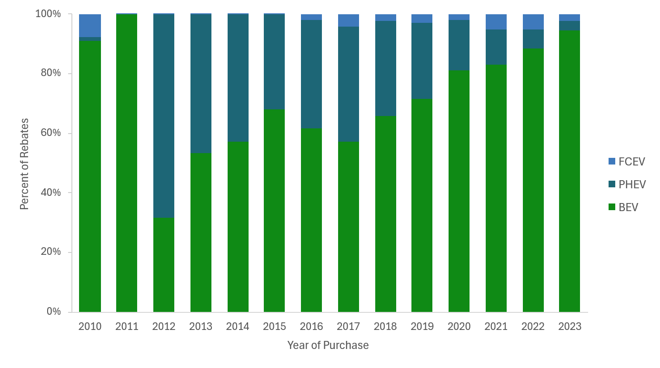

Figure c2
Average Electric Range Capability of Rebated Vehicles Over Time
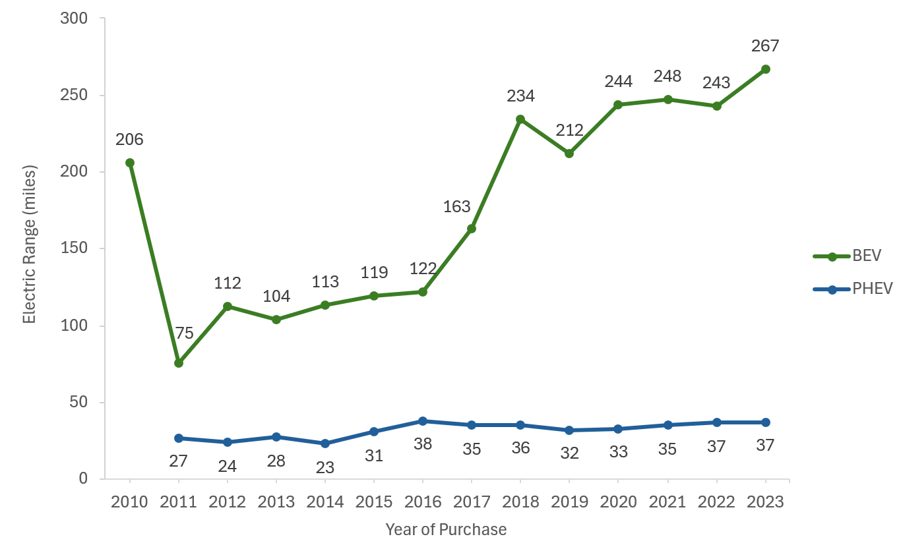
Note: Electric range based on the minimum range of any trim for a given model and model year.

Figure c3
Rebates by Vehicle Class
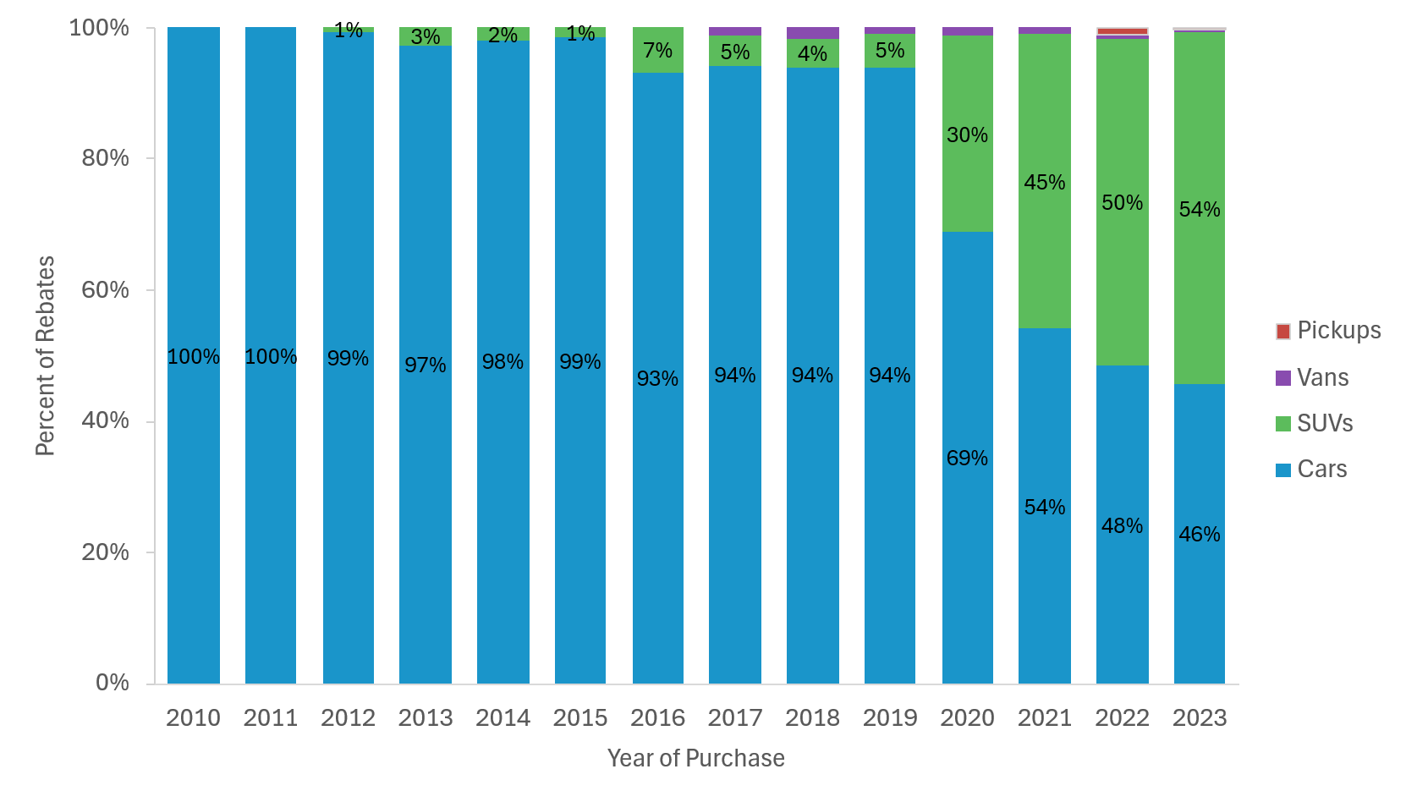

Appendix D: Fleet and TNC GHG Emission Reductions

Fleet GHG Emission Reductions
Public and private fleet vehicles totaled 2% of all CVRP rebates and are analyzed separately from personal (nonfleet) participants. Rebates by consumer type and technology type are detailed in Table D1 and D2, respectively.
TABLE D1
Rebates by Consumer Type
Fleet Participants
Consumer Type | Rebate Counts | Total Rebate Dollars
Business | 11,308  (80%) | $24,672,885  (75%)
Local Government Entity | 2,196  (15%) | $6,795,500  (21%)
Federal Government Entity | 201  (1%) | $212,000  (1%)
Non-Profit | 144  (1%) | $293,000  (1%)
State Government Entity | 348  (2%) | $784,000  (2%)
All | 14,197  (100%) | $32,757,385  (100%)

TABLE D2
Rebates by Vehicle Technology Type
Fleet Participants
Technology Type | Rebate Counts | Total Rebate Dollars
PHEV | 3,140  (22%) | $5,093,150  (16%)
BEV | 10,743  (76%) | $26,112,235  (80%)
FCEV | 314  (2%) | $1,552,000  (5%)
All | 14,197  (100%) | $32,757,385  (100%)

California fleet-specific annual VMT data are available as detailed in Table D3. These sources indicate that commercial EVs tend to be driven slightly more miles annually than personal EVs and government EVs are driven fewer miles.
TABLE D3
Annual VMT Values and Sources
Fleet Type | Technology Type | Annual VMT (First Year) | Detail and Sources
Business/Non-profit | PHEV | 14,545 | (California Energy Commission, 2021)
Business/Non-profit | Short Range BEV* | 11,227 | (California Energy Commission, 2021)
Business/Non-profit | Long Range BEV* | 14,344 | (California Energy Commission, 2021)
Business/Non-profit | FCEV | 13,434 | PHEV VMT from (California Energy Commission, 2021) scaled down based on the magnitude observed for personal consumers
State/Local Government | PHEV | 9,665 | (California Department of General Services, 2025)
State/Local Government | Short Range BEV* | 4,045 | (California Department of General Services, 2025)
State/Local Government | Long Range BEV* | 7,343 | (California Department of General Services, 2025)
State/Local Government | FCEV | 4,948 | (California Department of General Services, 2025)
Federal Government | PHEV | 8,666 | (US General Services Administration, 2025) average of all passenger vehicles years 2010–2023
Federal Government | Short Range BEV | 3,626 | Average of all passenger vehicles years 2010–2023 from (California Department of General Services, 2025) scaled down based on the magnitude observed for state government
Federal Government | Long Range BEV | 6,584 | Average of all passenger vehicles years 2010–2023 from (California Department of General Services, 2025) scaled down based on the magnitude observed for state government
Federal Government | FCEV | N/A | N/A
All | Baseline vehicle | 3,626 –14,545 | Same as paired rebated vehicle, consistent with (CARB, 2017b)
* Range subcategory distinguished based on known long-range makes (Tesla).

The CVRP Consumer Survey was not administered to fleet consumers, so only “rebated reductions” (reductions for all vehicles, relative to new gasoline vehicles) are quantified for fleets. Reporting focuses on first-year GHG reductions since fleets may be less likely to retain vehicles for 100k miles. In total, estimated first-year reductions average 3.1 tons per vehicle (Table D4). Reductions vary significantly by fleet type, driven largely by the differences in VMT (Table D3). Business and non-profit fleets, which are attributed a higher annual mileage than government fleets, display more reductions on average.
TABLE D4
GHG Reduction and Cost-Effectiveness Estimates by Fleet and Technology
All Rebated Emissions, New Gasoline Baseline
Fleet Type | Technology Type | Total Vehicles | Average First-Year Reductions  Per Vehicle (tons)
Business | PHEV | N = 2,246 | 2.7
Business | BEV | N = 8,825 | 3.7
Business | FCEV | N = 237 | 2.3
Non-profit | PHEV | N = 62 | 2.6
Non-profit | BEV | N = 79 | 3.4
Non-profit | FCEV | N = 3 | 1.4
Federal Government | PHEV | N = 5 | 1.4
Federal Government | BEV | N = 196 | 1.1
Federal Government | FCEV | N = 0 | N/A
State Government | PHEV | N = 207 | 2.1
State Government | BEV | N = 116 | 1.2
State Government | FCEV | N = 25 | 0.9
Local Government | PHEV | N = 620 | 1.9
Local Government | BEV | N = 1,527 | 1.2
Local Government | FCEV | N = 49 | 0.9
All | All | N = 14,197 | 3.1

TNC GHG Emission Reductions
The CVRP Consumer Survey 2020–2023 Edition asked respondents if they use their EV to drive for a transportation network company (TNC) such as Uber or Lyft. Since complete information about which participants drive for TNCs is unavailable (it is only known for respondents to the 2020–2023 Survey Edition), we separately analyze the GHG impacts of the known TNC sample here and provide an illustrative example of how GHG impacts overall may change when extrapolating the results.

California TNC driver annual VMT are estimated to range between 15,522 miles and 20,869 miles, as detailed in Table D5.
TABLE d5
Annual VMT Values and Sources
Technology Type | Annual VMT (First Year) | Detail and Sources
PHEV | 20,869 | PHEV TNC annual miles from (CARB, 2019) added to personal PHEV miles in Table A3
Short range BEV | 17,242 | BEV TNC annual miles from (CARB, 2019) added to personal short range BEV miles in Table A3
Long range BEV (200+ mi.) | 19,776 | BEV TNC annual miles from (CARB, 2019) added to personal long range BEV miles in Table A3
FCEV | 15,522 | FCEV TNC annual miles from (CARB, 2019) added to personal FCEV miles in Table A3
Baseline vehicle | 15,522 to 20,869 | Same as paired rebated vehicle, consistent with (CARB, 2017b)

The 2020–2023 Survey Edition identified 610 survey respondents (approximately 2.5% of the survey sample) who reported they use their EV for TNC driving. Because TNC vehicles are expected to be utilized more intensively than personal vehicles, they present a significant opportunity for GHG abatement. Reporting focuses on first-year GHG reductions since it is unknown how long participants will remain as TNC drivers. The average first-year GHG reduction for a TNC driver is estimated to be 5.3 tons, 59% more than the 3.3-ton average of other personal vehicle drivers relative to new gasoline vehicles. This highlights the potential of targeting high-mileage drivers to maximize the environmental return on rebate investments.

Extrapolating the survey prevalence of TNC drivers to the full personal vehicle program population of 570,668 vehicles suggests there may be approximately 14,219 TNC drivers within the CVRP participant base. If these drivers achieve the estimated additional GHG savings compared to the average participant, the program could be realizing an additional 74,000 tons of GHG reduction (+4%) annually beyond primary estimates for all rebated reductions.

References
Anderson, J. B., & Williams, B. D. H. (2019). Proposed FY 2019–20 Funding Plan: Final CVRP Supporting Analysis. Clean Vehicle Rebate Project. https://cleanvehiclerebate.org/en/content/proposed-fy-2019%E2%80%9320-funding-plan-final-cvrp-supporting-analysis
Auto Innovators. (2024). Economic Insights: State Facts. https://www.autosinnovate.org/resources/insights/ca
Auto Innovators. (2025). Electric Vehicle Sales Dashboard. https://www.autosinnovate.org/resources/electric-vehicle-sales-dashboard
Boston, D., & Werthman, A. (2016). Plug-in Vehicle Behaviors: An analysis of charging and driving behavior of Ford plug-in electric vehicles in the real world. World Electric Vehicle Journal 2016, Vol. 8, Pages 926-935, 8(4), 926–935. https://doi.org/10.3390/WEVJ8040926
California Department of General Services. (2025). California State Fleet. California Open Data Portal. https://data.ca.gov/dataset/california-state-fleet
California Energy Commission. (2021). 2019 California Vehicle Survey. https://www.energy.ca.gov/data-reports/surveys/california-vehicle-survey
California Energy Commission. (2025). Annual Power Content Labels for 2023. https://www.energy.ca.gov/programs-and-topics/programs/power-source-disclosure-program/power-content-label/annual-power-4
California State Auditor. (2021). Report 2020-114. www.auditor.ca.gov
California Air Resources Board (CARB). (2017a). Californias Advanced Clean Car Midterm Review Appendix G: Plug-in Electric Vehicle In-Use and Charging Data Analysis. California Air Resources Board.
CARB. (2017b). Proposed Fiscal Year 2017-18 Funding Plan for Clean Transportation Incentives.
CARB. (2019). SB 1014 Clean Miles Standard 2018 Base-year Emissions Inventory Report. https://ww2.arb.ca.gov/sites/default/files/2019-12/SB%201014%20-%20Base%20year%20Emissions%20Inventory_December_2019.pdf
CARB. (2020a). Assessment of CARB’s Zero-Emission Vehicle Programs Per Senate Bill 498. California Air Resources Board. https://ww3.arb.ca.gov/programs/zev/SB-498-Report-072320.pdf
CARB. (2020b). Low Carbon Fuel Standard Regulation.
CARB. (2025a). LCFS Pathways Requiring Public Comments: Archives. https://ww2.arb.ca.gov/resources/documents/lcfs-pathways-requiring-public-comments#t2
CARB. (2025b). Low Carbon Fuel Standard Regulation. https://ww2.arb.ca.gov/our-work/programs/low-carbon-fuel-standard/lcfs-regulation
CARB. (2025c). Low Carbon Fuel Standard Reporting Tool Quarterly Summaries. CARB. https://ww2.arb.ca.gov/resources/documents/low-carbon-fuel-standard-reporting-tool-quarterly-summaries
Chakraborty, D., Bunch, D. S., Brownstone, D., Xu, B., & Tal, G. (2022). Plug-in electric vehicle diffusion in California: Role of exposure to new technology at home and work. Transportation Research Part A: Policy and Practice, 156, 133–151. https://doi.org/10.1016/j.tra.2021.12.005
Chakraborty, D., Hardman, S., & Tal, G. (2021). Integrating Plug-in Electric Vehicles (PEVs) into Household Travel-Factors Influencing PEV Use in California. Transportation Research Board Annual Meeting.
Coffman, M., Bernstein, P., & Wee, S. (2017). Integrating electric vehicles and residential solar PV. Transport Policy, 53, 30–38. https://doi.org/10.1016/j.tranpol.2016.08.008
Center for Sustainable Energy (CSE). (2021, September). Summary of CVRP Rebate Eligibility and Funding Availability Over Time. Clean Vehicle Rebate Project. https://cleanvehiclerebate.org/en/content/summary-cvrp-rebate-eligibility-and-funding-availability-over-time-updated
Clean Vehicle Rebate Project (CVRP). (2023, August 15). IMPLEMENTATION MANUAL FOR THE CLEAN VEHICLE REBATE PROJECT (CVRP). Clean Vehicle Rebate Project. https://cleanvehiclerebate.org/sites/default/files/docs/nav/transportation/cvrp/documents/CVRP-Implementation-Manual.pdf
CVRP. (2024). Eligibility & Requirements. https://cleanvehiclerebate.org/en/eligibility-guidelines
Davis, S. C., & Boundy, R. G. (2022). TRANSPORTATION ENERGY DATA BOOK (40th ed.). Vehicle Technologies Office Office of Energy Efficiency and Renewable Energy, U.S. Department of Energy. https://tedb.ornl.gov/wp-content/uploads/2022/03/TEDB_Ed_40.pdf
Demuro, D. (2019). Buying a Car: How Long Can You Expect a Car to Last? https://www.autotrader.com/car-shopping/buying-car-how-long-can-you-expect-car-last-240725
US Department of Energy and Environmental Protection Agency (DOE and EPA). (2021). Fueleconomy.gov. https://www.fueleconomy.gov/
Duhon, A. N., Sevel, K. S., Tarnowsky, S. A., & Savagian, P. J. (2015). Chevrolet Volt Electric Utilization. SAE International Journal of Alternative Powertrains, 4(2), 269–276. https://doi.org/10.4271/2015-01-1164
Francfort, J., Bennett, B., Carlson, R., Garretson, T., & et al. (2015). Plug-in Electric Vehicle and Infrastructure Analysis. Idaho National Laboratory. https://inldigitallibrary.inl.gov/sites/sti/sti/6799570.pdf
Gillingham, K., & Stock, J. H. (2018). The Cost of Reducing Greenhouse Gas Emissions. Journal of Economic Perspectives, 32(4), 53–72. https://doi.org/10.1257/jep.32.4.53
Gohlke, D., & Zhou, Y. (2021). Assessment of Light-Duty Plug-in Electric Vehicles in the United States (2010—2020) (ANL/ESD--21/2, 1785708, 167626; p. ANL/ESD--21/2, 1785708, 167626). https://doi.org/10.2172/1785708
Grubert, E., Stokes-Draut, J., Horvath, A., & Eisenstein, W. (2020). Utility-specific projections of electricity sector greenhouse gas emissions: A committed emissions model-based case study of California through 2050. Environmental Research Letters, 15(10). https://doi.org/10.1088/1748-9326/abb7ad
Hardman, S. (2019). Understanding the Early Adopters of Fuel Cell Vehicles. https://doi.org/10.7922/G2736P4V
Idaho National Laboratory. (2015, June 9). Electric Vehicle Mile Traveled (eVMT): On-Road Results and Analysis. https://www.energy.gov/sites/prod/files/2015/07/f24/vss171_carlson_2015_p.pdf
Johnson, C., & Williams, B. (2017). Characterizing Plug-In Hybrid Electric Vehicle Consumers Most Influenced by California’s Electric Vehicle Rebate: Transportation Research Record, 2628, 23–31. https://doi.org/10.3141/2628-03
Lattanzio, R. K., & Clark, C. E. (2020). Environmental Effects of Battery Electric and Internal Combustion Engine Vehicles. Congressional Research Service.
Marmiroli, B., Messagie, M., Dotelli, G., & Van Mierlo, J. (2018). Electricity generation in LCA of electric vehicles: A review. Applied Sciences (Switzerland), 8(8), 1384-undefined. https://doi.org/10.3390/app8081384
Muehlegger, E. J., & Rapson, D. S. (2023). Correcting Estimates of Electric Vehicle Emissions Abatement: Implications for Climate Policy. Journal of the Association of Environmental and Resource Economists, 10(1), 263–282. https://doi.org/10.1086/721374
Pallonetti, N., & Williams, B. D. H. (2021). Refining Estimates of Fuel-Cycle Greenhouse-Gas Emission Reductions Associated with California’s Clean Vehicle Rebate Project with Program Data and Other Case-Specific Inputs. Energies, 14(15). https://doi.org/10.3390/en14154640
Pallonetti, N., & Williams, B. D. H. (2022a). Evaluating the Cost-Effectiveness of Greenhouse Gas Emission Reductions Associated with California’s Statewide Electric Vehicle Rebate Program in 2020 (with a Discussion of Two-State Results in 2019). International Energy Program Evaluation Conference 2022. International Energy Program Evaluation Conference 2022, San Diego, California. Forthcoming
Pallonetti, N., & Williams, B. D. H. (2022b). Evaluating the Cost-Effectiveness of Greenhouse Gas Emission Reductions Associated with Statewide Electric Vehicle Rebate Programs in California and Massachusetts in 2019 (p. 13). https://cleanvehiclerebate.org/en/content/evaluating-cost-effectiveness-greenhouse-gas-emission-reductions-associated-statewide
Pallonetti, N., & Williams, B. D. H. (2023). Vehicle Replacement: Findings from California’s Clean Vehicle Rebate Project. 36th International Electric Vehicle Symposium. EVS36, Sacramento CA, USA. https://evs36.com/wp-content/uploads/finalpapers/FinalPaper_Pallonetti_Nicholas.pdf
Pallonetti, N., Williams, B. D. H., & Sa, B. (2023). CVRP Greenhouse Gas Emission Reductions and Cost-Effectiveness, Update: 2021 Purchases/Leases. https://cleanvehiclerebate.org/sites/default/files/attachments/CVRP-2021-GHG-CE-update.pdf
Pallonetti, N., Williams, B. D. H., & Sa, B. (2024). CVRP Greenhouse Gas Emission Reductions and Cost-Effectiveness: 2022 Purchases/Leases. Center for Sustainable Energy. https://cleanvehiclerebate.org/sites/default/files/attachments/CVRP-2022-GHG-Cost-Effectiveness.pdf
Santulli, C., & Williams, B. (2015). Implementation Status Update | Clean Vehicle Rebate Project (CVRP Long-Term Planning Workshop). California Air Resources Board (CARB). https://cleanvehiclerebate.org/sites/default/files/attachments/2015-12-08%20Implementation%20Update.pdf
Sheldon, T. L., Dua, R., & Alharbib, O. A. (2023). How Cost-effective are Electric Vehicle Subsidies in Reducing Tailpipe-CO2 Emissions? An Analysis of Major Electric Vehicle Markets. The Energy Journal, 44(3), 223–250. https://doi.org/10.5547/01956574.44.2.tshe
Sarode, S., Elkind, E., & Cremers, E. (2023). CALIFORNIA’S POLICY APPROACH TO REDUCING MOBILE SOURCE EMISSIONS: The Regents of the University of California, on behalf of its Berkeley campus (UC Berkeley). https://www.law.berkeley.edu/wp-content/uploads/2023/06/CARB-Policies-Paper-Final.pdf
Tal, G., Raghavan, S. S., Karanam, V. C., Favetti, M., Sutton, K. M., Ogunmayin, J. M., Lee, J. H., Nitta, C., Kurani, K., Chakraborty, D., Nicholas, M., & Turrentine, T. (2020). Advanced Plug-in Electric Vehicle Travel and Charging Behavior Final Report.
US Department of Energy. (2020). U.S. HEV Sales by Model. https://afdc.energy.gov/data/10301
US Department of Energy & US Environmental Protection Agency. (2024). Fueleconomy.gov. https://www.fueleconomy.gov/
US Environmental Protection Agency. (2024). 2024 EPA Automotive Trends Report. https://www.epa.gov/automotive-trends/explore-automotive-trends-data
US Environmental Protection Agency. (2025). Greenhouse Gas Equivalencies Calculator. https://www.epa.gov/energy/greenhouse-gas-equivalencies-calculator
US General Services Administration. (2025). 2025 Federal Fleet Report (FFR) Open Data Set Library. https://www.gsa.gov/policy-regulations/policy/motor-vehicle-management-policy/ffr-open-data-set-library
US Office of Energy Efficiency and Renewable Energy. (2020). Electric Car Safety, Maintenance, and Battery Life. https://www.energy.gov/eere/electricvehicles/electric-car-safety-maintenance-and-battery-life#:~:text=Like%20the%20engines%20in%20conventional,5%20years%20or%2060%2C000%20miles.
Violette, D. M., & Rathbun, P. (2017). Chapter 21: Estimating Net Savings – Common Practices. In The Uniform Methods Project: Methods for Determining Energy Efficiency Savings for Specific Measures. National Renewable Energy Laboratory. https://www.nrel.gov/docs/fy17osti/68578.pdf
Warranty Requirements for Zero-Emission and Batteries in Plug-in Hybrid Electric 2026 and Subsequent Model Year Passenger Cars and Light-Duty Trucks (2022). https://govt.westlaw.com/calregs/Document/IB6A672007AEE11EDBFDBE1C0BB4630B7?viewType=FullText&originationContext=documenttoc&transitionType=CategoryPageItem&contextData=(sc.Default)#co_anchor_I701CA1E07D2511ED9EC0AB2F6B3FD1A8
Williams, B., & Anderson, J. (2018). Strategically Targeting Plug-in Electric Vehicle Rebates and Outreach Using Characteristics of “Rebate-Essential” Consumers in 2016-2017. 31st International Electric Vehicle Symposium.
Williams, B. D. H. (2022). Targeting Incentives Cost Effectively: ‘Rebate Essential’ Consumers in the New York State Electric Vehicle Rebate Program. 35th International Electric Vehicle Symposium (EVS35), Oslo, Norway. https://doi.org/doi: 10.13140/RG.2.2.22877.28640
Williams, B. D. H. (2025, March). Assessing Progress Toward Equitable Access to EVs with Incentive Program Metrics: Lessons Learned from CVRP and NY DCRP Using Program Data and Baselines of Comparison. CARB Clean Transportation Equity Incentives Symposium, Sacramento CA, USA. https://cleanvehiclerebate.org/en/content/assessing-progress-toward-equitable-access-evs-incentive-program-metrics-lessons-learned
Williams, B. D. H., & Anderson, J. (2019). Growing the Electric Vehicle Market: EV Adopters, ‘Rebate Essentials,’ and ‘EV Converts.’ Roadmap 12 Conference, Portland, OR. https://energycenter.org/thought-leadership/research-and-reports/growing-electric-vehicle-market-ev-adopters-rebate
Williams, B. D. H., & Pallonetti, N. (2023, June). Rebate Influence on Electric Vehicle Adoption in California. 36th International Electric Vehicle Symposium and Exhibition (EVS36), Sacramento CA, USA.
Williams, B. D. H., & Pallonetti, N. (2024). CVRP 2022 Data Brief: Vehicle Replacement. Center for Sustainable Energy. https://cleanvehiclerebate.org/en/content/presentation-%E2%80%9Ccvrp-2022-data-brief-vehicle-replacement%E2%80%9D
Williams, B., & DeShazo, J. R. (2014). Pricing Workplace Charging: Financial Viability and Fueling Costs. Transportation Research Record: Journal of the Transportation Research Board, 2454(1), 68–75. https://doi.org/10.3141/2454-09
Williams, B., Orose, J., Jones, M., & Anderson, J. (2018). Clean Vehicle Rebate Project: Summary of Disadvantaged Community Responses to the Electric Vehicle Consumer Survey, 2013–2015 Edition. Center for Sustainable Energy. https://cleanvehiclerebate.org/sites/default/files/attachments/DAC_Summary-CVRP_Cnsmr_Srvy_2013-15.pdf
Williams, B., & Pallonetti, N. (2022, February 10). Cost-Effectiveness of Greenhouse Gas Emission Reductions Associated with California’s Clean Vehicle Rebate Project in 2019 (and 2020) [Video Recording]. CARB’s First Public Workshop on the Fiscal Year 2022-23 Update to the Three Year Plan for Light-Duty Vehicles and Clean Transportation Equity Investments. https://www.youtube.com/watch?v=XhnXEoFb7Wo
Williams, B., & Pallonetti, N. (2023). CVRP 2021 Data Compilation: Incentive Influence & MSRP Considerations. https://cleanvehiclerebate.org/sites/default/files/attachments/CVRP-2021-Incentive-Influence.pdf
Williams, B., & Searles, K. (2017). California’s Electric Vehicle Rebates: Exploring Impact. https://cleanvehiclerebate.org/en/content/presentation-california%E2%80%99s-electric-vehicle-rebates-exploring-impact
Xing, J., Leard, B., & Li, S. (2021). What does an electric vehicle replace? Journal of Environmental Economics and Management, 107, 102432. https://doi.org/10.1016/j.jeem.2021.102432
Zero-Emission Vehicle Standards for 2018 and Subsequent Model Year Passenger Cars, Light-Duty Trucks, and Medium-Duty Vehicles (2012).

See the CVRP Implementation Manual (CVRP, 2023) for vehicle category definitions.
< 1% of applications had irregular rebate amounts due to extenuating circumstances.
Contains content licensed from S&P Global Mobility © 2024.
Sensitivity analysis indicates that the potential impact of varying carbon intensity of electricity across utilities is minor (see Appendix B).
Including conventional, non-plug-in hybrid models.
Precursor work modeled first-year emissions and scaled those up to estimate the lifetime period.
PHEV batteries are covered for 150,000 miles as required by California’s ZEV Standards (Zero-Emission Vehicle Standards for 2018 and Subsequent Model Year Passenger Cars, Light-Duty Trucks, and Medium-Duty Vehicles, 2012).
Other response options included “Not at all important” and “Slightly important.”
FCEV consumers (2% of rebates) are presented tailored survey questions and response options and are omitted from the counterfactual reductions analysis for simplicity.
Assigning non-Rebate Essential respondents no emission reductions is a conservatism. In data from prior survey editions, 3% of non-Rebate-Essential respondents reported non-EV counterfactual behaviors and another 3% reported that they would not have made a purchase/lease at all.
In Survey Editions 2020–2023 & 2023–Close, 95% of replaced vehicles were reported to previously be their primary vehicle.
In prior editions, the counterfactual behavior question was provided to all respondents, so those responses are used directly and Rebate Essentiality is not referenced.
However, FCEV results are sensitive to the assumed carbon intensity of hydrogen, as explored in Appendix B.
One such approach focused on minimizing free ridership was explored in (Pallonetti et al., 2024).
Previous related work has characterized replaced vehicles as primarily consisting of older gasoline vehicles, though replacement of previously-owned EVs increased modestly over time (B. D. H. Williams & Pallonetti, 2024). Replaced vehicle characteristics will be explored further in additional forthcoming CVRP retrospective reporting.
This group was assumed to drive their previous vehicle for three additional years, with the remainder of their 100k miles being represented by the average for the cohort three years after their purchase date (2023 cohorts were used for years 2023 or later).
However, logistic regression-based predictive modeling of Rebate Essentiality explored for this analysis did not yield better predictive performance than the cohort averages used.
Counterfactual reductions use alternative baselines, detailed further below.
Sales are based on new vehicle registration data from S&P Global Mobility. The 75 top-selling models were found to compose more than 75% of the light-duty vehicle sales for each model year.
Specifically, rebated EV emissions from non-respondents are first compared to a gasoline vehicle with an average fuel consumption rate equal to the cohort-specific average MPG of the gasoline and conventional hybrid counterfactual comparison vehicles. Previous vehicle MPGs are included in the MPG averages for the first three years and excluded from year four on. GHG reduction results are then scaled down by cohort-specific weighted percentages of participants for which no emission reductions are attributed: the sum of counterfactual vehicles that were electric and, from 2021 on, respondents that were non-Rebate-Essential.
Based on ~60 top-selling gasoline models excluding hybrids, which composed >72% of all sales in each model year.
Cohort average vehicles as applied to survey non-respondents. 2023 cohorts used for EVs purchased from 2020 on.
Based on ~70 top-selling gasoline models excluding hybrids, which composed >75% of all sales in each model year.
Hybrid/Gasoline mix based on 2021 data (the first year of data available).
Cohort average vehicles as applied to survey non-respondents.
Additional literature-derived sensitivity tests on vehicle and fuel inputs, as well as tests on rebate influence estimation can be found in precursor work (Pallonetti et al., 2024). Additional sensitivity analysis on counterfactual behavior input values will be provided in forthcoming work characterizing the GHG cost-effectiveness of CVRP in 2023.
Question and response options across survey editions can be found in forthcoming survey documentation.
Assuming daily VMT equals 1/365th of annual VMT. Daily electric VMT for PHEVs is calculated with the model-specific utility factor. Daily electric VMT quantified with solar charging was capped at each vehicle’s model-specific electric range, though this was non-binding in all cases.

