



CVRP Consumer Characteristics & Equity Metrics
Clean Vehicle Rebate Project
Retrospective Participant Summary
February 12, 2026

Please cite this reference: Pallonetti, N. (2026, February). “CVRP Consumer Characteristics & Equity Metrics: Clean Vehicle Rebate Project Retrospective Participant Summary.” Prepared by the Center for Sustainable Energy for the Clean Vehicle Rebate Project, California Air Resources Board, Sacramento USA.

© 2026 Center for Sustainable Energy
Disclaimer: The Center for Sustainable Energy® (CSE) makes every effort to present accurate and reliable information. However, the content is presented “as is” without warranty of any kind. Reference to any specific commercial product, process or service does not constitute or imply endorsement, recommendation or favoring by CSE. Center for Sustainable Energy, CSE and CSE logo are registered trademarks of the Center for Sustainable Energy.
CSE Headquarters
Center for Sustainable Energy
3980 Sherman Street, Suite 170
San Diego, CA 92110
858-244-1177
EnergyCenter.org
Contents
Introduction 4
Previous Related Work 6
Data and Methods 6
Program Data 6
External Data 7
Results and Discussion 8
What does the overall CVRP participant makeup look like? 8
How does the CVRP participant makeup compare to new-car buyers? 15
What was the effect of equity-related program elements & what is the road ahead? 21
Rebates vs Funding 21
Market-Majority Metrics Among Strategic Consumer Segments 24
Key Insights 29
Acknowledgments 30
APPENDICES 31
Appendix A: Data Summary 32
Appendix B: Rebates vs Funding – Additional Characteristics 33

Introduction
California’s Clean Vehicle Rebate Project (CVRP) ran between 2010–2023 and offered a post-purchase cash incentive for residents who purchased or leased an eligible new EV. The program was funded by the California Air Resources Board (CARB) and administered statewide by the Center for Sustainable Energy (CSE). From its inception in March 2010 through its closure in late 2023, the bulk of CVRP incentives were the 556,758 rebates for personal-use battery electric vehicles (BEVs) and plug-in electric vehicles (PHEVs), totaling $1.375 billion in rebates. This summary builds on prior work by CSE detailing the characteristics of EV rebate program participants with an aim to describe who benefitted from CVRP over the life of the program and how equitable it was relative to new-car buyers in the state.
Over the course of CVRP’s nearly 14 years, the EV market developed significantly from its infancy to the point where over 1 in 4 new vehicles sold was electric. As EVs became more widely adopted in California, program goals evolved from broadly spurring consumer demand for EVs, to reaching mainstream consumers and priority populations, and eventually improving equity in the EV transition. Accordingly, the program rolled out design changes with vehicle- and income-based criteria that increasingly directed funding and eligibility to these target markets. Because the program spanned such fluctuations, its participant characteristic and equity metrics can be better understood when evaluated over time and against the backdrop of distinct program designs. As such, metrics are analyzed year over year and across five distinct eras of CVRP, each distinguished by major changes made to the program over time. Pertinent program changes in each era are summarized in Table 1 and rebate amounts over time are detailed in Table 2. Program and market context will be detailed further in additional retrospective CVRP reporting and more detail on program eligibility is available on the CVRP website.,
Previous related work is summarized next, followed by a description of the data and methods used. The remainder of this summary 1) characterizes the CVRP participant makeup overall, across strategic consumer segments, and relative to new-car buyers, and 2) examines how the distribution of rebate funding across participant groups differs from rebate volumes, leading to the following key insights.
- CVRP became considerably more equitable over the course of the program.
  - Across each consumer characteristic measured, CVRP participants progressed substantially toward mainstream new-car buyers over time.
- By the final year of CVRP, metrics of race/ethnicity, income, and age had reached or surpassed mainstream new-car buyer levels while metrics of gender, education, and homeownership had not.
- The Increased Rebate and other equity-focused program changes were effective in directing rebate funds toward lower-income consumers.
- Targeting income-qualified consumers and other strategic consumer segments can help move the characteristics of program participants closer to, or further beyond, those of mainstream car buyers.
Table 1
Program Design Over Time
Personal (nonfleet) PHEVs and BEVs
Program Era 1 (March 15, 2010 – March 28, 2016)​  as of Mar. 2010​  - Incentive stacking permitted​  - 36-month ownership requirement​  - Rebates per year limit = 20​  as of Dec. 2013​  - Rebates per year limit = 2​  as of May 2014​  - 18-month application window​  as of Dec. 2014 / Jan. 2015​  - 30-month ownership requirement (retroactive)​  - Total rebate limit = 2​ | Program Era 4 (December 3, 2019 – February 23, 2022)​  as of Dec. 2019​  - Total rebates limit = 1 §​  - Base MSRP ≤ $60k (PEVs)​  - 3-month application window ‡​  - ≥ 35 UDDS electric miles​  - +$2,500 † for income-qualified households (≤ 300% FPL), excl. ZEMs​  as of Apr. 2020​  - Stacking with CVAP grant permitted​  as of Jan. 2021​  - +$2,500 for income-qualified households, ≤ 400% FPL, excl. ZEMs​  as of Apr. 2021​  - ≥ 30 U.S. EPA electric miles (45 UDDS)​  - Rebate Now preapproval option limited to income-qualified households, expanded from San Diego to include San Joaquin Valley​
Program Era 2 (March 29, 2016 – October 31, 2016)​
as of Mar. 2016​
- $250k–$500k income cap (PEVs)​
- +$1,500 for income-qualified households (≤ 300% FPL), excluding ZEMs​
Program Era 5 (February 24, 2022 – Program Close)​
as of Feb. 2022​
- Base MSRP: ≤ $60k for Large Vehicles*, ≤ $45k for Cars*​
- $135k–$200k income cap (PEVs)​
- $135k–$200k income cap on stacking HOV decal (only binding on FCEVs)​
as of Jul. 2022​
- $150k–$300k income cap on stacking HOV decal (only binding on FCEVs)​
as of Feb. 2023​
- +$3,000–$5,500 for income-qualified households, ≤ 400% FPL, excl. ZEMs​
as of Aug. 2023​
- $2,000 EV Charge Card for income-qualified households, ≤ 400% FPL (PEVs)​
Program Era 3 (November 1, 2016 – December 3, 2019)​
as of Nov. 2016​
- $150k–$300k income cap (PEVs)​
- ≥ 20 UDDS electric miles​
- +$2,000 for income-qualified households (≤ 300% FPL), excl. ZEMs​
as of Jan. 2018​
- $150k–$300k income cap on stacking HOV decal (only binding on FCEVs)​
- Rebate Now San Diego County preapproval pilot with point-of-sale option​
as of Jan. 2019​
- Stacking with CVAP grant not permitted (retroactive)​

PEVs = plug-in EVs. FPL = Federal Poverty Level. ZEMs = zero-emission motorcycles. UDDS = Urban Dynamometer Driving Schedule. HOV = high-occupancy-vehicle. FCEVs = fuel-cell EVs. CVAP = Clean Vehicle Assistance Program. MSRP = manufacturer suggested retail price.
§ A second rebate can be approved for a FCEV if the first rebate was for a PEV.
‡ COVID exemptions on application window effectively delayed implementation until 4/15/2021.
† Change due to $500 decrease in Standard Rebate amounts (see Table 2).
* Large Vehicles = minivans, pickups, and SUVs; Cars = all other light-duty vehicle classes (e.g., hatchbacks, sedans, wagons, and two-seaters).
Table 2
Rebate Amounts Over Time
Technology Type | as of  Mar. 2010 | as of  Jun. 2011 | as of  Jul. 2013 | as of  Jun. 2014 | as of  Mar. 2016 | as of  Nov. 2016 | as of  Dec. 2019 | as of  Feb. 2023
Battery EVs † | $3,000§– $5,000‡ | $1,500§– $2,500‡ | $2,500 | $2,500 | SR*: $2,500  IR*: $4,000 | SR: $2,500  IR: $4,500 | SR: $2,000  IR: $4,500 | SR: $2,000  IR: $7,500
Plug-in Hybrid EVs | $3,000§ | $1,500 | $1,500 | $1,500 | SR: $1,500  IR: $3,000 | SR: $1,500  IR: $3,500 | SR: $1,000  IR: $3,500 | SR: $1,000  IR: $6,500
† Range-extended battery electric vehicles were given the BEV rebate amount.
‡ Amounts varied by ZEV type. For definitions, see CCR 1962.1.
* SR = Standard Rebate, IR = Increased Rebate
§ None distributed.

Previous Related Work
This participant summary builds on a rich collection of previous work detailing the characteristics of CVRP and other EV rebate program participants. Recent work providing the framework for this summary includes a series of annual CVRP data briefs through 2022 with select 2023 updates available in a CARB Clean Transportation Equity Incentives Symposium presentation, and a refereed journal article. A compilation of additional related work can be found in the CARB Symposium presentation (see slides 7–9). This summary extends past work by providing a final life-of-program accounting of CVRP consumer characteristics and equity metrics.

Data and Methods

Program Data
CVRP administered voluntary surveys of participants since 2012 to better understand EV consumers, the evolving EV market, and program impacts. This report examines 98,089 responses to the CVRP Consumer Survey, collected over six sequential editions. It includes personal (nonfleet) consumers of plug-in hybrid electric vehicles (PHEVs) and battery electric vehicles (BEVs). Survey representativeness, statistical weighting, and other data details specific to this analysis are provided in Appendix A. More information on the CVRP Consumer Survey is available online and updated details will be made available in forthcoming survey documentation. Important changes in survey question language and/or response options across survey editions will be noted throughout this summary. Beginning in 2017, CVRP applications included questions about age, gender, and race/ethnicity. Those data are reported alongside survey data in some sections below and are also further detailed in Appendix A.
Survey statistics (e.g., response proportions) are weighted in order to be more representative of the program participant population. Due to rounding, summing the weighted proportions may not always add to 100%. Application data statistics are unweighted, as responses were required by all applicants (see Appendix A for further detail).
As discussed in previous work, while CVRP participants have comprised large percentages of the California EV market during much of the analyzed period, it should not be assumed that they fully represent all EV consumers in the state. As such, though the results of this work may be useful for informing the assessment of other EV deployments and providing broader insights into the EV market, CVRP participants may not be a representative sample for these other use cases. Lack of insight into non-participant characteristics and behavior may limit the ability to appropriately extrapolate results outside the context of the program. Further, program eligibility requirements cause the CVRP population to systematically differ from the general EV-buying population, and changes in program eligibility over time (see Table 1) will affect results.

External Data
Following the previous related work described above, characteristics of California new-car buyers from two external data sources are compared to CVRP participants. The first is the 2017 National Household Travel Survey (NHTS), which is summarized in previous related work. Two new-car buyer survey datasets from the New Vehicle Experience Study (NVES) by Strategic Vision are also used—one each for 2019 and 2022 purchases/leases in California. To make NVES data more representative of the statewide market, CSE statistically weighted the 2022 dataset relative to vehicle models purchased in California based on 2022 registration data. Consumer characteristic metrics varied only slightly (by no more than one percentage point) when generated with these CSE weights versus weights provided by the data vendor, which were based on national vehicle data. Thus, the vendor-provided weights are used for the 2019 dataset for simplicity. Another important note about the NVES is that Tesla consumers are not included in the 2022 data, which may have an effect on results. Lastly, Census data are reported for additional context on how California’s population changed over time. The American Community Survey Public Use Microdata Sample 1-year estimates were used.

Results and Discussion

What does the overall CVRP participant makeup look like?
In this section, CVRP survey data characterizing participant household income, age, gender identity, educational attainment, home ownership, and racial/ethnic identity metrics are described across time.
Household income data were collected in each edition of the CVRP Consumer Survey. The distribution of participant incomes is presented year over year in Figure 1. Since many program eras had design changes that directly affected eligibility based on income (see Table 1), income distributions are also displayed by program era in Figure 2. Household income of $100k to $150k was consistently the most common among participants, ranging from 23% of rebates in 2015 to 32% of rebates in 2023. Prevalence of incomes less than $150k increased over time. The $50k to $100k group increased the most from the start to the end of the program, doubling from 14% to 31%. Incomes of $300k or more were relatively common in the first program era but decreased markedly after 2015 when income-based eligibility requirements were established (in era 2) and then lowered (in era 3). Prevalence of incomes between $200k and $300k decreased modestly in era 4 and substantially in era 5 when income-based eligibility requirements were again made more stringent.
Figure 1
Annual Household Income by Year of Vehicle Purchase
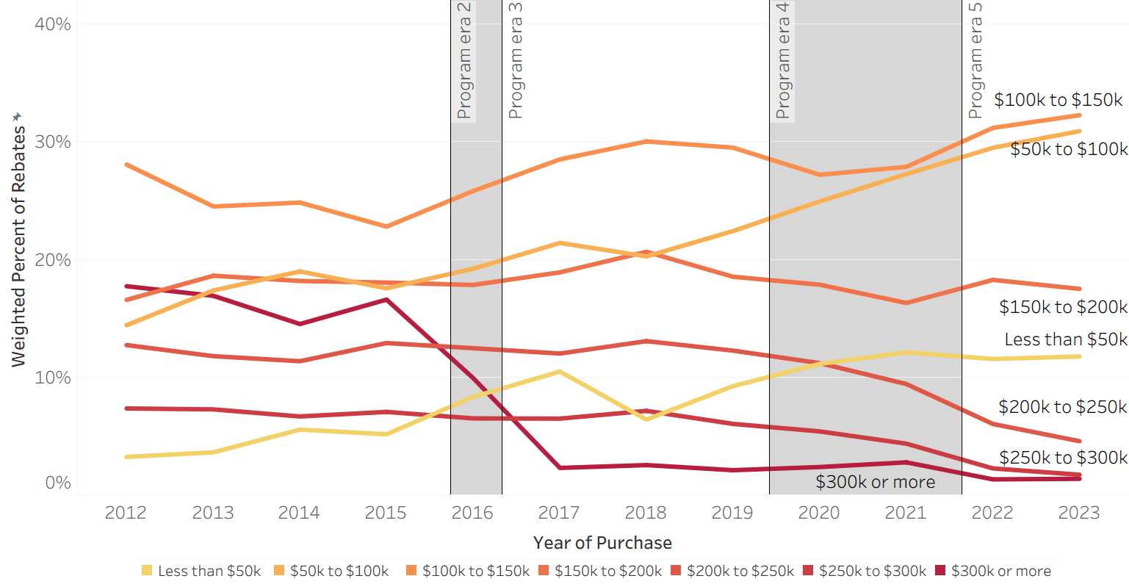

Figure 2
Annual Household Income by Program Era
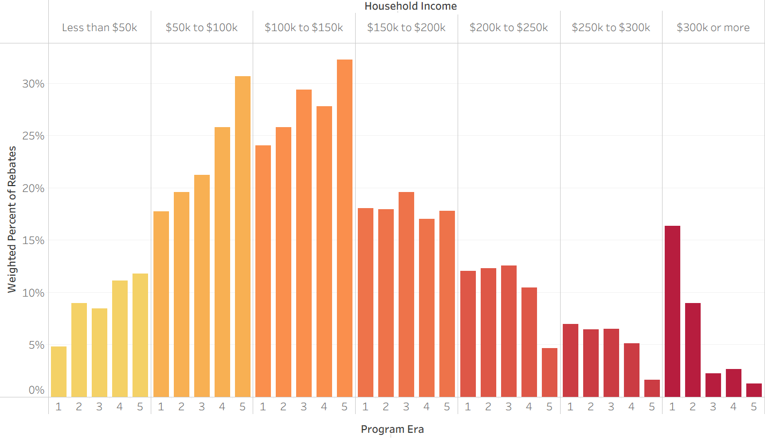

Participant age data were collected in each edition of the CVRP Consumer Survey except the 2020–2023 Edition, which included vehicles purchased from December 2020 through July 2023. Response proportions by survey age groups are presented over time in Figure 3. Participant ages in the 40s and 50s were the most common, followed by 30s and 60s. Participation of consumers in their 20s and 70s generally increased over time while participation of those in their 40s and 50s decreased. Increasing trends among participants in their 60s and 70s reversed between 2020 and 2023, as participation among those in their 20s and 30s both increased substantially.
Figure 3
Participant Age Over Time
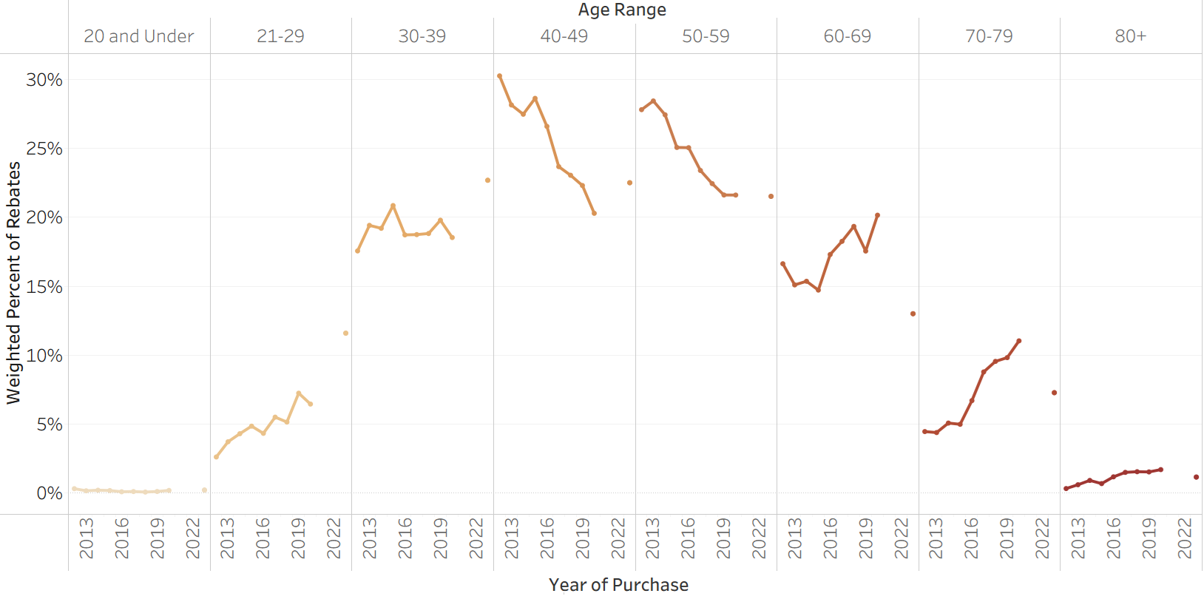 Note: Age data unavailable in 2020–2023 Survey Edition.

Gender identity data were collected in each edition of the CVRP Consumer Survey except the 2020–2023 Edition (which spanned December 2020 through July 2023). The distribution of gender responses is presented for each available year in Figure 4. Male gender was by far the most common, though it declined over time, falling from 80% in 2012 to 65% in 2023. Female participation increased over time but reached a high of only 35% in 2023.
Figure 4
Gender Over Time
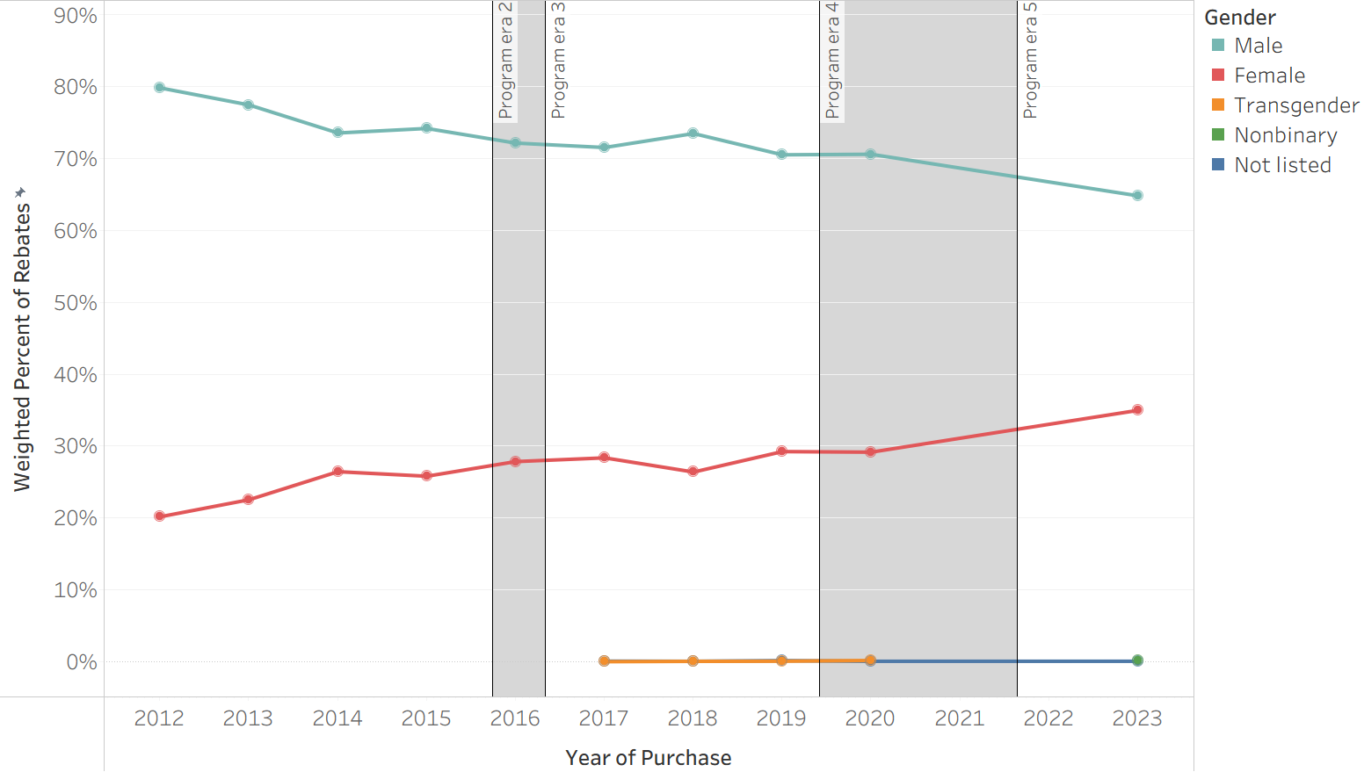
Note: Gender data unavailable in 2020–2023 Survey Edition. Transgender and “Not listed” response options introduced in the 2017–2020 Survey Edition and Nonbinary response option introduced in the 2023–Close Survey Edition.

Educational attainment data were collected in each edition of the CVRP Consumer Survey. The distribution of education levels is presented year over year in Figure 5. Over time, most participants (70%–86%) had a college degree. Postgraduate degree was the most common education level through 2020, though it declined over time. Postgraduate participation fell substantially from 2019 through 2021 as participation among those with bachelor’s degrees continued a steady increase (which began after the first program era) and participation among consumers without college degrees also increased. From 2021 on, bachelor’s degree was the most common education level.
Figure 5
Educational Attainment Over Time
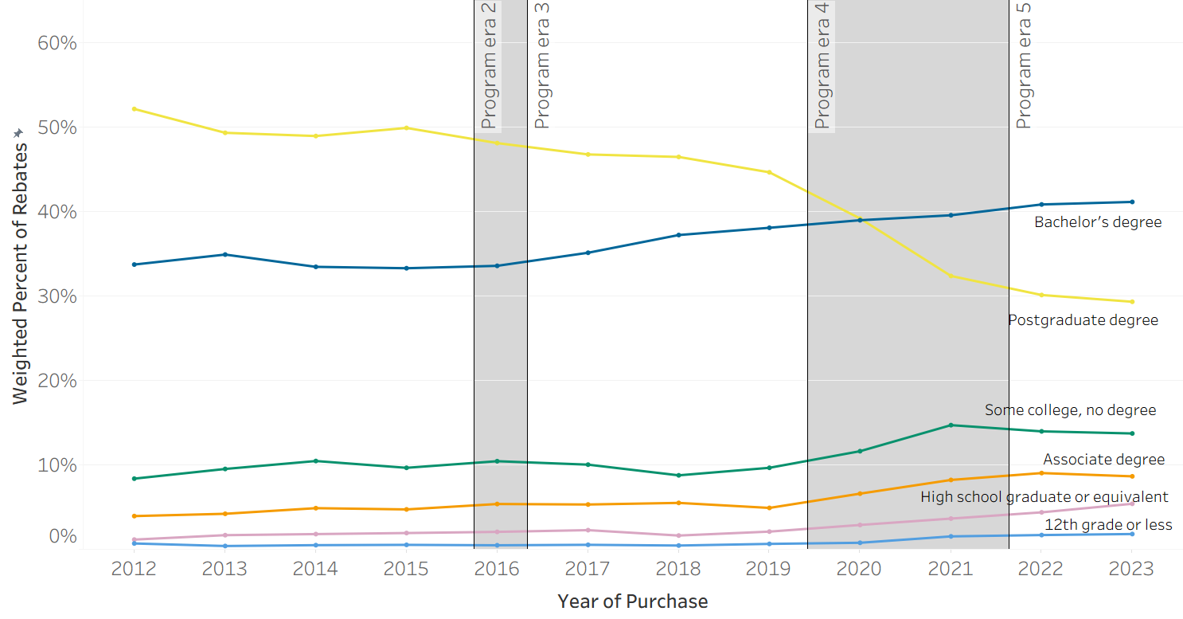

Home ownership data were collected in each edition of the CVRP Consumer Survey. As displayed in Figure 6, participants tended to be homeowners. Home ownership decreased modestly over time from 89% in 2012 to 71% in 2023 as participation among renters increased from 11% to 26%. The “Neither rent nor own” response option was introduced in the 2020–2023 Survey Edition (starting Dec. 2020) and composed 3% of respondents each year from 2021–2023.
Figure 6
Home Ownership Over Time
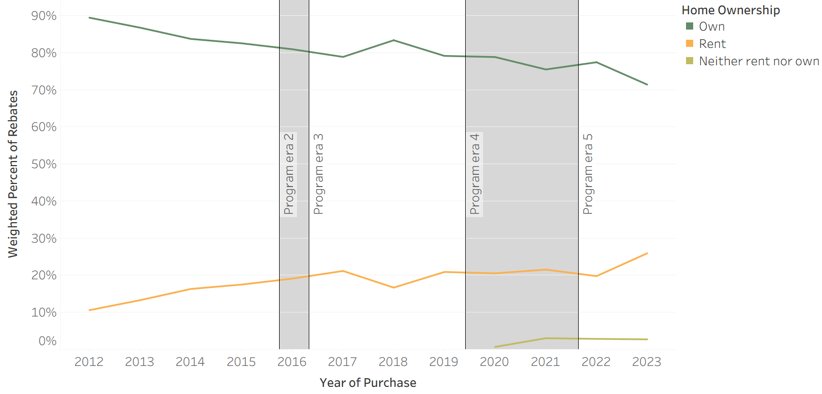
Note: “Neither rent nor own” response option introduced in the 2020–2023 Survey Edition (starting Dec. 2020).
Race/ethnicity data were collected in each edition of the CVRP Consumer Survey except the 2020–2023 Edition. Because the response options that were provided tended to vary across survey editions (with an aim to reflect evolving data collection best practices), Figure 7 provides responses by survey edition, rather than year over year. Participants most commonly identified as solely white or Caucasian, though levels declined substantially over time. In the 2013–2015 Edition, 65% of respondents identified as white/Caucasian. By the 2023–Close Edition that had decreased to 32%. Asian was the second most common option selected in the first two survey editions (22% in both). In subsequent editions, when more specific Asian response options were provided, East Asian (13–19%), South Asian (7–10%), and Southeast Asian (14%, provided only in the 2023–Close Edition) were each commonly selected. Latino(a) or Hispanic participants steadily increased over time (from 6% to 15%) as did those who selected more than one race/ethnicity (from 3% to 6%). The additional race options each composed no more than 2% of any survey edition, including Black or African American, Middle Eastern or North African, Filipino, Native Hawaiian or other Pacific Islander, and American Indian or Alaska Native.
Figure 7
Race/Ethnicity by Survey Edition

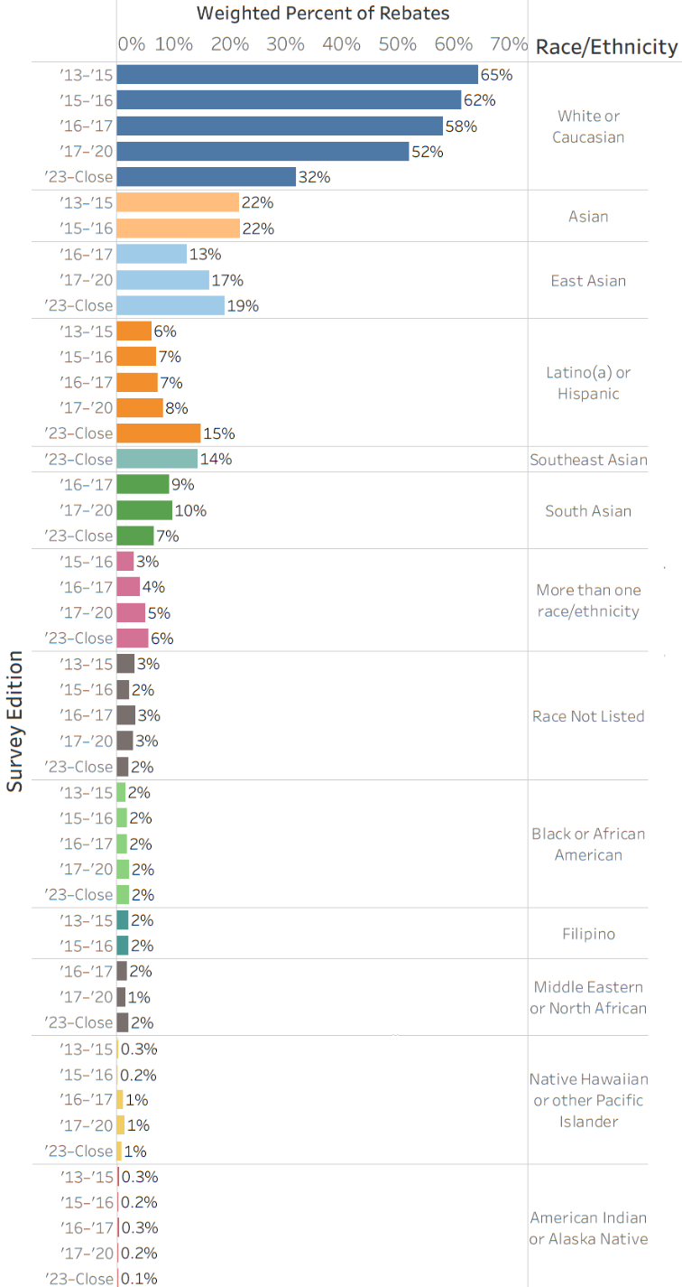
Note: Race/ethnicity data unavailable in 2020–2023 Survey Edition.

How does the CVRP participant makeup compare to new-car buyers?
Previous related work has demonstrated that because CVRP was a program for which only new vehicles were eligible, new-vehicle buyers are the appropriate comparison point from which to assess the characteristics of CVRP participants. Following the approach set out in that previous work, this section 1) describes broad consumer characteristics that constitute the majority of new-vehicle buyers in California (or “Market-Majority Metrics”) and 2) presents the proportion of CVRP rebates over time that went to participants with those characteristics.
Based on the 2022 NVES data, the following characteristics describe the majority of new-vehicle buyers in California:
- Annual household income: $100k or more (58%)
- Age: 30–59 years (65%)
- Gender: male (58%)
- Educational attainment: bachelor’s degree or higher (60%)
- Homeownership: owns residence (62%)
- Race/ethnicity: solely white/Caucasian (44%)
In the remainder of this section, consumer characteristics based on CVRP application data are presented alongside CVRP Consumer Survey data when available (from 2017 on, for age, gender, and race/ethnicity). Census data, while not an appropriate comparison for participants of a new-vehicle program, are provided for additional context of how the general population in California has changed over the same time period.

The proportion of California new-car buyers with annual household income of $100k or more is estimated to range between 54% and 58% (based on data describing the years 2017, 2019, and 2022), making it the Market-Majority Metric for income. CVRP Consumer Survey data indicate that CVRP participants were more frequently in this income group early on but steadily progressed toward mainstream new-car buyers over time, reaching parity by the programs end (Figure 8). In 2012, an all-time high of 82% of CVRP participants had incomes of $100k or more—24 percentage points above even the highest new-car buyer estimate of 58%. The proportion of CVRP participants in this income group continually decreased over time. By 2019, participants were within 14 percentage points of the 2019 new-car buyer estimate and were within 1 percentage point by 2022. By the end of the program in 2023, participants with household income of $100k or more had decreased sharply from 82% to 57%. This is even more notable considering the statewide population (CA Census) in this income group increased sharply from 28% to 48% across this same period.
Figure 8
CVRP and CA New-Car Buyer Household Income ($100k or more)
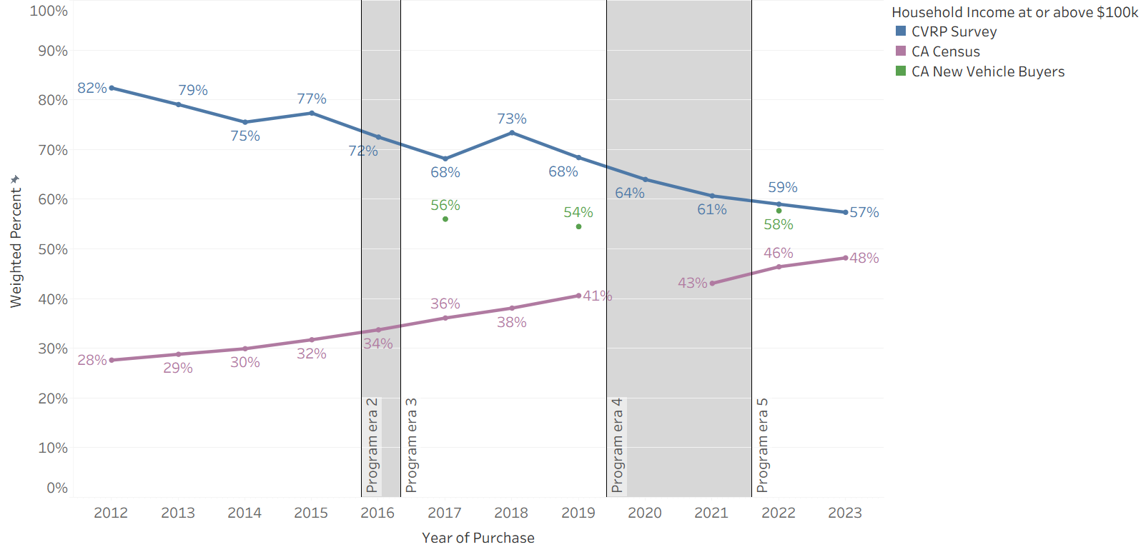
Note: NVES data (used for New Vehicle Buyers in 2019 and 2022) characterizes income > $100k (not ≥).

The proportion of California new-car buyers age 30–59 (or “middle aged”) is estimated to range between 60% and 66%. CVRP Consumer Survey data indicate CVRP participants were more frequently in this Market-Majority age group early on, but the proportion of middle-aged participants decreased to approximate new-car buyers’ levels in 2017 (Figure 9). From 2012–2013, an all-time high of 76% of CVRP participants were middle aged—10 percentage points above the highest new-car buyer estimate. The survey data indicate that the proportion of CVRP participants that were middle aged decreased in 2016 and 2017 and was within the range of new-car buyers thereafter. However, a secondary measure of participant age from rebate applications (see Appendix A for application data details) indicates a higher middle-age frequency persisted between 2017 and 2022 (suggesting that middle-aged program participants may be less likely to respond to the survey). The two CVRP data sources roughly converge in 2023, however, with the application data indicating that middle-age participation decreased in 2023 and was within 3 percentage points of the nearest (2022) estimate of new-car buyers. While the state population (CA Census) in the Market-Majority age group also decreased during this period, it was modest (3 percentage points) relative to either estimate of CVRP participants through 2023 (5–9 percentage points).
Figure 9
CVRP and CA New-Car Buyer Age (30–59 years)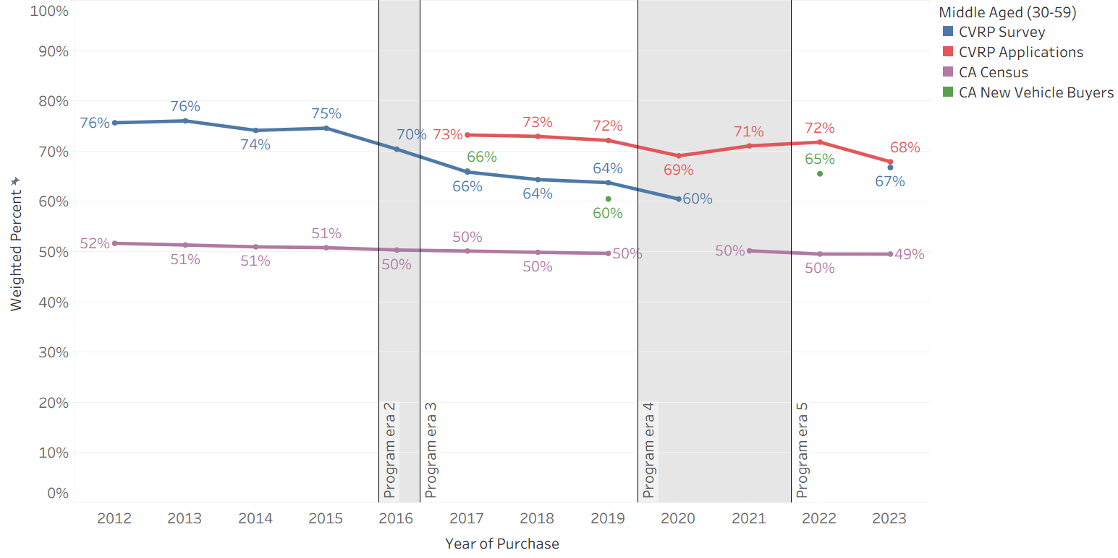

The proportion of California new-car buyers that were male is estimated to range between 50% and 59%. CVRP Consumer Survey data indicate that CVRP participants were more frequently male but progressed toward new-car buyers’ levels over time (Figure 10). In 2012, an all-time high of 80% of CVRP participants were male—21 percentage points above the highest new-car buyer estimate. The CVRP application data show similar but slightly lower levels of male participation during years when the data sources overlap. By 2019, male participation was within 10–12 percentage points of new-car buyers and by 2022 they were within 5 percentage points. By the end of the program in 2023, male particpation had decreased approximately 15 percentage points from 80% to 64–65%.
Figure 10
CVRP and CA New-Car Buyer Gender (Male)
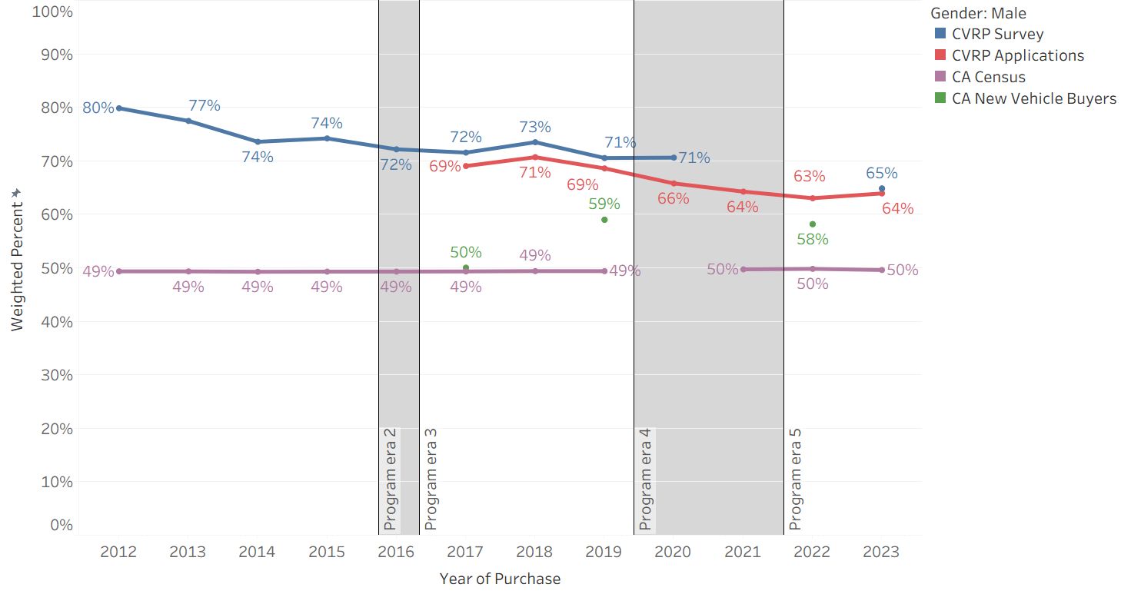

The proportion of California new-car buyers that had a bachelor’s degree or higher is estimated to range between 58% and 63%. CVRP Consumer Survey data indicate that CVRP participants tended to be more highly educated than new-car buyers early on but progressed toward the mainstream over time (Figure 11). In 2012, an all-time high of 86% of CVRP participants had at least a bachelor’s degree, 23 percentage points above the highest new-car buyer estimate. The proportion of CVRP participants in this Market Majority group decreased only slightly through 2019 but dropped substantially in 2020 and 2021. By 2023, participant education in the Market Majority was within 10 percentage points of the nearest (2022) estimate of new-car buyers. In contrast, the statewide population with this level of educational attainment increased by 7 percentage points across this period.
Figure 11
CVRP and CA New-Car Buyer Education (Bachelor’s degree or higher)
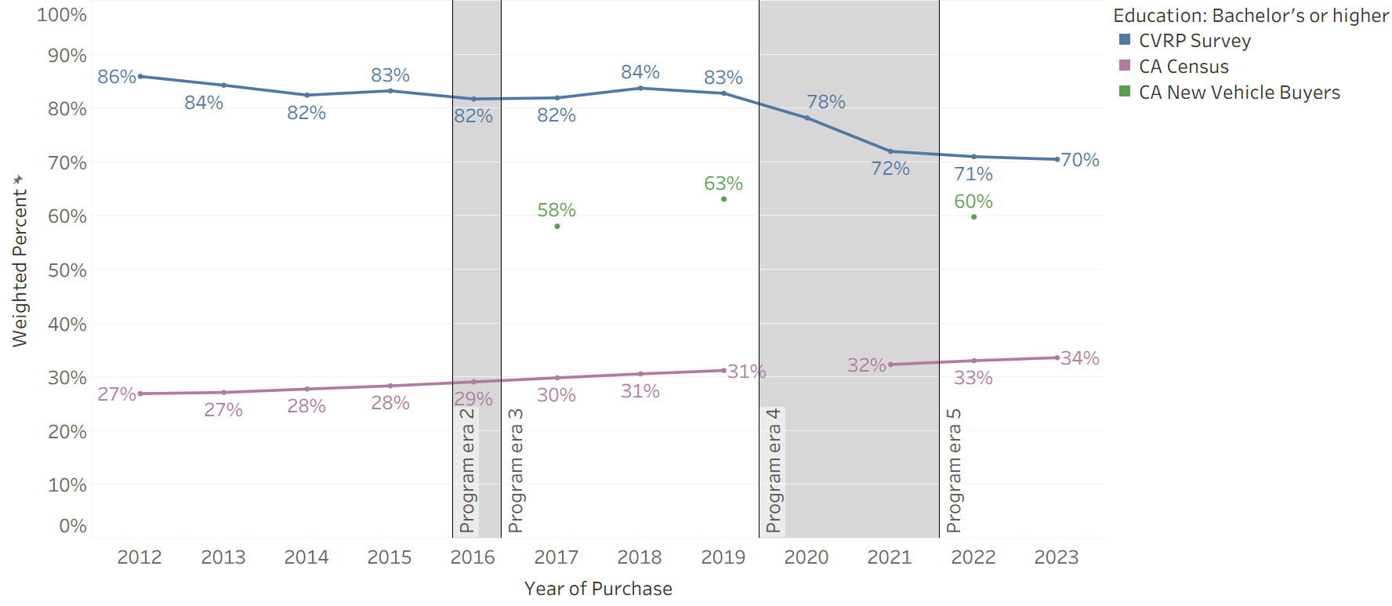

The proportion of California new-car buyers that owned their home is estimated to range between 62% and 63%. CVRP Consumer Survey data indicate that CVRP participants were more commonly homeowners early on but progressed toward new-car buyers’ levels over time (Figure 12). In 2012, an all-time high of 89% of CVRP participants were homeowners—26 percentage points above the highest new-car buyer estimate. The proportion of CVRP participants that owned homes decreased gradually over time. By 2022, participant homeownership was within 15 percentage points of new-car buyers. Homeownership decreased to an all-time low (71%) in 2023—within 9 percentage points of the 2022 new-car buyer estimate.
Figure 12
CVRP and CA New-Car Buyer Home Ownership (Owns residence)
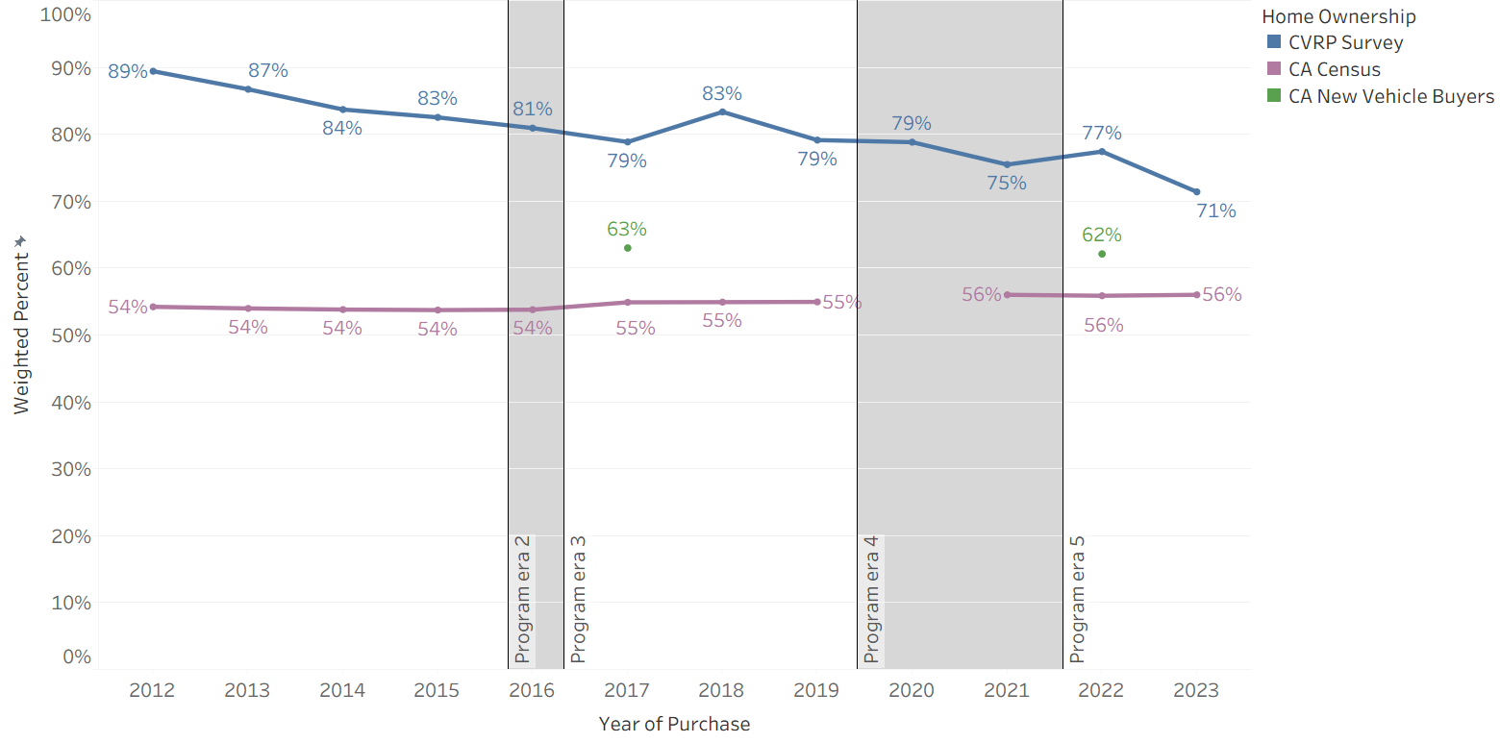
Note: Home ownership data not available for New Vehicle Buyers in 2019.
The proportion of California new-car buyers identifying as solely (non-Hispanic) white/Caucasian is estimated to range between 44% and 51%. CVRP Consumer Survey data indicate that the identification of solely white/Caucasian among CVRP participants began higher but steadily progressed toward and then beyond mainstream new-car buyers over time (Figure 13). In 2012, an all-time high of 70% of CVRP participants identified as solely white/Caucasian—19 percentage points higher than the highest new-car buyer estimate. The CVRP application data shows 5–10 percentage point lower levels of white/Caucasian participation. By 2018, the survey and application results straddled new-car buyers and by 2022 solely white/Caucasian identification among CVRP participants was 12 percentage points lower than new-car buyers. By the end of the program in 2023, the program proportion fell even further to 24%–32%, up to 20 percentage points lower than the latest new-car buyer estimate. From 2012 through the end of the program, solely white/Caucasian identification had decreased drastically from 70% to 24%–32%.
Figure 13
CVRP and CA New Car Buyer Race/Ethnicity (Solely white/Caucasian)
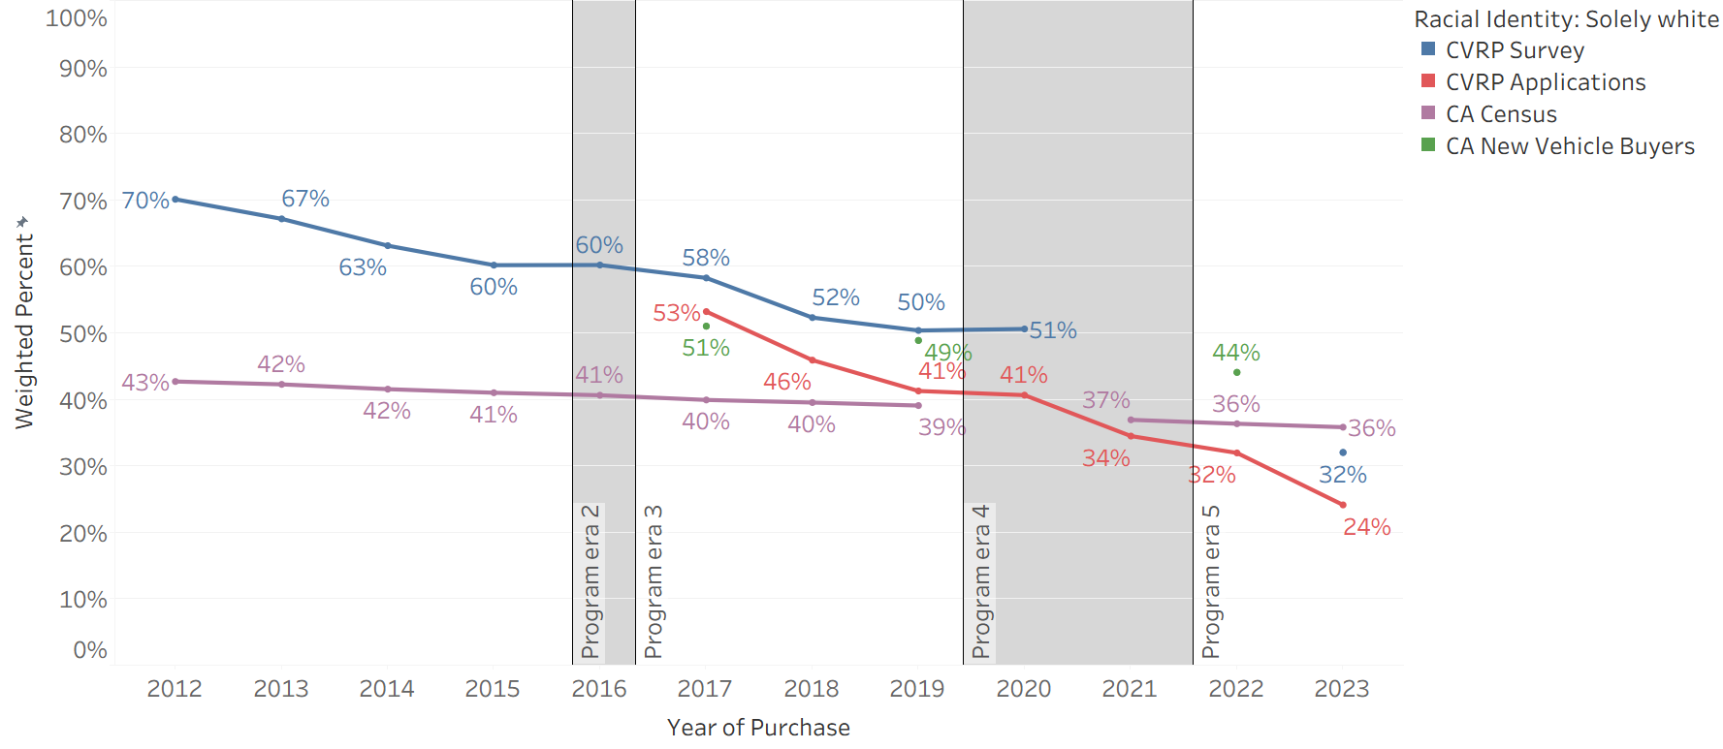

What was the effect of equity-related program elements & what is the road ahead?
CVRP program design was changed over time (Table 1) to reflect evolving program goals. These increasingly aimed to direct rebate funding toward priority populations and included elements such as limiting consumer eligibility based on income, providing an Increased Rebate to low- to moderate-income consumers, and both conducting additional outreach to and prioritizing incentive payments to low-income consumers. Further, Standard Rebate amounts were incrementally reduced over time while Increased Rebate amounts were raised (Table 2). Here, we review the effect of equity-related program elements, focusing on the Increased Rebate for income-qualified consumers, by comparing distributions of rebate volumes to rebate dollars across participant income groups (the effect of income caps on rebate volumes across participant income groups is discussed above). We then review consumer characteristics across various strategic consumer segments identified in prior work that represent steps forward for EV consumers on the road toward the mainstream and beyond to priority populations.,

Rebates vs Funding
Differences in the distribution of rebate volumes and rebate funding (the blue and red lines, respectively, in Figure 14) illustrate how the Increased Rebate for low- to moderate-income consumers affected where rebate dollars went. Figure 15 provides further detail by displaying the full income distribution of rebates (bars) and rebate funding (green markers) by program era. These figures indicate that both metrics, but especially funding, increasingly went to income groups less than $100k over time. From 2012–2015 (program Era 1), the proportion of rebate volumes and rebate funding that went to each household income group was very similar. During this period, funding only varied from rebates due to differences in the technology types acquired, since BEVs received larger rebate amounts than PHEVs (see Table 2). The rebate and funding proportions begin diverging in 2016 (or Era 2) when the Increased Rebate was introduced. An increasing proportion of funding went to the minority characteristic group (less than $100k income) over time as program design changes made income-based program eligibility criteria more stringent, Increased Rebate amounts were raised, and Increased Rebates were made available to a larger income group (Table 1 and Table 2). By 2020, rebate funding going to the Market Majority income group had decreased to within the range of new-vehicle buyers (54%–58%) and by 2021 only half of rebate funding went to this group. In 2023, after Increased Rebate amounts were raised by $3,000, rebate funding to households with income of $100k or more was down to an all-time low of 40%, even as 57% of rebates went to this group (which also was an all-time low and within the range of new-car buyers).
Since Increased Rebate eligibility was directly tied to participant income, this consumer characteristic displays the most significant difference between rebate and funding distributions. The two distributions are much more similar for other consumer characteristics, with the largest differences consistently occurring in 2023. Differences between rebates and funding in 2023 ranged from as much as 6 percentage points for both home ownership and solely white/Caucasian to as little as 1 percentage point for male gender. These results are visualized for each Market-Majority Metric in Appendix B.
Importantly, differences in rebate and funding percentages illustrate only one of the positive effects of the Increased Rebate. Additional dynamics outside the scope of this summary, such as rebate influence metrics, help speak to the effect of Increased Rebates on enabling lower income consumers to access an EV who would not otherwise. Previous work has demonstrated higher levels of rebate influence among recipients of the Increased Rebate, indicating that this program element is encouraging a large swath of consumers to participate in the EV market.,,,
Figure 14
CVRP and CA New-Car Buyer Household Income ($100k or more) — Rebates vs Funding
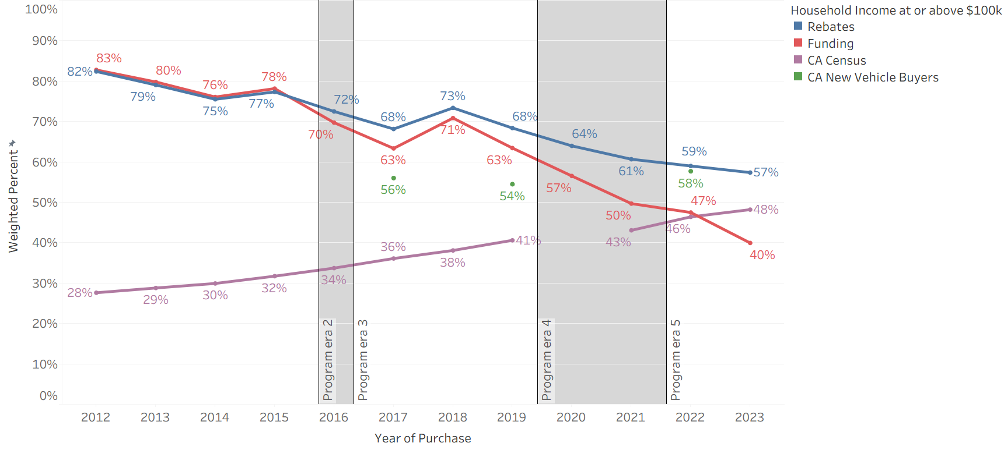

Figure 15
Household Income by Program Era — Rebates vs Funding
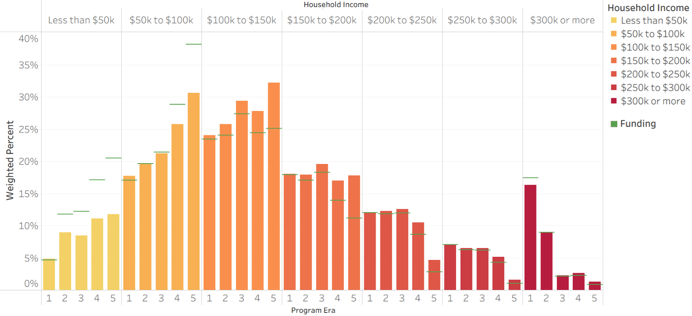 Note: Bars display rebate distributions and green markers display funding distributions during each program era.

Market-Majority Metrics Among Strategic Consumer Segments
This section reviews the Market-Majority Metrics of select consumer segments to assess how strategically targeting these consumers can propel EV market participation toward mainstream consumers and beyond. As described in previous related work, strategic consumer segments include the following:
- “Rebate Essential” consumers,,,: EV buyers highly influenced by the rebate to join the EV market, who stated they would not have acquired their EV in absence of CVRP.
- “EV Converts”,: EV buyers with low initial interest in EVs when they started their vehicle shopping.
- Increased Rebate recipients: EV buyers who received the larger rebate amount available to income-eligible CVRP participants (see Table 1 and Table 2).
The household income of Rebate Essential consumers and EV Converts have tended to be closer to, or further beyond, new-car buyers than CVRP participants overall (Figure 16). Both were in the Market Majority income group as much as 9 percentage points less frequently than the program overall (in 2017 for EV Converts and 2021 for Rebate Essential consumers). Both of these strategic market segments entered the range of new-car buyers (54%–58%) in 2020—much earlier than the program overall (2023). Due to the income-eligibility requirements, Increased Rebate recipients rarely had incomes above $100k (especially before eligibility was extended to a broader income base in 2021, see Table 1). All three strategic market segments therefore played an important role in moving the income of CVRP participants toward that of mainstream new-car buyers.
Figure 16
CVRP Strategic Consumer Segments — Household Income ($100k or more)
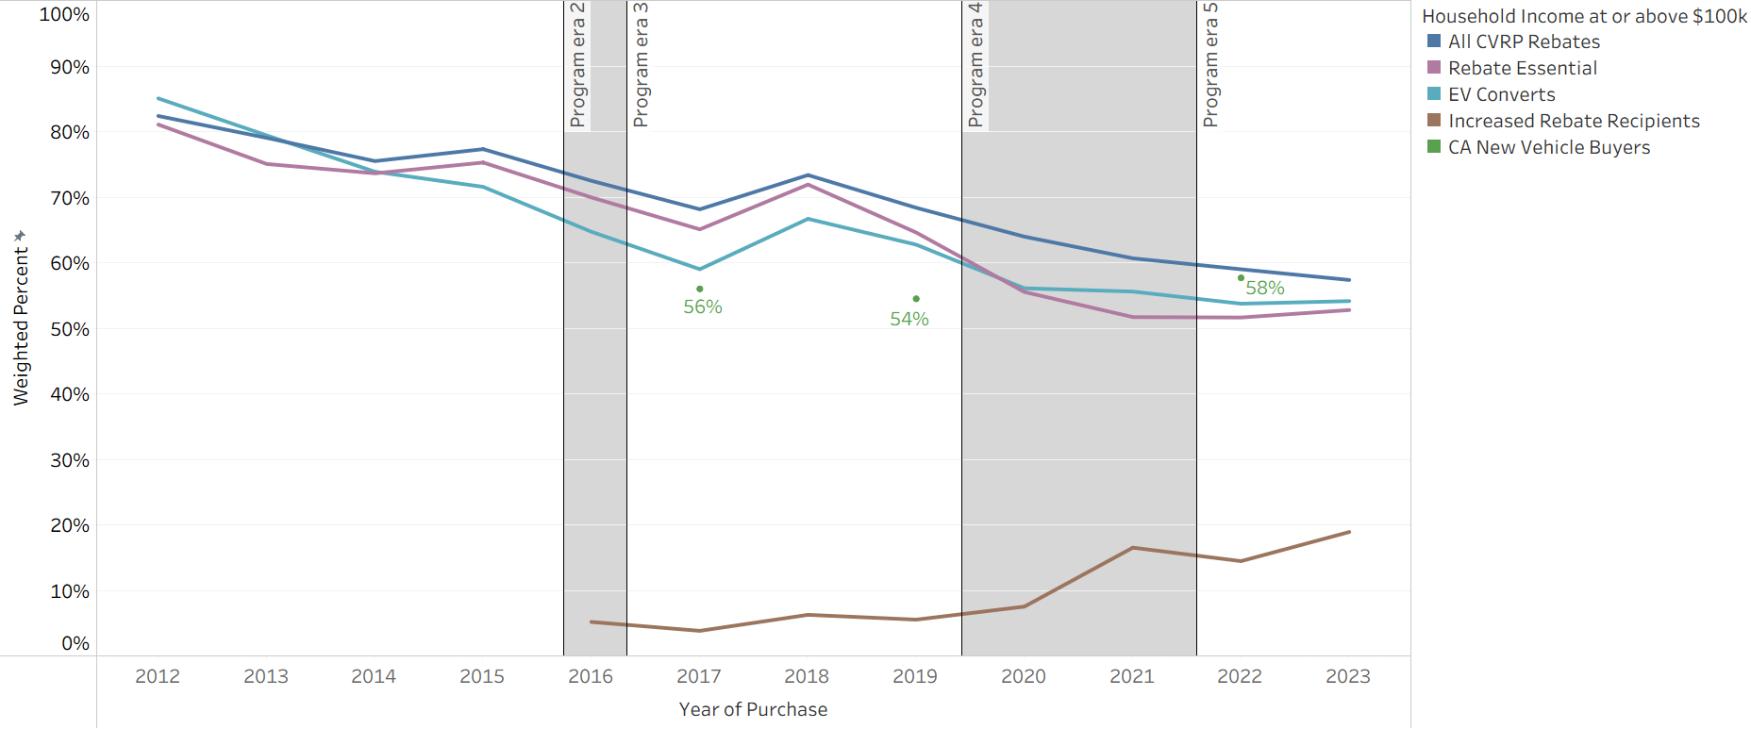
Rebate Essential consumers and EV Converts have interestingly tended to be in the Market Majority age group (30–59 years) slightly more frequently than the program overall (Figure 17). This suggests targeting these strategic consumer segments won’t necessarily help progress participant age beyond mainstream car buyers. Increased Rebate recipients were not consistently more or less frequently middle-aged than the program overall, suggesting targeting low-/moderate-income consumers may not substantially affect the age of participants.
Figure 17
CVRP Strategic Consumer Segments — Age (30–59 years)
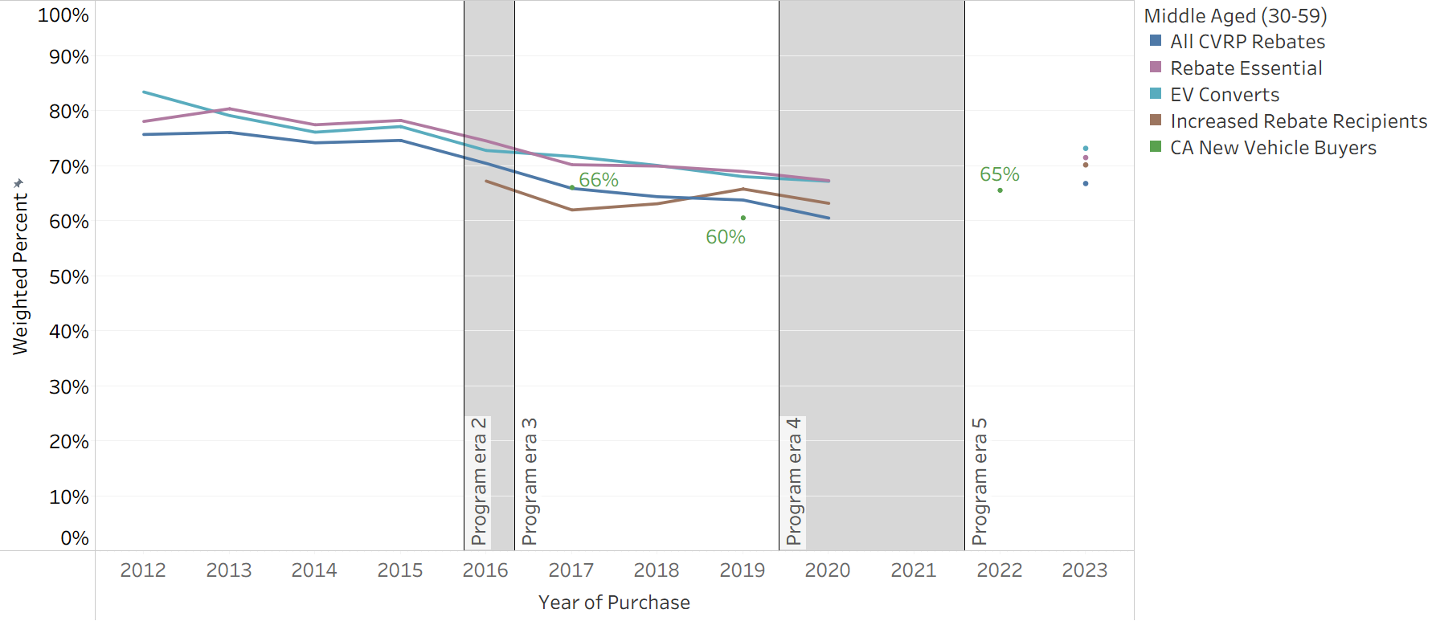

Overall program gender identification metrics have not differed substantially from the gender metrics of Rebate Essential respondents (Figure 18). Male identification among the overall program has tended to be slightly higher (by as much as 5 percentage points) than among EV Converts, and higher than Increased Rebate recipients (by as much as 9 percentage points). This indicates that targeting Converts and consumers claiming the income-qualified rebate can help bring participant gender metrics closer to that of the mainstream new-car buyer market.
Figure 18
CVRP Strategic Consumer Segments — Gender (Male)
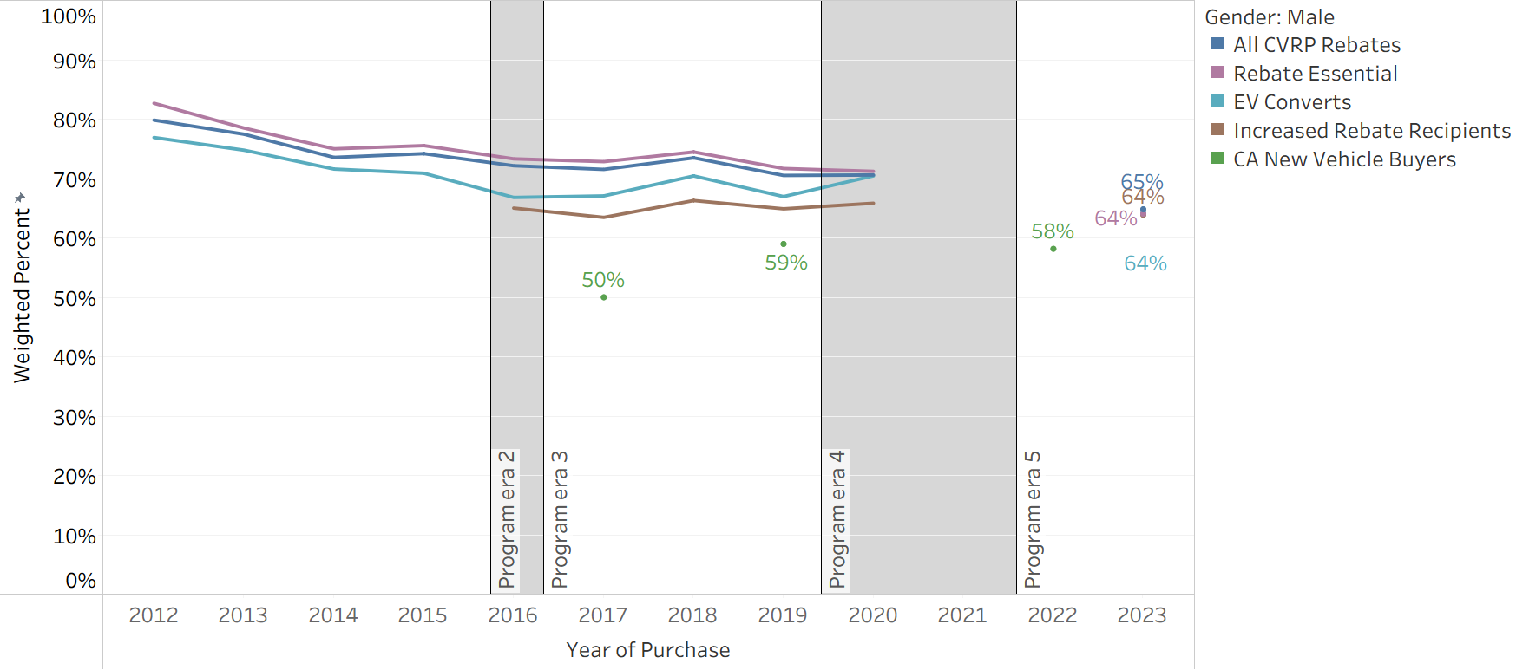

The proportion of overall program education in the Market Majority has not differed substantially from the education levels of Rebate Essential respondents (Figure 19). It has tended to be ~5 percentage points higher than EV Converts, indicating that targeting Converts can help bring participant education closer toward that of the mainstream market. Increased Rebate recipients also helped move the program toward new-car buyers, as those participants ranged from having similar educational levels to new-car buyers in 2019 to 4 percentage point lower levels in 2022.
Figure 19
CVRP Strategic Consumer Segments — Education (Bachelor’s degree or higher)
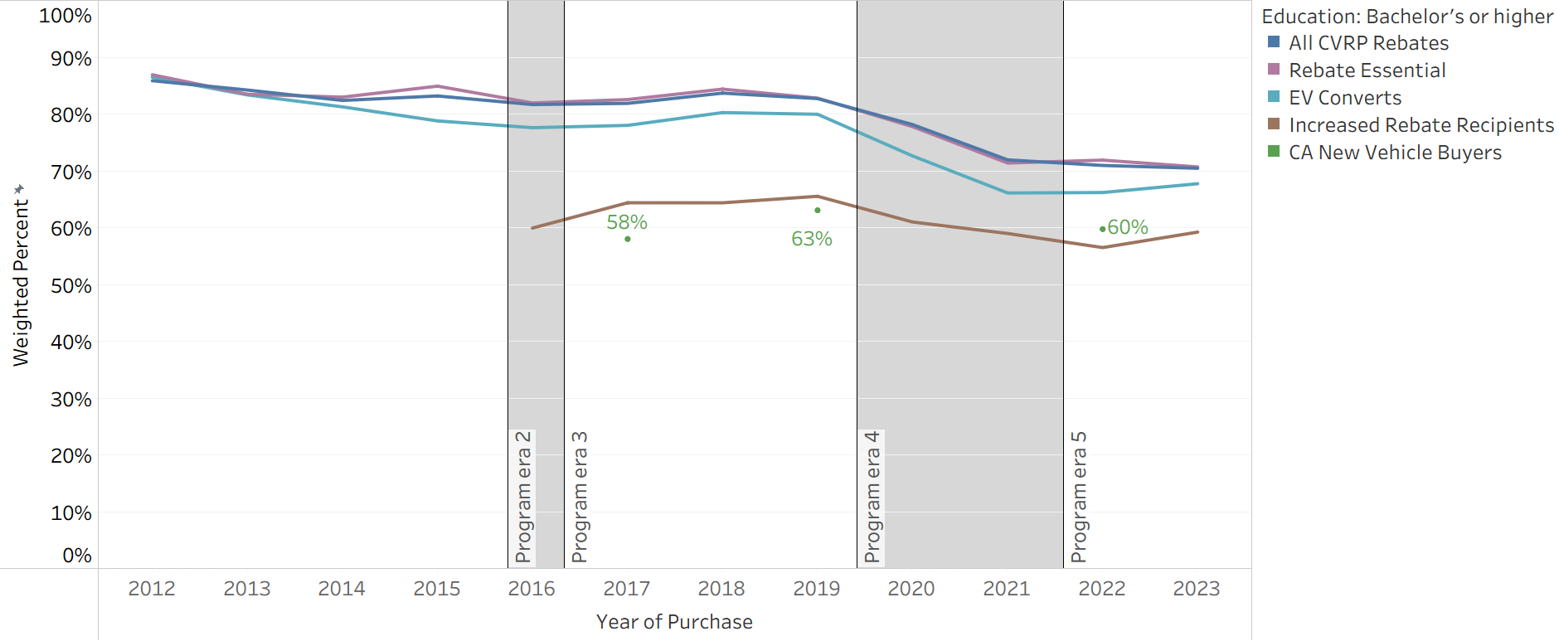

Home ownership levels of Rebate Essential consumers and EV Converts have tended to be closer to new-car buyers than CVRP participants overall (Figure 20). Rebate Essential consumers were only slightly closer to new-car buyers (as much as 4 percentage points in 2021) and EV Converts were often even closer (as much as 8 percentage points lower than the program overall in 2016). Therefore, targeting either strategic consumer segment may help move total program homeownership toward the mainstream new-car buyer market. Homeownership was the lowest among Increased Rebate recipients. This group was within the range of new-car buyers, indicating that targeting low-/moderate-income consumers will help move program total homeownership toward the mainstream.
Figure 20
CVRP Strategic Consumer Segments — Home Ownership (Owns residence)
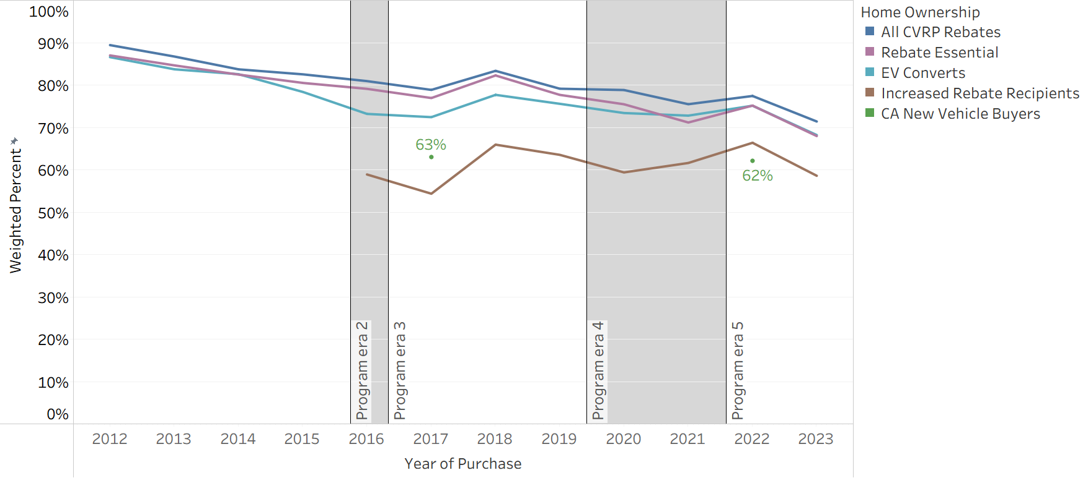
Note: Home ownership data not available for New Vehicle Buyers in 2019.

The frequency of solely white/Caucasian identification among Rebate Essential consumers and EV Converts has tended to be closer to, or further beyond, new-car buyers than CVRP participants overall (Figure 21). Rebate Essential consumers were as much as 9 percentage points less frequently solely white/Caucasian than the program overall and EV Converts were as much as 14 percentage points less. Increased Rebate recipients tended to identify as solely white/Caucasian even less frequently than other strategic consumer segments (by as much as 16 percentage points less than the program overall). All three strategic segments therefore played an important role in propelling this metric of racial/ethnic diversity toward, and then further beyond, that of mainstream new-car buyers.
Figure 21
CVRP Strategic Consumer Segments — Race/Ethnicity (Solely white/Caucasian)
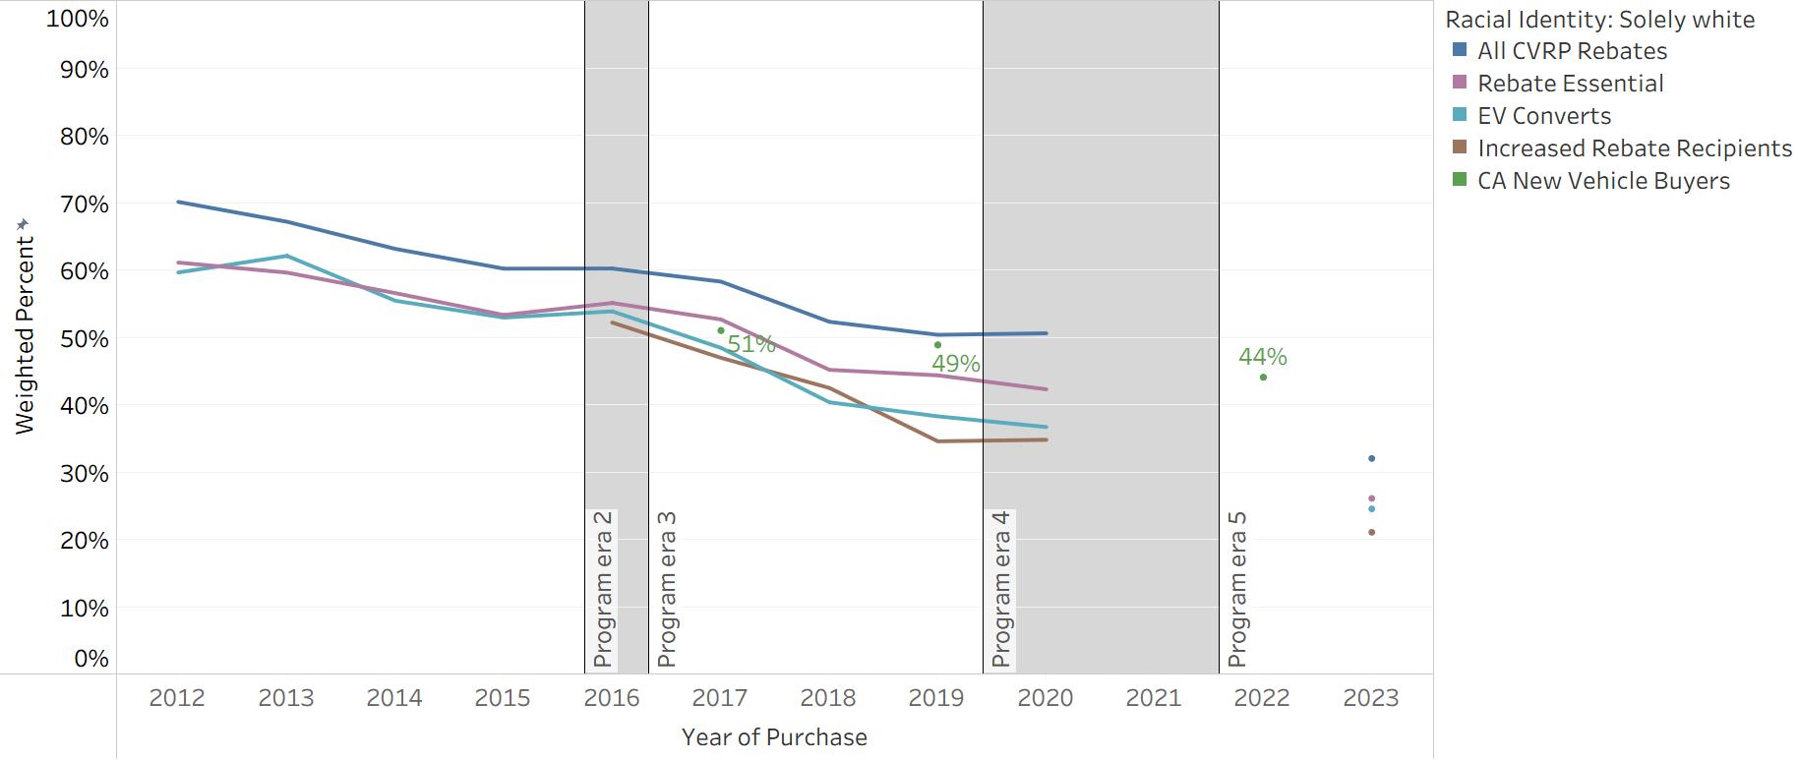

Key Insights
- CVRP became considerably more equitable over the course of the program.
  - Across each consumer characteristic measured, CVRP participants progressed substantially toward mainstream new-car buyers over time.
- By the final year of CVRP (2023), Market-Majority Metrics of:
  - Race/ethnicity surpassed the mainstream.
  - Income and age reached the mainstream.
  - Gender, education, and homeownership had not reached the mainstream.
- The Increased Rebate and other equity-focused program changes were effective in directing rebate funds toward lower-income consumers.
  - Each program era extended equity-related program elements and saw increasing shares of rebate funds going to low- to moderate-income consumers.
  - In 2023, percentages of rebates and funding that went to households with income of $100k or more reached all-time lows: rebate volumes were down to 57% (within the 54%–58% range of new-car buyers) and rebate funding was down to only 40% —well below the range of new-car buyers.
- Targeting income-qualified consumers and other strategic consumer segments can help move the characteristics of program participants closer to, or further beyond, those of mainstream car buyers.
  - Rebate Essential consumers, EV Converts, and particularly Increased Rebate recipients tend to be closer to or further beyond mainstream new-car buyers across the Market-Majority Metrics measured.

Acknowledgments
We thank our CARB program managers and those at CSE who supported this work, including Latrice Puckett, Anjelica Thang, and Meridith Bartley. Thanks are also due to Brett Williams for leading and collaborating on precursor work that included the development of approaches that were applied here.


APPENDICES

Appendix A: Data Summary
The survey sample size, program population (that the sample was weighted to represent), and response rate associated with each survey edition are provided in Table A1. Responses are weighted to make the survey data more representative of all rebate recipients using iterative proportional fitting. The dimensions used as weighting strata are survey edition, vehicle category, vehicle model, purchase vs lease, county, year of purchase, and rebate type. These weights are used to calculate the descriptive statistics in this report. Further details will be made available in forthcoming survey summary documentation. The population used to weight the Consumer Survey consisted of paid-rebate nonfleet recipients who purchased or leased their BEV or PHEV between 9/1/2012 and 3/22/2024, with applications received between 8/17/2012 to 4/10/2024.
Application data that included consumer characteristics are summarized in Table A2. Application data statistics are unweighted, as responses were required by all applicants (response rates less than 100% reflect “Prefer not to answer” response selections or, in 2017, applications submitted before questions were introduced in March).
Table A1
CVRP Consumer Survey Sample Size and Representativeness by Survey Edition
BEVs and PHEVs
Survey Edition | 2013–2015 Edition | 2015–2016 Edition | 2016–2017 Edition | 2017–2020 Edition | 2020–2023 Edition | 2023–Close Edition | Total
Purchase/  Lease Dates | 9/1/2012–5/31/2015 | 4/1/2015– 5/31/2016 | 5/1/2016– 6/01/2017 | 6/1/2017–11/30/2020 | 12/1/2020– 7/31/2023 | 8/1/2023– Close | 9/1/2012– Close
Program Population* | 90,329 | 48,852 | 48,212 | 195,812 | 150,320 | 13,416 | 546,941
Survey Responses | 19,365 | 11,607 | 8,923 | 32,524 | 24,069 | 1,601 | 98,089
Response Rate | 21% | 24% | 19% | 17% | 16% | 12% | 18%
* Application data used to weight the survey were current as of February 2025 and may differ from final program totals due to data settling.

Table A2
CVRP Application Question Sample Size by Purchase/Lease Year*
Purchase/  Lease year | 2017 | 2018 | 2019 | 2020 | 2021 | 2022 | 2023
Total Applications | 46,153 | 78,612 | 61,421 | 36,481 | 45,303 | 33,703 | 77,144
Question-specific Responses | 33,870 – 39,086 | 66,843 – 77,883 | 52,502 – 60,741 | 31,318 – 36,102 | 39,061 – 45,015 | 28,896 – 33,461 | 66,385 – 76,151
Response Rates | 73% – 85% | 85% – 99% | 85% – 99% | 86% – 99% | 86% – 99% | 86% – 99% | 86% – 99%
* Questions added to application as of March 2017. Data as of 4/30/2025.

Appendix B: Rebates vs Funding – Additional Characteristics
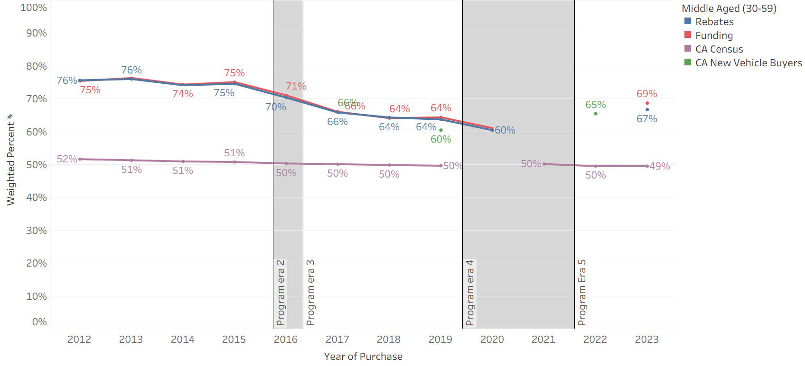

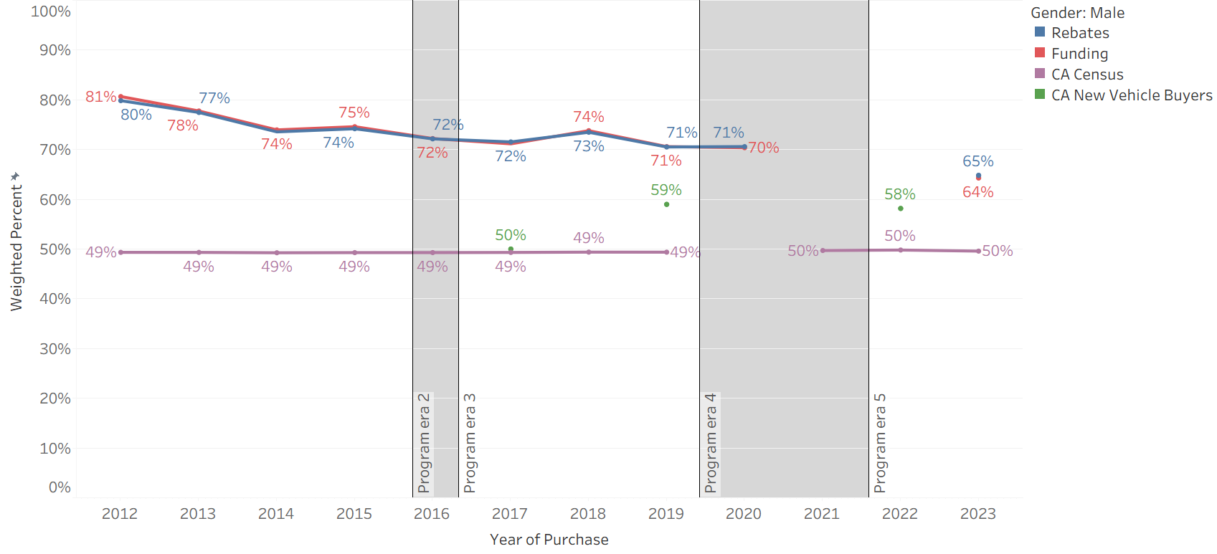

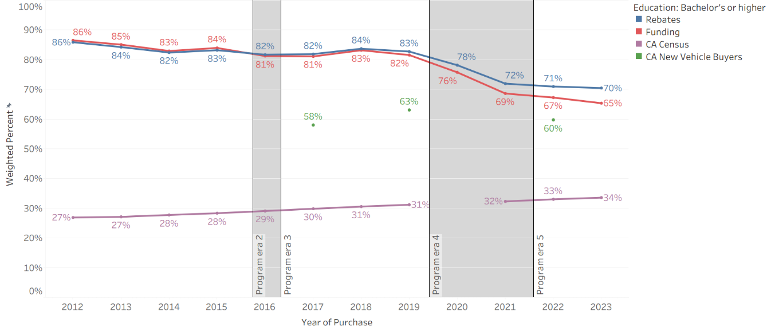

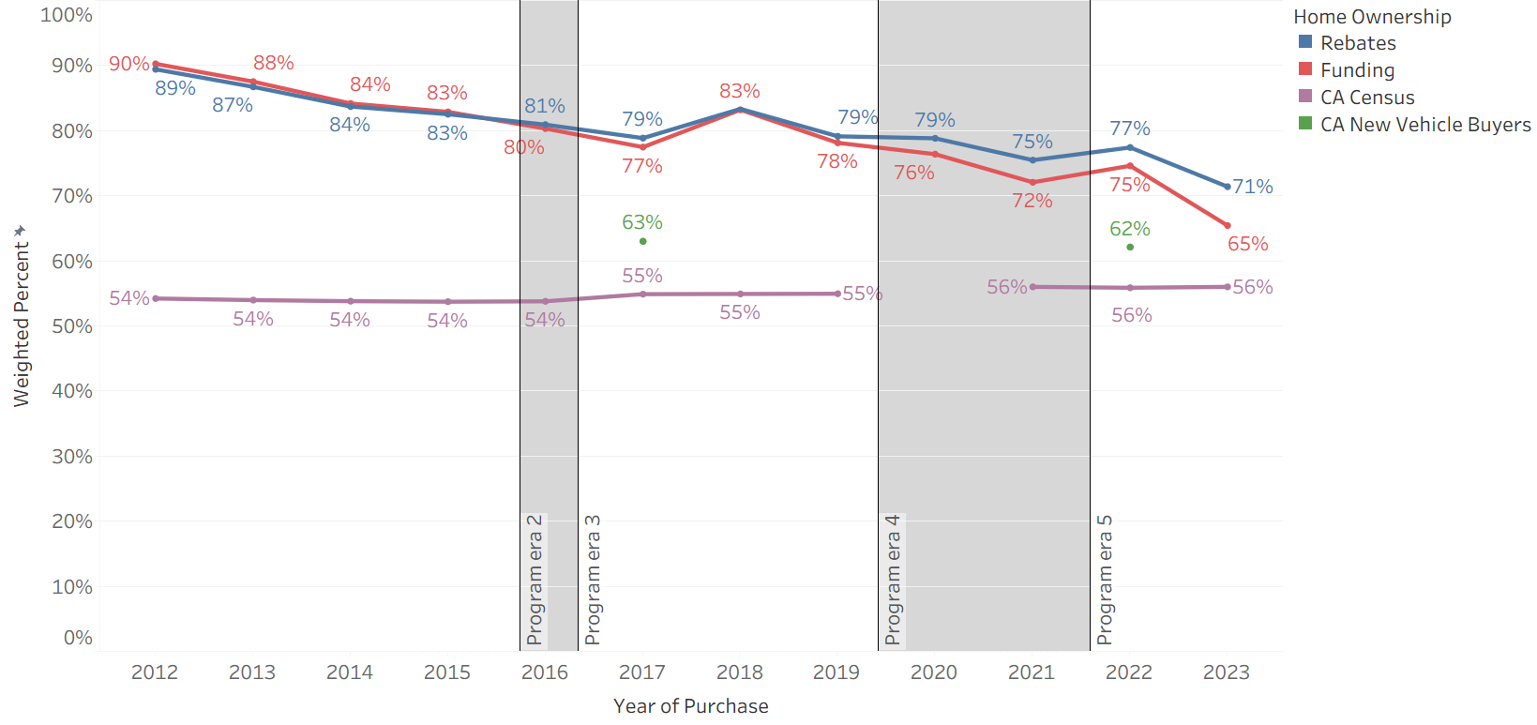

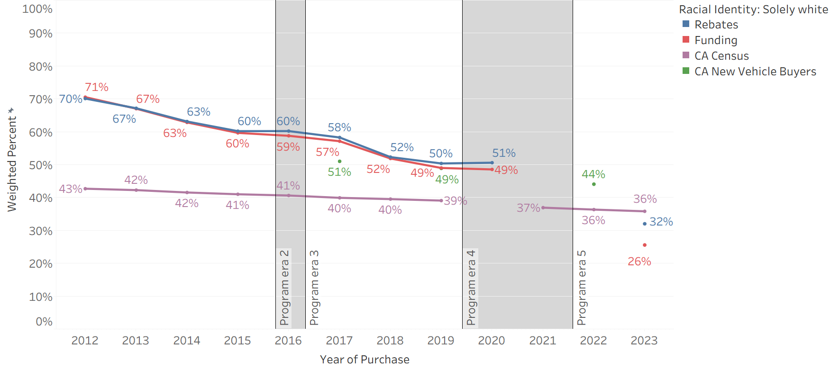

EnergyCenter.org
One mission — DECARBONIZE.®
Center for Sustainable Energy® (CSE) is a national nonprofit that accelerates adoption of clean transportation and distributed energy through effective and equitable program design and administration. Governments, utilities and the private sector trust CSE for its data-driven and software-enabled approach, deep domain expertise and customer-focused team. CSE’s fee-for-service business model frees it from the influence of shareholders, members and donors, and ensures its independence.

https://ww2.arb.ca.gov/our-work/programs/clean-vehicle-rebate-project-cvrp/outcomes-and-results-clean-vehicle-rebate.
https://ww2.arb.ca.gov/project-background.
https://cleanvehiclerebate.org/en/eligibility-guidelines.
https://cleanvehiclerebate.org/sites/default/files/attachments/Disruptions_Fact_Sheet_9_2021.pdf.
Adapted from Williams, B.D.H. (2025, Mar.). Presentation: “Assessing Progress Toward Equitable Access to EVs with Incentive Program Metrics: Lessons Learned from CVRP and NY DCRP Using Program Data and Baselines of Comparison,” for CARB Clean Transportation Equity Incentives Symposium, Sacramento CA. https://cleanvehiclerebate.org/en/content/assessing-progress-toward-equitable-access-evs-incentive-program-metrics-lessons-learned.
Ibid.
Williams, B.D.H., & Pallonetti, N. (2024, Aug.). Presentation: “CVRP 2022 Data Brief: Consumer Characteristics & Equity Metrics,” prepared by the Center for Sustainable Energy for the Clean Vehicle Rebate Project, California Air Resources Board, Sacramento USA. https://cleanvehiclerebate.org/en/content/presentation-%E2%80%9Ccvrp-2022-data-brief-consumer-characteristics%E2%80%9D.
Williams, B.D.H. (2025, Mar.). Presentation: “Assessing Progress Toward Equitable Access to EVs with Incentive Program Metrics: Lessons Learned from CVRP and NY DCRP Using Program Data and Baselines of Comparison,” for CARB Clean Transportation Equity Incentives Symposium, Sacramento CA. https://cleanvehiclerebate.org/en/content/assessing-progress-toward-equitable-access-evs-incentive-program-metrics-lessons-learned.
Williams, B.D.H. (2023). Assessing progress and equity in the distribution of electric vehicle rebates using appropriate comparisons. Transport Policy, 137, 141–151. https://doi.org/10.1016/j.tranpol.2023.04.009.
Williams, B., Orose, J., Jones, M., & Anderson, J. (2018). Clean Vehicle Rebate Project: Summary of Disadvantaged Community Responses to the Electric Vehicle Consumer Survey, 2013–2015 Edition. Center for Sustainable Energy, San Diego CA. https://cleanvehiclerebate.org/sites/default/files/attachments/DAC_Summary-CVRP_Cnsmr_Srvy_2013-15.pdf.
Pallonetti, N., & Williams, B. D.H. (2023). Vehicle Replacement: Findings from California’s Clean Vehicle Rebate Project. 36th International Electric Vehicle Symposium. EVS36, Sacramento CA, USA. https://evs36.com/wp-content/uploads/finalpapers/FinalPaper_Pallonetti_Nicholas.pdf.
https://nhts.ornl.gov/.
Williams, B. D.H. (2023). Assessing progress and equity in the distribution of electric vehicle rebates using appropriate comparisons. Transport Policy, 137, 141–151. https://doi.org/10.1016/j.tranpol.2023.04.009.
https://www.strategicvision.com/nves.
https://www.census.gov/programs-surveys/acs/microdata.html.
Question updates include a change from a single response selection in the 2013–2015 Edition to a “select all that apply” format as of the 2015–2016 Edition.
Respondents who selected more than one race/ethnicity are reported as a separate group.
Williams, B. D.H. (2023). Assessing progress and equity in the distribution of electric vehicle rebates using appropriate comparisons. Transport Policy, 137, 141–151. https://doi.org/10.1016/j.tranpol.2023.04.009.
Ibid.
White/Caucasian is not a majority (of over 50%) but is the most common racial/ethnic identity.
https://ww2.arb.ca.gov/project-background.
Williams, B. D.H., & Anderson, J. (2019). Growing the Electric Vehicle Market: EV Adopters, ‘Rebate Essentials,’ and ‘EV Converts.’ Roadmap 12 Conference, Portland, OR. https://energycenter.org/thought-leadership/research-and-reports/growing-electric-vehicle-market-ev-adopters-rebate.
Williams, B. D.H. (2025, Mar.). Presentation: “Assessing Progress Toward Equitable Access to EVs with Incentive Program Metrics: Lessons Learned from CVRP and NY DCRP Using Program Data and Baselines of Comparison,” for CARB Clean Transportation Equity Incentives Symposium, Sacramento CA. https://cleanvehiclerebate.org/en/content/assessing-progress-toward-equitable-access-evs-incentive-program-metrics-lessons-learned.
Williams, B. D.H., & Pallonetti, N. (2023, Mar.). Rebate Influence on Electric Vehicle Adoption in California. 36th International Electric Vehicle Symposium (EVS36), Sacramento CA, USA. https://www.researchgate.net/publication/371905706_Rebate_Influence_on_Electric_Vehicle_Adoption_in_California.
Johnson, C., & Williams, B. (2017). Characterizing Plug-In Hybrid Electric Vehicle Consumers Most Influenced by California’s Electric Vehicle Rebate: Transportation Research Record, 2628, 23–31. https://doi.org/10.3141/2628-03.
Williams, B. (2022). Targeting Incentives Cost Effectively: ‘Rebate Essential’ Consumers in the New York State Electric Vehicle Rebate Program. 35th International Electric Vehicle Symposium. 35th International Electric Vehicle Symposium, Oslo, Norway.
Pallonetti, N., Williams, B. D.H., & Sa, B. (2024). CVRP Greenhouse Gas Emission Reductions and Cost-Effectiveness: 2022 Purchases/Leases. Center for Sustainable Energy. https://cleanvehiclerebate.org/en/content/cvrp-greenhouse-gas-emission-reductions-and-cost-effectiveness-2022-purchasesleases.
Williams, B. D. H., & Pallonetti, N. (2024, Aug.). Presentation: “CVRP 2022 Data Brief: Consumer Characteristics & Equity Metrics,” prepared by the Center for Sustainable Energy for the Clean Vehicle Rebate Project, California Air Resources Board, Sacramento USA. https://cleanvehiclerebate.org/en/content/presentation-%E2%80%9Ccvrp-2022-data-brief-consumer-characteristics%E2%80%9D.
Williams, B. D. H., & Pallonetti, N. (2023, March). Rebate Influence on Electric Vehicle Adoption in California. 36th International Electric Vehicle Symposium (EVS36), Sacramento CA, USA. https://www.researchgate.net/publication/371905706_Rebate_Influence_on_Electric_Vehicle_Adoption_in_California.
Johnson, C., & Williams, B. (2017). Characterizing Plug-In Hybrid Electric Vehicle Consumers Most Influenced by California’s Electric Vehicle Rebate: Transportation Research Record, 2628, 23–31. https://doi.org/10.3141/2628-03.
Williams, B. D.H. (2022). Targeting Incentives Cost Effectively: ‘Rebate Essential’ Consumers in the New York State Electric Vehicle Rebate Program. 35th International Electric Vehicle Symposium (EVS35), Oslo, Norway. https://doi.org/doi: 10.13140/RG.2.2.22877.28640.
Pallonetti, N., Williams, B. D.H., & Sa, B. (2024). CVRP Greenhouse Gas Emission Reductions and Cost-Effectiveness: 2022 Purchases/Leases. Center for Sustainable Energy. https://cleanvehiclerebate.org/sites/default/files/attachments/CVRP-2022-GHG-Cost-Effectiveness.pdf.
Williams, B. D.H., & Anderson, J. B. (2021). Strategically Targeting Plug-In Electric Vehicle Rebates and Outreach Using “EV Convert” Characteristics. Energies, 14(7), 1899. https://doi.org/10.3390/en14071899.
Williams, B. D. H., & Anderson, J. B. (2023). From Low Initial Interest to Electric Vehicle Adoption: “EV Converts” in New York State’s Rebate Program. Transportation Research Record: Journal of the Transportation Research Board, 2677(3), 866–882. https://doi.org/10.1177/03611981221118537.
https://cleanvehiclerebate.org/sites/default/files/attachments/Disruptions_Fact_Sheet_9_2021.pdf.
Only six survey responses and 21 rebates have purchase dates after Sept. 2023 (as of February 2025).

