Driving Down Costs: Policy Support for Electric Vehicle Affordability for High-mileage Transportation Network Company Drivers in California
Authors: Kabanda Herve Christian Sheja, Janet Bowers, Lance Noel
Contributors: John Anderson, Regina McCormack, Benjamin MacNeille, Mina Afayee

Introduction
The need to reduce greenhouse gas (GHG) emissions has been extensively documented by many international climate science organizations (IPCC, 2023; International Energy Agency, 2023). In the United States, transportation represents the largest source of GHG emissions, accounting for approximately 28% of total emissions nationwide in 2021 (EPA, 2023). Electric vehicles (EVs) offer a practical pathway to reduce transportation-related emissions over time.
In California, substantial efforts have helped build the broader EV market through programs such as the Clean Vehicle Rebate Project (CVRP). By the end of the second quarter of 2025, zero-emission vehicles (ZEVs) represented over 21% of all new vehicles sold in California (California Energy Commission, 2025). However, this progress across the general population has not fully extended to certain key segments of the market, such as drivers for transportation network companies (TNCs).
Although TNCs represent a small share of total vehicles in use, they account for about 14% of total vehicle miles traveled in major U.S. urban areas (SFCTA, 2017). In California, TNC vehicles log an average of 180 miles per day, nearly eight times more than a personal vehicle, and emit approximately 50% more greenhouse gases per passenger mile traveled (Fleming & Cohen D’Agostino, 2020). To address this disproportionate environmental impact, California has set ambitious goals for TNC fleets, including full electrification by 2030 under the Clean Miles Standard (CMS) established by the California Public Utilities Commission (CPUC, 2023).
TNC drivers are critical to achieving California climate goals, yet they face significant affordability barriers to EV adoption. Most TNC drivers in California earn less than the state minimum wage (Reich, 2020), and studies of ride-hailing drivers in Los Angeles County confirm that many earn below the mandated rate, underscoring their financial vulnerability (Waheed et al., 2018). Whereas moderate-income households spend only 10–12% of their annual income on transportation, low-income households, including TNC drivers, can spend nearly 30%, and as much as 38% for households with at least one vehicle (Bureau of Transportation Statistics, 2024). On top of these financial pressures, the cost of an EV can be prohibitive, with the average transaction price for a new battery electric vehicle (BEV) at $58,124 in September 2025, approximately 16% higher than the average new internal combustion engine vehicle (ICEV) (Cox Automotive, 2025). Equity concerns for TNC drivers are therefore likely to be exacerbated by the higher upfront costs of BEVs, despite their lower operating costs and pollution benefits.
This analysis investigates how California can overcome affordability barriers and accelerate BEV adoption within the TNC driver segment to achieve climate change mitigation goals. To do so, this paper explores the incentive levels required to meet two different thresholds for TNC drivers:
- The adoption threshold: the point at which BEVs become cheaper to obtain and operate than a comparative ICEV.
- The affordability threshold: the point at which monthly vehicle costs comprise 15% or less of a given household income.
In the sections below we compare different configurations of vehicle type (new and used) and financing (lease and purchase) choices in order to explore the different options TNC drivers will be presented when deciding between a BEV and ICEV. The results identify incentive amounts needed to drive EV adoption and achieve affordability. To calculate these results, we employ the Center for Sustainable Energy’s (CSE) Affordability Tool, which considers both financing and operational costs over time and consolidates all costs into an expected monthly payment.
By analyzing these questions, the paper identifies potential solutions to make BEV ownership more affordable for TNC drivers and to advance sustainable urban transportation, thereby supporting California’s broader emission reduction goals.

Methods

Model Description
Two common approaches for evaluating whether a BEV is affordable are Affordability Purchase Models (which typically focuses on upfront costs) and Total Cost of Ownership (TCO) models (which adopt a long-term perspective by incorporating all costs over the vehicle’s life span) (Burnham et al., 2021; Lazer et al., 2021; Fernandes et al., 2023). Both models have been relied upon by policymakers to correctly set incentive amounts for specific or general market programs.
CSE’s Affordability Tool combines aspects of both methods to faithfully recreate what TNC drivers will likely consider at the point of purchase. That is, it uses purchase and financing options but also includes operational costs for the first five years of operation (or three years in the case of a lease). This duration was selected instead of the entire vehicle lifespan because it reflects the perspective of actual vehicle drivers at the point of purchase. As such, the hybrid configuration of CSE’s Affordability Tool is more useful when designing incentive programs intended to effectively convert actual drivers (including TNCs) to adopt BEVs.
The Affordability Tool used in this study examines TNC drivers’ monthly expense ratios—defined as the percentage of total monthly vehicle expenses divided by the monthly household income (scaled to household size). The vehicle expenses are the sum of:
- Financing costs, which are dependent on MSRP, purchase type, loan terms, and APR.
- Operational costs, which are dependent on miles driven such as fuel, maintenance, and insurance.
This sum is then compared to the household income, which is scaled for the number of people in the household. In this study, affordability is defined as spending no more than 15% of household income on vehicle expenses, which aligns closely with the 2022 U.S. household transportation average costs (Bureau of Transportation Statistics, 2024).
In this study, we assume 10% down payment and a 5-year loan term or a 3-year term for leasing. Leveraging baseline assumptions and sensitivity analyses, the study assesses the impact of key financing and operational costs on overall monthly affordability. Recent trends show that 46% of new BEV acquisitions in 2024 were leases, reflecting a broader consumer shift toward financing options that minimize upfront costs (Experian, 2024). Recognizing this trend, the study examines both purchasing and leasing pathways to capture the range of financial strategies available to TNC drivers.

Model Assumptions
The Affordability Tool, as discussed above, requires three sets of assumptions: 1) assumptions related to financing, 2) assumptions regarding operational costs, and 3) assumptions regarding household demographics. These assumptions are categorized and described in Table 1 and discussed further in the following sections.
Table 1
Financial Assumptions
Parameter | Baseline Value | Basis/Description
Vehicle MSRP | BEV (new): $31,050  BEV (used): $25,400  ICEV (used): $11,380 | Based on 2024 California specific IHS dataset
Down payment | 10% of vehicle MSRP | Adopted from the CPUC CMS proposed decision (CPUC, 2024)
Loan term | Purchase: 5 years  Lease: 3 years | U.S. market typical financing and leasing periods.
Annual percentage rate (APR) | Purchase: 13.38%  Used: 18.90% | (Bradley 2024; Edmunds, 2024; SoFi, 2024)
Operational
Weekly TNC VMT | 900 miles | See Appendix B
Electricity rate or charging costs per kWh | $0.40 (DC fast charging) | Derived from recent market data on California charging costs (U.S. News, 2024).
Fuel costs per gallon | $4.35 | (Auto Club of Southern California, 2024)
EPA fuel economy (kWh/mile or gal/mile) | BEV: 0.26kWh/mile  ICEV: 0.02 gal/mile | EPA fuel economy (U.S. Department of Energy, 2024)
Vehicle maintenance per mile | BEV: $0.06  ICEV: $0.10 | Adopted from a comprehensive analysis study of total cost of ownership for vehicles of different size, class, and powertrains (Burnham et al., 2021)
Insurance costs per month | BEV: $337  ICEV: $281 | 2024 insurance National averages (Timmons, 2024)
TNC wages per mile | $1.31 | Reported rate of Los Angeles Uber Drivers including a 50% tip (Stilt, 2024; The Rideshare Guy, 2024)
Billable TNC miles | 60% of total VMT | Mileage assumed when a TNC driver is driving a passenger in the vehicle (CARB, 2021; Fehr & Peers, 2019)
Demographics
Household income | $50,000 | Adopted from CVRP 2020-23 consumer survey (see Appendix A)
Household size | 4 | Adopted from CVRP 2020-23 consumer survey (see Appendix A)
Notes: Baseline values for vehicle financing and operational costs and household demographics model parameters used in monthly BEV and ICEV cost analysis.

Financing Costs Inputs
The financing costs are comprised of four main inputs: vehicle MSRP, down payment, financing term, and APR. First, and most importantly, the MSRP of the vehicle was determined using 2024 IHS Markit data sets of actual purchases in California, filtered to likely TNC drivers with limited purchasing power, resulting in a lower BEV price for this segment than the average stated above ($58,124 compared to $31,000). This data was filtered for purchasers with an income at or below 400% of the Federal Poverty Level (FPL). Next, representative vehicles were selected: Tesla Model 3 and Model Y for BEVs and Toyota Prius for ICEVs, because these represented the most used vehicles operated by TNC drivers. The IHS dataset includes purchase prices for new vehicles, but to calculate the used BEV and ICEV prices, we employed Kelley Blue Book Fair Listing Price, averaged across representative ZIP codes, age distribution, and sales distribution. For each purchase type we added the California sales tax (9%) to the MSRP to determine the final purchase price.
Next, though financial advisors recommend a 20% down payment (Bradley & Woock, 2024), we employ a 10% down payment, to align with the CPUC recommendations to enhance vehicle financing accessibility for low- and moderate-income individuals (CPUC, 2024).
We assume a 5-year loan term (60 months) to limit the accrual of interest over time while maintaining monthly payment affordability. Likewise, this corresponds to market realities where, as of Q1 2024, the average loan term for financing a new vehicle was 68.3 months, and for a used vehicle 69.7 months (Edmunds, 2024). For leasing, we assume a 3-year term (36 months), which reflects the most common leasing period in the U.S. market.
Finally, the average annual percentage rate (APR) for new vehicles was 7.3% in 2024 (Edmunds, 2024). However, this rate primarily reflects borrowers with good to great credit scores. For low-income individuals who tend to have lower credit scores, the APR is typically higher (SoFi, 2024). Based on Bradley (2024) a typical subprime credit score would be able to finance a new purchase with an APR of 13.38% and a used purchase with an APR of 18.90%.

Operational Costs Inputs Per Mile
Beyond the capital cost of purchasing a vehicle, there are many considerations to calculate the monthly operational cost of driving it. First, is the operational cost of fueling and maintaining the vehicle. The primary assumption that affects both metrics is the assumed miles driven per week. Based on an average distribution of trip types (e.g., urban, suburban, or airport trips [see Wenzel, 2024]), we assume 10 miles per trip, which translates to about 900 miles per week, assuming 45,000 trips per year (which is required to qualify for the current TNC incentive under the CPUC Driver Assistance Program [DAP]).
However, since these miles include both billable and nonbillable miles associated with working as a TNC driver, only a portion of the cost of operation will be offset by the wages received by the driver (the remaining miles are unbillable). This in turn depends on the proportion of billable miles and the wages received per mile. Based on two studies analyzing usage national and usage in California (CARB, 2021; Fehr & Peers, 2019), billable miles ranged from around 54% to 62%, thus we use 60% in this study. The TNC wage used per mile was based on recent studies of Uber drivers in Los Angeles (Stilt, 2024; The Rideshare Guy, 2024), which resulted in a base wage of $0.87 per mile, plus a 50% bonus due to tips and surge pricing (GB Times, 2024).
Next, the average fuel cost is calculated based on average EPA efficiency metrics obtained from fueleconomy.gov (U.S. Department of Energy, 2024). This was then multiplied by the charging costs and gasoline costs for BEVs and ICEVs. One may note that this study uses relatively higher electricity costs (as compared to home electricity costs), but this is a result of higher utilization of public chargers and is based on CVRP Consumer Survey data (see Appendix A). This study assumes 100% of charging comes from public DC fast charging stations in order to be conservative while assuming TNC drivers will need to charge fast. However, TNC drivers who can charge at level 2 stations may experience lower monthly refueling costs than those estimated in this study.
The vehicle maintenance cost per mile was adapted from a comprehensive analysis of all vehicle types, using a national average for service costs and multiple data sources (Burnham et al., 2021). Similarly, insurance cost was based on national averages for each vehicle type (Timmons, 2024). It is important to note that actual insurance rates may vary by model, location, and driver profile.

Demographics
To calculate the affordability threshold described above, where transportation-related costs should not exceed 15% of annual income, two key assumptions are necessary—household size and household income. Based on the CVRP Consumer Survey (see Appendix A), the most frequently reported household size for participants using their vehicles for TNC driving was four. Likewise, the most frequently selected income range was $50,000 to $74,999. In order to be conservative, as well as align with FPL thresholds, this study uses $50,000 as a starting family income.
To account for differences in household purchasing power, we adjust the baseline household income by dividing by the square root of household size. This adjustment, while often used to reflect economies of scale, is applied here to reflect the greater income burden that larger households may face when only one or two members contribute to household income (Garner et al., 2020). Applying this adjustment ensures that our affordability threshold (15% of adjusted monthly income) provides a more accurate comparison of financial burden across households of different sizes, rather than assuming all household income is fully available for vehicle expenses.

Results
The results of the Affordability Tool analysis are presented in Figure 1. The figure shows the expense ratio (total monthly vehicle costs divided by total monthly income) of different vehicle configurations (BEV/ICEV, new/used) and purchase type (purchased new, purchased used, and leasing), depending on the level of incentive made available. The expense ratios of the BEV options decrease as the incentive increases. The points where the BEV options cross the gray lines can be interpreted as the adoption point—meaning at that incentive, the monthly cost of the BEV is the same or lower as the monthly cost of buying a used ICEV. The higher standard of affordability is represented by the dotted purple line represents the 15% threshold, and the affordability threshold can be seen where each ratio line crosses it.
For the purchased new and used BEVs (blue and green lines in Figure 1), one may note that the slope changes. This is the point at which the incentive covers the entire cost of the vehicle and the remaining incentive is amortized over five years to offset the monthly operational cost. The slope is higher before this point because each incentive dollar reduces both the principal cost as well as the cost of financing, leading to increased savings. For example, in the case of purchasing a new BEV, a $5,000 incentive increase before this inflection point would decrease monthly costs by approximately $120, whereas the same incentive increase would decrease monthly costs by $83.33 after this inflection point.
Figure 1
Expense Ratio for each BEV Acquisition as a Function of Incentive Amount
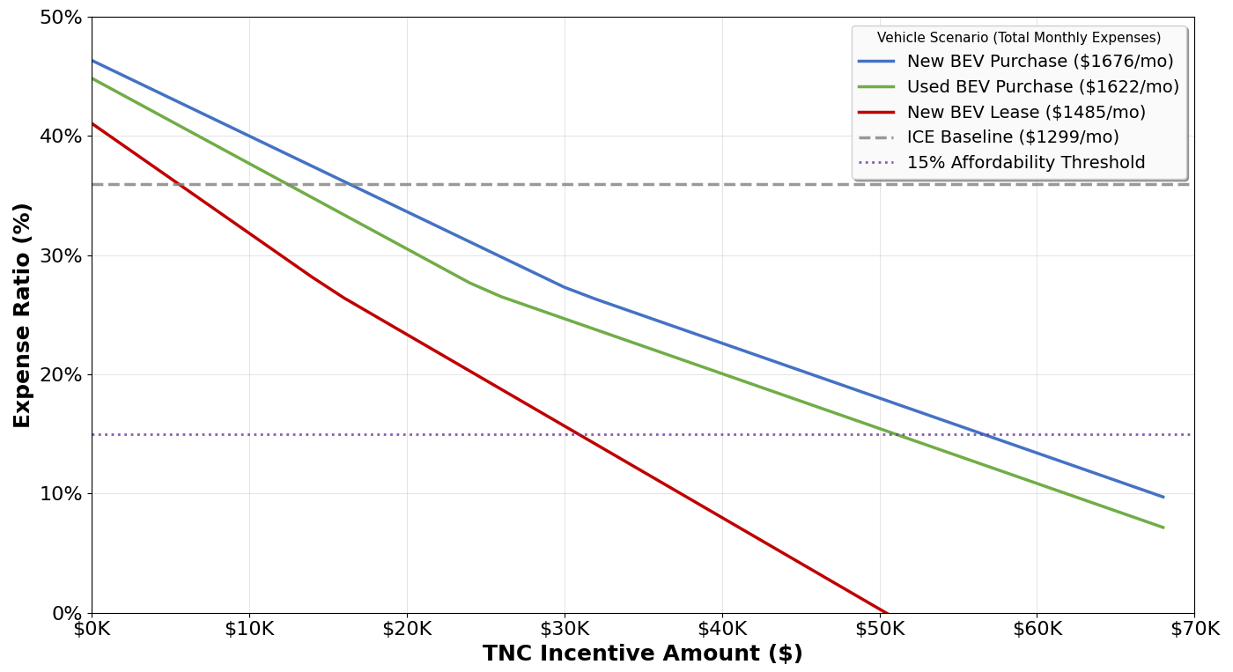

Based on these calculations, incentives are required for BEVs to reach the adoption point in all cases. The incentive required to meet these points depends on the purchase type and financing option, but range from $6,000 to $18,000, as summarized in Table 2. The stricter threshold of affordability requires substantially higher incentives, ranging from $32,000 to $58,000.

Table 2
Incentive Required for Equity or Affordability by Vehicle
Vehicle Type | Adoption (ICEV=35.9%) | Affordability (15%)
Purchase New BEV | $18,000 | $58,000
Purchase Used BEV | $14,000 | $52,000
Lease New BEV | $6,000 | $32,000
Notes: Incentive required to make given purchase type of BEV adoptable or affordable, where adoptable is defined as the same monthly cost as a used ICEV, and affordable is defined as 15% of monthly income.

Figure 2 shows the monthly cost composition for the various vehicle types. As reflected in Figure 1 , the ICEV would represent 36% of monthly income despite substantially cheaper capital costs. When pushing aside the financing cost, the ICEV operational costs total $1,012 per month. The fixed operating cost of a BEV is slightly less at $977 per month, which is not enough to offset the higher capital costs without an incentive. To reach the adoption point, incentives need to greatly reduce the financing costs first and foremost. In order to reach the 15% affordability threshold, total monthly costs need to reach around $550 per month, meaning the incentive will have to offset both the financing costs as well as a portion of monthly operational cost. Incentives from TNC companies for purchasing an EV can further reduce the upfront and monthly driving costs. For example, in October 2025, Uber announced a $4,000 grant for eligible drivers to purchase an EV, and Lyft offers discounts on public charging through Electrify America, as well as bonuses specific to EV drivers (Uber, 2025; Lyft, 2025).
Figure 2
Monthly Expenses Composition for each Vehicle Type
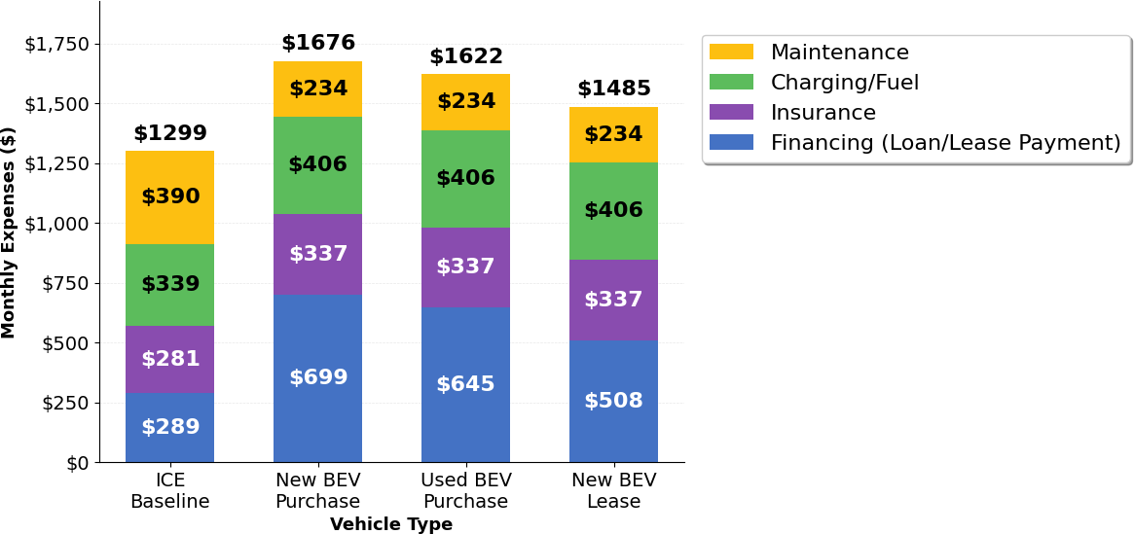
Note: Monthly expenses in Figure 2 are based on assumption of no incentive.
To maximize adoption, the most optimal choice for policymakers would be to focus attention on incentivizing TNC drivers to lease new BEVs or purchase used BEVs. On the other hand, this may induce equity concerns as it either leaves TNC drivers without an asset (for a leased BEV) or with a comparatively lesser vehicle (for a used BEV). Leasing a new BEV may also prove financially challenging given that the leasing mileage caps could prevent TNC drivers from driving enough to reach profits (Shaheen et al., 2025). Similarly, a used BEV may have potential range concerns as older vehicles have smaller batteries and the maximum range decays due to battery degradation. For these reasons, purchasing a new BEV may be the most feasible while also improving equity by leaving the user with an asset. Addressing this equity concern by incentivizing purchased new BEVs would increase the requisite incentive to reach the adoption point by anywhere from 300% to only about 15% (compared to leasing and purchased used, respectively).
Equity concerns are exacerbated when considering the affordability threshold in place of the adoption threshold. Given that low-moderate income households currently spend well more than the advised 15% of their income on transportation costs (e.g., a typical used ICEV would comprise 36% of our representative household’s monthly income), the incentive required to get the more expensive BEV to such a threshold is immense. As Table 2 showed, the incentive amount for each purchase type may be prohibitively expensive for policymakers to implement on a wide scale, ranging from two to three times the incentive amount as the adoption point.

Sensitivity Analysis
The flexible nature of the Affordability Tool allowed exploration of the relative impacts of different input variables combined with different incentive amounts. The charts in Figure 3 show a range of incentives on the x axis, and +/- 30% of the default input value on the y axis. The z axis, or the colors, represents the expense ratio, which is the proportion of transportation costs as compared to monthly income, ranging from 10 to 50%. All the squares with numeric percentages show the level at which each configuration reaches the 15% affordability threshold. This is then shown for each of the three financing types (purchased new, purchased used, leased new). Though these charts focus on affordability, similar narratives can be constructed for the adoption threshold, though at a substantially lower incentive amount. In this section we present four analyses, on vehicle MSRP, household income, electricity rates, and weekly miles driven. Four additional analyses (monthly insurance, BEV maintenance costs, APR amount, and TNC wages) are included in Appendix C.
Figure 3

Sensitivity Analysis for Vehicle MSRP
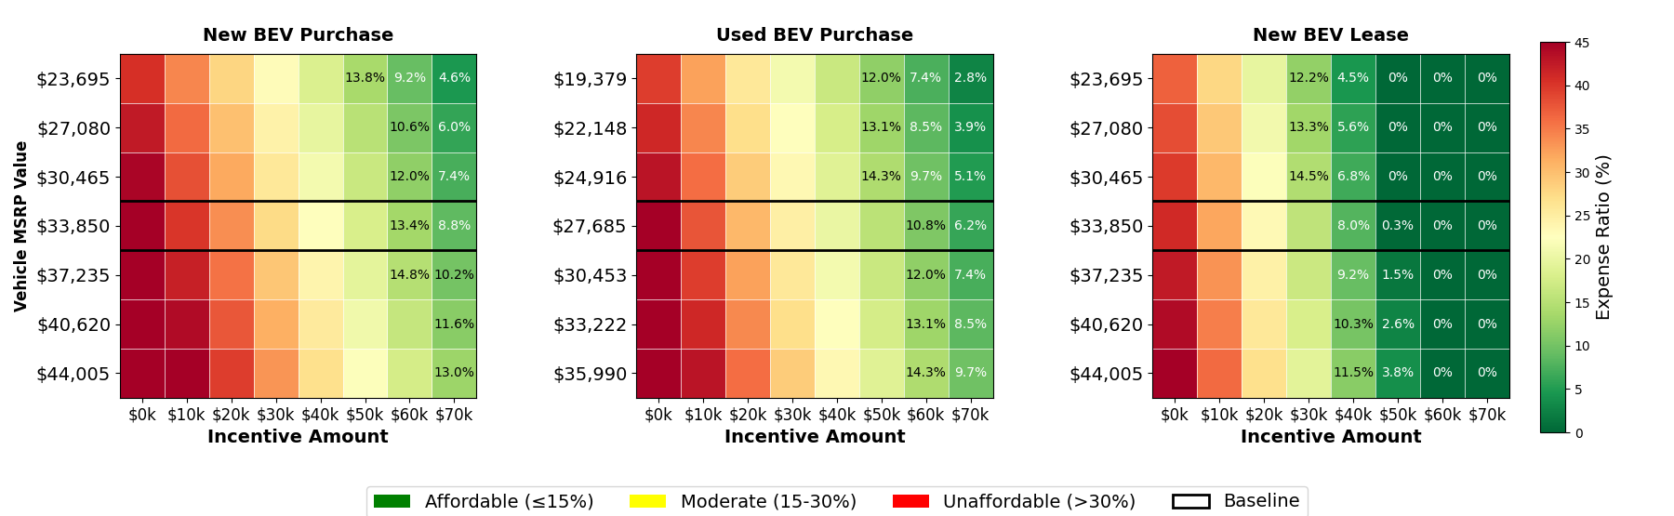
The price of the vehicle is obviously influential to purchase decisions, and reducing the MSRP garners substantial benefits to affordability, with the strongest effect across all sensitivity analyses. Reducing the MSRP by 30% improves affordability by roughly 4-5%, and a 10% reduction in MSRP can reduce the requisite incentive amount by approximately $10,000 (Figure 3). From another perspective, this chart also belies the necessity of an incentive to reach affordability thresholds—even when prices are reduced by 30%, none of the purchase types reach affordability without incentives.
Figure 4

Sensitivity Analysis for Household Income
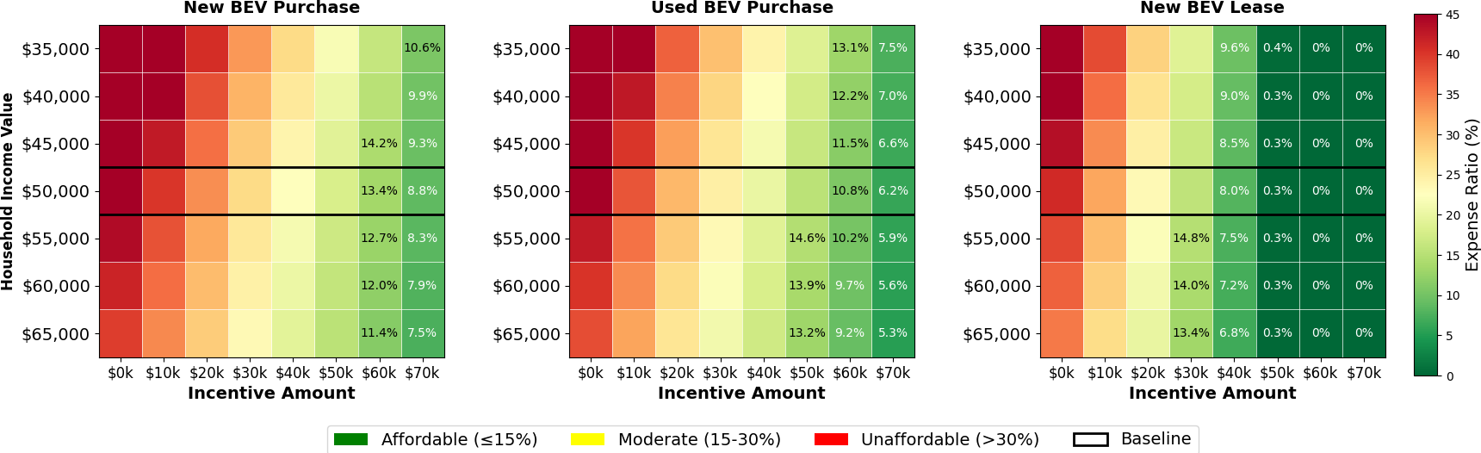
Household income is also a very influential variable on the analysis. Increasing the household income by 30% can reduce the requisite incentive amount by $10,000-$20,000 (Figure 4). A lower household income (which may make up a larger proportion of TNC drivers) likewise increases the requisite incenting. If incentive levels do not consider income, program participation is likely to be greater among individuals with higher incomes (>400% FPL) for whom EVs are more affordable, although they may not be eligible given income thresholds (e.g., DAPCUC is limited to 400% FPL and below). Instead, the program may want to lower income eligibility thresholds to start and, as the EV market continues to mature, incrementally restrict income eligibility over time. Alternatively, an increased incentive amount for lower income bands (e.g., 200% FPL) may be necessary to offset decreased affordability.
Figure 5

Sensitivity Analysis for Charging Costs
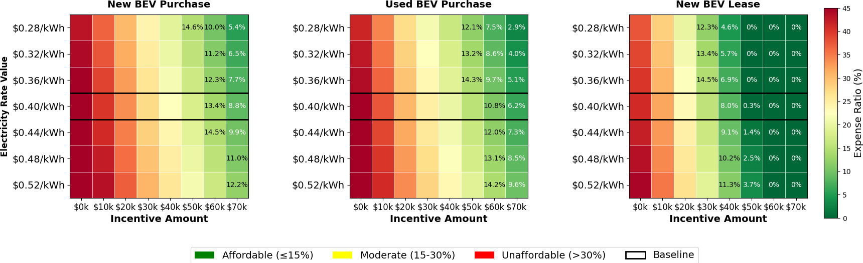
Fees for EV charging (usually measured in $/kWh) have a moderate impact on overall affordability (Figure 5). A 30% decrease (from $0.40/kWh to $0.28/kWh) results in slightly less than a $10,000 decrease in requisite incentive amount. Policymakers have historically not focused on reducing charging costs for TNC drivers, but now some programs provide EV owners with cash or cards to pay for public charging. Programs like this could include incentivizing Level 2 charging costs at workplaces or other long dwell locations that charge lower fees of approximately $0.25/kWh (Stable Auto, 2025) as a supplement to more expensive DC fast charging. Not only could this improve the affordability, but it would also address drivers’ concerns regarding charging sufficiency. While it may not be realistic for TNC drivers to solely use Level 2 chargers, policies to incentivize higher usage of Level 2, for example in multifamily housing, underscore the interconnected nature of EV diffusion and the positive feedback loops that can leveraged to optimize EV policymaking.
Figure 6
Sensitivity Analysis for Weekly Miles Driven 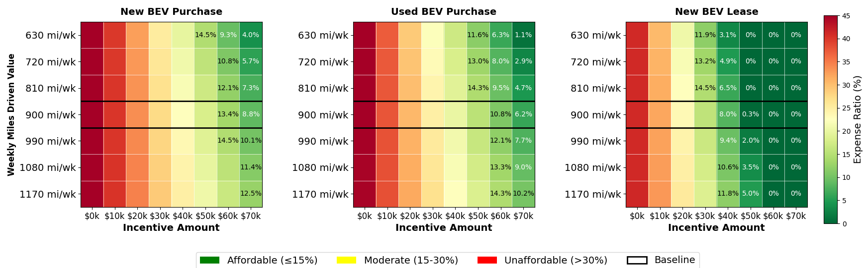
Counterintuitively, affordability does not improve as weekly miles driven increase, instead there is a slight decrease (Figure 6). The primary reason for this is that expenses increase at a rate higher than the additional revenue received (particularly when accounting for household corrections, see Appendix B). This does not imply that gross revenue would decrease, but just the relative effectiveness of affordability would not improve, which is measuring two separate concepts. From a policy perspective, these charts show that increasing miles driven is not a reasonable approach to improve affordability—TNC drivers can’t “outdrive” affordability. Indeed, policymakers may want to search for use cases of higher income, lower mileage TNC drivers as a targeted segment if their primary goal is to ensure affordability (though this would hinder climate change mitigation goals).

Discussion
The goals of BEV adoption within the TNC driver segment are twofold: decarbonize high usage drivers and improve equity among light-duty drivers during the transition. However, the costs associated with each of these goals are likely to be very different. For example, to maximize adoption, an incentive of only $18,000 is recommended, while an incentive of $58,000 is required to reach affordability. In short, the policy goals of decarbonization and equity might be mutually exclusive. Policymakers may choose to have larger programs with lower incentives that accelerate the transition to BEVs, or they may choose to have more targeted programs of very high incentives that bring higher levels of equity. Perhaps the best option is to compromise and have moderate incentives that improve upon equity concerns (though do not completely resolve them).
Policymakers may also want to carefully consider the equity aspects of incentivizing specific purchasing and financing choices for TNC drivers. For example, this report shows that leasing BEVs is likely to be the easiest way to induce BEV adoption with the smallest incentives for TNC populations. However, leasing contracts typically have mileage restrictions that may prove infeasible to a TNC driver’s business model. In addition, policymakers may also have an equity-driven goal to structure BEV incentives that leave low-moderate income consumers with an asset that stretches beyond the scope of the original incentive. That is, a lease may be a more affordable option for TNC drivers to adopt EVs, but the beneficiary would no longer have access to low-carbon transportation at the end date of the lease term and would have to make another purchase decision potentially without the assistance of the government. Alternatively, purchasing a BEV outright would continue to benefit the incentive recipient beyond the duration of financing, albeit at a more expensive upfront option for both TNC driver and policymaker.
The incentives discussed are primarily focused on the purchasing and operation cost differential between BEVs and ICEVs. There are two key aspects when considering the incentive structure underlying these assumptions. First, the model is based on the assumption that TNC drivers are highly rational actors who would switch to BEVs as soon as the cost calculation tips in their favor. However, this may be ignoring real barriers, such as hesitancy to adopt a new technology that is used for work or general ignorance of BEVs. To supplement these factors, additional incentive may be required, or targeted outreach programs used in tandem with incentive programs.
Secondly, these underserved populations may face additional barriers related to charging infrastructure. To ensure actual adoption by TNC drivers, policymakers will need to address BEV barriers comprehensively. For example, Hardman et al. (2021) recommended increasing investments in charging infrastructure in underserved communities to promote accessibility and equity for lower-income and rural populations. In addition, having access to a home charger would greatly reduce the cost of battery recharging, which is a key determinant of affordability. Similarly, Shaheen et al. (2025) also recommended prioritizing reducing EV charging costs as one of the most effective ways to improve EV cost barriers.
Finally, although this study employs a $50,000 salary for a household of four, the average TNC driver may make even less per year, which makes adoption and affordability particularly difficult. While increasing wages would make BEVs increasingly affordable, the two main levers of income—per mile TNC wage and total miles driven—may be difficult to change. For example, a policymaker may institute a program that adds a fee for electric miles driven that is passed on to the driver (improving their wages), though this may be politically unpopular (see Appendix C). At the same time, TNC drivers may elect to drive more trips and miles per month (which improves the business case of BEVs and increases wages), but may result in infeasible charging requirements.

Conclusion & Policy Recommendations
This paper explores two unique societal challenges: the large-scale decarbonization of the light-duty vehicle sector and equity concerns related to transportation costs for low-income households. Mitigating both challenges within the TNC driver segment will require a well-structured program that offsets the substantial financial hurdles facing TNC drivers. It is feasible to provide incentives under multiple scenarios that move vehicle ownership costs below the adoption threshold and closer to affordability, even if the full 15% affordability benchmark is not achieved. This approach would improve affordability outcomes for TNC drivers while reducing transportation emissions, advancing both equity and decarbonization goals simultaneously.
The results of this analysis show that substantial incentive amounts are required to reach ambitious affordability goals, and incentives are still necessary to reach the point of financial feasibility, particularly for new EV purchases. Given the confluence of policy goals, this analysis underscores the importance of targeted incentives to induce EV adoption within specific driver segments. While direct purchase incentives are essential, policymakers should also prioritize enhancing driver benefits and reducing charging costs to spur adoption among TNC driver segments. As discussed above, complementary policies expand access to Level 1 and Level 2 charging at multifamily housing and other work or public sites can create positive feedback loops with outsized impacts on adoption.
Further research should examine how incentive levels can evolve over time as BEV technologies improve and the 15% of income affordability goal becomes more attainable. However, Hardman et al. (2021) note that improvements in the EV market have often resulted in vehicles that are higher-performing but also more expensive, primarily appealing to higher-income buyers. As a result, BEV affordability may remain a persistent challenge for TNC drivers, necessitating continued or expanded incentive support to sustain decarbonization within this segment. Future research should also examine how policymakers, TNC companies, and industry stakeholders can collaborate on a multifaceted strategy to improve BEV affordability for TNC drivers, including identifying the most effective combinations of vehicle types, financing structures, and incentive designs.

References
- Auto Club of Southern California. (2024). Gas prices tick up slightly over holiday; 2024 ends with third-highest annual gas-price average [Press release]. https://news.aaa-calif.com/news/auto-club-gas-prices-tick-up-slightly-over-holiday-2024-ends-with-third-highest-annual-gas-price-average
- Bradley, S. (2024, November). Average Car Loan Interest Rates by Credit Score. Retrieved November 25, 2024, from https://www.nerdwallet.com/auto-loans/learn/average-car-loan-interest-rates-by-credit-score
- Bradley, S., & Woock, K. (2024). How much of a down payment should you make when buying a car? NerdWallet. Retrieved December 5, 2024, from https://www.nerdwallet.com/article/loans/auto-loans/how-much-down-payment-make-buying-car
- Bureau of Transportation Statistics. (2024). The household cost of transportation: Is it affordable? U.S. Department of Transportation. https://www.bts.gov/data-spotlight/household-cost-transportation-it-affordable
- Burnham, A., Gohlke, D., Rush, L., Stephens, T., Zhou, Y., Delucchi, M. A., ... & Birky, A. (2021). Comprehensive total cost of ownership quantification for vehicles with different size classes and powertrains. Argonne National Laboratory. https://publications.anl.gov/anlpubs/2021/05/167399.pdf
- California Air Resources Board. (2016). Fiscal year 2016–17 grant solicitation for the Clean Vehicle Rebate Project (CVRP). https://ww2.arb.ca.gov/sites/default/files/2020-05/fy1617_cvrp_solicitation.pdf
- California Air Resources Board. (2021). 2018 Base-Year Emissions Inventory Report: Clean Miles Standard. Retrieved from https://ww2.arb.ca.gov/sites/default/files/barcu/regact/2021/cleanmilesstandard/appb.pdf
- California Air Resources Board. (2022). Appendix C: Updated long-term plan for light-duty zero-emission vehicles (EVs) (FY 2022-23 Funding Plan). https://ww2.arb.ca.gov/sites/default/files/2022-10/fy2022_23_funding_plan_appendix_c.pdf
- California Energy Commission. (2025). Over 100,000 ZEVs sold in California in second quarter 2025. California Energy Commission News Release. https://www.energy.ca.gov/news/2025-07/over-100000-zevs-sold-california-second-quarter-2025
- California Public Utilities Commission. (2023). Clean Miles Standard. California Public Utilities Commission. Retrieved from https://www.cpuc.ca.gov/regulatory-services/licensing/transportation-licensing-and-analysis-branch/clean-miles-standard
- California Public Utilities Commission. (2024). Clean miles standard program: Driver assistance program. Retrieved from https://docs.cpuc.ca.gov/PublishedDocs/Efile/G000/M523/K124/523124840.PDF
- CarEdge. (2024). The average price of an electric car in America (2024 update). CarEdge. https://caredge.com/guides/average-price-of-an-electric-car-2024
- Cox Automotive (2025). Kelley Blue Book Report: New-Vehicle Average Transaction Price Hits Record High in September, Surges Past $50,000 for the First Time Ever. Retrieved from https://www.coxautoinc.com/insights-hub/sept-2025-atp-report/.
- Edmunds. (2024). Elevated auto loan rates hinder new and used car shoppers in Q1 2024, according to Edmunds. Retrieved December 5, 2024, from https://www.edmunds.com/industry/press/elevated-auto-loan-rates-hinder-new-and-used-car-shoppers-in-q1-2024-according-to-edmunds.html
- Environmental Protection Agency. (2023). Inventory of U.S. greenhouse gas emissions and sinks: 1990-2021. United States Environmental Protection Agency. https://www.epa.gov/ghgemissions/inventory-us-greenhouse-gas-emissions-and-sinks
- Experian. (2024). More people are choosing to lease BEVs. Experian. Retrieved from https://www.experian.com/blogs/ask-experian/electric-vehicle-trends/
- Fehr & Peers. (2019). Estimated TNC share of VMT in six US metropolitan regions (Revision 1). Retrieved from https://issuu.com/fehrandpeers/docs/tnc_vmt_findings_memo_08.06.2019
- Fleming, K. L., & Cohen D’Agostino, M. (2020). Policy pathways to TNC electrification in California [Issue paper]. UC Davis Policy Institute for Energy, Environment, and the Economy. https://escholarship.org/uc/item/9zx112v2
- Garner, T. I., Phipps, S., & Sierminska, E. (2020). Differences across place and time in household expenditure patterns: Implications for the estimation of equivalence scales. U.S. Bureau of Labor Statistics.​ https://www.bls.gov/osmr/research-papers/2020/pdf/ec200010.pdf
- GB Times. (2024, July 13). How does the surge work on Uber? GB Times. https://gbtimes.com/how-does-the-surge-work-on-uber/
- Hardman, S., Fleming, K. L., & Khare, E. (2021). A perspective on equity in the transition to electric vehicles. MIT Science Policy Review. https://sciencepolicyreview.org/2021/08/equity-transition-electric-vehicles/
- International Energy Agency. (2023). Net Zero Roadmap: A Global Pathway to Keep the 1.5 °C Goal in Reach. IEA. https://www.iea.org/reports/net-zero-roadmap-a-global-pathway-to-keep-the-15-0c-goal-in-reach
- Lazer, L., Li, S., Marra, A. D., & Cseh, J. (2021). Electrifying ride-hailing in the United States, Europe, and Canada: How to enable ride-hailing drivers to switch to electric vehicles. ResearchGate. https://www.researchgate.net/publication/356120867_Electrifying_Ride-Hailing_in_the_United_States_Europe_and_Canada_How_to_Enable_Ride-Hailing_Drivers_to_Switch_to_Electric_Vehicles
- Lyft. (2025). Lyft electric vehicles hit 1 million electric miles. Lyft Blog. https://www.lyft.com/blog/posts/lyft-electric-vehicle-million-miles
- Reich, M. (2020). “Pay, Passengers and Profits: Effects of Employee Status for California TNC Drivers.” IRLE Working Paper No. 107-20. http://irle.berkeley.edu/files/2020/10/Pay-Passengers-and-Profits.pdf
- San Francisco County Transportation Authority. (2017). TNCs Today: A profile of San Francisco transportation network company activity. SFCTA. https://www.sfcta.org/projects/tncs-today
- Shaheen, S., Martin, E., & Ju, M. (2025). Acquiring and Operating an Electric Vehicle is Largely Out of Reach for Most Ridehailing Drivers. UC Office of the President: University of California Institute of Transportation Studies. http://dx.doi.org/10.7922/G2NG4P0T Retrieved from https://escholarship.org/uc/item/4rf2191v
- SoFi. (2024). Average car loan interest rate by credit score: What to expect in 2024. https://www.sofi.com/learn/content/average-car-loan-interest-rate-by-credit-score/
- Stable Auto. (2025). Electric vehicle charger price by state. https://stable.auto/insights/electric-vehicle-charger-price-by-state
- Gogol, F. (2024). How much does Uber pay? Stilt. https://stilt.com/careers/how-much-does-uber-pay/
- The Rideshare Guy. (2024). How much do Uber drivers make? The Rideshare Guy. Retrieved from https://therideshareguy.com/how-much-do-uber-drivers-make/
- Timmons, M. (2024). How much does electric car insurance cost? ValuePenguin. Retrieved December 5, 2024, from https://www.valuepenguin.com/how-having-electric-car-affects-your-auto-insurance-rates
- Uber. (2025). Say hello to Uber Electric ⚡ Uber Newsroom. https://www.uber.com/newsroom/uber-electric/ Uber

- U.S. Department of Energy. (2024). Find and compare cars. Retrieved from https://www.fueleconomy.gov/feg/findacar.shtml
- U.S. News. (2024). Electric car charging costs: How much does it cost to charge an electric car? Retrieved from https://cars.usnews.com/cars-trucks/advice/electric-car-charging-costs
- Waheed, S., Herrera, L., Gonzalez-Vasquez, A. L., Shadduck-Hernández, J., Koonse, T., & Leynov, D. (2018). More than a gig: A survey of ride-hailing drivers in Los Angeles. UCLA Institute for Research on Labor and Employment. https://irle.ucla.edu/wp-content/uploads/2018/05/Final-Report.-UCLA-More-than-a-Gig.pdf
- Wenzel, T. P. (2024). Net change in energy use from ridehail services in five California regions. Future Transportation, 4(3), 891–918. https://doi.org/10.3390/futuretransp4030043

Appendix A

Findings on TNC Drivers from the CVRP Consumer Survey (2020-2023)
The Clean Vehicle Rebate Project (CVRP), administered by the California Air Resources Board (CARB), provided financial incentives to promote the adoption of zero-emission vehicles (ZEVs) among California residents from 2010 to 2023. In 2016, CVRP increased rebate amounts for low- and moderate-income consumers and established income eligibility caps to make clean vehicles more accessible to lower-income consumers, thus concentrating state resources among California new-car shoppers of more moderate financial means (CARB, 2016).
To better understand program participation, as well as to assess the program’s impact and increase understanding of participant perceptions, motivations, and car-buying experience, CVRP conducted surveys among rebate recipients. The 2020–2023 CVRP Consumer Survey edition analyzed here covered participants who purchased their vehicles between December 1, 2020, and July 31, 2023, and included questions on vehicle use, including TNC driving. These data offer valuable insights into TNC-related characteristics associated with ZEV adoption, as outlined below.
To better represent the full population of all nonfleet CVRP rebate recipients, all percentages reported in this section are weighted based on vehicle model, technology type, county, and purchase/lease status.

TNC Driver Participation and Demographics
Among the 25,052 survey respondents, 610 individuals—or 2.4%—reported using their CVRP-rebated vehicle for TNC driving. Of these participants, the largest share resided in Los Angeles County (29%), followed by Orange County (18%) and San Diego County (8%).
The most frequently reported household size among TNC-driving participants was four people, and the most common household income range was $50,000 to $74,999. Regarding housing status, 61% of TNC drivers reported owning their homes, while 39% indicated they rent.

Rebate Distribution and Vehicle Preferences
Among TNC drivers in the CVRP survey dataset, approximately 51% received the Increased Rebate designed for low- to moderate-income households, while 49% received the Standard Rebate. In contrast, among non-TNC participants, 26% received the Increased Rebate and 74% received the Standard Rebate. In terms of vehicle preference, the Tesla Model 3 emerged as the most rebated vehicle, accounting for 36% of weighted responses. It was followed closely by the Tesla Model Y at 34% and the Toyota Mirai Fuel Cell Vehicle at 4%.

Charging Preferences
Access to reliable home charging remains a central concern and barrier for many potential BEV adopters. Table 3 shows the most common charging patterns reported by TNC and non-TNC drivers.
Table 3
Weighted responses to Survey Charging Question
Question: "Where do you charge your BEV?” (multiple selections allowed)
Charging location | TNC | Non-TNC
Public only | 26% | 10%
Home and Public | 19% | 25%
Home only | 31% | 40%

Survey respondents could select multiple charging locations, allowing for the identification of combined charging behaviors such as "Home and Public." Public charging includes Level 2 and/or DC fast charging. Percentages are weighted and calculated using all respondents in each group as the denominator; respondents who did not select any charging location are included in the denominator but not shown as a separate group. Because responses were not mutually exclusive, percentages do not sum to 100%.
Home charging emerged as the most common charging method among both TNC and non-TNC drivers, though usage patterns varied between the two groups. Among TNC drivers, 31% relied exclusively on home charging. An additional 19% reported using both home and public charging infrastructure.
Notably, over one-quarter of TNC drivers (26%) relied exclusively on public charging—more than double the rate observed among non-TNC drivers (10%). In contrast, a smaller share of TNC drivers relied solely on home charging (31% vs. 40%).
These differences suggest that TNC drivers may face greater dependence on public charging infrastructure to support their work-related driving needs.

Appendix B

Computations
- Equivalized income is used to adjust household income to account for the economies of scale. For example, a family of four does not need four times the income of a one-person household. Computing the monthly equivalized income:
$$Equivalized Monthly Income =\frac{\left(\frac{Annual Income}{12 months}\right)}{\sqrt{HH Size}}$$
- Monthly miles based on incentive program eligibility requirements:
$$\frac{4,500trips}{year}*\frac{10miles}{trip}*\frac{year}{50}weeks=\frac{900 miles}{week}$$
- TNC Revenue Calculation based on the assumption that drivers are only able to bill about 60% of their miles due to “deadhead” miles. The reported rate for California is $1.31 per mile including tips.
- Monthly TNC Revenue = Monthly Miles × Billable Ratio × Wage Rate
- Loan payments are computed using the standard amortization formula where the fixed monthly payment (P) is determined as the ratio of the monthly interest rate (r), the number of payments (n), and the principal loan amount (L). It is important to note that the APR determines the monthly interest rate (APR/12), and the loan amount assumes a 10% down payment on the original MSRP.
$$P = L ×\frac{\left[r{\left(1+r\right)}^{n}\right]}{\left[{\left(1+r\right)}^{n}- 1\right]}$$
- Lease payments are calculated as the sum of the depreciation component and the finance component. The depreciation component represents the dollar amount the car is expected to depreciate over time – a ratio of the initial cost less any incentives divided by the lease term (in this case 36 months). The finance component determines the amount of money the lessor makes. This is computed as a fraction of the sum of the vehicle at beginning and end of lease. In this case, the fractional value is APR/2400, and the residual value is set to 55%.

Appendix C
This appendix shows additional sensitivity analyses conducted for additional input variables, including monthly insurance, maintenance cost, APR, and TNC wages.
Figure 7

Sensitivity Analysis for Monthly Insurance
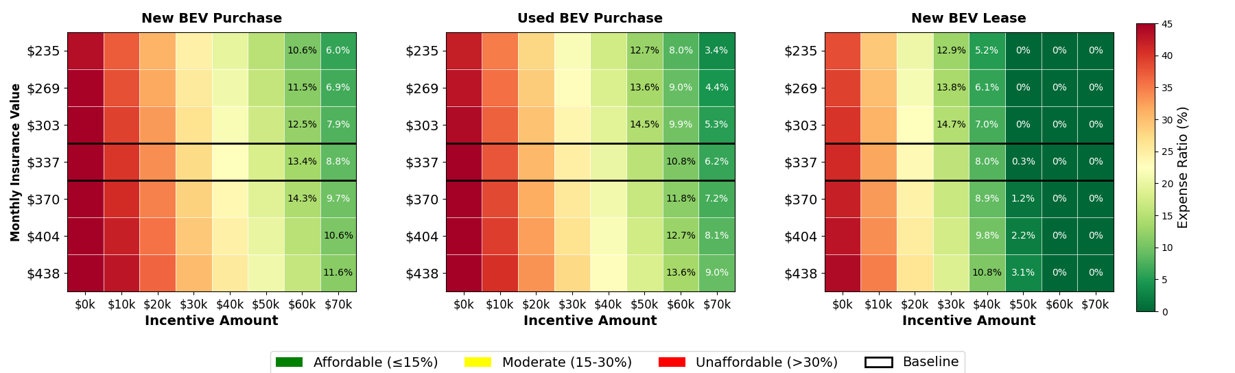
Varying the insurance amounts leads to moderate improvements to affordability (Figure 7). Although the capacity to reduce costs is relatively moderate (i.e., decreasing the insurance cost by 30% would only reduce the requisite incentive by less than $10,000), it may be worthwhile for policymakers to explore setting rules on insurance rates for BEVs. For example, governments can create their own insurance program (e.g., California offers fire insurance that is prohibitive in the market) or supplement insurance for TNC drivers specifically. This would likely save money from a government spending perspective as the supplemental insurance would reduce the amount of incentive dollars needed to reach a given equity goal.
Figure 8

Sensitivity Analysis for BEV Maintenance Costs
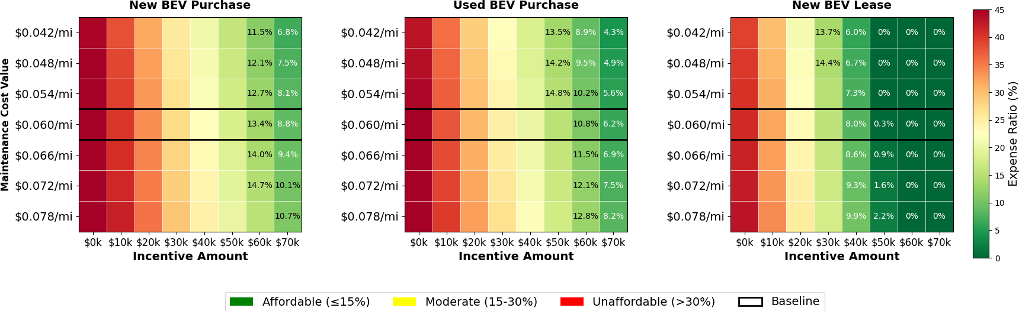
Altering the cost of maintenance has a minor to moderate impact on overall affordability. Reducing maintenance costs by 30% could reduce the requisite incentive by roughly $10,000. However, policymakers may have little control over the maintenance cost of a BEV. One possible area of research is battery health that policymakers could improve, though that would be unlikely to be realized economic benefits to TNC drivers.

Figure 9

Sensitivity Analysis for Loan/Lease Amount APR
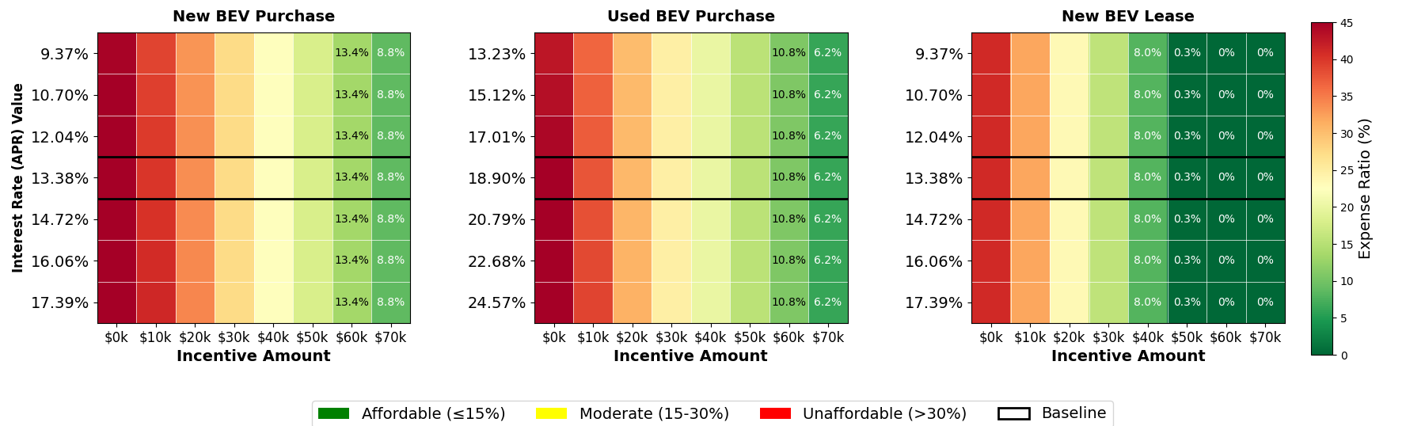
Next, varying the APR for the loan rate makes essentially no difference across various rates nor purchase types. Though loan guarantees can help certain segments that may face specific problems with loan origination, the cost of financing overall not the majority of the monthly cost of the BEV. As such, this limits the capability of APR to improve the affordability of BEVs for the representative household modeled here. Instead, policymakers should use other tools to improve general affordability (such as reducing the cost of electricity) and use APR as a tool only for niche cases.

Figure 10

Sensitivity Analysis for TNC Wage Rates
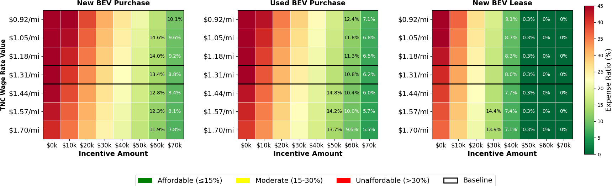
Improving the TNC wage unsurprisingly improves affordability, though not as much as one might assume. For example, improvements to household income outperform improvements to TNC wage rate—this is interrelated to the number of miles that can be billed to the TNC (Figure 10). Due to this, there are some efficiency losses when increasing per-mile wages. Increasing TNC wages through higher taxes on TNC users for EVs could also be unpopular, so policymakers who consider this as a tool for improving affordability should take caution, given that it would necessitate very high increases (e.g., 30% higher costs) to improve affordability for TNC drivers. Instead, policymakers should use a more moderate increase and complement it with other tools to improve affordability.

